## Kramers–Kronig Relations

The Kramers–Kronig relations (KKR) are relations between the real and imaginary part of the dielectric function. They are of a general nature and are based on the properties of a complex, analytical response function

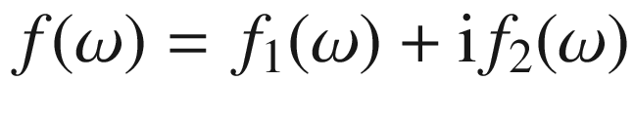

fulfilling the following conditions[1](The_Physics_of_Semiconductors00011.docx#u116076_4_En_BookBackmatter_OnlinePDF-Fn1):

The poles of

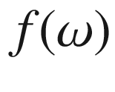

are below the real axis.

The integral of

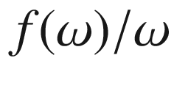

along a semicircle with infinite radius in the upper half of the complex plane vanishes.

The function

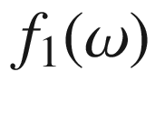

is even and the function

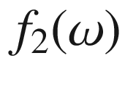

is odd for real values of the argument.

The integral of

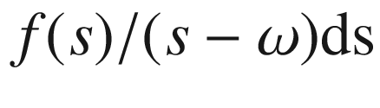

along the real axis and an infinite semicircle in the upper half of the complex plane is zero because the path is a closed line. The integral along a semicircle above the pole at

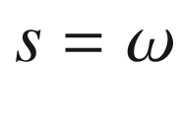

yields

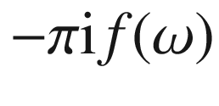

, the integral over the infinite semicircle is zero. Therefore the value of

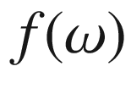

is given by[2](The_Physics_of_Semiconductors00011.docx#u116076_4_En_BookBackmatter_OnlinePDF-Fn2)

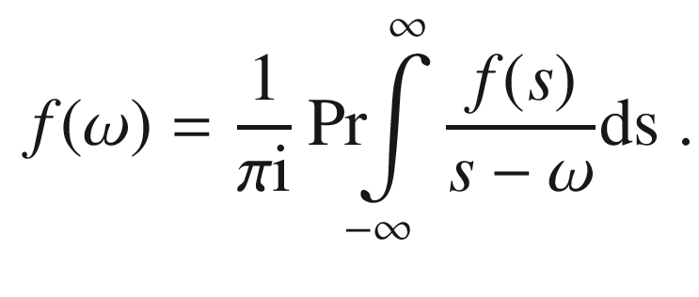

(C.1)

Equating the real and imaginary parts of ([C.1](#u116076_4_En_BookBackmatter_OnlinePDF-Equ23)) yields for the real part

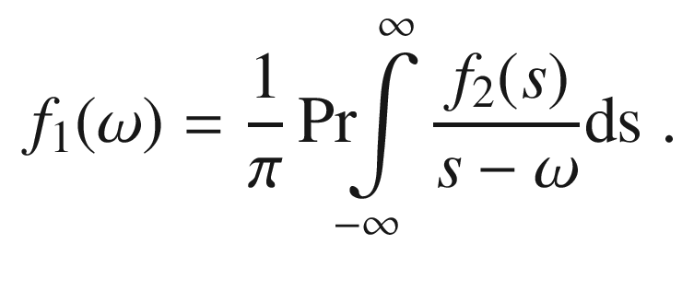

(C.2)

Splitting the integral into two parts

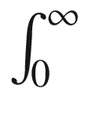

and

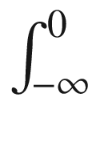

, going from *s* to

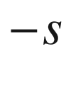

in the latter and using

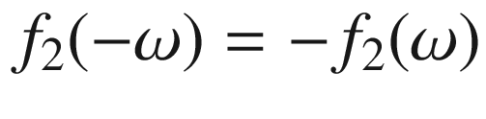

and

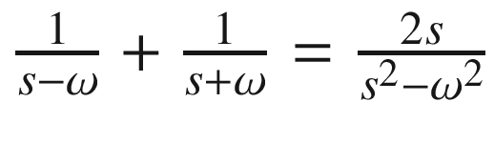

yields ([C.3a](#u116076_4_En_BookBackmatter_OnlinePDF-Equ25))

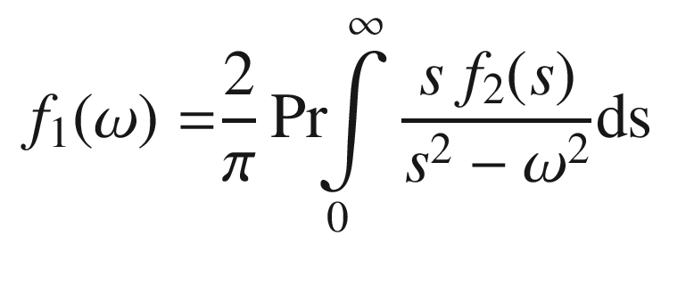

(C.3a)

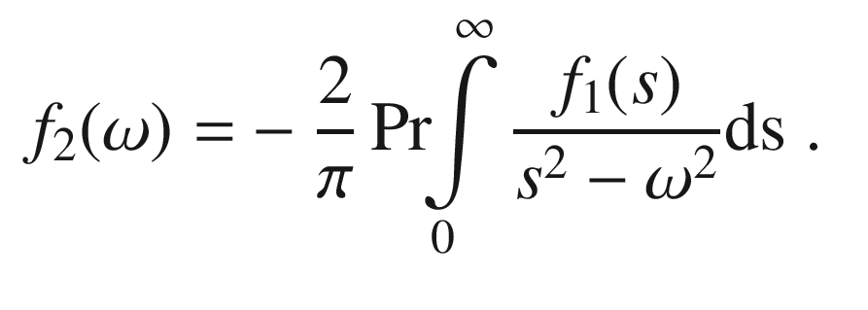

(C.3b)

In a similar way, ([C.3b](#u116076_4_En_BookBackmatter_OnlinePDF-Equ26)) is obtained. These two relations are the Kramers–Kronig relations [[2152](#u116076_4_En_BookBackmatter_OnlinePDF-CR2152), [2153](#u116076_4_En_BookBackmatter_OnlinePDF-CR2153)]. They are most often applied to the dielectric function

$$\epsilon $$

. In this case, they apply to the susceptibility , i.e.

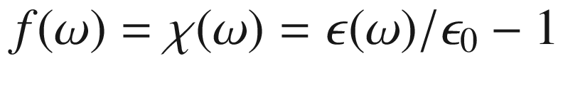

. The susceptibility can be interpreted as the Fourier transform of the time-dependent polarization  in the semiconductor after an infinitely short pulsed electric field, i.e. the impulse response of the polarization . For the dielectric function

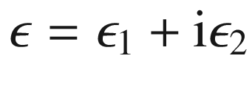

, the following KKR relations hold:

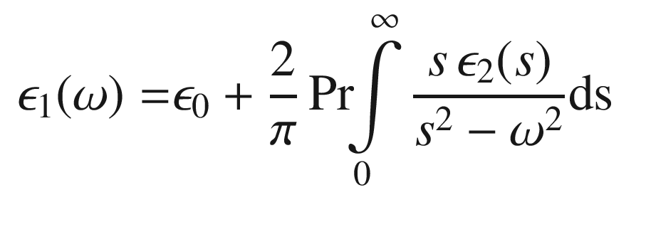

(C.4a)

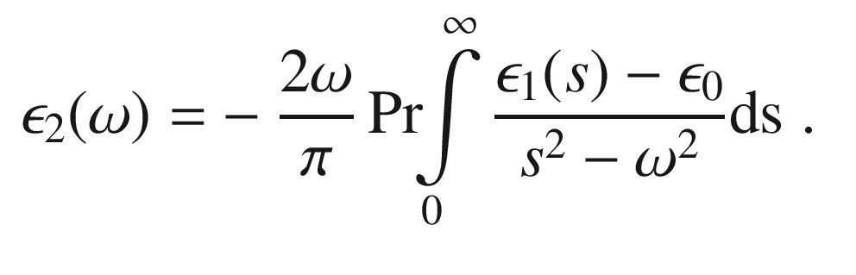

(C.4b)

The static dielectric constant is thus given by

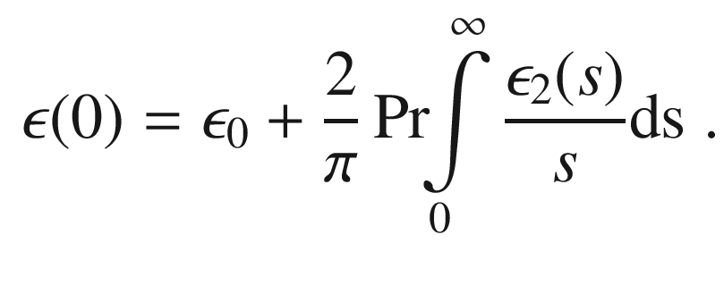

(C.5)

The integral does not diverge since

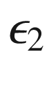

is an odd function and zero at

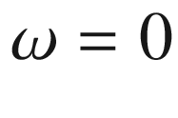

. Generally the *j*-

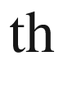

momentum



of the imaginary part of the dielectric function is

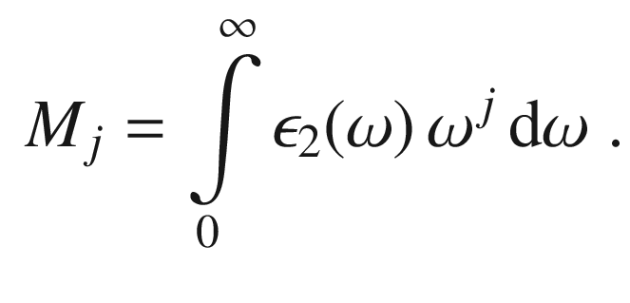

(C.6)

Thus,

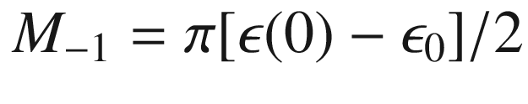

.

Other KKRs are, e.g., the relation between the index of refraction

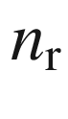

and the absorption coefficient

$$\alpha $$

:

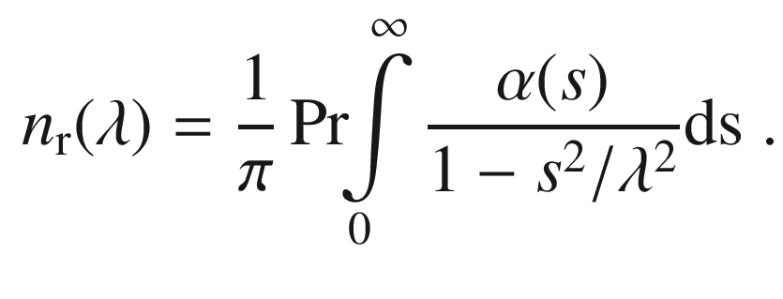

(C.7)

If the imaginary (real) part of the dielectric function is known (for all frequencies), the real (imaginary) part can be calculated via the KKR. If the dependence is not known for the entire frequency range, assumptions about the dielectric function in the unknown spectral regions must be made that limits the reliability of the transformation.

Appendix D

## Oscillator Strength

The response of an oscillator to an electric field



is formulated with the dielectric function. The resulting polarization

$$\mathbf{P}$$

is related to the electric field via

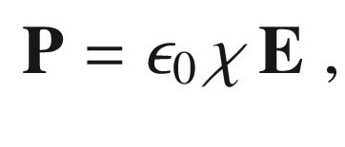

(D.1)

with

$$\chi $$

being the electric susceptibility, and the displacement field



is given by

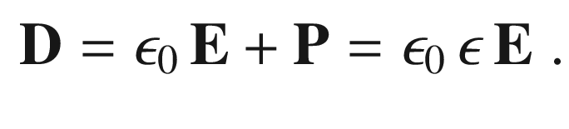

(D.2)

Thus the (relative) dielectric constant is

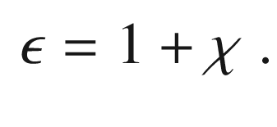

(D.3)

We assume a harmonic oscillator model for an electron, i.e. an equation of motion for the amplitude

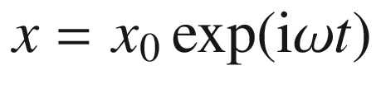

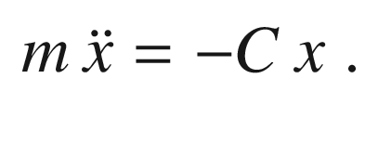

(D.4)

The resonance frequency is

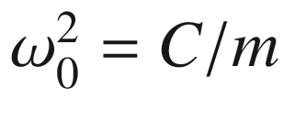

. The presence of a harmonic electric field *E* of frequency



and amplitude

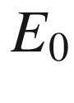

adds a force *eE*. Thus,

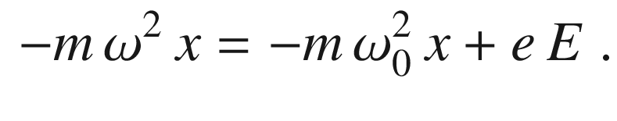

(D.5)

The polarization

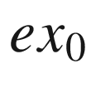

is given by

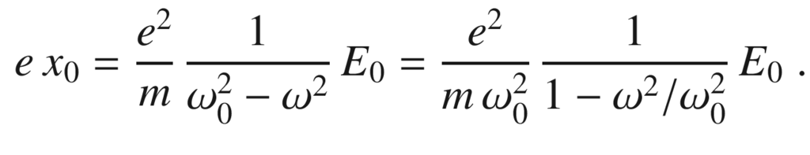

(D.6)

The pre-factor is called the (dimensionless) *oscillator strength* and will be denoted as

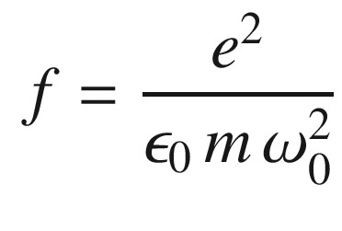

(D.7)

in the following. The frequency-dependent dielectric function of the resonance is thus

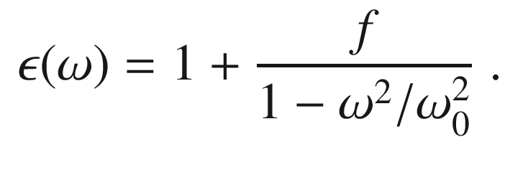

(D.8)

In the low-frequency limit, the dielectric function is

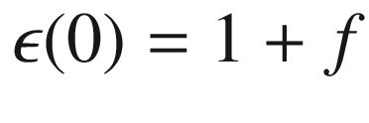

, in the high-frequency limit

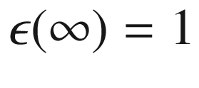

. The oscillator strength is the difference of

$$\epsilon $$

for frequencies below and above the resonance.

For all systems, the high-frequency limit of

$$\epsilon $$

is 1. This means that

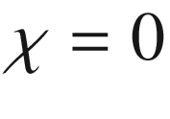

, i.e. there are no more oscillators to be polarized. The low-frequency limit includes all possible oscillators. If there are further oscillators between frequencies well above



and

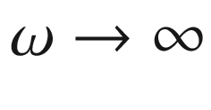

, these are summarized as the high-frequency dielectric constant

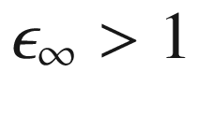

. Equation ([D.8](#u116076_4_En_BookBackmatter_OnlinePDF-Equ39)) then reads

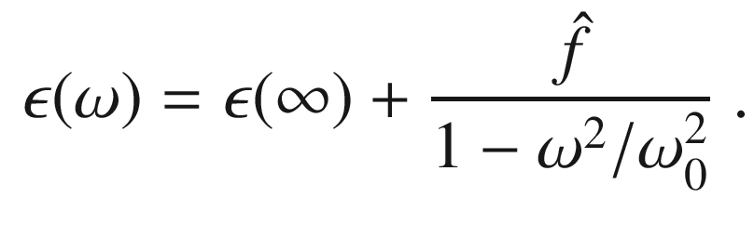

(D.9)

The limit

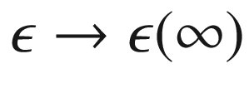

is only valid for frequencies above



but smaller than the next resonance(s) at higher frequencies.[3](The_Physics_of_Semiconductors00011.docx#u116076_4_En_BookBackmatter_OnlinePDF-Fn3) Another common form is to include the background dielectric constant via

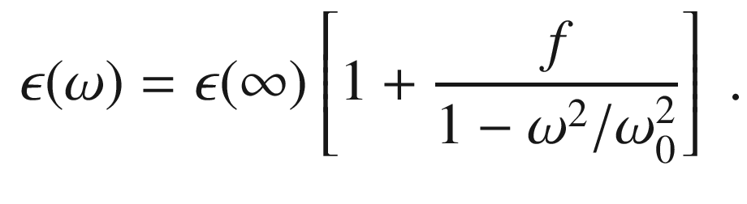

(D.10)

Obviously,

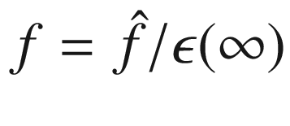

, making the two forms equivalent.

In order to discuss the lineshape, not only for

$$\epsilon $$

but also for the index of refraction

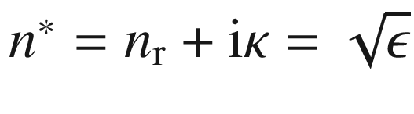

, we introduce damping to our calculation by adding a term

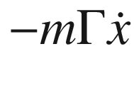

to the left side of ([D.5](#u116076_4_En_BookBackmatter_OnlinePDF-Equ36)). This term is something like a ‘friction’ and would cause the oscillation amplitude to decay exponentially with a time constant

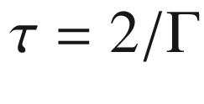

without external stimulus. The dielectric constant is

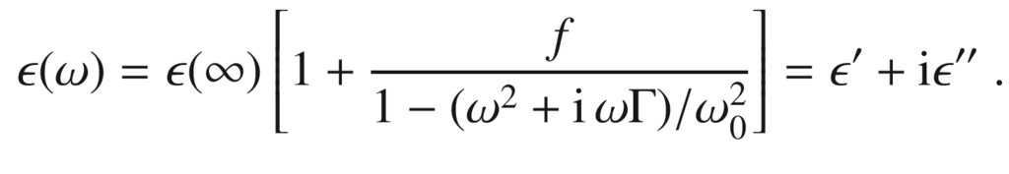

(D.11)

The real and imaginary part fulfill the Kramers–Kronig relations  ([C.3a](#u116076_4_En_BookBackmatter_OnlinePDF-Equ25)) and ([C.3b](#u116076_4_En_BookBackmatter_OnlinePDF-Equ26)). For the oscillator strength, the regimes of large oscillator strength (

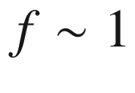

) and small oscillator strength (

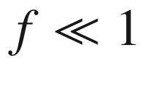

) are distinguished. For the damping, two regimes should be distinguished: Small damping (

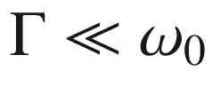

) and strong damping (

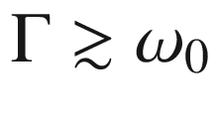

). Typical lineshapes are shown in Figs. [D.1](#u116076_4_En_BookBackmatter_OnlinePDF-Fig2) and [D.2](#u116076_4_En_BookBackmatter_OnlinePDF-Fig3).

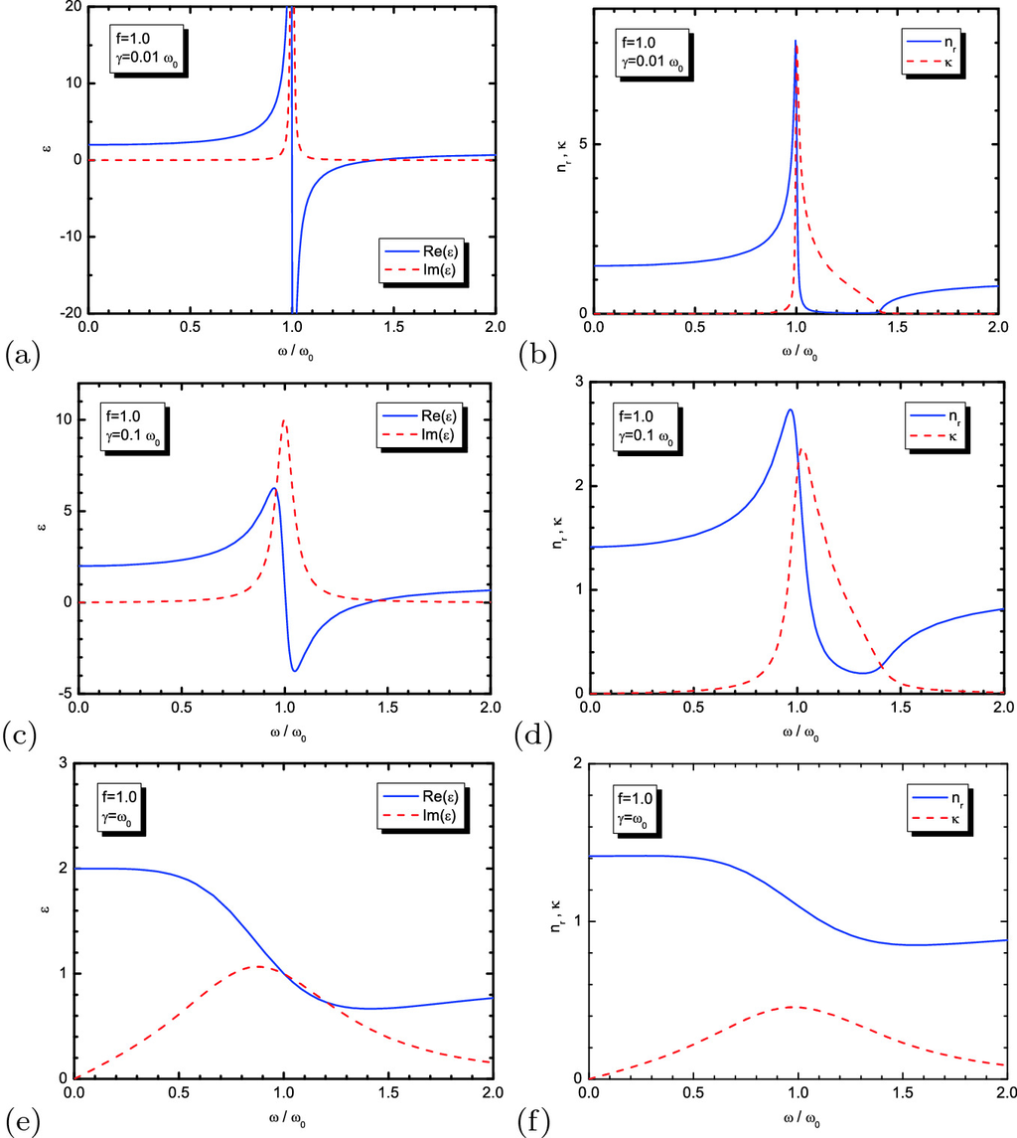

Fig. D.1

Real (*solid lines*) and imaginary (*dashed lines*) parts of the dielectric constant (**a**, **c**, **e**) and index of refraction (**b**, **d**, **f**) ([D.11](#u116076_4_En_BookBackmatter_OnlinePDF-Equ42)) for oscillator strength

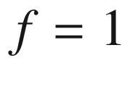

and various values of damping: (**a**, **b**)

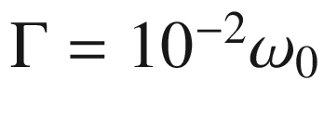

, (**c**, **d**)

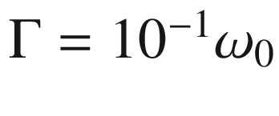

, and (**e**, **f**)

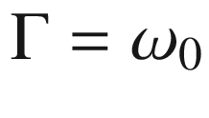

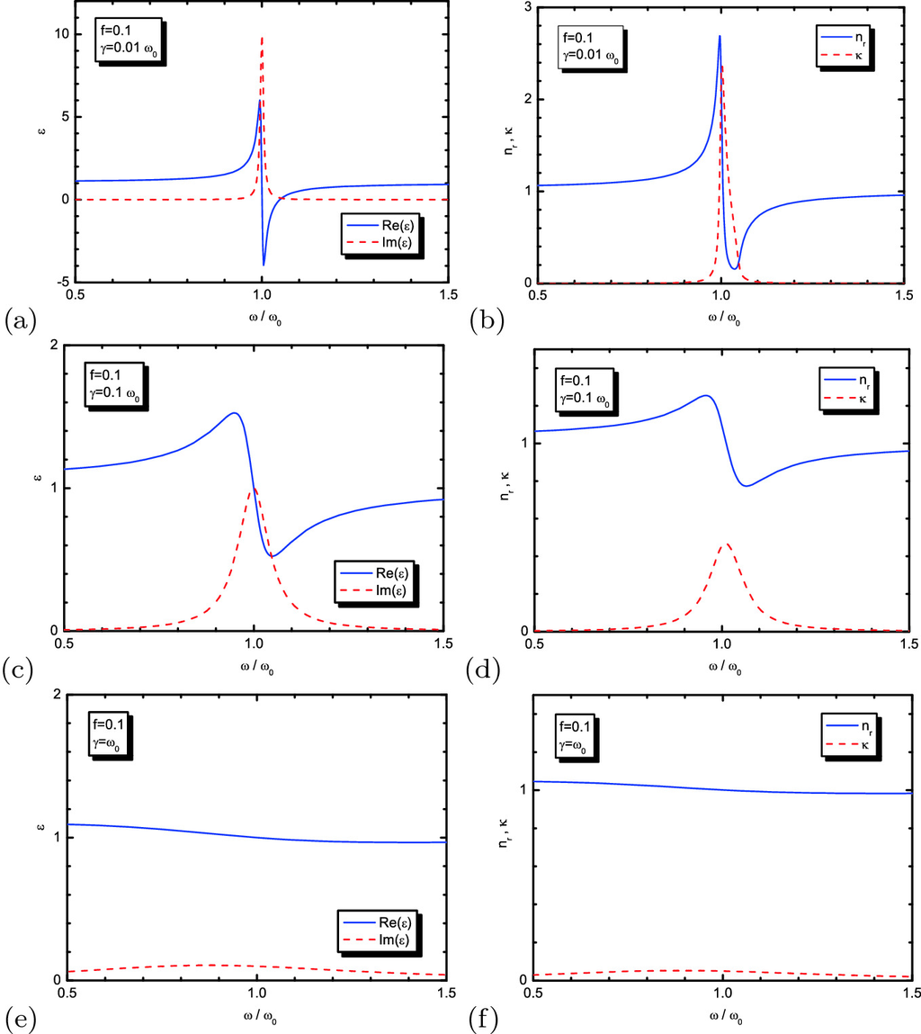

Fig. D.2

Real (*solid lines*) and imaginary (*dashed lines*) parts of the dielectric constant (**a**, **c**, **e**) and index of refraction (**b**, **d**, **f**) ([D.11](#u116076_4_En_BookBackmatter_OnlinePDF-Equ42)) for oscillator strength

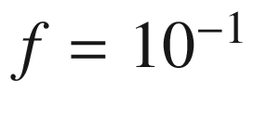

and various values of damping: (**a**, **b**)

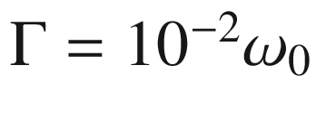

, (**c**, **d**)

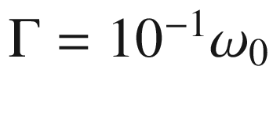

, and (**e**, **f**)

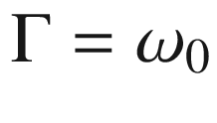

For small oscillator strength, i.e.

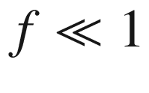

, the index of refraction

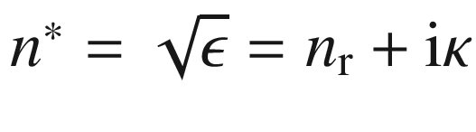

is given by (

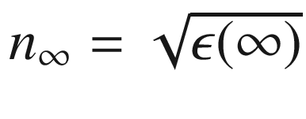

)

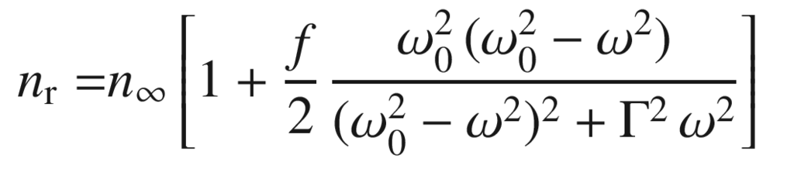

(D.12a)

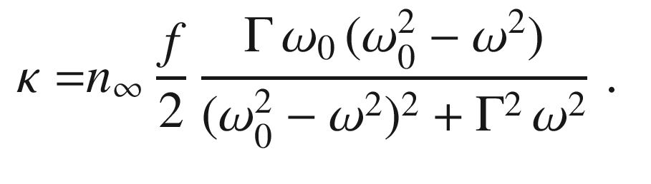

(D.12b)

For small detuning from the resonance frequency, i.e.

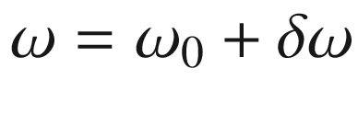

with

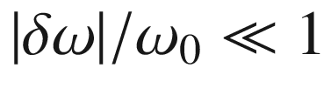

, the index of refraction is given by

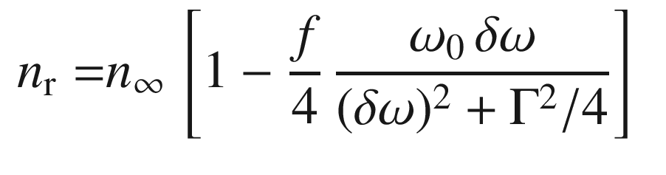

(D.13a)

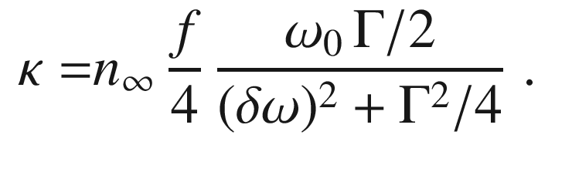

(D.13b)

The maximum absorption is given as

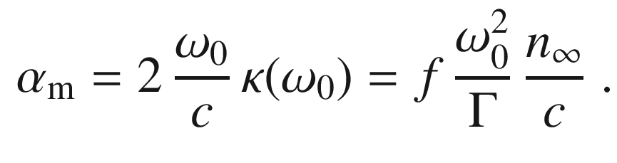

(D.14)

For zero damping, the dielectric function has a zero at

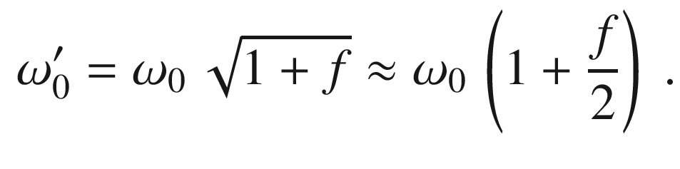

(D.15)

The latter approximation is valid for

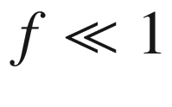

. In the region between



and

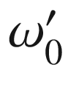

, the real part of the index of refraction is very small (for the physically unrealistic case of

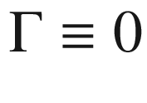

it is exactly zero since

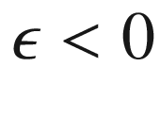

). The reflectance (for vertical incidence

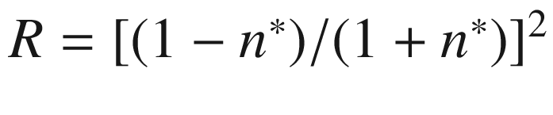

) in this region (width:

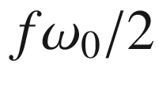

) is thus very high. For larger damping (and small oscillator strength), this effect is washed out.

The frequency

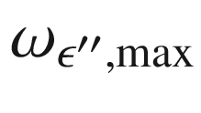

of the maximum of the imaginary part of

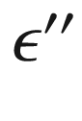

of the dielectric function (

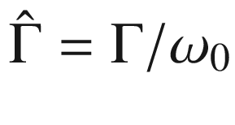

) is

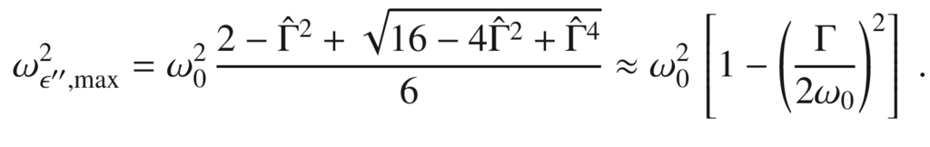

(D.16)

The approximation is valid for small damping

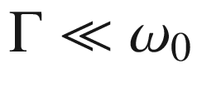

. In this case, the detuned frequency of the maximum is close to



(Fig. [D.3](#u116076_4_En_BookBackmatter_OnlinePDF-Fig4)). The frequency position of the maximum of

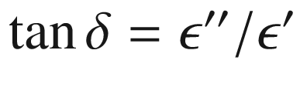

 is

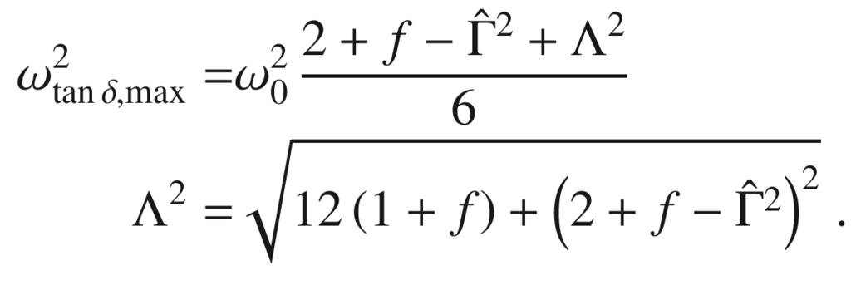

(D.17)

The value of

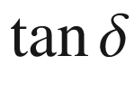

at its maximum is (



has the same meaning as in ([D.17](#u116076_4_En_BookBackmatter_OnlinePDF-Equ50)))

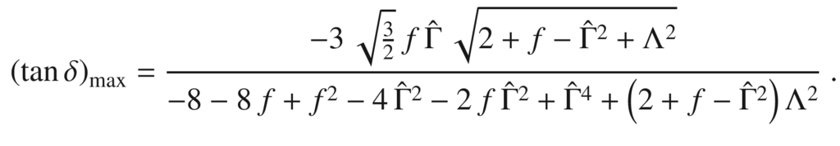

(D.18)

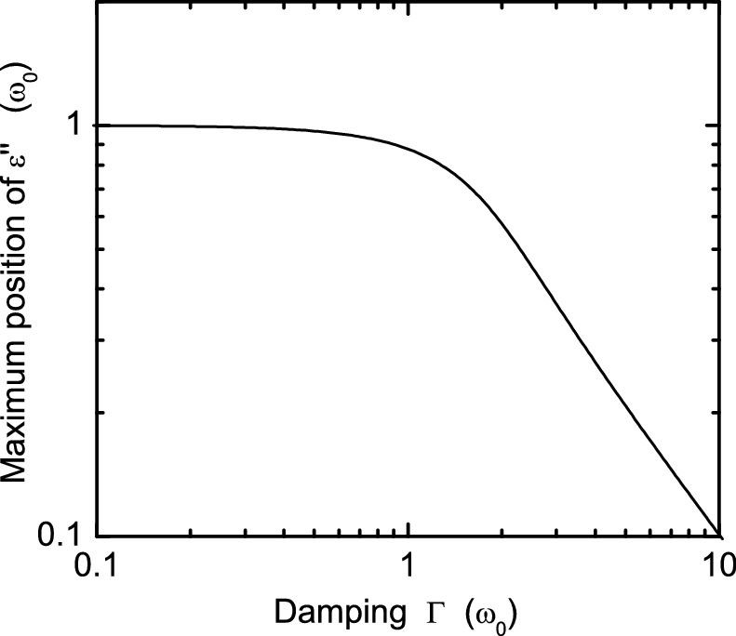

Fig. D.3

Frequency position of the maximum of

$$\epsilon $$

as a function of the damping

Appendix E

## Quantum Statistics

### E.1 Introduction

Bosons  are particles with integer spin

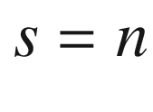

, fermions  are particles with spin

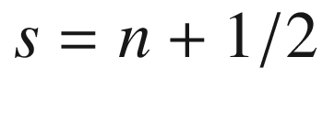

with *n* being an integer including zero. The fundamental quantum-mechanical property of the wavefunction of a system with *N* such particles is that under exchange of any two particles, the wavefunction is symmetric in the case of bosons and antisymmetric in the case of fermions. For two particles, these conditions read

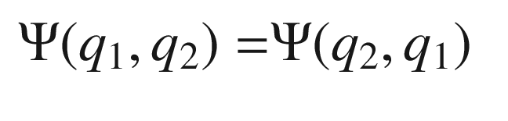

(E.1a)

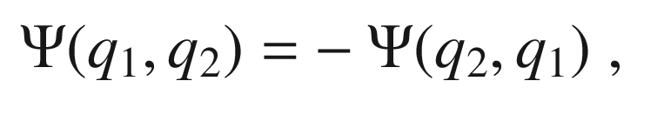

(E.1b)

where ([E.1a](#u116076_4_En_BookBackmatter_OnlinePDF-Equ52)) holds for bosons and ([E.1b](#u116076_4_En_BookBackmatter_OnlinePDF-Equ53)) holds for fermions. The variables

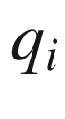

denote the coordinates and spin of the *i*-th particle. The Pauli principle allows bosons to populate the same single particle state with an arbitrary number of particles (at least more than one). For fermions, the exclusion principle  holds that each single particle state can only be populated once.

### E.2 Partition Sum

We consider a gas of *N* identical particles in a volume *V* in equilibrium at a temperature *T*. The possible quantum-mechanical states of a particle is denoted as *r*. The energy of a particle in the state *r* is

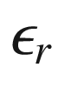

, the number of particles in the state *r* is

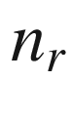

.

For vanishing interaction of the particles, the total energy of the gas in the state *R* (with

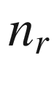

particles in the state *r*) is

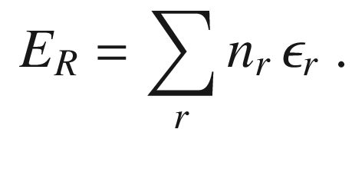

(E.2)

The sum runs over all possible states *r*. The total number of particles imposes the condition

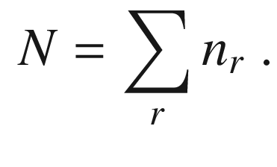

(E.3)

In order to calculate the thermodynamic potentials, the partition sum *Z* needs to be calculated

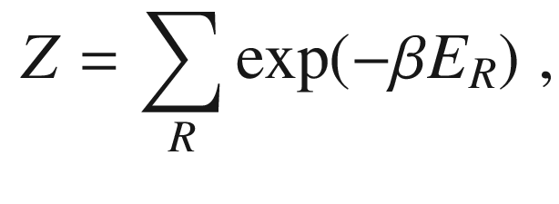

(E.4)

with

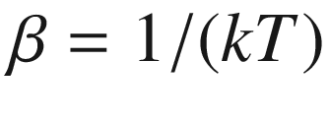

. The sum runs over all possible microscopic states *R* of the gas, i.e. all combinations of the

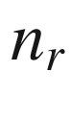

that fulfill ([E.3](#u116076_4_En_BookBackmatter_OnlinePDF-Equ55)). The probability

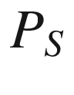

to find the system in a particular state *S* is given by (canonical ensemble)

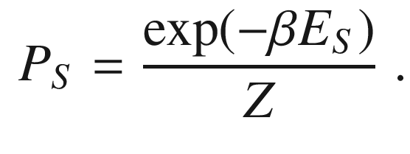

(E.5)

The average number

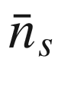

of particles in a state *s* is given by

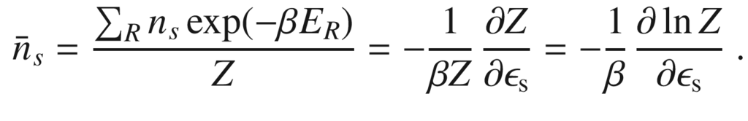

(E.6)

We note that the average deviation

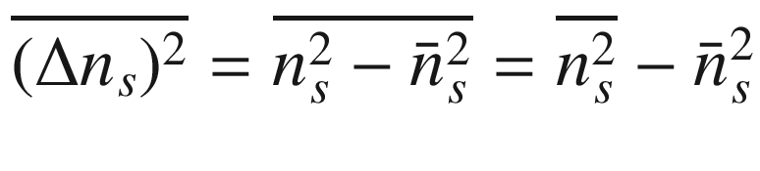

is given by

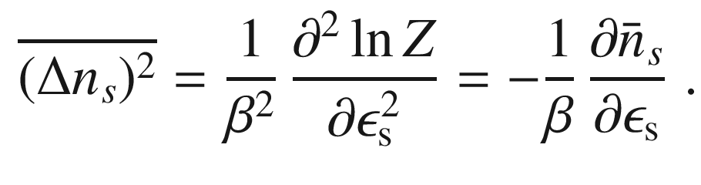

(E.7)

In the Bose–Einstein statistics (for bosons), the particles are fundamentally indistinguishable. Thus, a set of

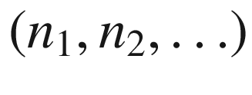

uniquely describes the system. In the case of fermions, for each state

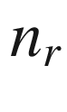

is either 0 or 1. In both cases, ([E.3](#u116076_4_En_BookBackmatter_OnlinePDF-Equ55)) needs to be fulfilled.

### E.3 Photon Statistics

This case is the Bose–Einstein statistics  (cf. ([E.24](#u116076_4_En_BookBackmatter_OnlinePDF-Equ76))) with undefined particle number. We rewrite ([E.6](#u116076_4_En_BookBackmatter_OnlinePDF-Equ58)) as

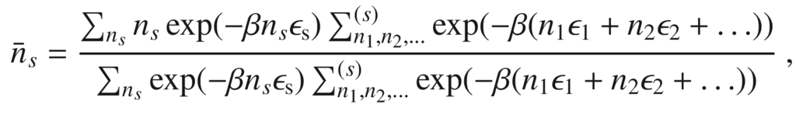

(E.8)

where

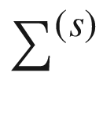

denotes a summation that does not include the index *s*. In the case of photons, the values

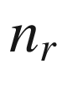

can take any value (integers including zero) without restriction and therefore the sums

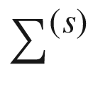

in the numerator and denominator of ([E.8](#u116076_4_En_BookBackmatter_OnlinePDF-Equ60)) are identical. After some calculation we find

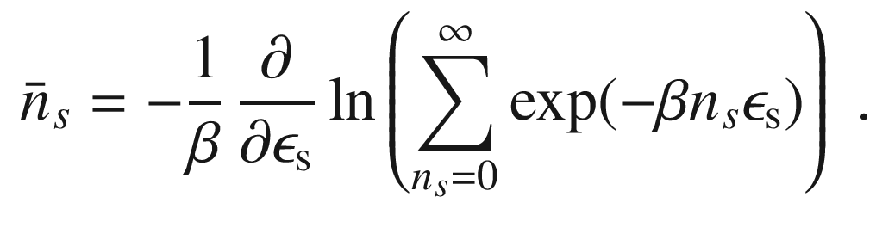

(E.9)

The argument of the logarithm is a geometrical series with the limit

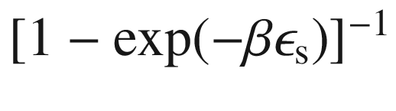

. This leads to the so-called Planck distribution

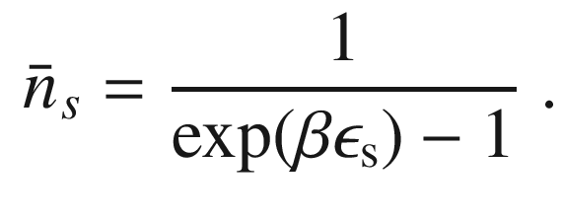

(E.10)

### E.4 Fermi–Dirac Statistics

Now, the particle number is fixed to *N*. For the sum

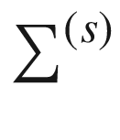

from ([E.6](#u116076_4_En_BookBackmatter_OnlinePDF-Equ58)), we introduce the term

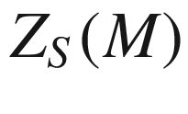

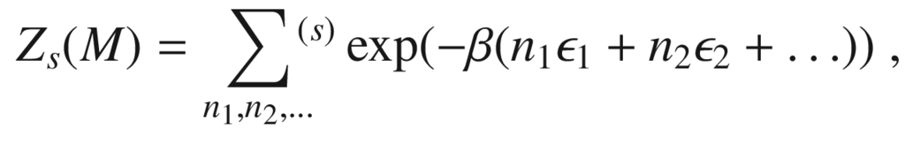

(E.11)

when *M* particles are to be distributed over all states except *s* (

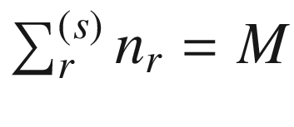

). *M* is either

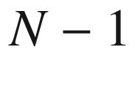

if

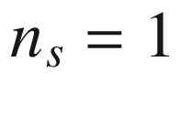

and *N* if

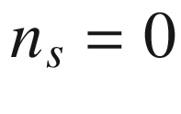

. Using

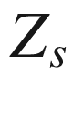

, we can write

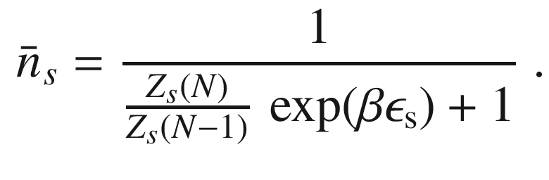

(E.12)

We evaluate

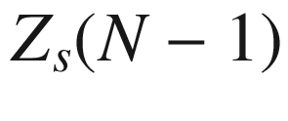

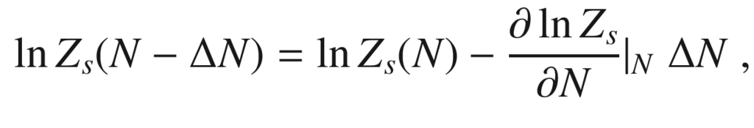

(E.13)

or

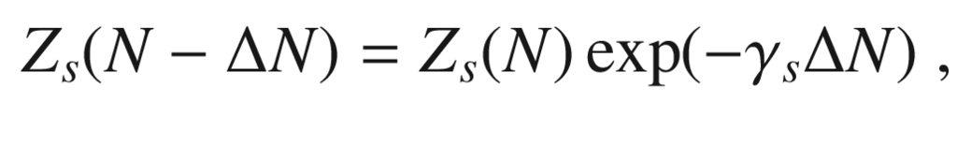

(E.14)

with

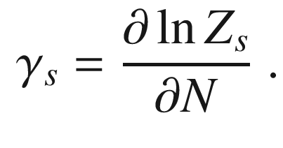

(E.15)

Since

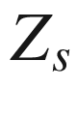

runs over many states, the derivative is approximately equal to

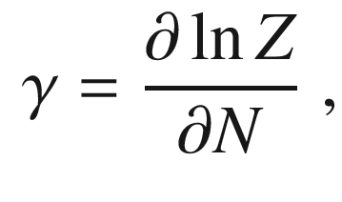

(E.16)

as will be shown below. Thus, we obtained so far

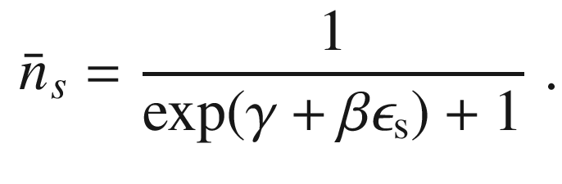

(E.17)

Equation ([E.3](#u116076_4_En_BookBackmatter_OnlinePDF-Equ55)) holds also for the average values

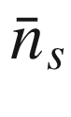

, i.e.

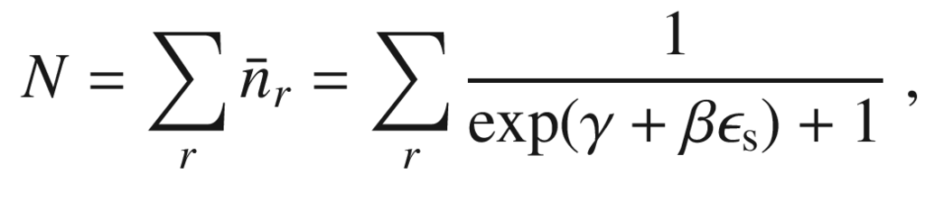

(E.18)

from which the value of

$$\gamma $$

can be calculated. Given that the free energy is given as

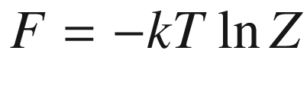

, we find that

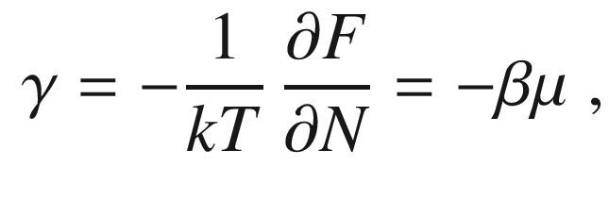

(E.19)

where

$$\mu $$

is the chemical potential by definition. Therefore, the distribution function for the Fermi–Dirac statistics (also called the Fermi function) is

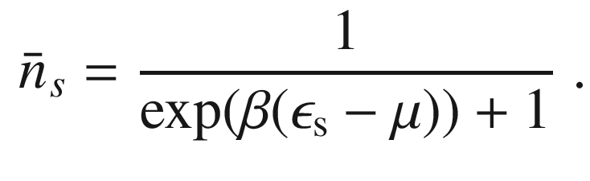

(E.20)

Now, we briefly revisit the approximation

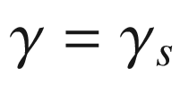

. Exactly,

$$\gamma $$

fulfills

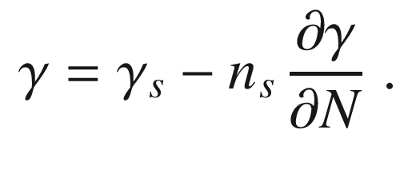

(E.21)

Thus, the approximation is valid if

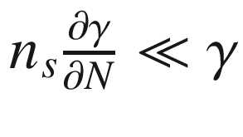

. Since

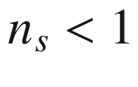

, this means that the chemical potential does not change significantly upon addition of another particle.

The Fermi–Dirac distribution function ([E.20](#u116076_4_En_BookBackmatter_OnlinePDF-Equ72)) for electrons is typically written as

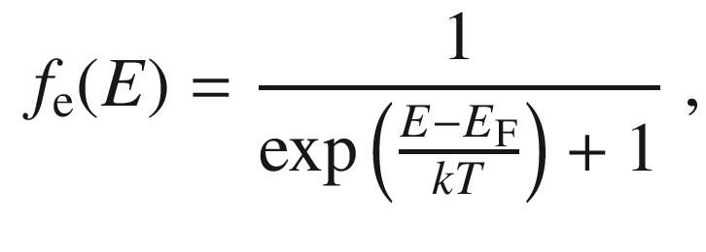

(E.22)

where *k* (or

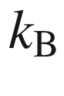

) denotes the Boltzmann constant, *T* is the temperature, and

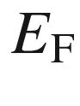

is the Fermi level, which is called the chemical potential

$$\mu $$

in thermodynamics. The Fermi distribution is shown in Fig. [E.1](#u116076_4_En_BookBackmatter_OnlinePDF-Fig5) for various parameters. The distribution function gives the probability that a state at energy *E* is populated in thermodynamic equilibrium. For

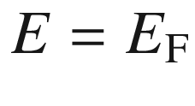

the population is 1/2 for all temperatures. At (the unrealistic case of)

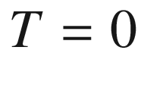

, the function makes a step from 1 (for

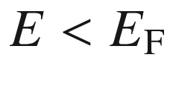

) to 0.

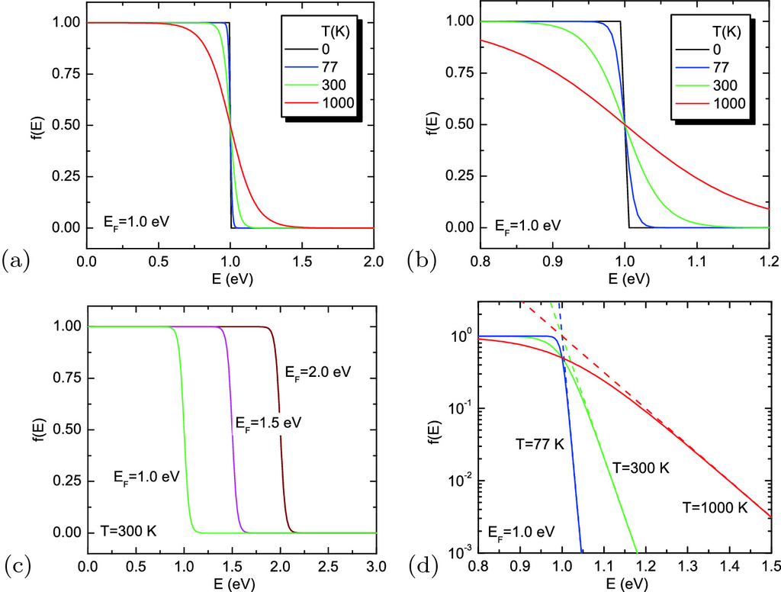

Fig. E.1

Fermi function for **a**, **b** different temperatures (for

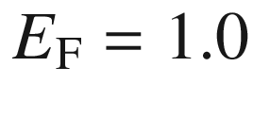

 eV) and **c** for different chemical potentials (for

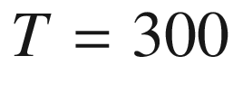

 K). **d** Fermi function (*solid lines*) compared with Boltzmann approximation (*dashed lines*) for various temperatures and

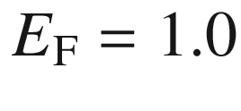

 eV on semilogarithmic plot

The high-energy tail of the Fermi distribution, i.e. for

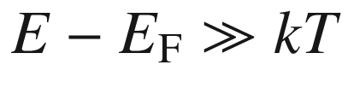

, can be approximated by the Boltzmann distribution:

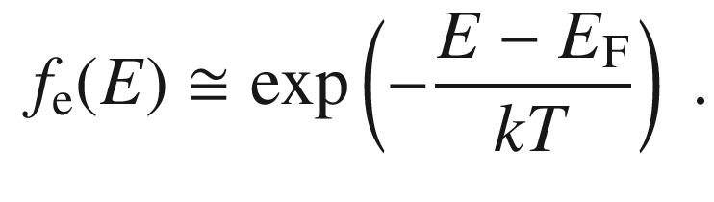

(E.23)

### E.5 Bose–Einstein Distribution

Executing ([E.8](#u116076_4_En_BookBackmatter_OnlinePDF-Equ60)) with the approximation

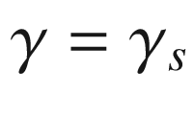

, the Bose–Einstein distribution is found to be

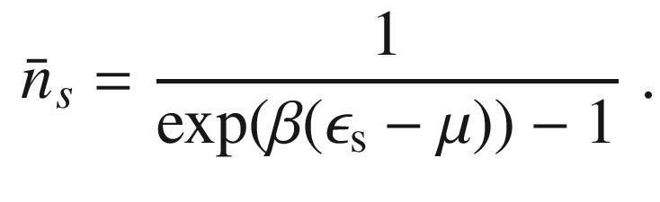

(E.24)

Appendix F

## Kronig-Penney Model

The Kronig-Penney model [[71](#u116076_4_En_BookBackmatter_OnlinePDF-CR71)] is a simple, one-dimensional analytically solvable model that visualizes the effect of the periodic potential on the dispersion relation of electrons, i.e. the formation of a band structure.

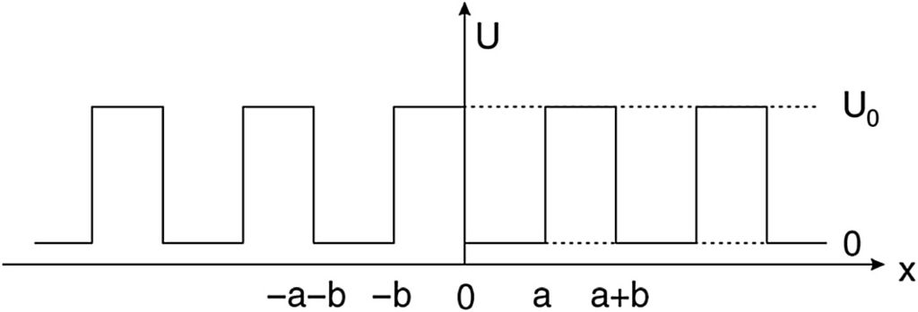

Fig. F.1

One-dimensional periodic hard-wall potential (Kronig-Penney model)

A one-dimensional periodic hard-wall potential of finite height is assumed (Fig. [F.1](#u116076_4_En_BookBackmatter_OnlinePDF-Fig6)). The well width is *a*, the barrier width *b* and thus the period

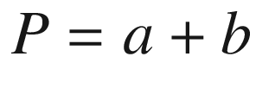

. The potential is zero in the well (regions

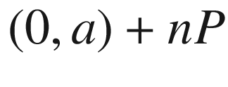

) and

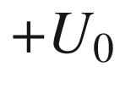

in the barrier. The Schrödinger equation

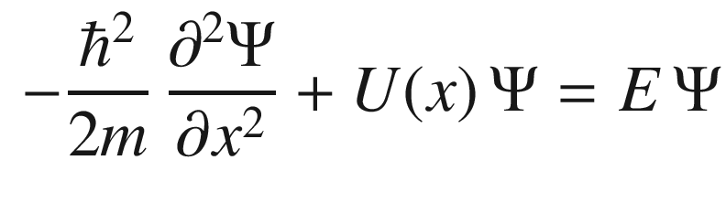

(F.1)

has to be solved. The solutions for a single hard-wall potential well are well known. In the well, they have oscillatory character, i.e.

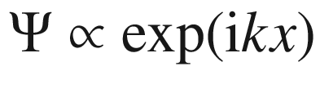

with real *k*. In the barrier, they have exponential character, i.e.

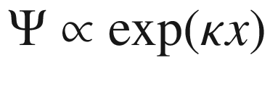

with real

$$\kappa $$

. Thus we chose

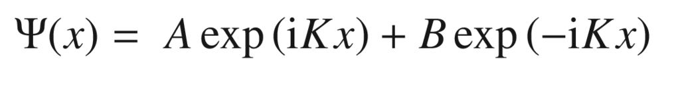

(F.2a)

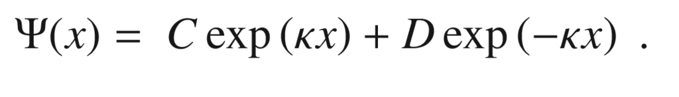

(F.2b)

The wavefunction from ([F.2a](#u116076_4_En_BookBackmatter_OnlinePDF-Equ78)) is for the well between 0 and *a* with

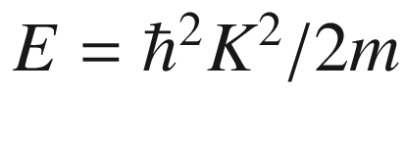

. The wavefunction from ([F.2b](#u116076_4_En_BookBackmatter_OnlinePDF-Equ79)) is for the barrier between *a* and

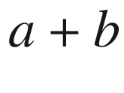

with

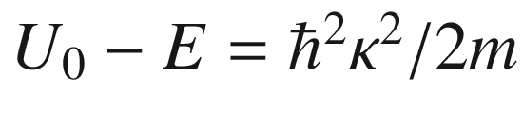

. From the periodicity and Bloch’s theorem ([6.​3](The_Physics_of_Semiconductors00003.docx#u116076_4_En_6_Chapter)) the wavefunction at

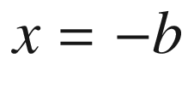

must have the form

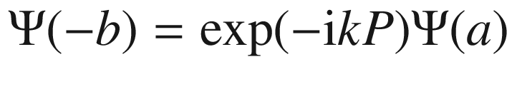

, i.e. between the two wavefunctions is only a phase factor. The wavevector *k* of the Bloch function (plane-wave part of the solution) is a new quantity and must be carefully distinguished from *K* and

$$\kappa $$

, both coding the eigenenergy.

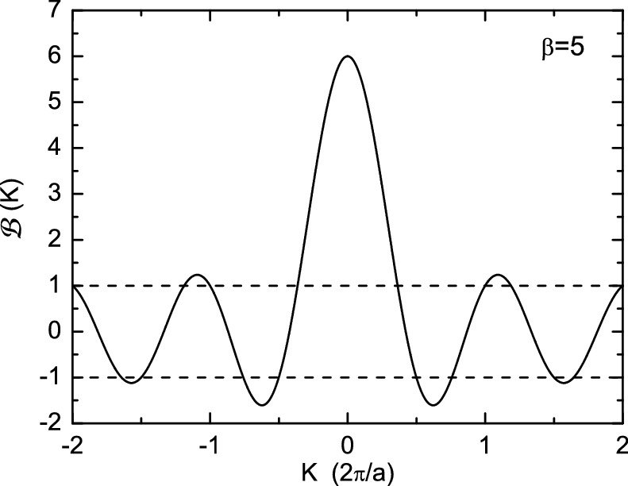

Fig. F.2

Transcendental function

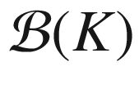

from ([F.5](#u116076_4_En_BookBackmatter_OnlinePDF-Equ85)) for

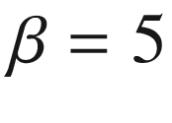

. The *dashed lines* indicate the

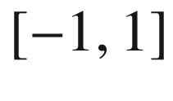

interval for which solutions exist for ([F.5](#u116076_4_En_BookBackmatter_OnlinePDF-Equ85))

As boundary conditions, the continuity of



and



are used.[4](The_Physics_of_Semiconductors00011.docx#u116076_4_En_BookBackmatter_OnlinePDF-Fn4) At

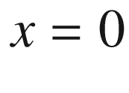

and

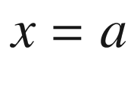

this yields

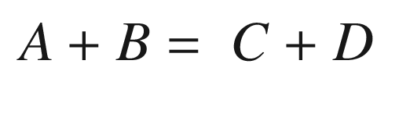

(F.3a)

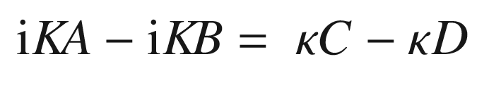

(F.3b)



(F.3c)



(F.3d)

The continuity of



and



at

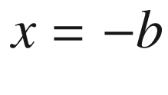

is used in the left sides of ([F.3c](#u116076_4_En_BookBackmatter_OnlinePDF-Equ82), [F.3d](#u116076_4_En_BookBackmatter_OnlinePDF-Equ83)). A nontrivial solution arises only if the determinant of the coefficient matrix is zero. This leads (after some tedious algebra) to

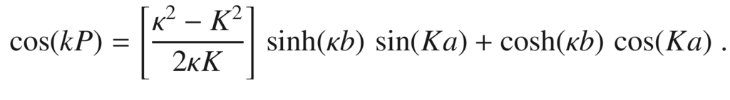

(F.4)

Further simplification are obtained by letting the barrier thickness

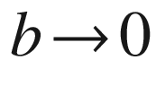

and

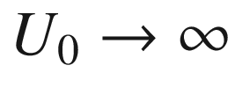

; then

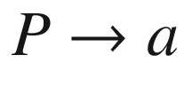

. The limit, however, is performed in such a way that the barrier ‘strength’

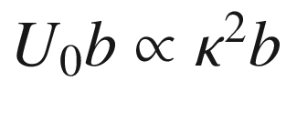

remains constant and finite, i.e.

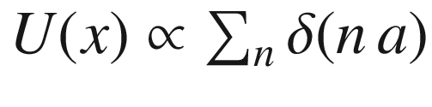

. Equation ([F.4](#u116076_4_En_BookBackmatter_OnlinePDF-Equ84)) then reads (for

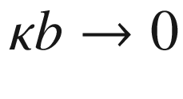

:

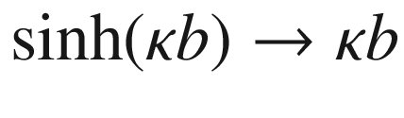

and

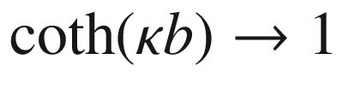

):

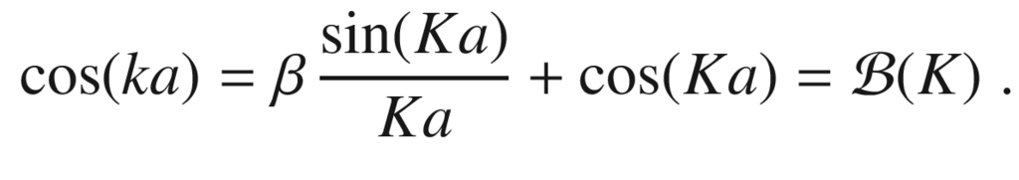

(F.5)

The dimensionless coupling parameter

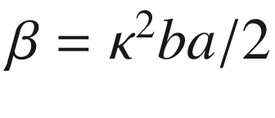

represents the strength of the barrier. Equation ([F.5](#u116076_4_En_BookBackmatter_OnlinePDF-Equ85)) only has a solution if the right side is in the interval

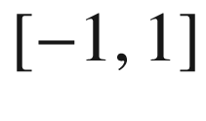

(Fig. [F.2](#u116076_4_En_BookBackmatter_OnlinePDF-Fig7)). The function

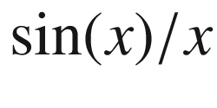

oscillates with decreasing amplitude such that for sufficiently high values of *Ka* a solution can always be found (

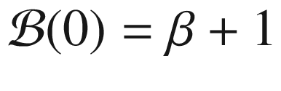

). The resulting dispersion is shown in Fig. [F.3](#u116076_4_En_BookBackmatter_OnlinePDF-Fig8)a, b for two different values of

$$\beta $$

. The dispersion is different from the free-electron dispersion (for

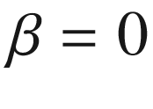

, i.e.

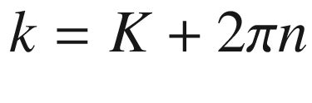

) and has several bands separated by gaps. The band gaps are related to the *K*-values for which ([F.5](#u116076_4_En_BookBackmatter_OnlinePDF-Equ85)) cannot be fulfilled. At the center (

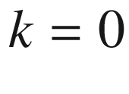

,

$$\Gamma $$

-point) and the zone boundary (X-point), (

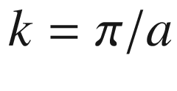

) the bands are split and the tangent is horizontal (

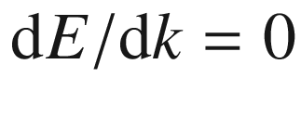

). The form of the dispersion  is similar to the arccos function. The first band has the value

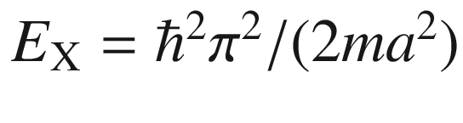

at the X-point for all values of

$$\beta $$

.

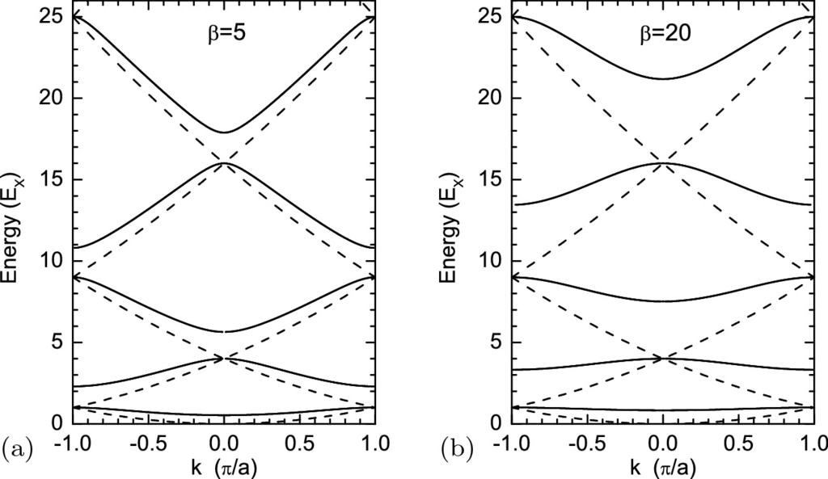

Fig. F.3

Energy dispersion of Kronig-Penney model (in units of

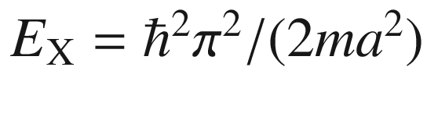

) as a function of the superlattice wavevector *k* for (**a**)

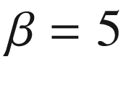

and (**b**)

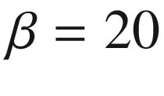

in ([F.5](#u116076_4_En_BookBackmatter_OnlinePDF-Equ85)). The *dashed lines* are the free-electron dispersion (for

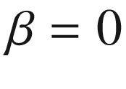

) (cf. Fig. [6.​2](The_Physics_of_Semiconductors00003.docx#u116076_4_En_6_Chapter-Fig2)a)

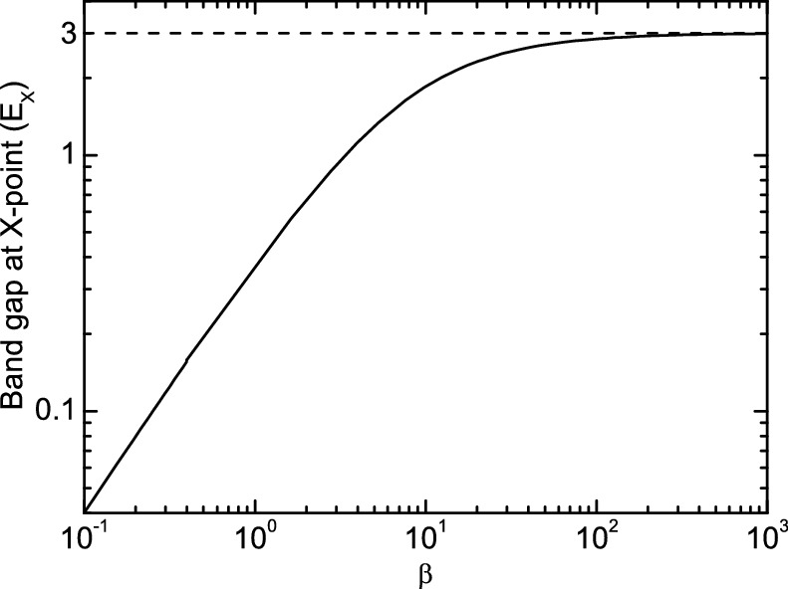

Fig. F.4

Band gap between first and second subband (at X-point, in units of

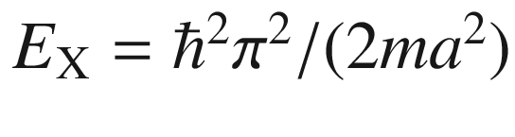

) as a function of

$$\beta $$

. For small

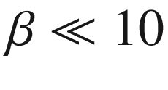

, the band gap is

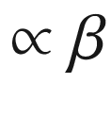

. For thick barriers (

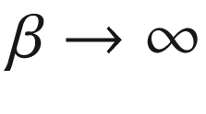

) the band gap saturates towards

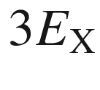

as expected for uncoupled wells

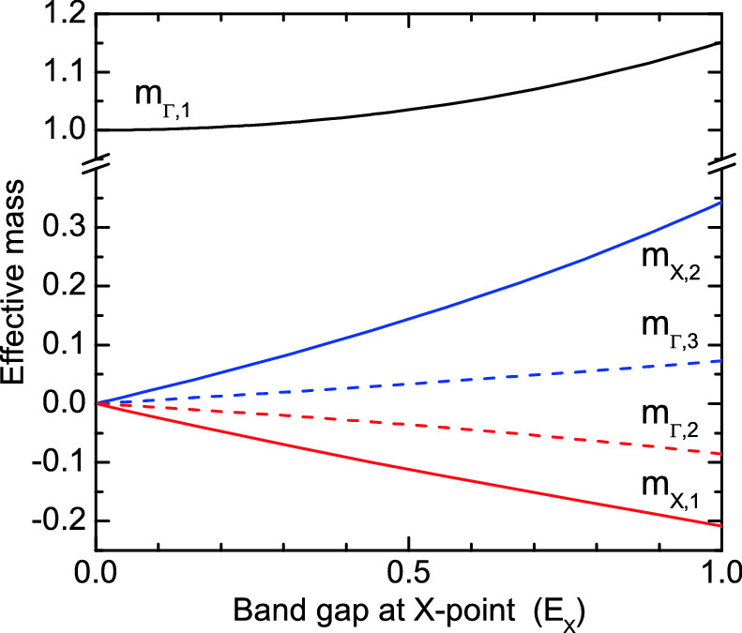

Fig. F.5

Effective mass (in units of *m*) of the first band extrema at the

$$\Gamma $$

- and X-points (

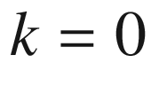

and

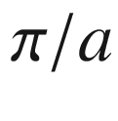

, respectively) as a function of the band gap at the X-point (in units of

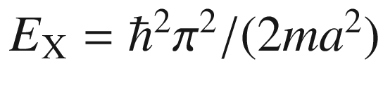

). The number in the index of the mass denotes the band

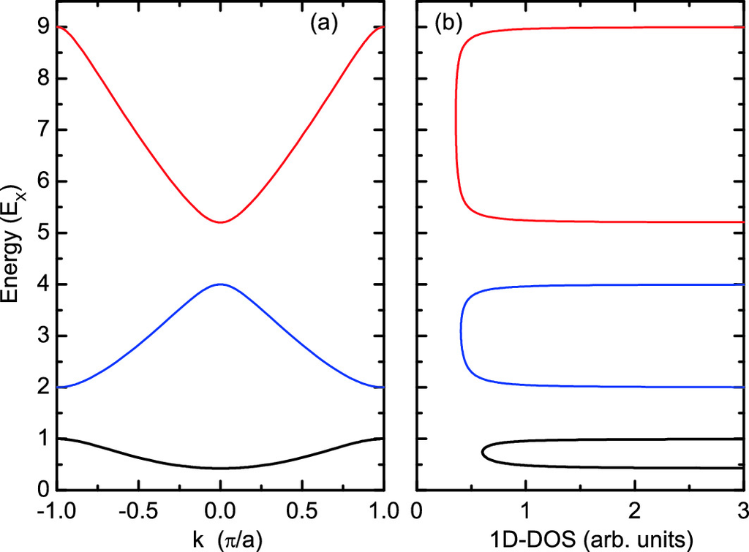

Fig. F.6

**a** Band dispersion and **b** density of states from the Kronig-Penney model for the first band gap being equal to

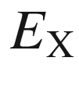

(

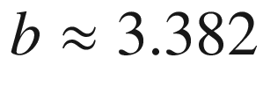

)

The band gap

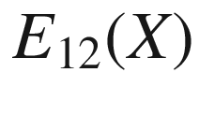

between the first and the second subband (at the X-point) is shown in Fig. [F.4](#u116076_4_En_BookBackmatter_OnlinePDF-Fig9). For large coupling between the potential wells (small

$$\beta $$

,

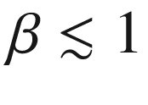

) it is

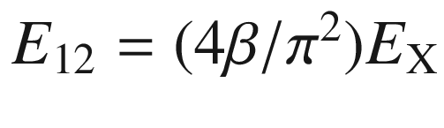

. In this case, the width of the subbands is wide. For small coupling (large

$$\beta $$

) the band gap

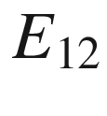

converges towards

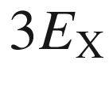

, as expected for decoupled potential wells with energy levels

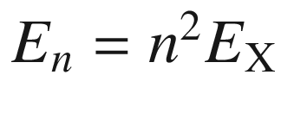

. In this case, the width of the bands is small. Also, the character of the wavefunction is that of the solution for the individual quantum wells, i.e. even or s-type (for

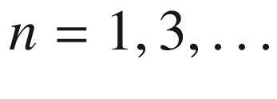

) or odd or p-type (for

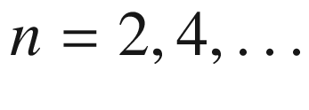

).

Other interesting quantities related to real bandstructures are the width of the valence band

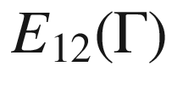

and the fundamental bandgap

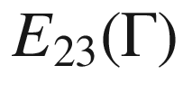

. Typical values of

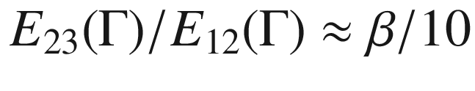

(for

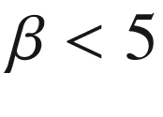

) of real semiconductors are in the range of 0.03–0.3, i.e. for

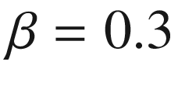

–3.

In Fig. [F.5](#u116076_4_En_BookBackmatter_OnlinePDF-Fig10) the effective masses are shown for the first five band extrema. The mass at the lowest minimum remains close to 1, i.e. keeps the carrier mass *m* from ([F.1](#u116076_4_En_BookBackmatter_OnlinePDF-Equ77)). Around the first gaps at the X- and the

$$\Gamma $$

-point, the effective masses are pairwise positive and negative, according to the character of the extremum as minimum or maximum, respectively. The absolute values are smaller than 1 for the given range of gaps. The mass increases initially linearly from zero with increasing gap.

The one-dimensional density of states (1D-DOS) has peaks (poles) at the band edges and is flat throughout most of the bands where the dispersion is linear (Fig. [F.6](#u116076_4_En_BookBackmatter_OnlinePDF-Fig11)).

Appendix G

## Tight-Binding Model

### G.1 Concept

The tight-binding model of electronic states rests on the concept of linear combination of atomic orbitals for finding a solution of the Hamiltonian of a periodic lattice. The ingredients of the model are the lattice structure and overlap matrix elements.[5](The_Physics_of_Semiconductors00011.docx#u116076_4_En_BookBackmatter_OnlinePDF-Fn5)

Let us for now assume that there is one atom per lattice site. The atomic Hamiltonian

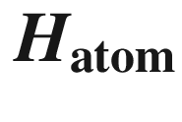

has the solutions

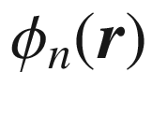

with

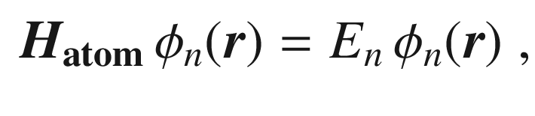

(G.1)

where

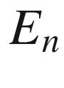

the energy of the *n*-th energy level (

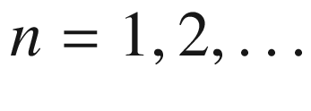

) of the free atom.

The lattice shall be spanned by the lattice vectors

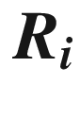

with the index *i* running over all *N* sites. For bulk-like solutions, a Bloch-type wave function, fulfilling ([6.​3](The_Physics_of_Semiconductors00003.docx#u116076_4_En_6_Chapter)), can be constructed from the atomic orbitals,

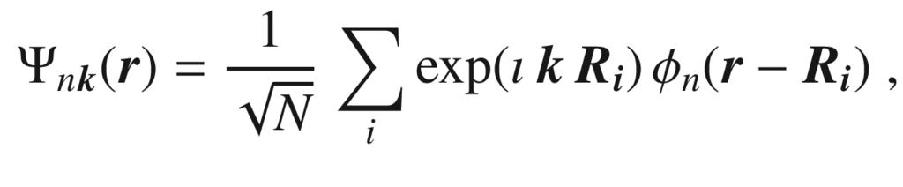

(G.2)

and will be taken as Ansatz for the solution of the crystal Hamiltonian



that is the sum of the atomic Hamiltonians plus a deviation



due to the crystal, which is small at the atomic site.

For now we consider only a single atomic state[6](The_Physics_of_Semiconductors00011.docx#u116076_4_En_BookBackmatter_OnlinePDF-Fn6)

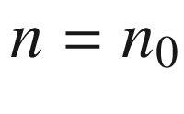

forming the band structure and write simple

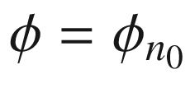

. The single particle energy in the crystal is then given by

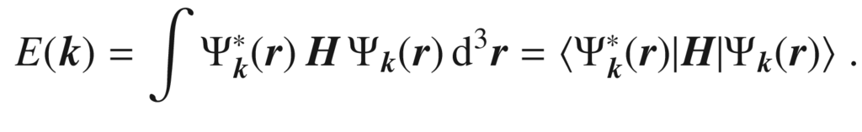

(G.3)

Equation ([G.3](#u116076_4_En_BookBackmatter_OnlinePDF-Equ88)) contains a double sum over the lattice sites *i* and *j*,

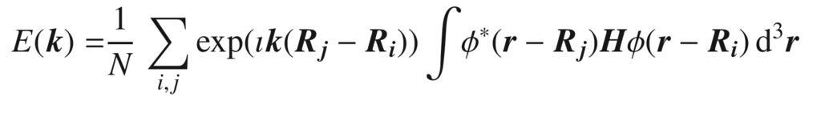

(G.4)

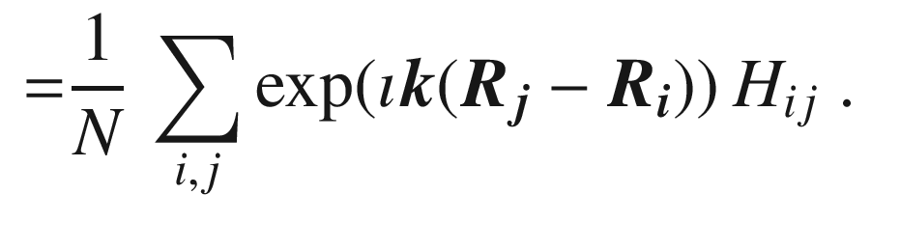

(G.5)

Now, for

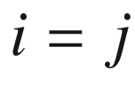

, i.e.

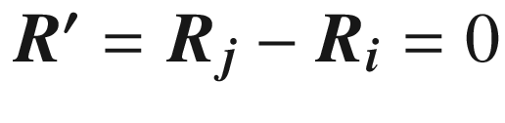

, the matrix element

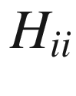

gives a value

$$\alpha $$

,

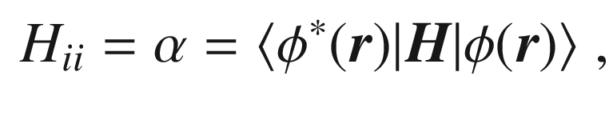

(G.6)

which is nothing else but the atomic energy level

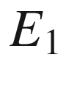

. Since the wave function

$$\phi $$

decays (rather quickly) with increasing distance

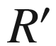

from the atom, the matrix elements will decrease as well. In the nearest-neighbor approximation, the sum of the



runs only over the *m* (equivalent) nearest neighbors

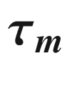

and we only consider one more matrix element

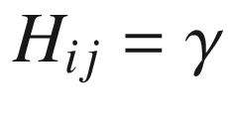

, when *i* and *j* are neighboring sites. This matrix element is not calculated explicitly but adjusted empirically to match experiments (empirical tight-binding model). Thus we find the energy dispersion

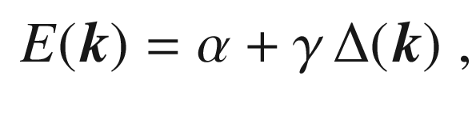

(G.7)

with the sum

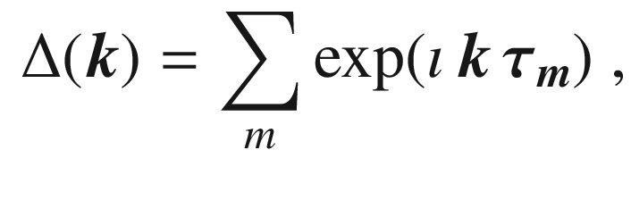

(G.8)

running over the nearest-neighbor sites. Extensions of the model consider second or even third next-neighbor sites with parameters

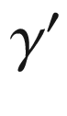

and

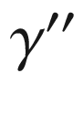

. Also, a larger number of atomic orbitals than a single one can be included, forming further bands.

### G.2 One-Dimensional Model

In a one-dimensional model,

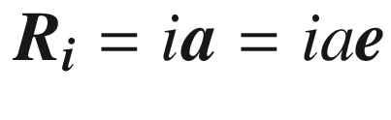

,

$$\varvec{e}$$

being the unit vector. The nearest neighbors to the atom at

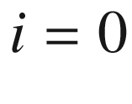

are at

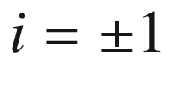

and

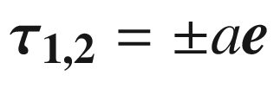

. Therefore,

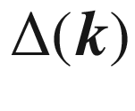

([G.8](#u116076_4_En_BookBackmatter_OnlinePDF-Equ93)) is given by (

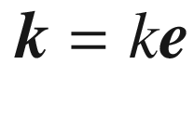

)

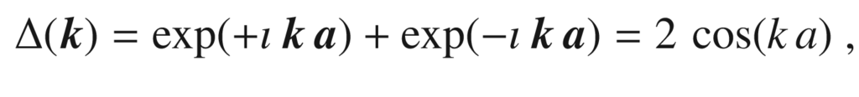

(G.9)

and the dispersion relation represents a band of width

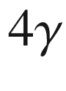

with extrema at

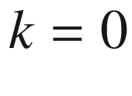

and

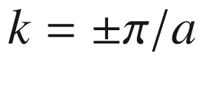

,

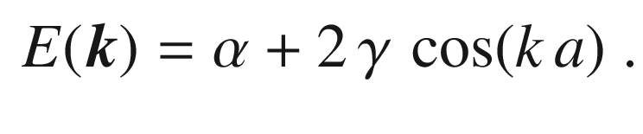

(G.10)

It is straightforward to extend this scheme to the case of a two-dimensional square lattice with four nearest neighbors (Appendix [G.3.1](#u116076_4_En_BookBackmatter_OnlinePDF-Sec19)) or to three-dimensional cubic lattices.

In the usual semiconductor cases, the basis has more than one atom; here we consider a two-atom basis with an A- and a B-site (like Fig. [5.​5](The_Physics_of_Semiconductors00002.docx#u116076_4_En_5_Chapter-Fig5)). Two different (the sites A and B having the same atom is a special case discussed below) atomic Hamiltonians

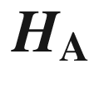

and

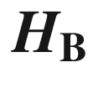

exist with sets of eigenfunctions

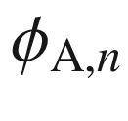

and

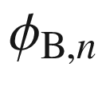

. We again consider only a single state at this point, i.e. we use

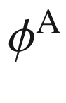

and

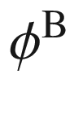

. Bloch-like functions ([6.​3](The_Physics_of_Semiconductors00003.docx#u116076_4_En_6_Chapter)) with these two orbitals are,

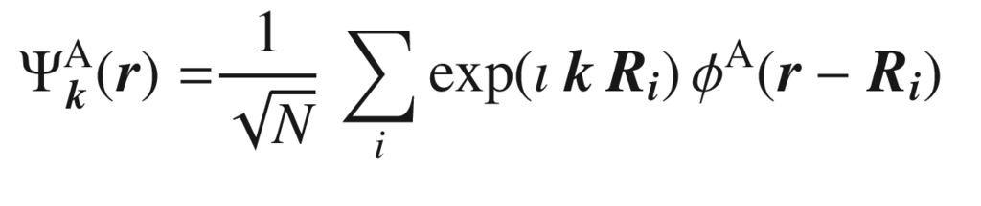

(G.11)

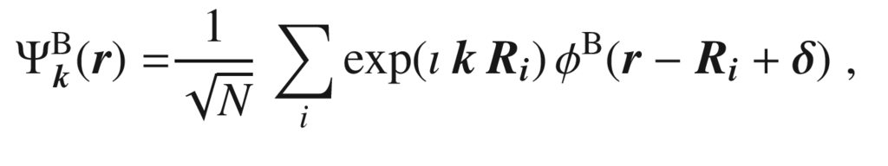

(G.12)

according to ([G.2](#u116076_4_En_BookBackmatter_OnlinePDF-Equ87)) with

$$\varvec{\delta }$$

being the vector pointing from the A- to the B-site. The total wave function is given by

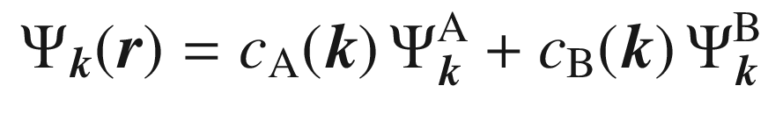

(G.13)

with complex coefficients

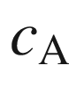

and

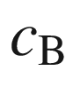

, denoting amplitudes and phases on the A- and B-site. This scheme can be generalized to larger number of atoms in the unit cell. Multiplying

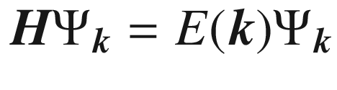

with

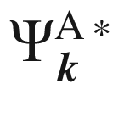

and

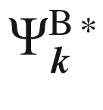

from the left side, respectively, and integration leads to the equation system,

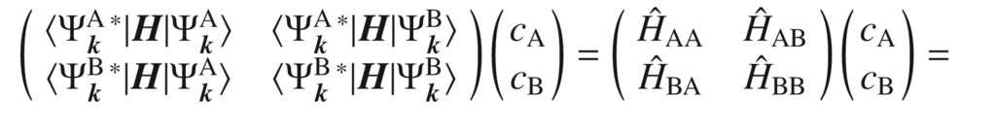

(G.14)

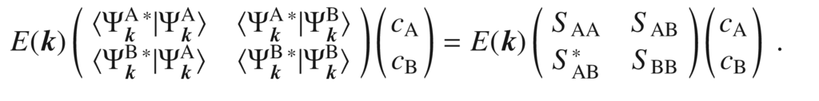

(G.15)

The overlap matrix

$$\varvec{S}$$

is approximately the unity matrix

$$\varvec{1}$$

, assuming the overlap integral of the atomic A and B wave functions

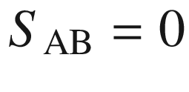

(of course, always

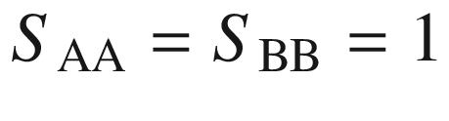

). The matrix



belongs to the Hamiltonian in the

$$\varvec{k}$$

-representation. A non-trivial solution is only possible if the determinant fulfills,

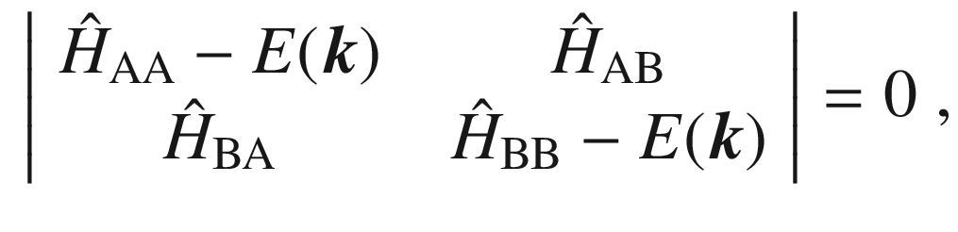

(G.16)

With

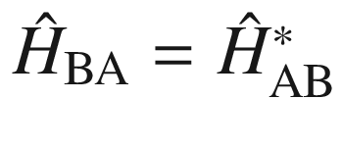

, the solutions are

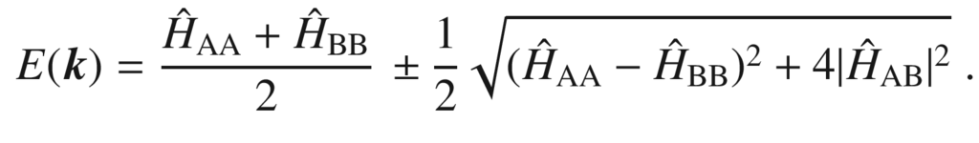

(G.17)

### G.3 Two-Dimensional Lattices

#### G.3.1 Square Lattice

The nearest neighbors in the square lattice (with simple base) with lattice constants *a* and *b*, are in orthogonal directions,

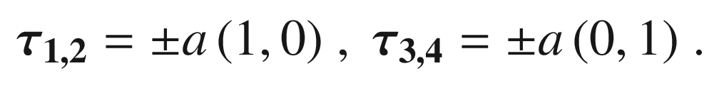

(G.18)

Thus

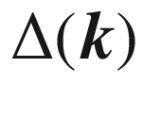

from ([G.8](#u116076_4_En_BookBackmatter_OnlinePDF-Equ93)) is given as

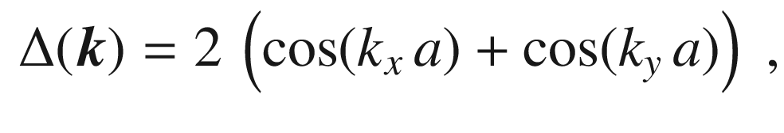

(G.19)

yielding the dispersion relation,

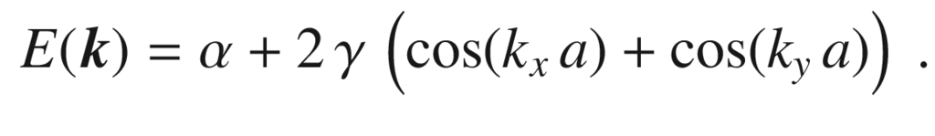

(G.20)

It should be mentioned that such model with an additional magnetic field perpendicular to the plane was treated by Hofstadter [[1471](#u116076_4_En_BookBackmatter_OnlinePDF-CR1471)] leading to a fractal behavior as function of the tight-binding energy

$$\gamma $$

and the magnetic field (‘Hofstadter butterfly’). Experiments on moiré graphene bilayers (cf. Sect. [13.​3](The_Physics_of_Semiconductors00006.docx#u116076_4_En_13_Chapter)) seemingly show such effects. Also the Hofstadter butterfly is the blueprint for assigning topological quantum numbers to the quantum Hall phases (cf. Sect. [15.​2.​8](The_Physics_of_Semiconductors00006.docx#u116076_4_En_15_Chapter)) [[1472](#u116076_4_En_BookBackmatter_OnlinePDF-CR1472)].

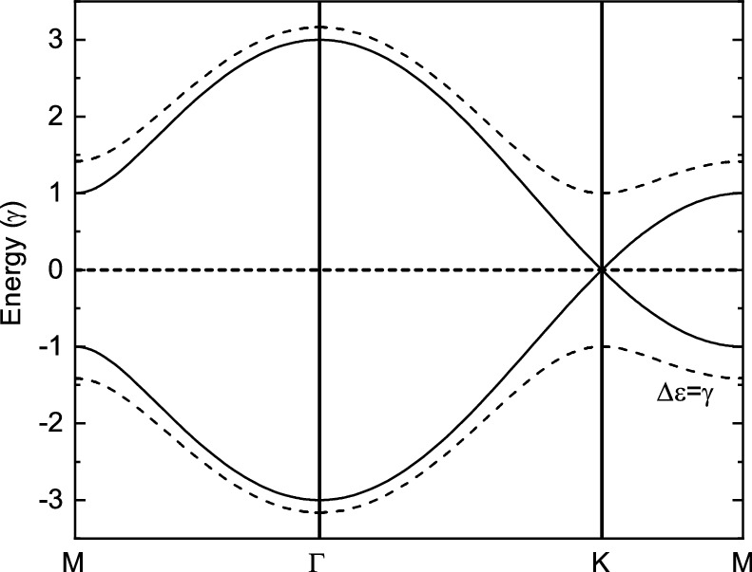

Fig. G.1

Tight-binding model band structure for honeycomb lattice with A

$$=$$

B according to ([G.24](#u116076_4_En_BookBackmatter_OnlinePDF-Equ109)) (solid line) and A

$$\ne $$

B according to ([G.25](#u116076_4_En_BookBackmatter_OnlinePDF-Equ110)) with

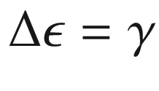

(*dashed line*)

#### G.3.2 Honeycomb Lattice

We now look at the honeycomb lattice which is a model for graphene or other two-dimensional semiconductors (cf. Fig. [13.​1](The_Physics_of_Semiconductors00006.docx#u116076_4_En_13_Chapter-Fig1)a). For an A-atom, the three vectors to the neighboring B-sites are

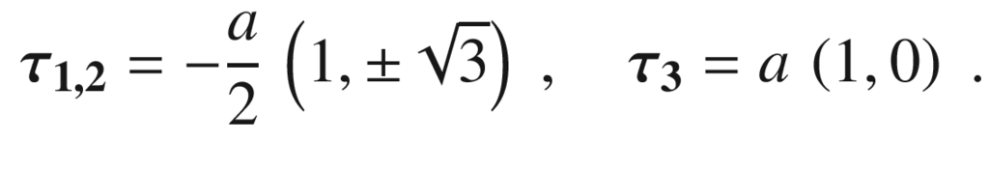

(G.21)



from ([G.8](#u116076_4_En_BookBackmatter_OnlinePDF-Equ93)) is given by

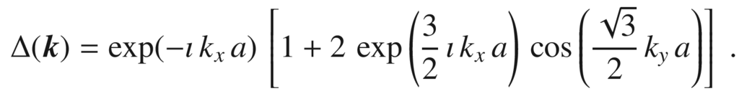

(G.22)

For the A- and B-atoms being the same (as for graphene),

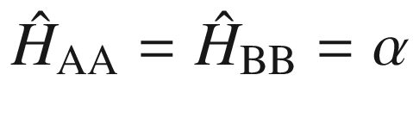

, giving a constant part to the energy that is ignored in the following. The square root in ([G.17](#u116076_4_En_BookBackmatter_OnlinePDF-Equ102)) yields a band structure (cf. Fig. [G.1](#u116076_4_En_BookBackmatter_OnlinePDF-Fig12))

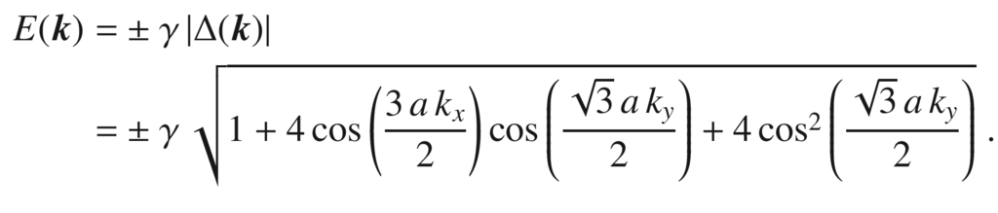

(G.23)

The energy is zero for at the K-points

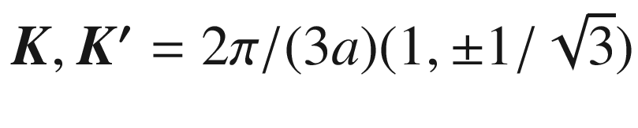

and their other equivalents (cmp. Fig. [13.​1](The_Physics_of_Semiconductors00006.docx#u116076_4_En_13_Chapter-Fig1)b). The band gap at the M-point is

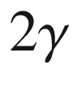

. Around the K-points, the energy can be expanded with

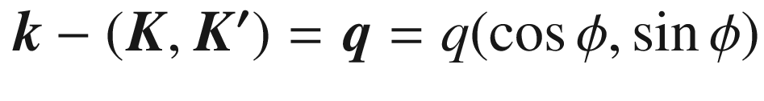

. We find

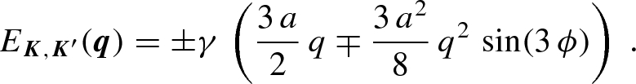

(G.24)

This shows that the dispersion is linear and isotropic around the K- and K’-points (Dirac points)  and (further away) has threefold symmetry (triangular warping, cmp. Sect. [6.​10.​2](The_Physics_of_Semiconductors00003.docx#u116076_4_En_6_Chapter)). The dispersion at the Dirac points is often written as

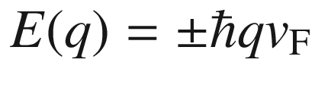

with

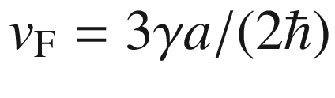

. Also, the K- and K’-points are non-equivalent, reflecting the two-atomic base. The winding sense in the

../images/116076_4_En_BookBackmatter_IEq516_HTML.gif

-term around K and K’ is opposite which leads to further ‘pseudo-spin’ physics.

For the case of the A- and B-sites being non-identical (e.g. for BN),

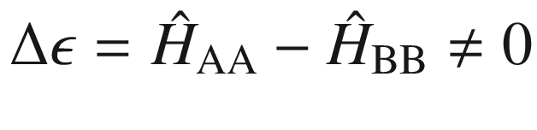

, the (non-constant part of the dispersion) is,

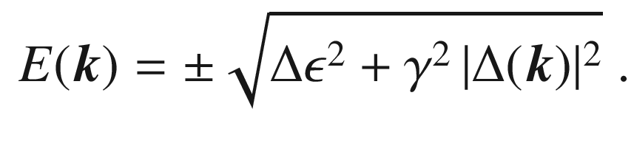

(G.25)

Thus a gap of

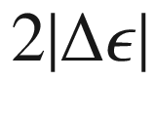

opens up at the K- and K’-points. Developing the solution around the K-points yields

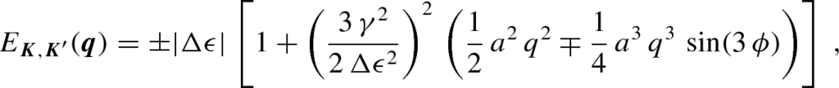

(G.26)

and therefore (isotropic) parabolic extrema close to K and K’; the different winding sense of K and K’ appears in the

../images/116076_4_En_BookBackmatter_IEq519_HTML.gif

-term.

### G.4 Edge States and Topological Aspects

#### G.4.1 One-Dimensional Model

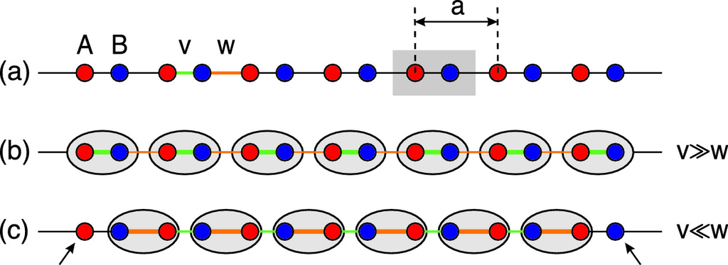

Fig. G.2

Schematic of the Su-Schrieffer-Heeger (SSH) model. (**a**) One-dimensional chain of unit cells (*grey area*) with A- and B-sites. The lattice constant is *a*. The hopping potentials *v* (intra-base, *green line*) and *w* (inter-base, *orange line*) are indicated. Dimers (*grey ellipses*) are shown for the cases (**b**)

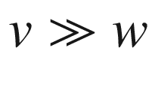

and (**c**)

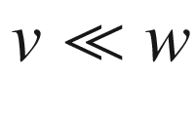

The Su-Schrieffer-Heeger (SSH) model [[370](#u116076_4_En_BookBackmatter_OnlinePDF-CR370), [2154](#u116076_4_En_BookBackmatter_OnlinePDF-CR2154), [2155](#u116076_4_En_BookBackmatter_OnlinePDF-CR2155)] is a tight-binding model very much like the one in Appendix [G.2](#u116076_4_En_BookBackmatter_OnlinePDF-Sec17), describing a single spin-less electron on a one-dimensional lattice with a two-sites (A and B) unit cell (Fig. [G.2](#u116076_4_En_BookBackmatter_OnlinePDF-Fig13)a), suitable e.g. to describe an polyacetylene molecule. One electron per unit cell is assumed such that states are half filled. Also, the length of the chain will eventually be finite (*N* unit cells). The model has no on-site potential, which means that the constant energy parts

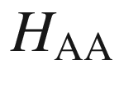

and

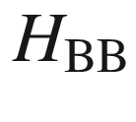

in ([G.16](#u116076_4_En_BookBackmatter_OnlinePDF-Equ101)) are now considered non-essential. The momentum-space Hamiltonian can be then written as

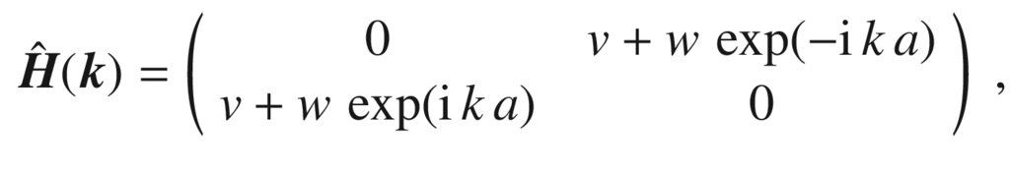

(G.27)

with the energy eigenvalues[7](The_Physics_of_Semiconductors00011.docx#u116076_4_En_BookBackmatter_OnlinePDF-Fn7) given by



(G.28)

The parameters *v* and *w* are real positive numbers[8](The_Physics_of_Semiconductors00011.docx#u116076_4_En_BookBackmatter_OnlinePDF-Fn8); *v* denotes the intra-base hopping amplitude between A and B, while *w* denotes the hopping between A and B belonging to different lattice points, i.e. from B to the right-neighbor A (Fig. [G.2](#u116076_4_En_BookBackmatter_OnlinePDF-Fig13)a). The band structure from ([G.28](#u116076_4_En_BookBackmatter_OnlinePDF-Equ113)) is shown in Fig. [G.3](#u116076_4_En_BookBackmatter_OnlinePDF-Fig14) for which we discuss five cases: in (a)

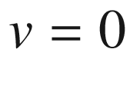

(

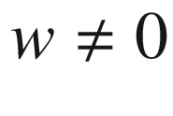

) and (e)

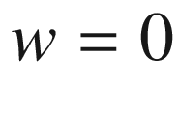

(

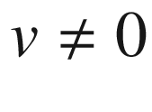

), the bands are flat with a gap (of size 2*v* or 2*w*). For (c)

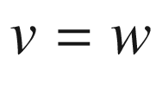

, the bands have no gap (similar to the graphene case). For the last two cases, (b)

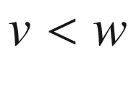

and (d)

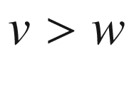

, the bands are curved with a gap (of size

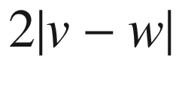

).

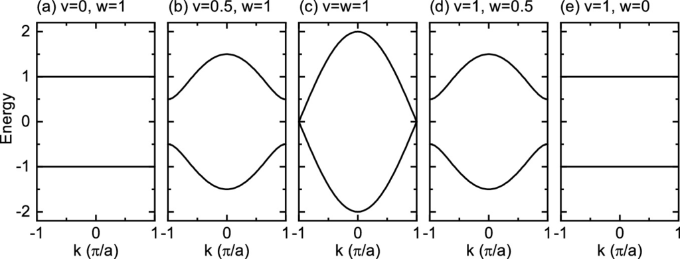

Fig. G.3

Band structure of the SSH model ([G.28](#u116076_4_En_BookBackmatter_OnlinePDF-Equ113)) for the cases

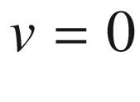

,

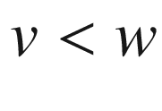

,

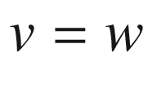

,

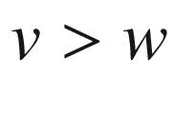

and

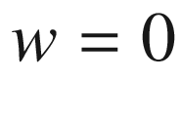

, as labeled

The point is now that the two seemingly similar cases Fig. [G.3](#u116076_4_En_BookBackmatter_OnlinePDF-Fig14)b and d result in the same band structure (i.e. the same eigenvalues), but they are different in other, maybe more subtle but actually very fundamental aspects, namely their eigenstates and eventually their topology .

The Hamiltonian for this two-band model ([G.27](#u116076_4_En_BookBackmatter_OnlinePDF-Equ112)) can be rewritten using the Pauli matrices,

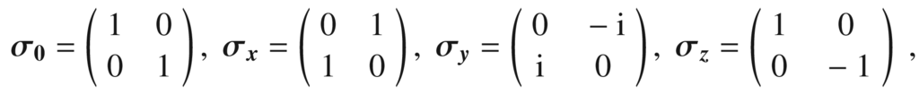

(G.29)

as

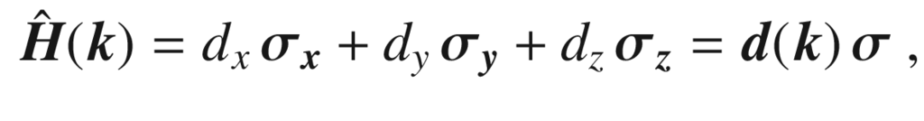

(G.30)

with the vector

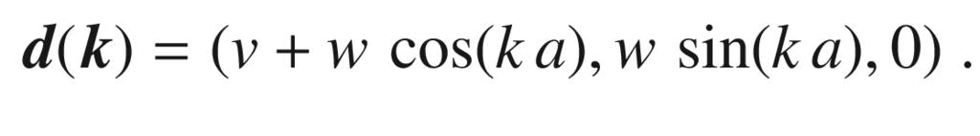

(G.31)

The coefficient of

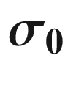

is zero in the SSH model (zero potential). Also

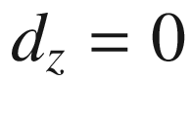

(due to ‘chiral’  symmetry,[9](The_Physics_of_Semiconductors00011.docx#u116076_4_En_BookBackmatter_OnlinePDF-Fn9)

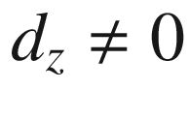

would open a gap[10](The_Physics_of_Semiconductors00011.docx#u116076_4_En_BookBackmatter_OnlinePDF-Fn10) for

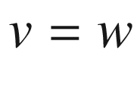

). Generally, the normalized vector

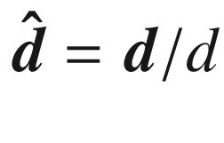

can be displayed on the Bloch sphere. In Fig. [G.4](#u116076_4_En_BookBackmatter_OnlinePDF-Fig15) the mapping of the Brillouin (torus, cf. Fig. [6.​6](The_Physics_of_Semiconductors00003.docx#u116076_4_En_6_Chapter-Fig6)) to the Bloch sphere to represent a unit vector.

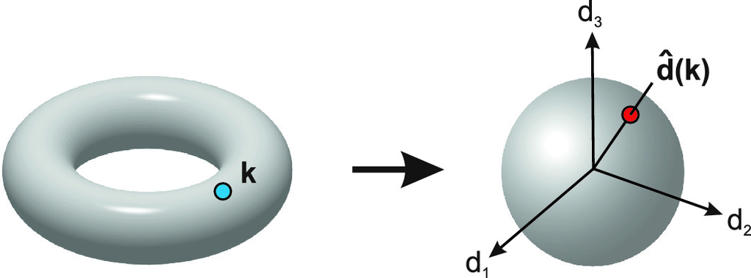

Fig. G.4

Mapping of the

$$\varvec{k}$$

-values from a 2D Brillouin zone (torus) to the vectors

$$\varvec{\hat{d}}$$

(Bloch sphere). Designed after a graph in [[2157](#u116076_4_En_BookBackmatter_OnlinePDF-CR2157)]

Here, the vector

$$\varvec{d}$$

is two-dimensional and its length is equal to

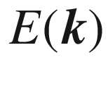

(positive value). While

$$\varvec{k}$$

runs through the entire Brillouin zone, i.e. from

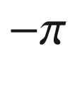

to

$$\pi $$

,

$$\varvec{d}$$

forms a circle of radius *w* around the point (*v*, 0); it is visualized in Fig. [G.5](#u116076_4_En_BookBackmatter_OnlinePDF-Fig16) for the cases (b) and (d).

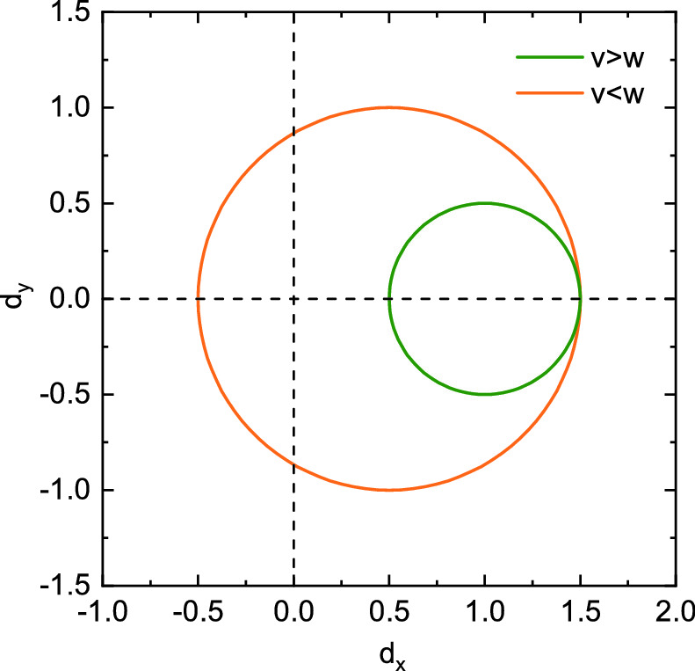

Fig. G.5

Vector

$$\varvec{d}$$

according to ([G.30](#u116076_4_En_BookBackmatter_OnlinePDF-Equ115)) for the cases

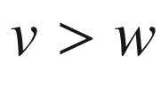

(*green*,

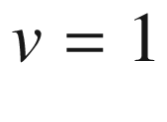

,

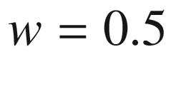

) and

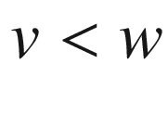

(*orange*,

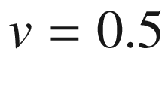

,

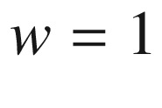

)

The main and *qualitative* difference of the two trajectories is that the origin (

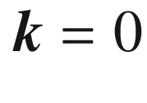

) is contained or not contained in the circle. Note, that for

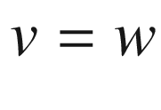

, the circle touches the origin and the case (c) is undefined with that respect; such material, however, does not have a gap and is no insulator but a metal. Now, a number as topological invariant  can be defined as the number of rotations that

$$\varvec{d}$$

makes in the

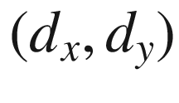

-plane around the origin (while

$$\varvec{k}$$

runs through the entire Brillouin zone and avoids the origin for any wave vector since the material should have a gap); this quantity should be termed the ‘bulk winding number’

$$\nu $$

. We note that in general, the trajectory of

$$\varvec{d}$$

will be deformed from a circle, but it will be a closed loop due to the periodicity of the bulk

$$\varvec{k}$$

-space. Also, it might wind more than once around the origin. The calculation of the winding number can be generalized to an integral in reciprocal space,

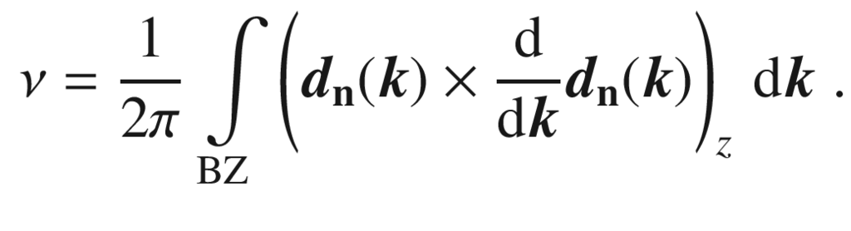

(G.32)

A look at the states of a finite chain model reveals another important distinction between the two cases

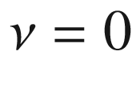

and

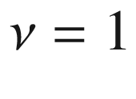

. Going to the extreme cases (a) and (e), the situation can be cartooned as shown in Fig. [G.2](#u116076_4_En_BookBackmatter_OnlinePDF-Fig13)b, c. For

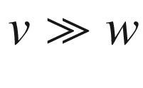

, the coupling within the base is strong and the chain disintegrates in *N* bases; this is called the ‘dimerized limit’. Then *N* identical uncoupled (or very weakly coupled) bases, split into their symmetric and anti-symmetric state, make up the flat bands. In the case

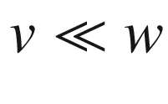

, the dimers group differently, giving the same flat bulk band structure. But, for a finite chain, at the edges two sites, indicated by arrows in Fig. [G.2](#u116076_4_En_BookBackmatter_OnlinePDF-Fig13)c remain unconnected to the bulk of the chain. Their energy is zero (since no on-site potentials are used in the SSH model). The discussed model is the simplest one to generate edge states. The edge states are only present for

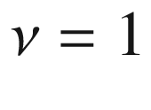

and not for the ‘topologically trivial’ case

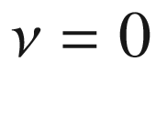

.

For finite *N*, the problem must be solved numerically. The Schrödinger equation ([G.27](#u116076_4_En_BookBackmatter_OnlinePDF-Equ112)) leads to the matrix eigenvalue problem,

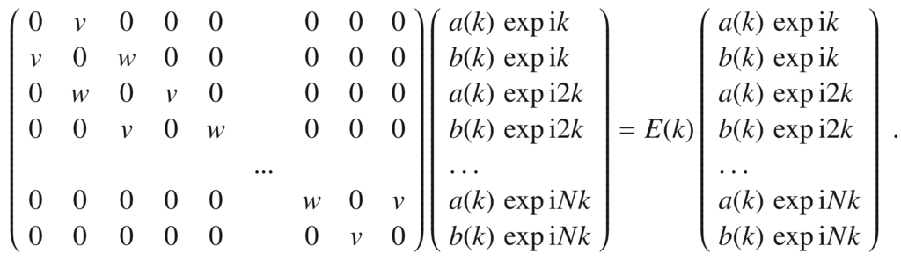

(G.33)

The eigenvalues for constant

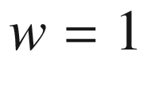

and *v* varying between 0 and 2 are shown in Fig. [G.6](#u116076_4_En_BookBackmatter_OnlinePDF-Fig17)a for a chain with

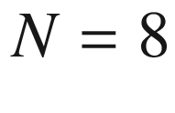

bases. For

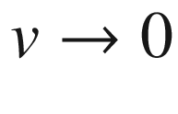

, two edges states develop with zero energy in the gap. For

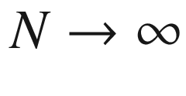

, the edge states develop for

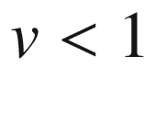

. The wave function amplitudes of the edge states are shown together with those of the HOMO/LUMO in Fig. [G.6](#u116076_4_En_BookBackmatter_OnlinePDF-Fig17)b. The edge states have significant amplitude only on the A- or B-site and are strongly localized at the edges.

For a system with periodic boundary conditions, the upper right and the lower left element in the matrix of ([G.33](#u116076_4_En_BookBackmatter_OnlinePDF-Equ118)) are equal to *w* and no edge states are present.

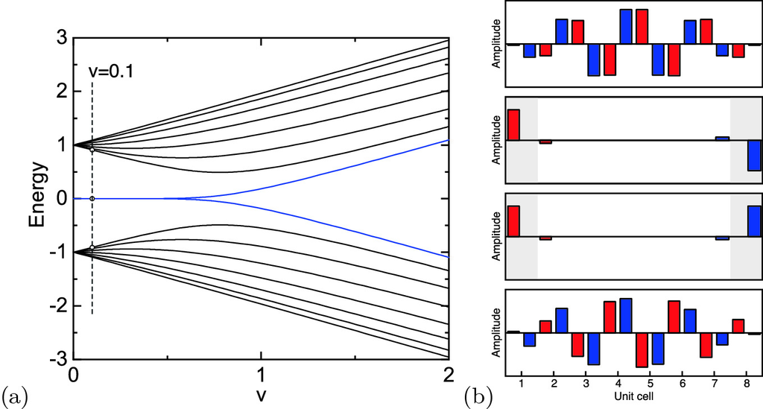

Fig. G.6

**a** Eigenvalues for SSH finite chain model ([G.33](#u116076_4_En_BookBackmatter_OnlinePDF-Equ118)) with

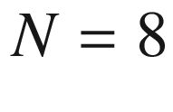

and

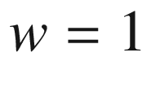

. For sufficiently small *v*, two zero energy edge states (*blue lines*) develop. The case

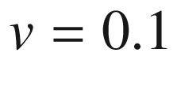

is highlighted with a *dashed line* and the HOMO, the LUMO and the two edge states are indicated by *circles*. **b** Mode patterns (for

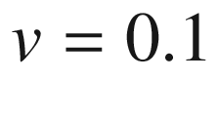

) of the two edge states (center graphs) (energy:

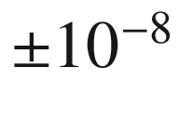

) and the HOMO (bottom graph) and LUMO (top graph) (energy:

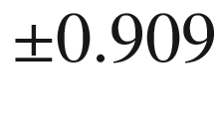

) as indicated in panel (**a**). The *red* (*blue*) bars denote the amplitude on the A (B) sites. The *greyed areas* denote the first and last unit cell of the chain

#### G.4.2 Two-Dimensional Models

Topological edge states  in two-dimensional lattices with alternating hopping potentials  have been investigated for square and honeycomb lattices in [[2156](#u116076_4_En_BookBackmatter_OnlinePDF-CR2156), [2158](#u116076_4_En_BookBackmatter_OnlinePDF-CR2158)]. Topological aspects of graphene  are discussed in [[2159](#u116076_4_En_BookBackmatter_OnlinePDF-CR2159), [2160](#u116076_4_En_BookBackmatter_OnlinePDF-CR2160)]. The gap due to breaking parity symmetry (graphene

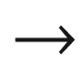

BN as discussed above) has been described in [[2161](#u116076_4_En_BookBackmatter_OnlinePDF-CR2161)]. It is topologically trivial while gaps in graphene due to next-nearest neighbor coupling [[1616](#u116076_4_En_BookBackmatter_OnlinePDF-CR1616)] or spin-orbit  interaction [[2162](#u116076_4_En_BookBackmatter_OnlinePDF-CR2162)] lead to non-trivial bulks. Two-dimensional topological insulators with arbitrary Chern number  can be constructed with the scheme given in [[2163](#u116076_4_En_BookBackmatter_OnlinePDF-CR2163)].

It was also found that zigzag graphene ribbons (cmp. Fig. [14.​16](The_Physics_of_Semiconductors00006.docx#u116076_4_En_14_Chapter-Fig16)) feature zero energy edge states, while armchair ribbons do not [[2164](#u116076_4_En_BookBackmatter_OnlinePDF-CR2164)].

Appendix H

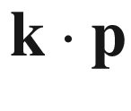

## Perturbation Theory

The

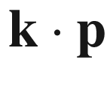

method is described in great detail in [[461](#u116076_4_En_BookBackmatter_OnlinePDF-CR461)] for various crystal symmetries. The solutions of the Schrödinger equation  (cf. Sect. [6.​2.​1](The_Physics_of_Semiconductors00003.docx#u116076_4_En_6_Chapter))

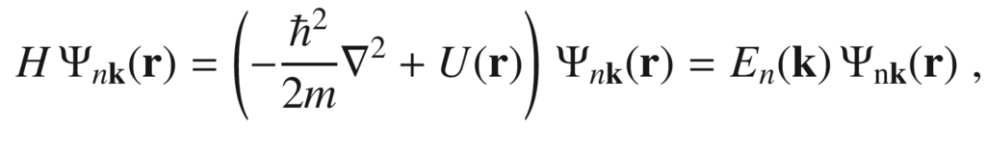

(H.1)

with a lattice periodic potential *U*, i.e.

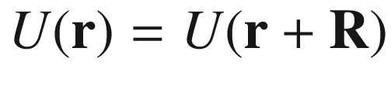

for direct lattice vectors



, are Bloch waves of the form

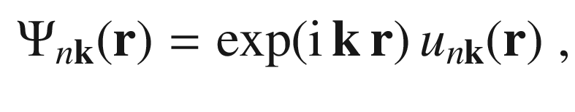

(H.2)

with the lattice periodic Bloch function

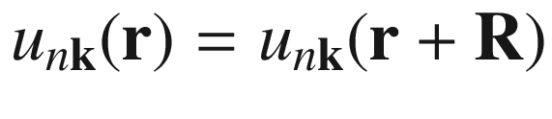

.

Inserting the Bloch wave into ([H.1](#u116076_4_En_BookBackmatter_OnlinePDF-Equ119)), the following equation is obtained for the periodic Bloch function:

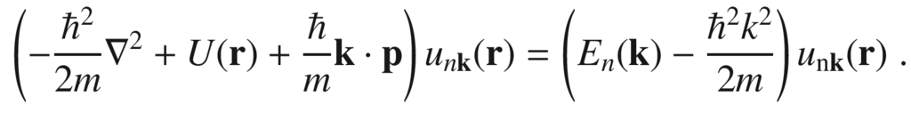

(H.3)

For simplicity, we assume a band edge

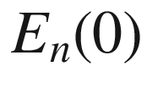

at

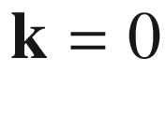

. In its vicinity, the

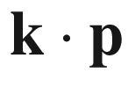

term can be treated as a perturbation. The dispersion for a nondegenerate band[11](The_Physics_of_Semiconductors00011.docx#u116076_4_En_BookBackmatter_OnlinePDF-Fn11) is given up to second order in *k*

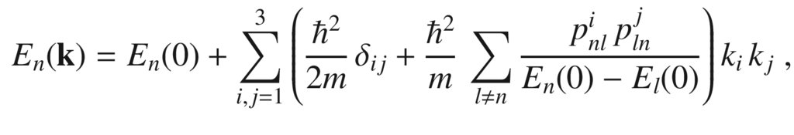

(H.4)

with *l* running over other, so-called *remote* bands. The momentum matrix element is given by

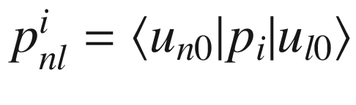

(cf. ([6.​39](The_Physics_of_Semiconductors00003.docx#u116076_4_En_6_Chapter))). The coefficients in front of the quadratic terms are the components of the dimensionless inverse effective-mass tensor (cf. ([6.​43](The_Physics_of_Semiconductors00003.docx#u116076_4_En_6_Chapter)))

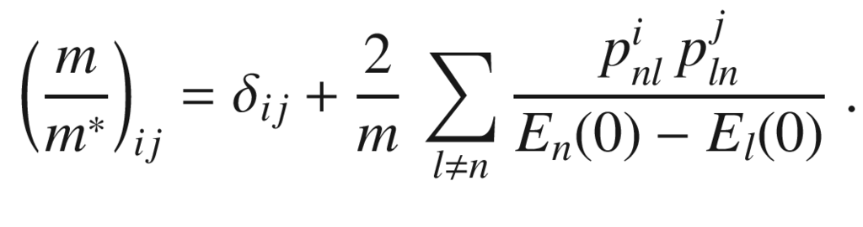

(H.5)

For degenerate bands, the

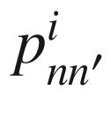

vanish when *n* and

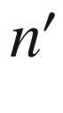

belong to the degenerate set and also the first-order correction is zero. In the  Löwdin perturbation theory [[2165](#u116076_4_En_BookBackmatter_OnlinePDF-CR2165)], the bands are separated into the close-by degenerate or nearly degenerate bands and the remote bands. The effect of the remote bands is taken into account by an effective perturbation

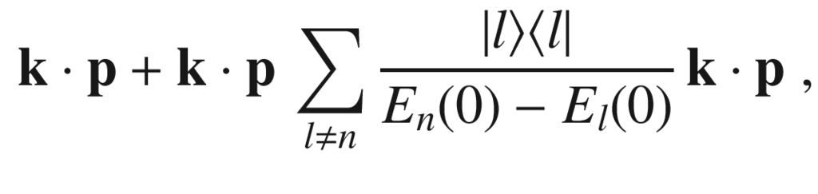

(H.6)

with the index *l* running over all bands not being in the degenerate set. The dispersion relation is obtained by diagonalization of the Hamiltonian ([H.3](#u116076_4_En_BookBackmatter_OnlinePDF-Equ121)) in the degenerate basis but with the perturbation given by ([H.6](#u116076_4_En_BookBackmatter_OnlinePDF-Equ124)).

The spin-orbit interaction [[1547](#u116076_4_En_BookBackmatter_OnlinePDF-CR1547)] adds an additional term

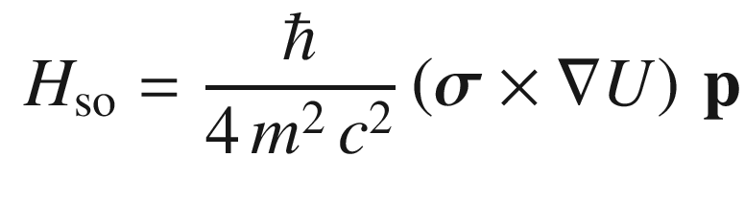

(H.7)

to the Hamiltonian, where

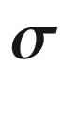

are the Pauli spin matrices and *c* the vacuum speed of light. In the Schrödinger equation for the Bloch functions two new terms arise:

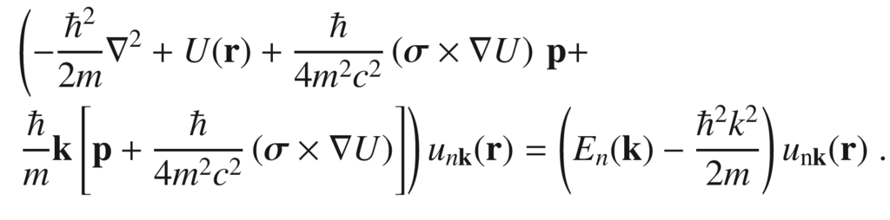

(H.8)

The linear term in

$$\mathbf{k}$$

is again treated as a perturbation. The first spin-orbit term in ([H.8](#u116076_4_En_BookBackmatter_OnlinePDF-Equ126)) is lattice periodic, thus the solutions at

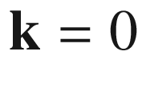

are still periodic Bloch functions, however, different ones from previously. If the band edge is not degenerate, the momentum operator in ([H.3](#u116076_4_En_BookBackmatter_OnlinePDF-Equ121)) is simply replaced by

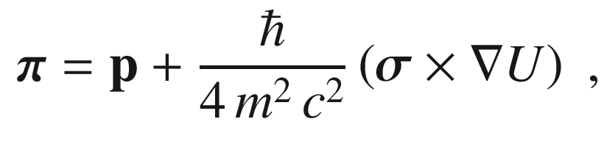

(H.9)

and the band edge is still parabolic. For a degenerate band edge, the effect can be more profound, in particular it can lead to the lifting of a degeneracy.Table H.1

Basis set that diagonalizes the spin-orbit interaction

| $$| J, m_j \rangle $$ | Wavefunction | Symmetry |
| --- | --- | --- |
| $$| \frac{1}{2}, \frac{1}{2} \rangle $$ | $${\mathrm {i}}| s \uparrow \rangle $$ | $$\Gamma _6$$ |
| $$| \frac{1}{2}, -\frac{1}{2} \rangle $$ | $${\mathrm {i}}| s \downarrow \rangle $$ | $$\Gamma _6$$ |
| $$| \frac{3}{2}, \frac{3}{2} \rangle $$ | $$ \frac{1}{\sqrt{2}} | (x+{\mathrm {i}}y) \uparrow \rangle $$ | $$\Gamma _8$$ |
| $$| \frac{3}{2}, \frac{1}{2} \rangle $$ | $$ \frac{1}{\sqrt{6}} | (x+{\mathrm {i}}y) \downarrow \rangle - \sqrt{\frac{2}{3}} | z \uparrow \rangle $$ | $$\Gamma _8$$ |
| $$| \frac{3}{2}, -\frac{1}{2} \rangle $$ | $$ -\frac{1}{\sqrt{6}} | (x-{\mathrm {i}}y) \uparrow \rangle - \sqrt{\frac{2}{3}} | z \downarrow \rangle $$ | $$\Gamma _8$$ |
| $$| \frac{3}{2}, -\frac{3}{2} \rangle $$ | $$ \frac{1}{\sqrt{2}} | (x-{\mathrm {i}}y) \uparrow \rangle $$ | $$\Gamma _8$$ |
| $$| \frac{1}{2}, \frac{1}{2} \rangle $$ | $$ \frac{1}{\sqrt{3}} | (x+{\mathrm {i}}y) \downarrow \rangle + \sqrt{\frac{1}{3}} | z \uparrow \rangle $$ | $$\Gamma _7$$ |
| $$| \frac{1}{2}, -\frac{1}{2} \rangle $$ | $$ -\frac{1}{\sqrt{3}} | (x-{\mathrm {i}}y) \uparrow \rangle + \sqrt{\frac{1}{3}} | z \downarrow \rangle $$ | $$\Gamma _7$$ |

In the 8-band Kane model [[510](#u116076_4_En_BookBackmatter_OnlinePDF-CR510)], four bands (lowest conduction band, heavy, light and split-off hole band) are treated explicitly and the others through Löwdin perturbation theory. The basis is chosen to be diagonal in the spin-orbit interaction  leaving the spin-orbit interaction

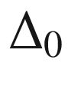

as parameter. The band- edge Bloch functions are denoted as

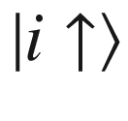

, where the index

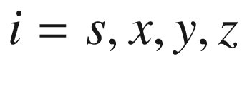

labels the symmetry of the different bands. The linear combinations that diagonalize the spin-orbit interaction are given in Table [H.1](#u116076_4_En_BookBackmatter_OnlinePDF-Tab4). The band gap and the spin-orbit interaction are given by

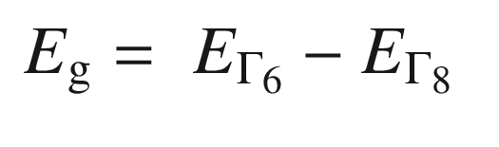

(H.10a)

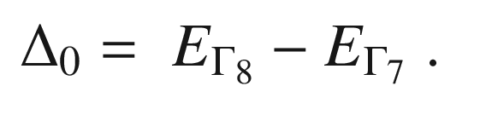

(H.10b)

The Hamiltonian in the basis states of Table [H.1](#u116076_4_En_BookBackmatter_OnlinePDF-Tab4) is given by

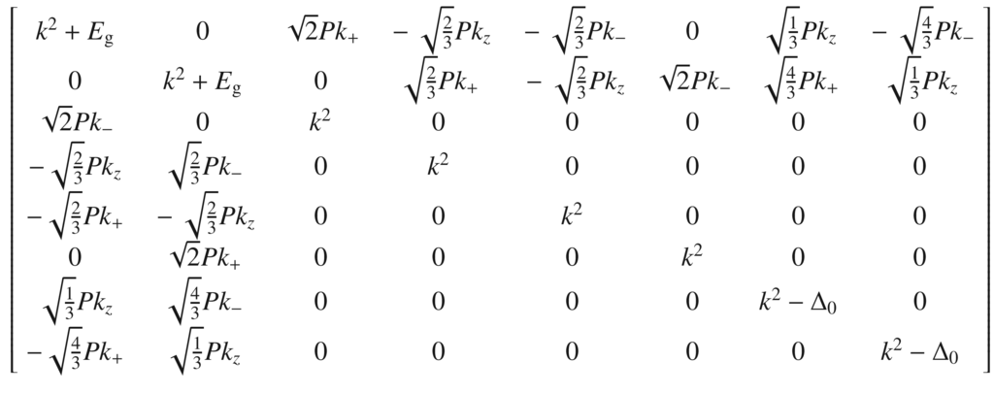

(H.11)

with the energy measured from the valence-band edge in units of

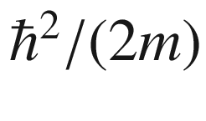

and

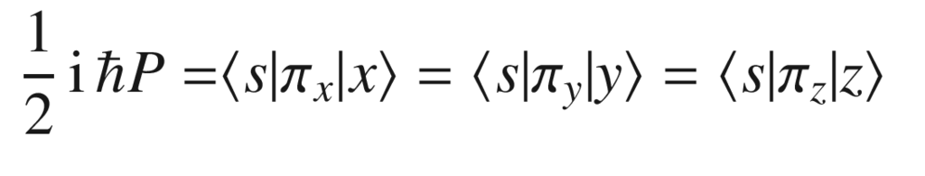

(H.12a)

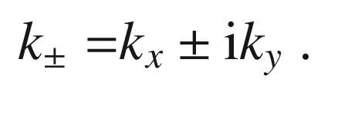

(H.12b)

The inclusion of remote bands renormalizes the above Hamiltonian to

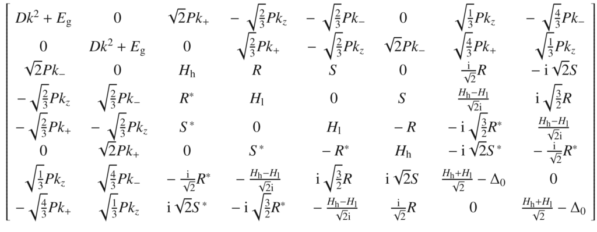

(H.13)

with

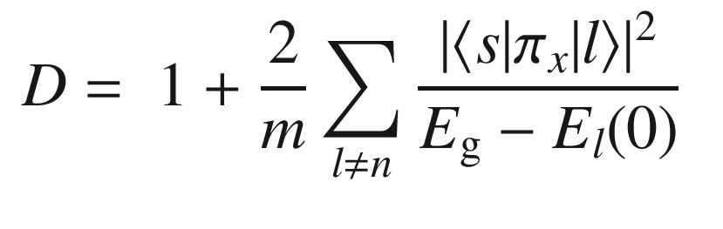

(H.14a)

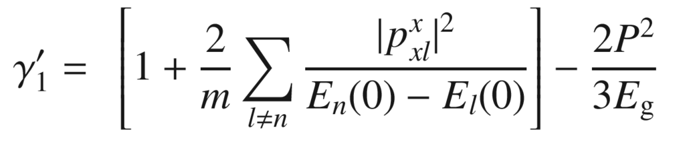

(H.14b)

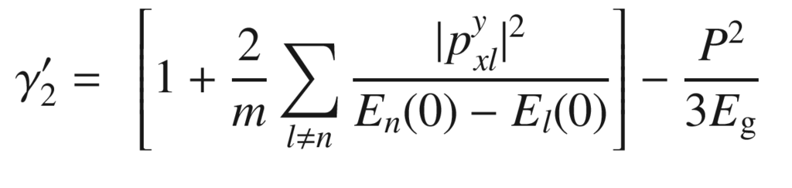

(H.14c)

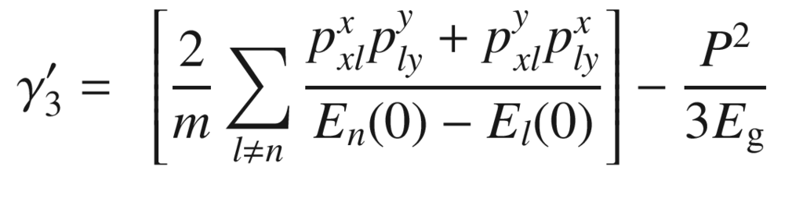

(H.14d)

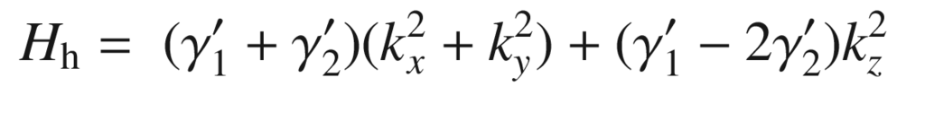

(H.14e)

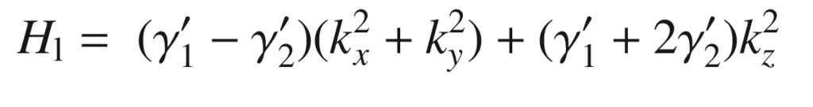

(H.14f)

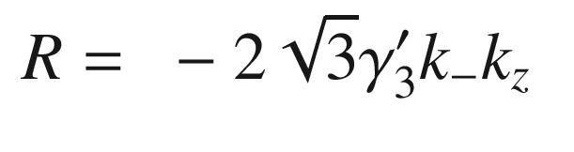

(H.14g)

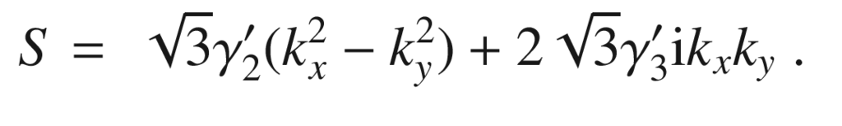

(H.14h)

The Hamiltonian in the presence of inhomogeneous strain is given in [[536](#u116076_4_En_BookBackmatter_OnlinePDF-CR536)]. The hole bands decouple from the conduction band for

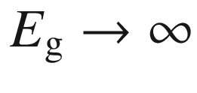

(six-band model [[1423](#u116076_4_En_BookBackmatter_OnlinePDF-CR1423)]). The heavy and light holes can be treated separately for

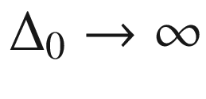

(Luttinger Hamiltonian). For the

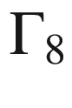

states, the Hamiltonian is then given by

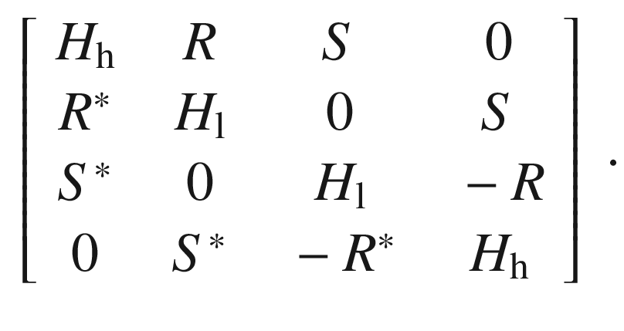

(H.15)

Appendix I

## Effective-Mass Theory

The effective-mass theory or approximation (EMA), also termed the envelope function approximation, is widely used for calculating the electronic properties of carriers in potentials in an otherwise periodic crystal. The strength of the method is that the complexities of the periodic potential are hidden in the effective-mass tensor

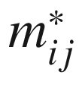

. The effective-mass theory is a useful approximation for the treatment of shallow impurities (Sect. [7.​5](The_Physics_of_Semiconductors00003.docx#u116076_4_En_7_Chapter)) or quantum wells (Sect. [12.​3.​2](The_Physics_of_Semiconductors00005.docx#u116076_4_En_12_Chapter)) with a potential that is slowly varying with respect to the scale of the lattice constant.

For the lattice-periodic potential, the Schrödinger equation

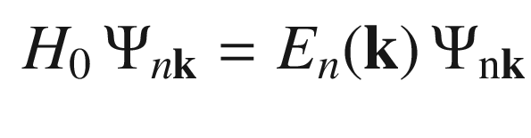

(I.1)

is solved by the Bloch wave



. With a perturbing potential *V*, the Schrödinger equation reads

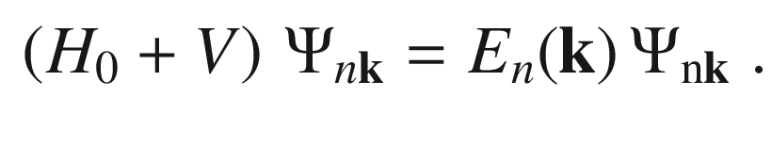

(I.2)

According to  Wannier’s theorem [[2166](#u116076_4_En_BookBackmatter_OnlinePDF-CR2166)], the solution is approximated by the solution of the equation

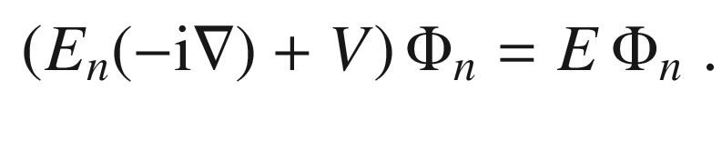

(I.3)

The dispersion relation is expanded to second order as described in Appendix [H](#u116076_4_En_BookBackmatter_OnlinePDF-Sec24). The function

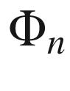

is termed the *envelope function* since it varies slowly compared to the lattice constant and the exact wavefunction is approximated (in lowest order) by

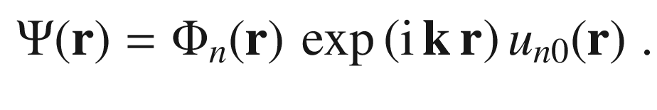

(I.4)

Appendix J

## Boltzmann Transport Theory

### J.1 Boltzmann Transport Equation

The Boltzmann treatment of transport  in semiconductors goes beyond the relaxation time approximation (cmp. Sect. [8.​2](The_Physics_of_Semiconductors00004.docx#u116076_4_En_8_Chapter)) and contains this approach as its simplest approximation. The distribution function of carriers

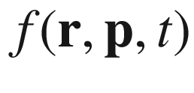

is considered with regard to their momentum

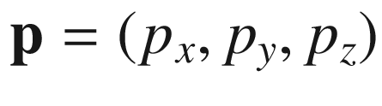

, their position

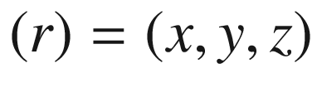

and time *t*. Via the dispersion relation(s) the momentum distribution also determines the energy distribution.

In thermodynamical equilibrium, the distribution function shall be termed

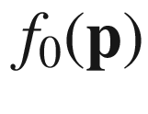

. In a homogeneous semiconductor it should be independent of

$$\mathbf{r}$$

, not depend explicitly on time and the momentum distribution be such that the resulting energy distribution should match the Fermi-Dirac distribution.

In non-equilibrium, the flow of electrons and heat is determined by the external forces

$$\mathbf{F}$$

(electrical and magnetic fields) and the scattering  of charge carriers via various processes (termed here collisions). In a (non-equilibrium) steady-state situation with constant forces, the distribution function *f* is constant in time; thus in a given time interval

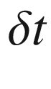

the change

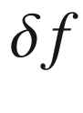

is zero,

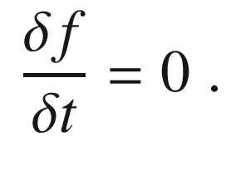

(J.1)

Within the time interval

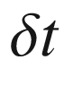

the momenta change as

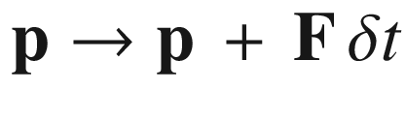

and the coordinates as

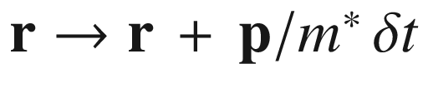

. We assume here for simplicity an isotropic mass and also the particle energy given by

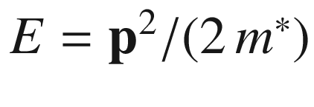

. The condition ([J.1](#u116076_4_En_BookBackmatter_OnlinePDF-Equ147)) written in partial derivatives reads

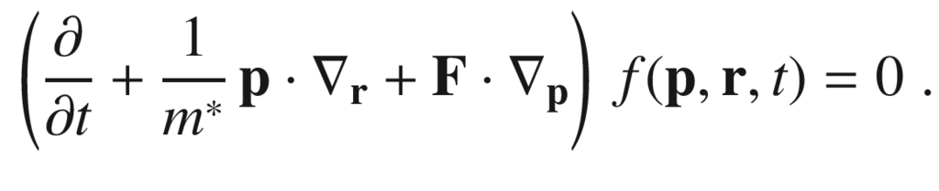

(J.2)

The force may be taken as the Lorentz force. So far no collisions  have been considered. Without giving an explicit form for the microscopic details of the collisions, the change of the distribution function due to collisions is written as

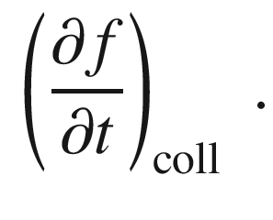

(J.3)

Assuming that only two-particle collisions play a role, sample boundaries play no role and that position and velocity of particles are uncorrelated, the collision term can be written as

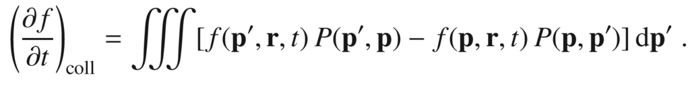

(J.4)

with

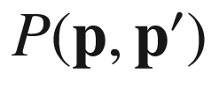

being the transition probability per time that a momentum

$$\mathbf{p}$$

is changed into

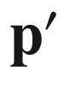

by collisions. The collision integral must be calculated explicitly using microscopic and eventually quantum mechanical models. This leads now to the Boltzmann transport equation

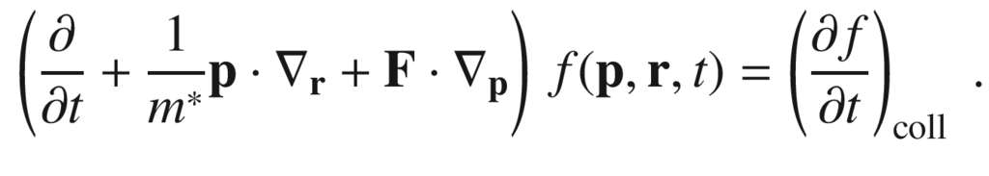

(J.5)

Under certain circumstances, the collision term can be effectively written as (for a homogeneous semiconductor and homogeneous fields, neglecting the spatial dependence of *f*)

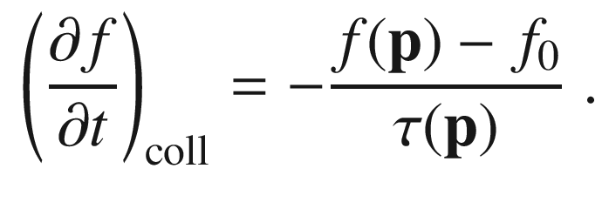

(J.6)

Compared to the relaxation time approximation, the major difference on the level of ([J.6](#u116076_4_En_BookBackmatter_OnlinePDF-Equ152)) here is the consideration of the momentum (and energy) dependence of the distribution function and the relaxation time.

### J.2 Conductivity

In thermodynamical equilibrium the number of electronic states per unit volume associated with an element

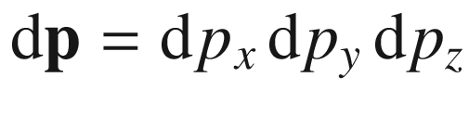

, including spin degeneracy of 2 is

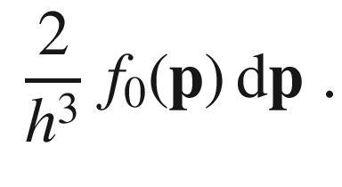

(J.7)

In the presence of an electric field



, which we assume here in *x*-direction, a steady-state current will arise and the number of electronic states changes to

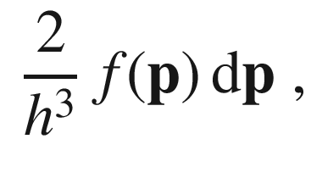

(J.8)

making the (electron) current density (along *x*-direction)

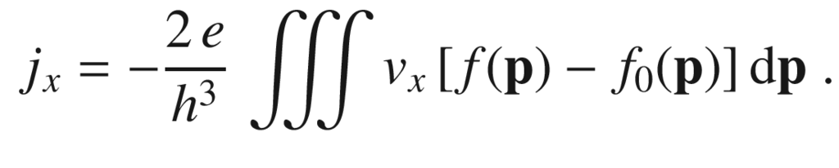

(J.9)

This is a generalization of ([8.​4](The_Physics_of_Semiconductors00004.docx#u116076_4_En_8_Chapter)). The Boltzmann transport equation ([J.5](#u116076_4_En_BookBackmatter_OnlinePDF-Equ151)) with ([J.6](#u116076_4_En_BookBackmatter_OnlinePDF-Equ152)) simplifies to

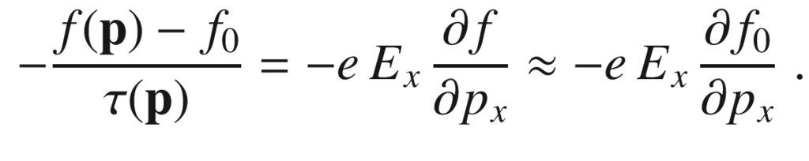

(J.10)

The last approximation is valid for small fields and makes

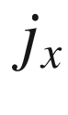

proportional to

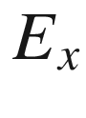

(ohmic regime). The derivative with respect to

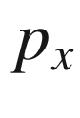

is converted to a derivative with respect to energy, yielding

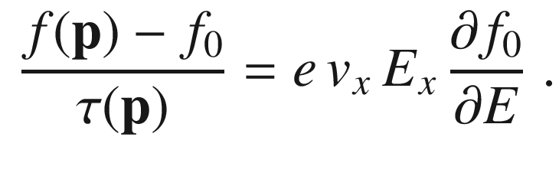

(J.11)

We note that for the Fermi-Dirac distribution ([E.22](#u116076_4_En_BookBackmatter_OnlinePDF-Equ74))

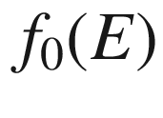

:

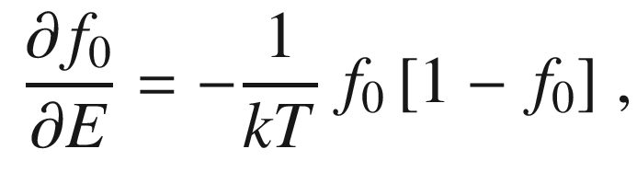

(J.12)

and in the case of a non-degenerate semiconductor (Boltzmann approximation), the right-hand side simplyfies to

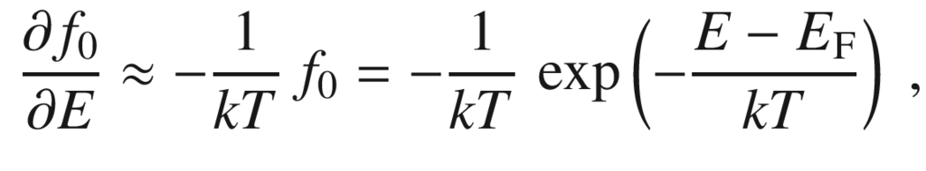

(J.13)

Now the current density is given as

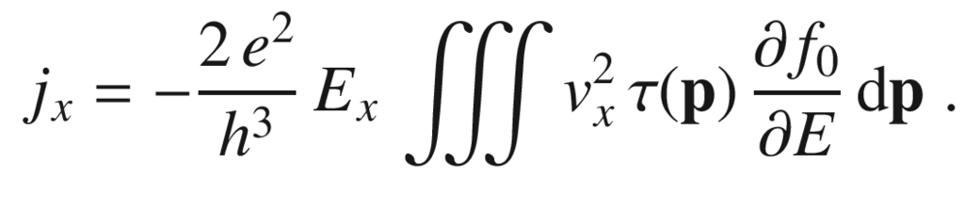

(J.14)

If we assume that

$$\tau $$

depends only on the momentum and not its direction[12](The_Physics_of_Semiconductors00011.docx#u116076_4_En_BookBackmatter_OnlinePDF-Fn12), and replace

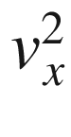

by

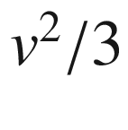

assuming isotropy, the integral reads[13](The_Physics_of_Semiconductors00011.docx#u116076_4_En_BookBackmatter_OnlinePDF-Fn13)

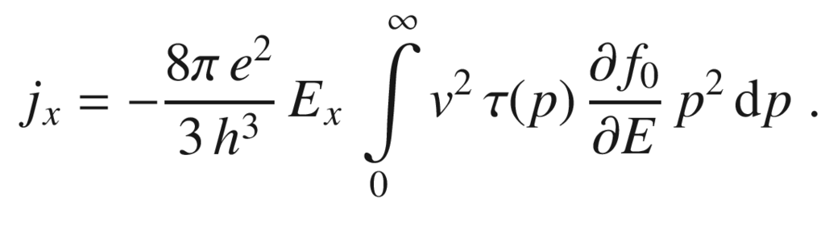

(J.15)

The quantity

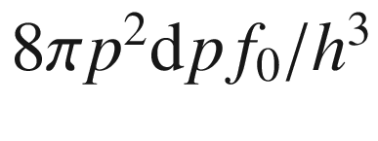

(cmp. [J.7](#u116076_4_En_BookBackmatter_OnlinePDF-Equ153)) denotes the number

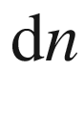

of electrons with momentum in the range

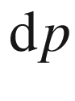

. Thus the integral can also be written as (in Boltzmann approximation)

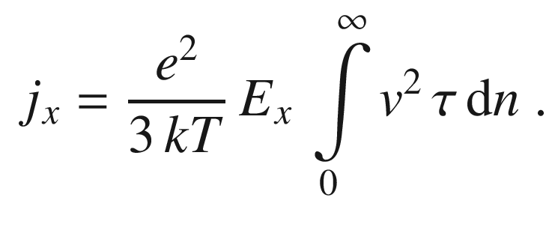

(J.16)

Denoting the average of a quantity *a* over the electron distribution with

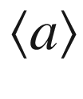

according to

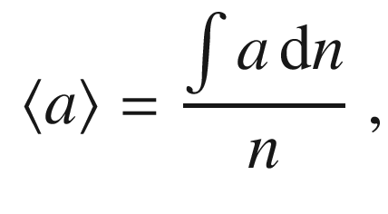

(J.17)

the equation ([J.16](#u116076_4_En_BookBackmatter_OnlinePDF-Equ162)) can be written as

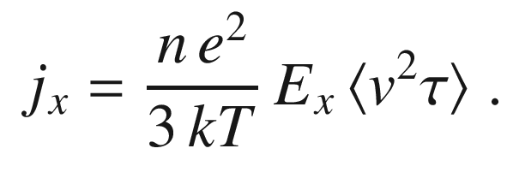

(J.18)

Using

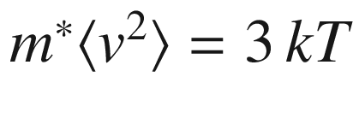

, we thus have obtained

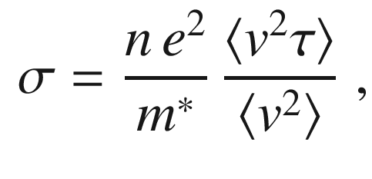

(J.19)

and with

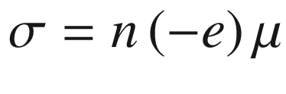

(for electrons), the mobility

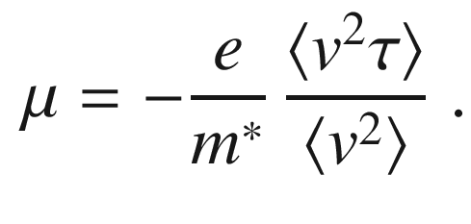

(J.20)

For degenerate semiconductors, similar as for metals, the derivative of

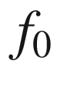

in ([J.15](#u116076_4_En_BookBackmatter_OnlinePDF-Equ161)) has a significant value only in the few-*kT* vicinity of the Fermi level. In an approximation we can evaluate the integral by replacing

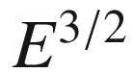

and

$$\tau $$

by their values at the Fermi level and find[14](The_Physics_of_Semiconductors00011.docx#u116076_4_En_BookBackmatter_OnlinePDF-Fn14) (using ([6.​70](The_Physics_of_Semiconductors00003.docx#u116076_4_En_6_Chapter)))

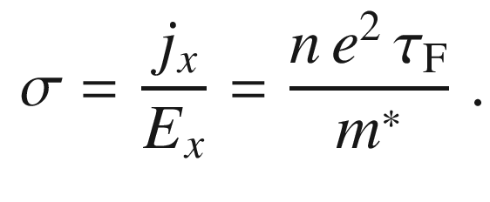

(J.21)

Starting again with ([J.15](#u116076_4_En_BookBackmatter_OnlinePDF-Equ161)), using the density of states ([6.​71](The_Physics_of_Semiconductors00003.docx#u116076_4_En_6_Chapter)) in the form (per volume)

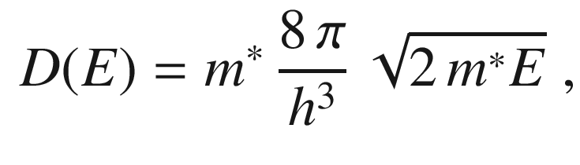

(J.22)

and

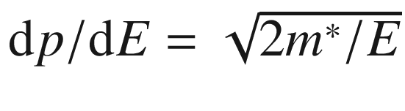

we write

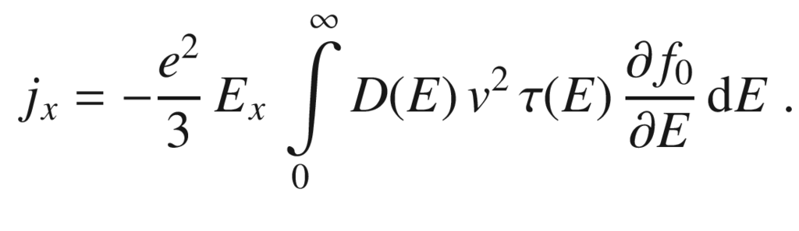

(J.23)

Using an energy-dependent mobility, in the spirit of ([J.20](#u116076_4_En_BookBackmatter_OnlinePDF-Equ166)) defined as

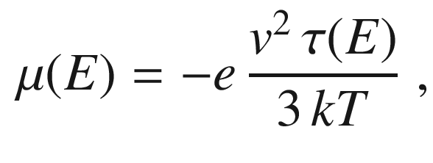

(J.24)

the conductivity can be written in a generalized form integrating over single electron states [[2167](#u116076_4_En_BookBackmatter_OnlinePDF-CR2167)] (neglecting correlation effects):

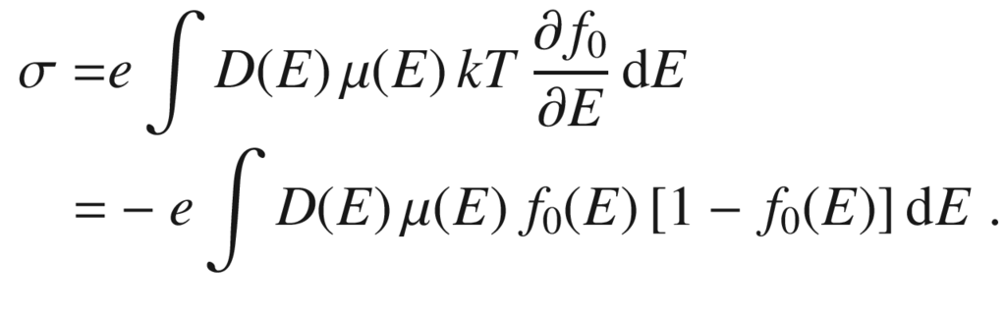

(J.25)

### J.3 Hall Effect

Treating the Hall effect with the Boltzmann transport equation and making the assumptions of isotropy, one obtains (cmp. ([15.​12](The_Physics_of_Semiconductors00006.docx#u116076_4_En_15_Chapter)) and ([15.​22](The_Physics_of_Semiconductors00006.docx#u116076_4_En_15_Chapter)))

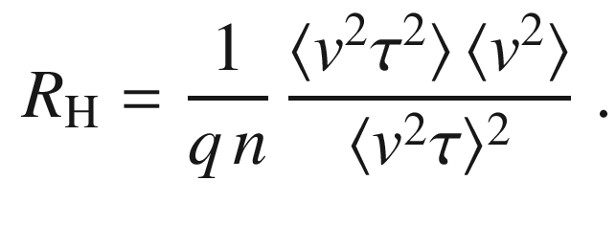

(J.26)

The Hall mobility determined from the Hall coefficient is

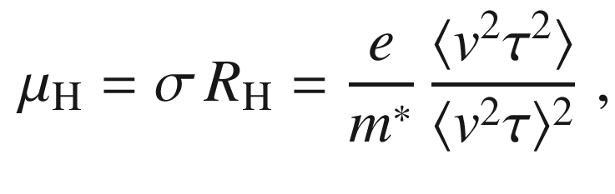

(J.27)

and thus different from the field mobility ([J.20](#u116076_4_En_BookBackmatter_OnlinePDF-Equ166)).

### J.4 Thermopower

The electronic energy transported per electron is

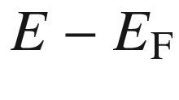

. Writing ([J.25](#u116076_4_En_BookBackmatter_OnlinePDF-Equ171)) as

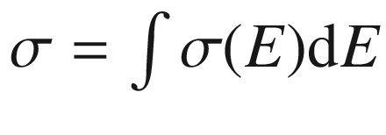

, the weighing factor for electrons at energy *E* contributing to conduction is

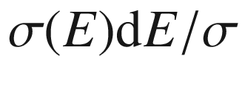

. Therefore the Seebeck coefficient (thermopower)  can be written [[823](#u116076_4_En_BookBackmatter_OnlinePDF-CR823)]

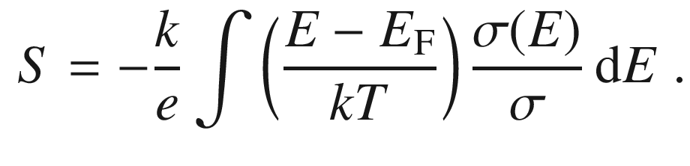

(J.28)

or

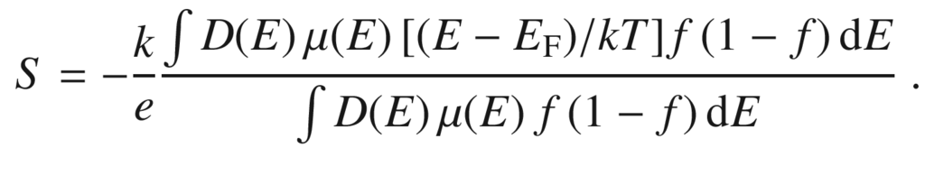

(J.29)

For band conduction the thermopower is obtained by integrating ([J.29](#u116076_4_En_BookBackmatter_OnlinePDF-Equ175)) for electrons (

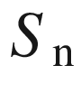

) and holes (

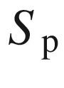

) (using the Boltzmann approximation) as [[823](#u116076_4_En_BookBackmatter_OnlinePDF-CR823)]

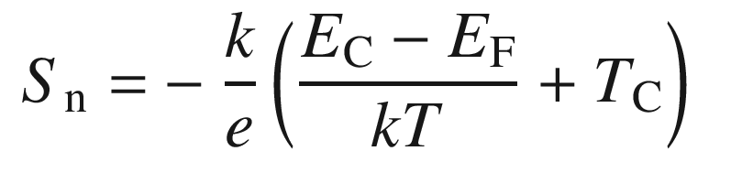

(J.30a)

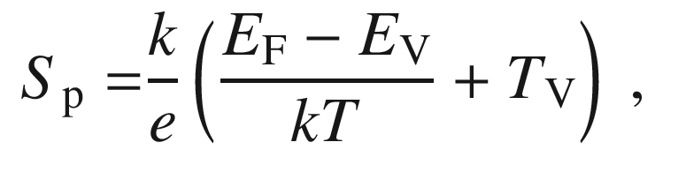

(J.30b)

where

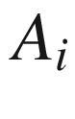

are constants depending on the energy dependence of the density of states and the mobility,

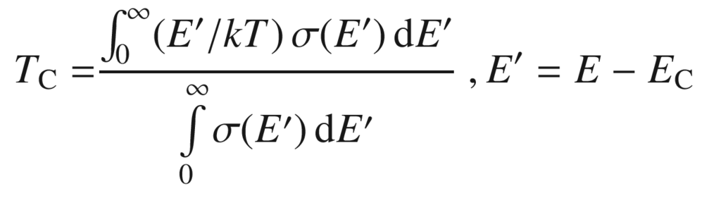

(J.31a)

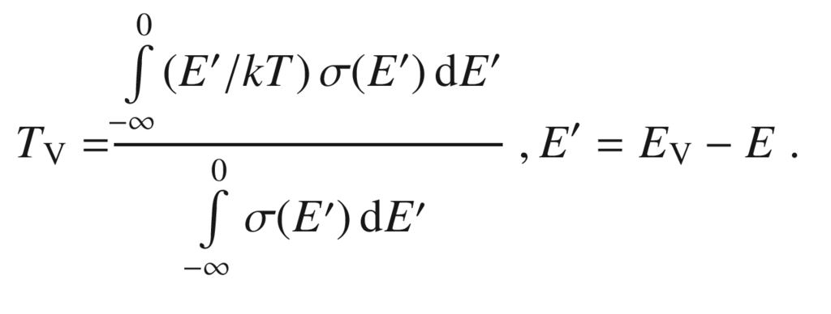

(J.31b)

If the product of the density of states and the mobility

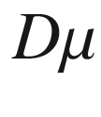

depends on the energy like



, the constant is

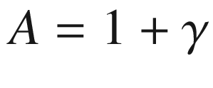

(for

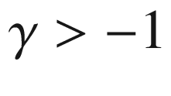

). For a parabolic band (

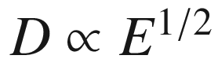

) and acoustic deformation potential scattering

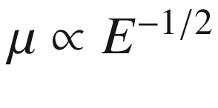

(Sect. [8.​3.​4](The_Physics_of_Semiconductors00004.docx#u116076_4_En_8_Chapter)), A=1; for moderate ionized impurity scattering

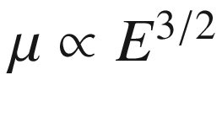

(Sect. [8.​3.​3](The_Physics_of_Semiconductors00004.docx#u116076_4_En_8_Chapter)) and

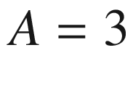

.

For two-band conduction, when electrons *and* holes contribute to transport,

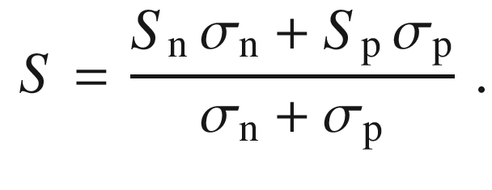

(J.32)

At low temperatures the interaction of the phonon flow with the current via electron-phonon scattering (phonon-drag effect) leads to an increase of thermopower [[825](#u116076_4_En_BookBackmatter_OnlinePDF-CR825), [2168](#u116076_4_En_BookBackmatter_OnlinePDF-CR2168)–[2170](#u116076_4_En_BookBackmatter_OnlinePDF-CR2170)].

Appendix K

## Noise

Noise is a general phenomenon effecting every measurement process and the performance of semiconductor devices [[2171](#u116076_4_En_BookBackmatter_OnlinePDF-CR2171)–[2178](#u116076_4_En_BookBackmatter_OnlinePDF-CR2178)]. Eventually, always a signal-to-noise ratio  is measured instead of a ‘signal’. Electrical noise fundamentally limits the sensitivity and resolution of communication, navigation, measurement, and other electronic systems [[2176](#u116076_4_En_BookBackmatter_OnlinePDF-CR2176)].

Behind the fluctuating signal stand microscopic classical and quantum mechanical processes that inherently contain randomness. From the physical standpoint, seemingly constant physical quantities even in thermodynamical equilibrium such as the free carrier density or the density of carriers on a trap are subject to fluctuations, e.g. leading to generation-recombination noise. Also the random motion of carriers, in equilibrium without net charge transport, leads to fluctuations , e.g. thermal noise on a resistor.

In this appendix necessary definitions, some mathematical basics and simple physical examples regarding noise are given.

### K.1 Fluctuating signals

The noisy signal under consideration can be ‘analog’, for example in the case of a fluctuating current, voltage or power or it can be ‘digital’ for example a photon count rate.

Let *A*(*t*) be an analog signal that fluctuates in time. Even under constant experimental conditions, it will fluctuate due to possibly many reasons, at least due to thermal fluctuations. We note that another, identically set-up experiment will have another signal *B*(*t*). The time average  (of first moment) of the signal within a time interval 2*T* (symmetric around

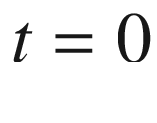

) is defined as

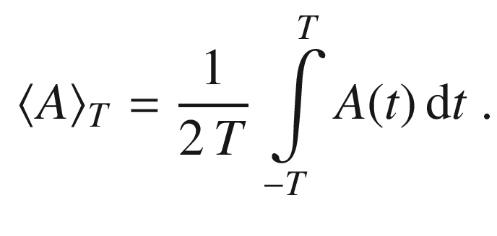

(K.1)

The time average of the signal

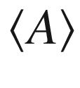

in general is the limit for large times,

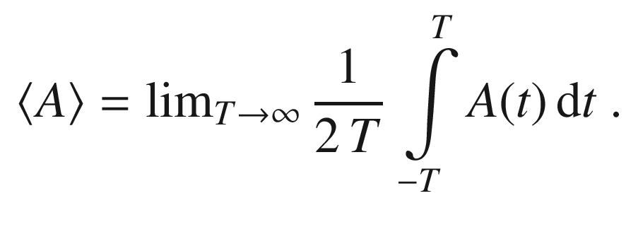

(K.2)

Two identical experiments will (should) share the same limits, i.e.

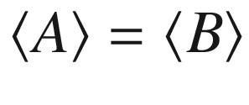

. The fluctuation or noise of *A* is defined as *a*(*t*) via

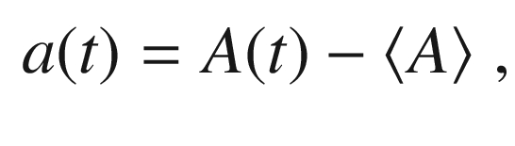

(K.3)

thus evidently

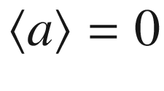

. For an identical but different experiment,

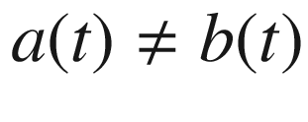

as stated before.

The *variance*

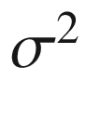

(or second moment) of the signal is the average of the squared fluctuation,

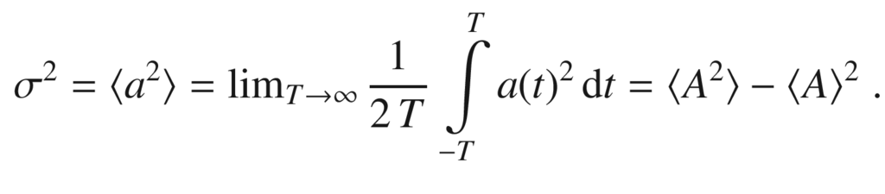

(K.4)

The *effective value* of the noise quantity *a* is the square root of the variance, also termed the ‘root mean square’ (or rms-value),

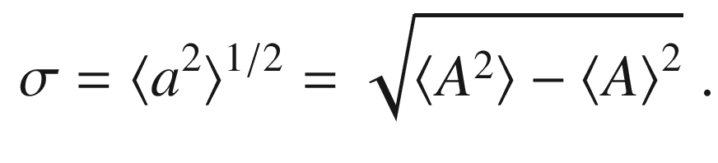

(K.5)

The quantity

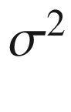

is a measure of the noise power, where

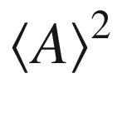

is a measure of the dc power.[15](The_Physics_of_Semiconductors00011.docx#u116076_4_En_BookBackmatter_OnlinePDF-Fn15)

In a measurement procedure, the noise of a signal can be reduced by integrating or averaging over time; however, the time for a specific measurement is always finite and maybe constricted by many conditions. Given a fixed (finite) averaging time of

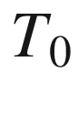

, the measured signals

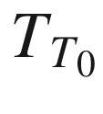

in a series of such subsequent identical measurements will still exhibit a fluctuation. How large this remaining fluctuation is depends on the choice of

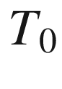

and the noise spectrum discussed below.

In the case of a digital signal, e.g. the count rate of a photomultiplier or from a scintillator, the signal consists of (integer) numbers

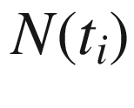

aggregated at times

$$t_i$$

,

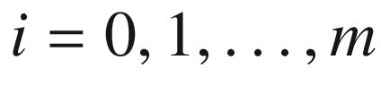

. The average is then defined as

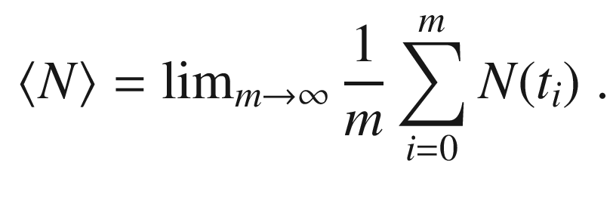

(K.6)

The definition of the variance and rms are analog to this definition. A well known result for photon counting, based on the Poisson statistics  of classical light is

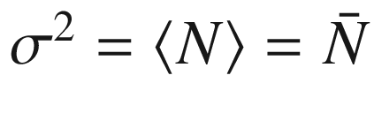

.

### K.2 Correlations

If a measurable quantity is subject to two fluctuating quantities

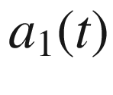

and

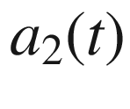

, the time average of

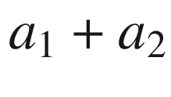

 is

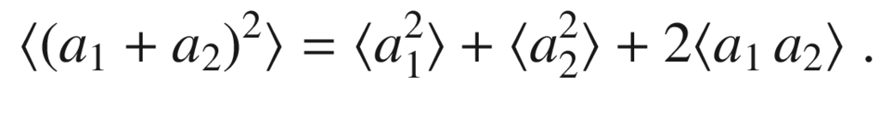

(K.7)

The third term is the decisive one; the correlation coefficient of noise quantities

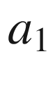

and

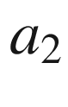

is defined as

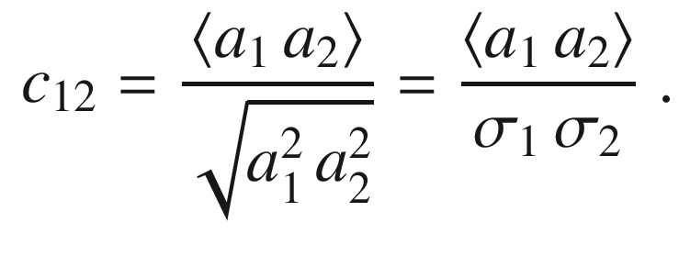

(K.8)

If the two noise quantities are independent of each other they are termed *uncorrelated* and

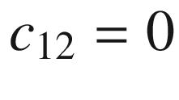

. In the following it will become clear that this is a necessary but not sufficient condition for two noise sources to be uncorrelated. In the case

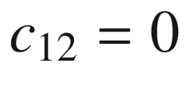

, the noise powers of the two processes are simply added,

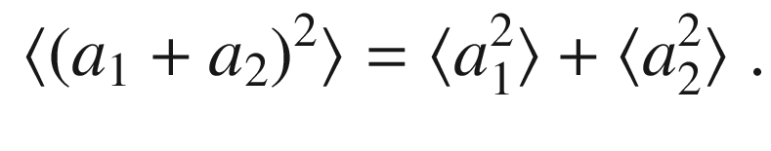

(K.9)

This concept can be generalized to several noise sources.

A more general concept to determine correlation of two functions

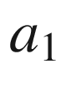

and

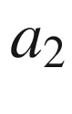

is the *cross correlation* function, defined by

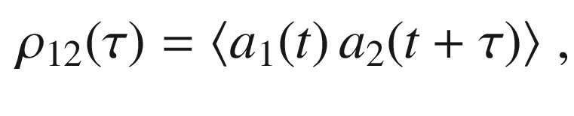

(K.10)

which is the average of function

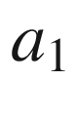

and time-shifted function

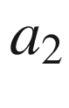

. Often

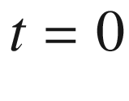

is used when the nature of the fluctuations does not change with time. An important time-shift is

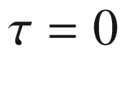

, and it follows that

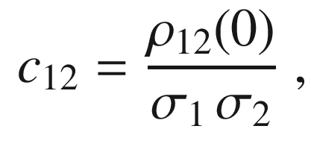

(K.11)

Two noise quantities

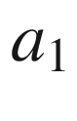

and

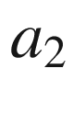

are uncorrelated if

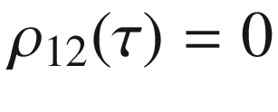

holds for all times

$$\tau $$

; thus

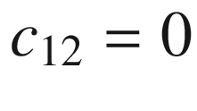

is a special but important case.[16](The_Physics_of_Semiconductors00011.docx#u116076_4_En_BookBackmatter_OnlinePDF-Fn16)

If

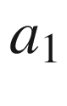

and

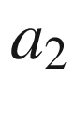

are the same function, i.e.

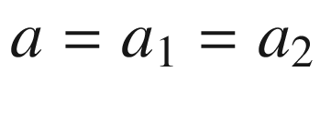

, ([K.10](#u116076_4_En_BookBackmatter_OnlinePDF-Equ190)) becomes the *auto correlation* function,

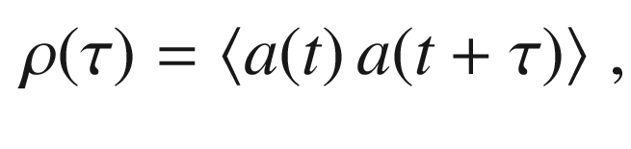

(K.12)

In stationary processes the auto correlation function must be symmetric with regard to

$$\tau $$

,

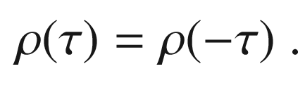

(K.13)

The value at

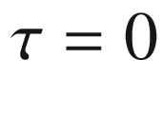

 is

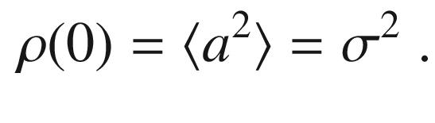

(K.14)

Typically,

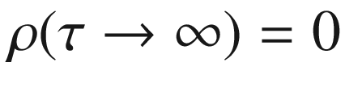

in a statistic (non-repetitive) process. For uncorrelated processes, the auto correlation function of the sum, is the sum of the individual auto correlation functions.

### K.3 Noise spectrum

Since the function *a*(*t*) is not known, the noise spectrum cannot be calculated from its Fourier transform. However, this is also unnecessary since we are not interested in the Fourier transform of *a* itself but rather the spectral power density for a given frequency

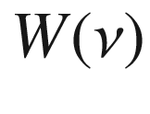

, with

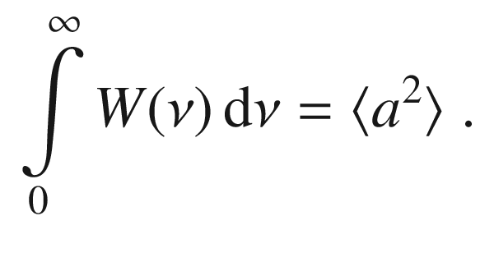

(K.15)

Since the quantity

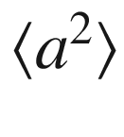

is finite and the spectral power density

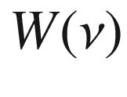

is positive, for high frequencies,

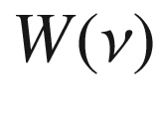

must decrease to zero. Starting from the auto correlation function

$$\rho $$

, its Fourier transform shall be denoted *w*,

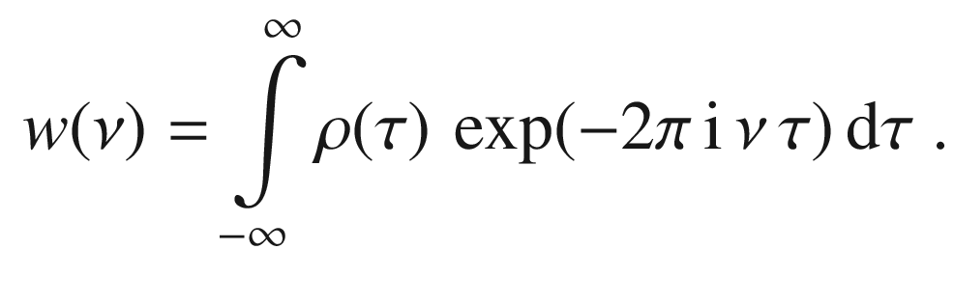

(K.16)

Also,

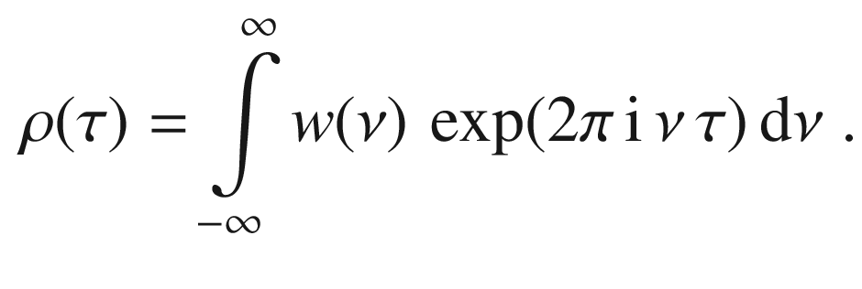

(K.17)

Using

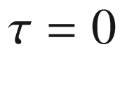

in this equation, we have obtained an equation similar to ([K.15](#u116076_4_En_BookBackmatter_OnlinePDF-Equ195)). With ([K.12](#u116076_4_En_BookBackmatter_OnlinePDF-Equ192))

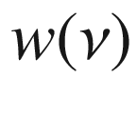

can be identified as a spectral power density. Due to ([K.13](#u116076_4_En_BookBackmatter_OnlinePDF-Equ193)), *w* is a real and even function and we find for the noise power spectrum *W* in ([K.15](#u116076_4_En_BookBackmatter_OnlinePDF-Equ195))

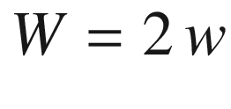

(Wiener–Khintchine theorem),

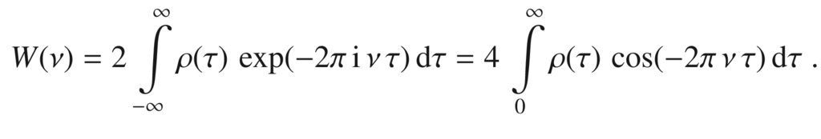

(K.18)

The noise power is practically measured in a finite frequency range, often in a narrow band of width  *B* (with varying central frequency). If the frequency dependence of *W* can be neglected within *B* around the frequency

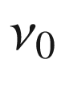

, the variance is given by

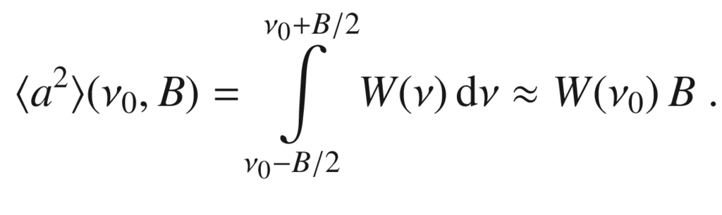

(K.19)

Typical noise mechanisms and spectra are discussed in the following sections.

#### K.3.1 Thermal Noise

Finite temperature induces random motion of particles, e.g. as known from the theory of ideal gases and diffusion. In the case of charge carriers such motions lead to fluctuations of current or at a resistor to fluctuation of voltage. This happens also in the case of zero bias (no external fields). Such ‘thermal noise’ at a resistor was experimentally found by Johnson [[1820](#u116076_4_En_BookBackmatter_OnlinePDF-CR1820), [1821](#u116076_4_En_BookBackmatter_OnlinePDF-CR1821)] and theoretically derived by Nyquist [[1822](#u116076_4_En_BookBackmatter_OnlinePDF-CR1822)].

Using the general result from Langevin theory of motion under a fluctuating force, the mobility[17](The_Physics_of_Semiconductors00011.docx#u116076_4_En_BookBackmatter_OnlinePDF-Fn17) is given as

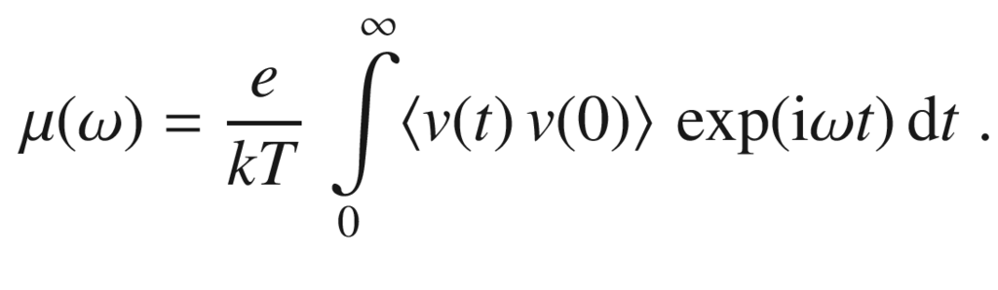

(K.20)

Now we restrict ourselves to times much longer than the relaxation time constant, and subsequently to frequencies much smaller than

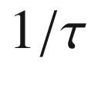

. In this case the conductivity

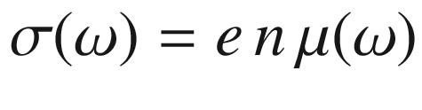

does not depend on frequency and can be taken as its low frequency limit

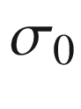

(cmp. Sect. [8.​5](The_Physics_of_Semiconductors00004.docx#u116076_4_En_8_Chapter)). In a conductor (resistor) of length *L* and cross section *A* shall be *N* electrons (

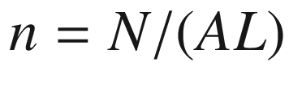

). With the electron velocities

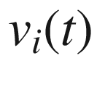

, the current is

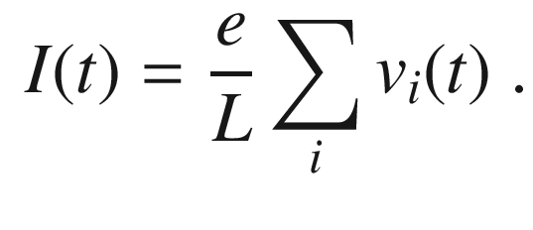

(K.21)

Without external field,

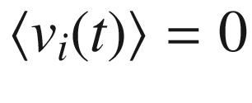

and

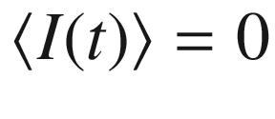

and we name this fluctuating current *i*(*t*). If all electrons move independently of each other,

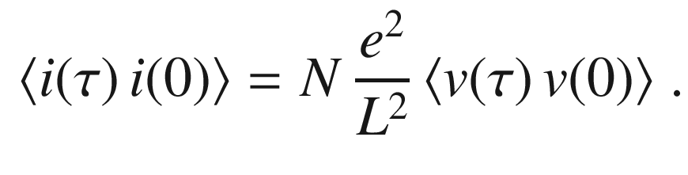

(K.22)

The power spectrum of *i*(*t*) is according to ([K.18](#u116076_4_En_BookBackmatter_OnlinePDF-Equ198)),

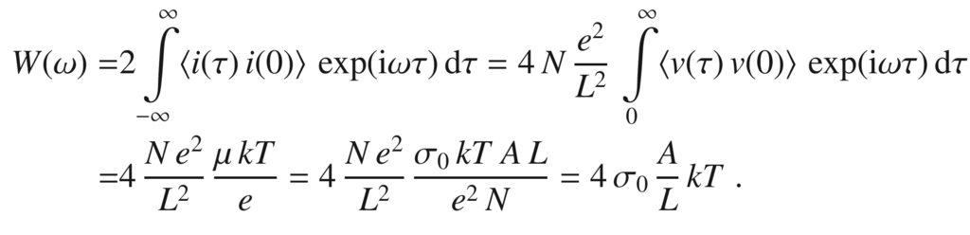

(K.23)

Then, using the conductance

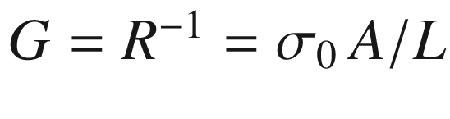

, we find the frequency independent spectral power

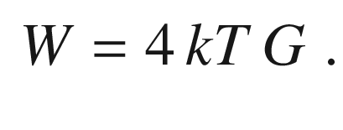

(K.24)

Therefore the fluctuation of the current induced by the thermal motion is

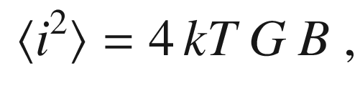

(K.25)

and the variance of the fluctuating voltage at a resistor with resistance *R* in a frequency range *B* is (

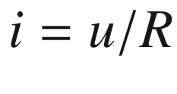

)

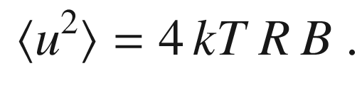

(K.26)

At room temperature (

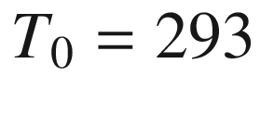

 K), the quantity

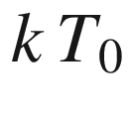

is about 26 meV; in the context here, the unit W s=W/Hz is the appropriate one, and

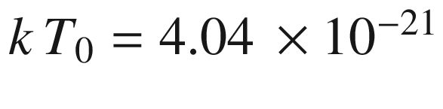

 W/Hz. This represents a fundamental limit to noise in devices. Since the power density is independent of frequency, this noise is ‘white’ noise. The formulas ([K.26](#u116076_4_En_BookBackmatter_OnlinePDF-Equ206)) and ([K.25](#u116076_4_En_BookBackmatter_OnlinePDF-Equ205)) are valid for frequencies

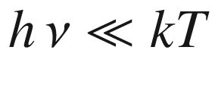

; for larger frequencies the quantum nature of electromagnetic radiation and photon statistics play a role. For practical purposes even cooled devices at



 K fulfill the limit condition for frequencies up in the 100 GHz regime. In the cases of heated electron (or hole) gases (cmp. Fig.[10.​3](The_Physics_of_Semiconductors00005.docx#u116076_4_En_10_Chapter-Fig3)), the lattice temperature must be replaced by the temperature of the carrier gas.

For a RC low pass, the power spectrum

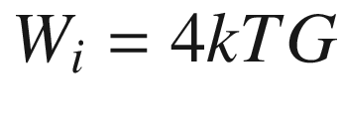

at the resistor is converted using

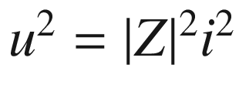

to

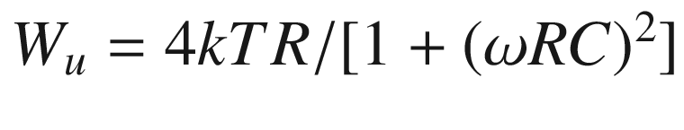

.

#### K.3.2 1/f Noise

For many processes a frequency dependent noise spectral power following a

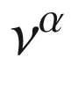

-law is found with

$$\alpha $$

close to

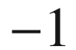

. Such noise is termed ‘pink noise’, 1/*f*-noise or Flicker noise. The microscopic reasons for such behavior can be manifold and various models have been proposed [[2179](#u116076_4_En_BookBackmatter_OnlinePDF-CR2179), [2180](#u116076_4_En_BookBackmatter_OnlinePDF-CR2180)]. As an example, the noise spectrum of a RuO

$$_2$$

thick film resistor is depicted in Fig. [K.1](#u116076_4_En_BookBackmatter_OnlinePDF-Fig18)a; for this system, the fluctuation of tunneling current in metal-insulator-metal units was used to explain the observed frequency (and temperature) dependence of the 1/*f*-noise. At high frequencies, the 1/*f* spectral power vanishes and other noise sources such as thermal noise dominate, as depicted in Fig. [K.1](#u116076_4_En_BookBackmatter_OnlinePDF-Fig18)b for an a-Si thin film transistor. The 1/*f*-dependence of the noise spectral power (of a carbon sheet resistor) has been detected for frequencies down to

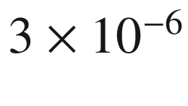

 Hz [[2181](#u116076_4_En_BookBackmatter_OnlinePDF-CR2181)].

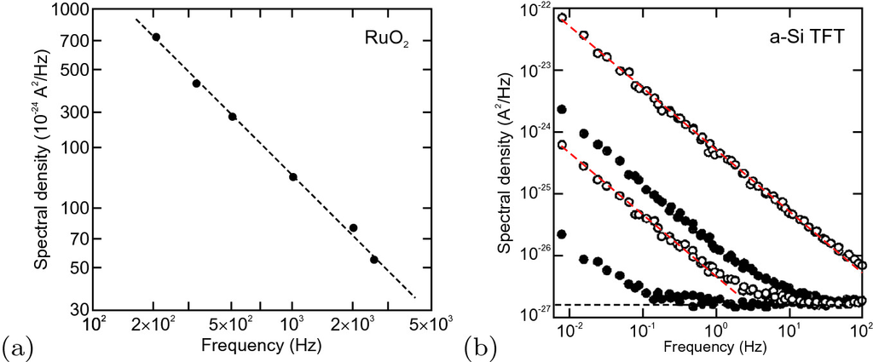

Fig. K.1

**a** Noise current density spectrum of a ruthenium oxide resistor (at

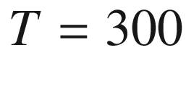

 K and current of

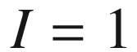

 mA), experimental data (*symbols*) and 1/*f*-dependency (*dashed line*). Adapted from [[2182](#u116076_4_En_BookBackmatter_OnlinePDF-CR2182)]. **b** Noise current density spectrum of an amorphous silicon thin film transistor, experimental data (*symbols*) for various source-drain voltages, thermal noise (*horizontal blue dashed line*) and 1/*f*-dependency (*red dashed lines*).

Adapted from [[2183](#u116076_4_En_BookBackmatter_OnlinePDF-CR2183)]

#### K.3.3 Shot Noise

A dc current

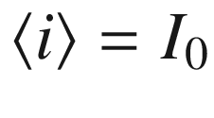

through a resistor is a sequence of electron transfers from one contact to the other. The transit time

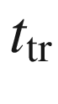

is given by the length *L* and the drift velocity

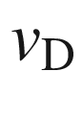

as

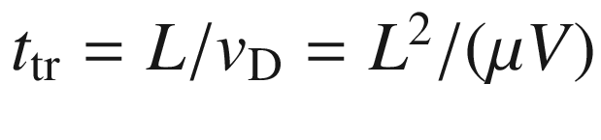

. The event times of these transits are random and thus lead to a noise (ac) component on top of the dc current. This is termed ‘shot’ noise, after the crackling arrival of shot pellets on a target. For low frequencies (

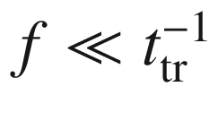

), the noise power is

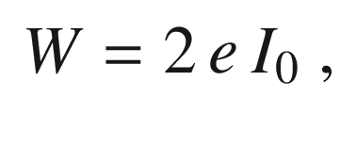

(K.27)

and the current noise thus is given by

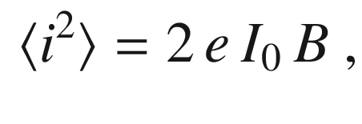

(K.28)

This noise term has been first found for vacuum diodes in the saturation regime which also serve as noise normals according to ([K.28](#u116076_4_En_BookBackmatter_OnlinePDF-Equ208)). It is important for the validity of ([K.28](#u116076_4_En_BookBackmatter_OnlinePDF-Equ208)) that in each event a full charge *e* is transferred. The situation in a semiconductor diode is more complicated since various currents contribute; if scattering events occur during transit, also fractional transferred charges can occur. The reverse current of an asymmetric diode if originating from the lowly doped region is due to carriers crossing the depletion layer. If generation in the depletion layer plays no role, the noise is also determined by the shot noise ([K.28](#u116076_4_En_BookBackmatter_OnlinePDF-Equ208)).

The maximal noise level ([K.28](#u116076_4_En_BookBackmatter_OnlinePDF-Equ208)) is present in absence of all correlations (Poisson process), both in the injection process as well as in the subsequent transport. Such value has been found, e.g., for intrinsic germanium in [[2184](#u116076_4_En_BookBackmatter_OnlinePDF-CR2184)] and in the limit of large currents for CdTe detectors [[2185](#u116076_4_En_BookBackmatter_OnlinePDF-CR2185)] (Fig. [K.2](#u116076_4_En_BookBackmatter_OnlinePDF-Fig19)). In a metallic conductor (or degenerate semiconductor) the noise is reduced to a third of that value due to correlations induced by the Pauli exclusion principle [[2186](#u116076_4_En_BookBackmatter_OnlinePDF-CR2186)]. The modification in non-degenerate semiconductors on length scales intermediate between the elastic and inelastic mean free paths is discussed in [[2187](#u116076_4_En_BookBackmatter_OnlinePDF-CR2187)]. The case of shot noise in semiconductors in the presence of transport of electrons and holes has been treated in [[2184](#u116076_4_En_BookBackmatter_OnlinePDF-CR2184), [2188](#u116076_4_En_BookBackmatter_OnlinePDF-CR2188)].

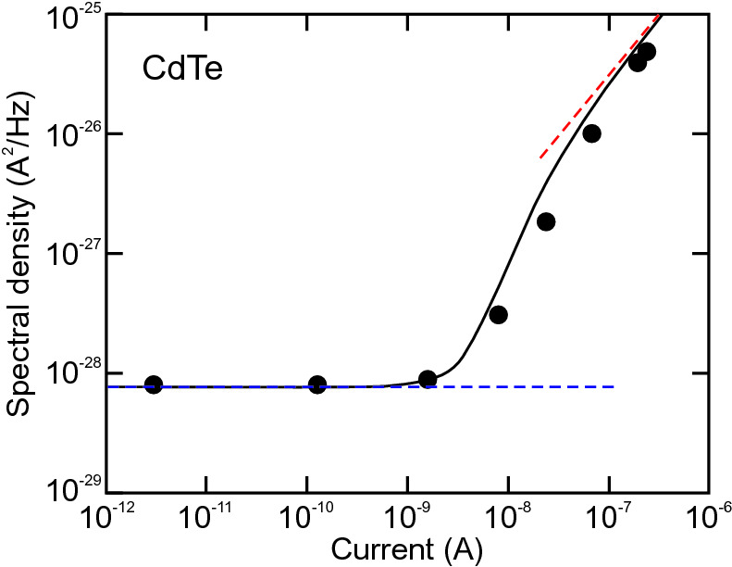

Fig. K.2

Noise of semi-insulating (dark) CdTe detector at

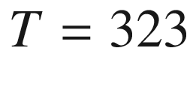

 K (at a frequency of about 1–2 kHz when 1/*f*-noise plays no role). Experimental data (*symbols*) and detailed theory (*black line*). The *dashed blue line* represents the thermal noise ([K.25](#u116076_4_En_BookBackmatter_OnlinePDF-Equ205)), the *dashed red line* the shot noise ([K.28](#u116076_4_En_BookBackmatter_OnlinePDF-Equ208)).

Adapted from [[2185](#u116076_4_En_BookBackmatter_OnlinePDF-CR2185)]

#### K.3.4 Generation-Recombination Noise

It is a semiconductor specific property that the carrier density is subject to fluctuations due to generation and recombination.[18](The_Physics_of_Semiconductors00011.docx#u116076_4_En_BookBackmatter_OnlinePDF-Fn18) A fluctuation in majority carrier density leads to a change of conductivity which will lead to a change in current if a constant voltage is applied. Typical examples of transitions leading to a fluctuation of the carrier density are between bands and localized levels and in between the conduction and valence bands. Usually, the sample remains neutral. Detailed treatments are given in [[2189](#u116076_4_En_BookBackmatter_OnlinePDF-CR2189), [2190](#u116076_4_En_BookBackmatter_OnlinePDF-CR2190)].

A simple example is the effect of carrier number fluctuation due to transitions between a conduction band and donor levels. This is manifested in the noise spectrum of a n-Si sample at

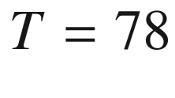

 K (Fig. [K.3](#u116076_4_En_BookBackmatter_OnlinePDF-Fig20)a) with the plateau at

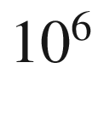

–

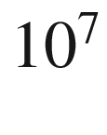

 Hz on top of the 1/*f* noise [[2191](#u116076_4_En_BookBackmatter_OnlinePDF-CR2191)] (The plateau at

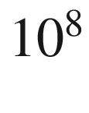

–

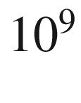

 Hz is due to velocity fluctuations). The spectral power of the generation-recombination noise contribution is given by

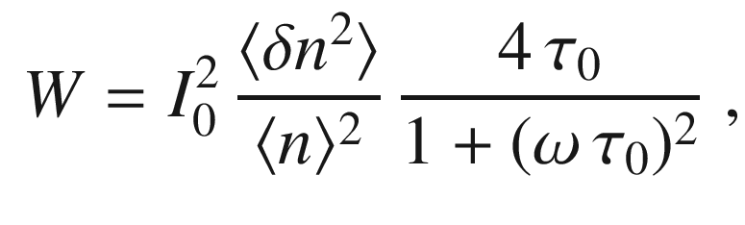

(K.29)

where

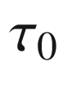

is the characteristic relaxation time,

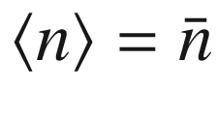

is the average carrier density (average carrier number per given volume) and

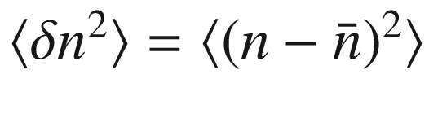

is the fluctuation of the carrier density. In order to better visualize the generation-recombination noise with respect to the 1/*f* noise, the quantity

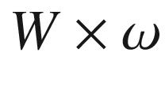

can be plotted (Fig. [K.3](#u116076_4_En_BookBackmatter_OnlinePDF-Fig20)b) which takes the shape of a peak (for logarithmic frequency axis) [[2192](#u116076_4_En_BookBackmatter_OnlinePDF-CR2192)].

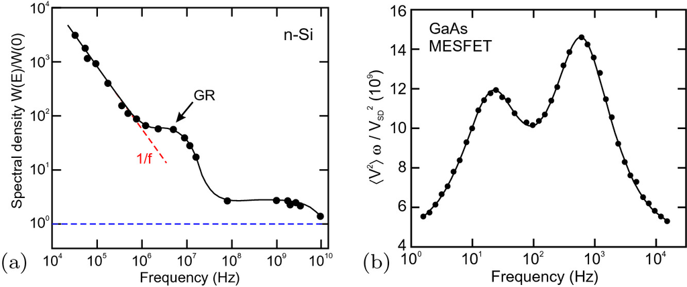

Fig. K.3

**a** Current noise spectrum of n-type Si (

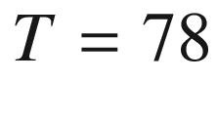

 K,

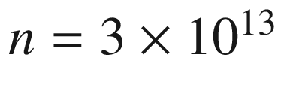

 cm

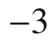

) for an electric field of

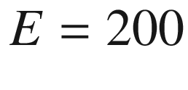

 V/cm along the

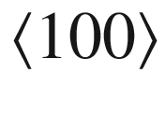

direction, in relative units to the noise spectrum for

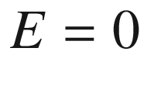

. The *dashed blue line* indicates the level of thermal noise, The *arrow* labeled ‘GR’ denotes the contribution of generation-recombination noise. Adapted from [[2191](#u116076_4_En_BookBackmatter_OnlinePDF-CR2191)]. **b** Voltage noise power times frequency of a GaAs MESFET. Experimental data (*symbols*) and fit (*solid line*) including two generation-recombination noise terms of the type ([K.29](#u116076_4_En_BookBackmatter_OnlinePDF-Equ209)) (times



) for two different traps. Adapted from [[2192](#u116076_4_En_BookBackmatter_OnlinePDF-CR2192)]

For a partially compensated semiconductor with

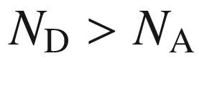

it is found (if holes can be neglected) [[2190](#u116076_4_En_BookBackmatter_OnlinePDF-CR2190)]

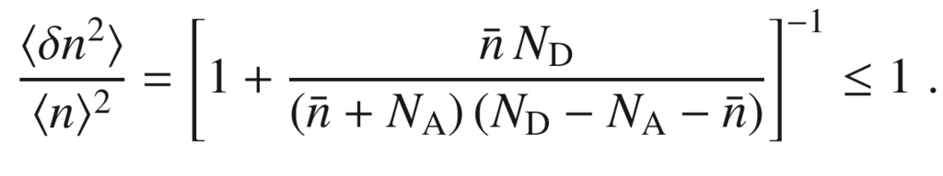

(K.30)

The fluctuation

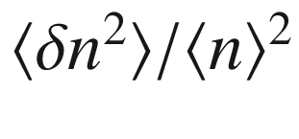

is typically smaller than the Poisson value of 1; such sub-Poissonian statistics is typical of a repulsive correlation. For the case

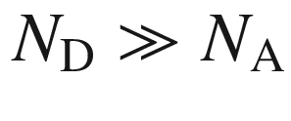

[[2190](#u116076_4_En_BookBackmatter_OnlinePDF-CR2190)], ([K.30](#u116076_4_En_BookBackmatter_OnlinePDF-Equ210)) simplifies to

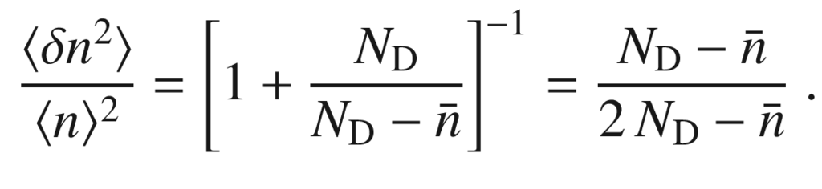

(K.31)

In the ambipolar regime, typically close to intrinsic conditions, when only free electrons and holes are important, it is found [[2190](#u116076_4_En_BookBackmatter_OnlinePDF-CR2190)] (

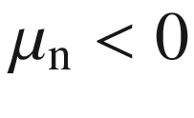

)

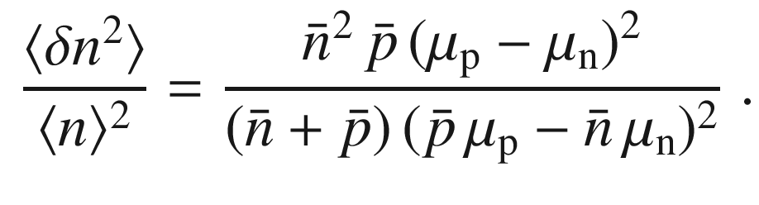

(K.32)

which simplifies to

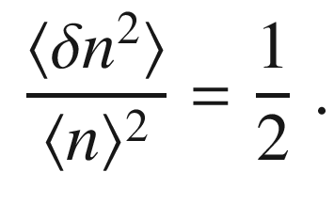

(K.33)

in the intrinsic case (

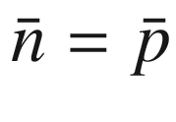

).

References

J.R. Chelikowsky, M.L. Cohen, Semiconductors: A pillar of pure and applied physics. J. Appl. Phys. **117**, 112812, 1–8 (2015). [10.​1063/​1.​4913838](https://doi.org/10.1063/1.4913838)

J.M. Bishop, *How to Win the Nobel Prize: An Unexpected Life in Science* (Harvard University Press, Cambridge, 2003)

G. Busch, Early history of the physics and chemistry of semiconductors—from doubts to fact in a hundred years. Eur. J. Phys. **10**, 254–264 (1989). [10.​1088/​0143-0807/​10/​4/​002](https://doi.org/10.1088/0143-0807/10/4/002)

L. Hoddeson, E. Braun, J. Teichmann, S. Weart, eds., *Out of the Crystal Maze* (Oxford University Press, Oxford, 1992)

K.C. Handel, *Anfänge der Halbleiterforschung und -entwicklung. Dargestellt an den Biographien von vier deutschen Halbleiterpionieren*, Ph.D. Thesis, RWTH Aachen (1999)

R.S. Feigelson, ed., *50 Years Progress in Crystal Growth* (Elsevier, Amsterdam, 2004)

P.R. Morris, A history of the world semiconductor industry, in *IEE History of Technology Series*, vol. 12 (Peter Peregrinus Ltd., London, 1990). [10.​1049/​PBHT012E](https://doi.org/10.1049/PBHT012E)

D. Holbrook, W.M. Cohen, D.A. Hounshell, S. Klepper, The nature, sources, and consequences of firm differences in the early history of the semiconductor industry. Strat. Mgmt. J. **21**, 1017–1041 (2000). [10.​1002/​1097-0266(200010/​11)21:​10/​11<1017:​:​AID-SMJ131>3.​0.​CO;2-G](https://doi.org/10.1002/1097-0266(200010/11)21:10/11%253C1017::AID-SMJ131%253E3.0.CO%3B2-G)

S.M. Sze, ed., *Semiconductor Devices: Pioneering Papers* (World Scientific, Singapore, 1991). [10.​1142/​1087](https://doi.org/10.1142/1087)

A. Volta, Del modo di render sensibilissima la più debole Elettricità sia Naturale, sia Artificiale. Phil. Trans. Roy. Soc. London **72**, 237–280 (1782) (followed by an English translation *Of the Method of rendering very sensible the weakest Natural and Artificial Electricity*). [10.​1098/​rstl.​1782.​0018](https://doi.org/10.1098/rstl.1782.0018)

T.J. Seebeck, Magnetische Polarisation der Metalle und Erze durch Temperaturdifferenz. Abhandl. Deut. Akad. Wiss. Berlin (Physik. Klasse) 265–373 (1822)

T.J. Seebeck, Über die magnetische Polarisation der Metalle und Erze durch Temperaturdifferenz. Ann. Physik **82**, 1–20, 133–160, 253–286 (1826). [10.​1002/​andp.​18260820102](https://doi.org/10.1002/andp.18260820102); [10.​1002/​andp.​18260820202](https://doi.org/10.1002/andp.18260820202); [10.​1002/​andp.​18260820302](https://doi.org/10.1002/andp.18260820302)

M. Faraday, Experimental Researches in Electricity, §10. On Conduction Power generally. Phil. Trans. Roy. Soc. London **123**, 507–522 (1833) (Series IV, paragraph 434, p. 519). [10.​1098/​rstl.​1833.​0022](https://doi.org/10.1098/rstl.1833.0022)

E. Becquerel, Recherches sur les effets de la radiation chimique de la lumière solaire au moyen des courants électriques. Comptes Rendus de L’Académie des Sciences **9**, 145–149 (1839)

E. Becquerel, Mémoire sur les effects électriques produits sous I’influence des rayons solaires. Comptes Rendus de L’Académie des Sciences **9**, 561–567 (1839)

E. Becquerel, Untersuchungen über die Wirkungen der chemischen Strahlen des Sonnenlichts mittelst elektrischer Ströme. Ann. Physik **130**, 18–35 (1841). [10.​1002/​andp.​18411300903](https://doi.org/10.1002/andp.18411300903)

E. Becquerel, Ueber die elektrischen Wirkungen unter Einfluss der Sonnenstrahlen. Ann. Physik **130**, 35–42 (1841). [10.​1002/​andp.​18411300904](https://doi.org/10.1002/andp.18411300904)

J. Peltier, Nouvelles Expériences sur la Caloricité des courans électriques. Ann. Chim. LVI 371–387 (1834)

W. Smith, The Action of Light on Selenium. J. Soc. Telegraph Engrs. **2**, 31–33 (1873). [10.​1049/​jste-1.​1873.​0023](https://doi.org/10.1049/jste-1.1873.0023)

W. Smith, Effect of light on selenium during the passage of an electric current. Nature **7**, 303 (1873). [10.​1038/​007303e0](https://doi.org/10.1038/007303e0)

S. Bidwell, On the sensitiveness of selenium to light, and the development of a similar property in sulphur. Proc. Phys. Soc. **7**, 129–145 (1885). [10.​1088/​1478-7814/​7/​1/​319](https://doi.org/10.1088/1478-7814/7/1/319)

S. Bidwell, The electrical properties of selenium. Proc. Phys. Soc. **13**, 552–579 (1894). [10.​1088/​1478-7814/​13/​1/​348](https://doi.org/10.1088/1478-7814/13/1/348)

W. Schreier, Ferdinand Braun in Leipzig, Zum 150. Geburtstag des Entdeckers des Halbleitereffektes und des Erfinders der Kathodenstrahlröhre, NTM Zeitschrift für Geschichte der Wissenschaften, Technik und Medizin **8**, 201–208 (2000). [10.​1007/​BF02914193](https://doi.org/10.1007/BF02914193)

F. Braun, Über die Stromleitung durch Schwefelmetalle. Ann. Phys. Chem. **153**, 556–563 (1874)

W.G. Adams, R.E. Day, The action of light on selenium. Proc. Roy. Soc. Lond. A **25**, 113–117 (1876)

W. Siemens, On the influence of light upon the conductivity of crystalline selenium. Phil. Mag. **50**, 416 (1875). [10.​1080/​1478644750864131​3](https://doi.org/10.1080/14786447508641313)

C.E. Fritts, On a new form of selenium cell, and some electrical discoveries made by its use. Am. J. Sci. **26**, 465–472 (1883). [10.​2475/​ajs.​s3-26.​156.​465](https://doi.org/10.2475/ajs.s3-26.156.465)

E.H. Hall, On a new action of the magnet on electric currents. Am. J. Math. **2**, 287–292 (1879). [10.​2307/​2369245](https://doi.org/10.2307/2369245)

E.H. Hall, On a new action of the magnet on electric currents. Philos. Mag. **9**, 225–230 (1879). [10.​1080/​1478644800862682​8](https://doi.org/10.1080/14786448008626828)

H.A. Rowland, Preliminary notes on Mr. Hall’s recent discovery. Philos. Mag. **9**, 432–434 (1880). [10.​1080/​1478644800862686​5](https://doi.org/10.1080/14786448008626865)

J.Z. Buchwald, The Hall effect and Maxwellian electrodynamics in the 1880’s. Part I: Discovery of a new electric field. Centaurus **23**, 51–99 (1979). [10.​1111/​j.​1600-0498.​1979.​tb00360.​x](https://doi.org/10.1111/j.1600-0498.1979.tb00360.x)

J.Z. Buchwald, The Hall effect and Maxwellian electrodynamics in the 1880’s. Part II: The unification of theory, 1881–1893. Centaurus **23**, 118–162 (1979). [10.​1111/​j.​1600-0498.​1979.​tb00227.​x](https://doi.org/10.1111/j.1600-0498.1979.tb00227.x)

J.C. Bose, *Detector for Electrical Disturbances*, US patent 755, 860, filed 1901, awarded 1904

G.W. Pickard, *Means for Receiving Intelligence Communicated by Electric Waves*, US patent 836, 531, filed 1906, awarded 1906

G.W. Pickard, *Oscillation-Receiver*, US patent 888, 191, filed 1907, awarded 1908

T. Jenkins, A brief history of ... semiconductors. Phys. Edu. **40**, 430–439 (2005). [10.​1088/​0031-9120/​40/​5/​002](https://doi.org/10.1088/0031-9120/40/5/002)

H.J. Round, A note on carborundum. Electron World **19**, 309 (1907). [10.​1142/​9789814503464\_​0116](https://doi.org/10.1142/9789814503464%255F0116)

K. Bädeker, Über die elektrische Leitfähigkeit und die thermoelektrische Kraft einiger Schwermetallverbindungen, Ann. Physik **327**, 749–766 (1907) and Habilitationsschrift. Universität Leipzig. [10.​1002/​andp.​19073270409](https://doi.org/10.1002/andp.19073270409)

W. Kaiser, Karl Bädekers Beitrag zur Halbleiterforschung. Centaurus **22**, 187–200 (1978). [10.​1111/​j.​1600-0498.​1979.​tb00588.​x](https://doi.org/10.1111/j.1600-0498.1979.tb00588.x)

M. Grundmann, Karl Bädeker (1877–1914) and the discovery of transparent conductive materials. Phys. Status Solidi A **212**, 1409–1426 (2015). [10.​1002/​pssa.​201431921](https://doi.org/10.1002/pssa.201431921)

K. Bädeker, Über eine eigentümliche Form elektrischen Leitvermögens bei festen Körpern. Ann. Physik **334**, 566–584 (1909). [10.​1002/​andp.​19093340807](https://doi.org/10.1002/andp.19093340807)

K. Steinberg, Über den Halleffekt bei jodhaltigem Kupferjodür. Ann. Physik **340**, 1009–1033 (1911). [10.​1002/​andp.​19113401010](https://doi.org/10.1002/andp.19113401010)

G.W. Pickard, The discovery of the oscillating crystal. Radio News **6**(7) (1925 issue), 1166, 1270 (1925)

J.A. Ratcliffe, William Henry Eccles. 1875-1966. Biogr. Memoirs Fell. Roy. Soc. **17**, 195–214 (1971). [10.​1098/​rsbm.​1971.​0008](https://doi.org/10.1098/rsbm.1971.0008)

W.H. Eccles, On an oscillation detector actuated solely by resistance-temperature variations. Proc. Phys. Soc. **22**, 360–368 (1910). [10.​1088/​1478-7814/​22/​1/​326](https://doi.org/10.1088/1478-7814/22/1/326)

J. Weiss: *Experimentelle Beiträge zur Elektronentheorie aus dem Gebiet der Thermoelektrizität*, Ph.D. Thesis, Albert-Ludwigs Universität Freiburg i.Br. (1910)

J. Königsberger, J. Weiss, Über die thermoelektrischen Effekte (Thermokräfte, Thomsonwärme) und die Wärmeleitung in einigen Elementen und Verbindungen und über die experimentelle Prüfung der Elektronentheorien. Ann. Physik **340**, 1–46 (1911). [10.​1002/​andp.​19113400602](https://doi.org/10.1002/andp.19113400602)

F. Friedrich, P. Knipping, M. von Laue, Interferenzerscheinungen bei Röntgenstrahlen, Bayerische Akademie der Wissenschaften, Mathematisch-Physikalische Klasse, Sitzungsberichte (1912), pp. 303–322 and Ann. Physik **346**, 971–988 (1913). [10.​1002/​andp.​19133461004](https://doi.org/10.1002/andp.19133461004)

M. von Laue, Eine quantitative Prüfung der Theorie für die Interferenz-Erscheinungen bei Röntgenstrahlen, Bayerische Akademie der Wissenschaften, Mathematisch-Physikalische Klasse, Sitzungsberichte (1912), pp. 363–373 and Ann. Physik **346**, 989–1002 (1913). [10.​1002/​andp.​19133461005](https://doi.org/10.1002/andp.19133461005)

G. Dörfel, *Julius Edgar Lilienfeld und William David Coolidge - Ihre Röntgenröhren und ihre Konflikte* (Max-Planck-Institut für Wissenschaftsgeschichte, Berlin, 2006)

Th.L. Thomas, The Twenty Lost Years of Solid-State Physics, Analog (Science Fact

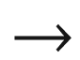

Science Fiction) **LXXV**(1) (March 1965 issue), pp. 8–13, 81 (1965) (Erroneously this article places Universität Leipzig into Poland.)

C. Kleint, Julius Edgar Lilienfeld: life and profession. Progr. Surf. Sci. **57**, 253–327 (1998). [10.​1016/​S0079-6816(98)80026-9](https://doi.org/10.1016/S0079-6816(98)80026-9)

J.E. Lilienfeld, *Method and Apparatus Controlling Electric Currents*, US patent 1,745, 175, filed 1926, awarded 1930

B.E. Crawford, *The Invention of the Transistor* (University of Vermont, Burlington, 1991). M.Sc. Thesis

J.E. Lilienfeld, *Device for Controlling Electric Current*, US patent 1,900,018, filed 1928, awarded 1933

J.E. Lilienfeld, *Amplifier for Electric Currents*, US patent 1,877,140, filed 1928, awarded 1932

W. Gosling, The pre-history of the transistor. Radio Electron. Eng. **43**, 10 (1973)

A. Schleede, H. Buggisch, Untersuchungen am Bleiglanz- und Pyritdetektor. Z. Anorg. Allg. Chemie **161**, 85–107 (1927). [10.​1002/​zaac.​19271610107](https://doi.org/10.1002/zaac.19271610107)

E. Körner: *Über die Darstellungsmethoden und die Lumineszenzfähigkeit reinsten Zinksulfids und Zinkoxydes*, Ph.D. Thesis, Universität Greifswald (1930)

A. Schleede, Über den strukturellen Bau der Leuchtzentren in den Zink- und Cadmium-Sulfid-Leuchtstoffen. Chem. Ber. **90**, 1162–1175 (1957). [10.​1002/​cber.​19570900642](https://doi.org/10.1002/cber.19570900642)

F. Bloch, Über die Quantenmechanik der Elektronen in Kristallgittern. Z. Phys. **52**, 555–560 (1928). [10.​1007/​BF01339455](https://doi.org/10.1007/BF01339455)

E.E. Loebner, Subhistories of the light emitting diode. IEEE Trans. Electron Dev. **23**, 675–699 (1976). [10.​1109/​T-ED.​1976.​18472](https://doi.org/10.1109/T-ED.1976.18472)

M.A. Nivikov, Oleg Vladimirovich Losev: Pioneer of semiconductor electronics. Fiz. Tverd. Tela **46**, 5–9 (2004) [Phys. Solid State **46**, 1–4 (2004)]. [10.​1134/​1.​1641908](https://doi.org/10.1134/1.1641908)

N. Zheludev, The life and times of the LED—a 100-year history. Nat. Photon. **1**, 189–192 (2007). [10.​1038/​nphoton.​2007.​34](https://doi.org/10.1038/nphoton.2007.34)

O.V. Lossev, Luminous carborundum detector and detection effect and oscillations with crystals. Philos. Mag. Series 7 **6**(39), 1024–1044 (1928). [10.​1080/​1478644110856468​3](https://doi.org/10.1080/14786441108564683)

R. Peierls, Zur Theorie der galvanomagnetischen Effekte. Zeitschr. f. Physik **53**, 255–266 (1929). [10.​1007/​BF01339727](https://doi.org/10.1007/BF01339727)

R.E. Peierls, Zur Theorie des Hall-Effekts. Phys. Zeitschrift **30**, 273–274 (1929)

M.J.O. Strutt, Zur Wellenmechanik des Atomgitters. Ann. Physik **391**, 319–324 (1928). [10.​1002/​andp.​19283911006](https://doi.org/10.1002/andp.19283911006)

R. Peierls, Zur Theorie der elektrischen und thermischen Leitfähigkeit von Metallen. Ann. Physik **396**, 121–148 (1930). [10.​1002/​andp.​19303960202](https://doi.org/10.1002/andp.19303960202)

W. Heisenberg, Zum Paulischen Ausschließungsprinzip. Ann. Physik **402**, 888–904 (1931). [10.​1002/​andp.​19314020710](https://doi.org/10.1002/andp.19314020710)

R. de L. Kronig, W.G. Penney, Quantum mechanics of electrons in crystal lattices. Proc. R. Soc. Lond. A **130**, 499–513 (1931). [10.​1098/​rspa.​1931.​0019](https://doi.org/10.1098/rspa.1931.0019)

A.H. Wilson, *Semi-Conductors and Metals, An Introduction to the Electron Theory of Metals* (Cambridge University Press, Cambridge, 1939)

R.W. Cahn, Silicon: child and progenitor of revolution, in *Into the Nano Era, Moore’s Law Beyond Planar Silicon CMOS*, ed. by H.R. Huff, pp. 3–10 (Springer, Berlin, 2009). [10.​1007/​978-3-540-74559-4\_​1](https://doi.org/10.1007/978-3-540-74559-4%255F1)

A.H. Wilson, The theory of electronic semi-conductors. Proc. R. Soc. Lond. A **133**, 458–491 (1931). [10.​1098/​rspa.​1931.​0162](https://doi.org/10.1098/rspa.1931.0162)

A.H. Wilson, The theory of electronic semi-conductors II. Proc. R. Soc. Lond. A **134**, 277–287 (1931). [10.​1098/​rspa.​1931.​0196](https://doi.org/10.1098/rspa.1931.0196)

Carl Wagner, Berichte der Bunsengesellschaft für Physikalische Chemie **95**, 936–949 (1991). [10.​1002/​bbpc.​19910950816](https://doi.org/10.1002/bbpc.19910950816)

C. Wagner, W. Schottky, Theorie der geordneten Mischphasen. Z. Phys. Chem. **11B**, 163–210 (1930)

C. Wagner, Theorie der geordneten Mischphasen II. Diffusionsvorgänge. Z. Phys. Chem. **1931A** (issue supplement), 177–186 (1931). [10.​1515/​zpch-1931-s120](https://doi.org/10.1515/zpch-1931-s120)

C. Wagner, Theorie der geordneten Mischphasen III. Fehlordnungserscheinungen in polaren Verbindungen als Grundlage für Ionen- und Elektronenleitung. Z. Phys. Chem. **22B**, 181–194 (1933). [10.​1515/​zpch-1933-2213](https://doi.org/10.1515/zpch-1933-2213)

H.H. v. Baumbach, C. Wagner, Die elektrische Leitfähigkeit von Zinkoxyd und Cadmiumoxyd. Z. Phys. Chem. **22B**, 199–211 (1933). [10.​1515/​zpch-1933-2215](https://doi.org/10.1515/zpch-1933-2215)

C. Zener, A theory of electrical breakdown of solid dielectrics. Proc. R. Soc. Lond. A **145**, 523–529 (1934). [10.​1098/​rspa.​1934.​0116](https://doi.org/10.1098/rspa.1934.0116)

J. Frenkel, On the absorption of light and the trapping of electrons and positive holes in crystalline dielectrics. Phys. Z. Sowjetunion **9**, 158–186 (1936)

B.I. Davydov, On the rectification of current at the boundary between two semiconductors. Dokl. Acad. Nauk SSSR (C.R. Acad. Sci. USSR) **20**, 279–282 (1938)

B.I. Davydov, On the theory of solid rectifiers. Dokl. Acad. Nauk SSSR (C.R. Acad. Sci. USSR) **20**, 283–285 (1938)

W. Schottky, Halbleitertheorie der Sperrschicht. Naturwissenschaften **26**, 843 (1938). [10.​1007/​BF01774216](https://doi.org/10.1007/BF01774216)

N.F. Mott, Note on the contact between a metal and an insulator or semiconductor. Proc. Camb. Philos. Soc. **34**, 568–572 (1938). [10.​1017/​S030500410002057​0](https://doi.org/10.1017/S0305004100020570)

N.F. Mott, The theory of crystal rectifiers. Proc. R. Soc. Lond. A **171**, 27–38 (1939). [10.​1098/​rspa.​1939.​0051](https://doi.org/10.1098/rspa.1939.0051)

R. Hilsch, R.W. Pohl, Steuerung von Elektronenströmen mit einem Dreielektrodenkristall und ein Modell einer Sperrschicht. Z. Phys. **111**, 399–408 (1938). [10.​1007/​BF01342357](https://doi.org/10.1007/BF01342357)

R.S. Ohl, *Light-Sensitive Electric Device*, US patent 2,402,662, filed 1941, awarded 1946

J.H. Scaff, The role of metallurgy in the technology of electronic materials. Metall. Mater. Trans. B **1**, 561–573 (1970). [10.​1007/​BF02811579](https://doi.org/10.1007/BF02811579)

M. Riordan, L. Hoddeson, The origins of the pn junction. IEEE Spectrum **34**(6), 46–51 (1997). [10.​1109/​6.​591664](https://doi.org/10.1109/6.591664)

R.S. Ohl, *Alternating Current Rectifier*, US patent 2,402,661, filed 1941, awarded 1946

J. Scaff, R.S. Ohl, The development of silicon crystal rectifiers for microwave radar receivers. Bell Syst. Tech. J. **26**, 1–30 (1947). [10.​1002/​j.​1538-7305.​1947.​tb01310.​x](https://doi.org/10.1002/j.1538-7305.1947.tb01310.x)

K. Clusius, E. Holz, H. Welker, *Elektrische Gleichrichteranordnung mit Germanium als Halbleiter und Verfahren zur Herstellung von Germanium für eine solche Gleichrichteranordnung*, German patent DBP 966 387, 21g, 11/02 (1942)

H. Welker, *Halbleiteranordnung zur kapazitiven Steuerung von Strömen in einem Halbleiterkristall*, German patent DBP 980 084, 21g, 11/02 (1945)

J. Bardeen, W.H. Brattain, *Three-electrode circuit element utilizing semiconductor materials*, US patent 2,524,035, filed 1948, awarded 1950

M. Riordan, L. Hoddeson, C. Herring, The invention of the transistor. Rev. Mod. Phys. **71**, S336–S345 (1999). [10.​1103/​RevModPhys.​71.​S336](https://doi.org/10.1103/RevModPhys.71.S336)

J. Bardeen, W.H. Brittain, Physical principles involved in transistor action. Phys. Rev. **75**, 1208–1225 (1949). [10.​1103/​PhysRev.​75.​1208](https://doi.org/10.1103/PhysRev.75.1208)

J. Bardeen, W.H. Brittain, The transistor, a semi-conductor triode. Phys. Rev. **74**, 230–231 (1948). [10.​1103/​PhysRev.​74.​230](https://doi.org/10.1103/PhysRev.74.230)

W.F. Brinkman, D.E. Haggan, W.W. Troutman, A history of the invention of the transistor and where it will lead us. IEEE J. Solid-State Circ. **32**, 1858–1865 (1997). [10.​1109/​4.​643644](https://doi.org/10.1109/4.643644)

W.B. Shockley, *Circuit Element Utilizing Semiconductor Material*, US patent 2,569,347, filed 1948, awarded 1951

N.A. Goryunova: *Grey Tin*, Ph.D. Thesis (in Russian), Leningrad State University (1951)

N.A. Goryunova: *The Chemistry of Diamond-Like Semiconductors* (Chapman and Hall, London, 1965) (translation of her book that was published 1963 in Leningrad)

H. Welker, *Verfahren zur Herstellung eines Halbleiterkristalls mit Zonen verschiedenen Leitungstyps bei A*

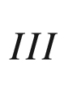

*-B*

$$_V$$

*-Verbindungen*, German patent DBP 976 709, 21g, 11/02 (1952)

H. Welker, *Verfahren zur Herstellung eines Halbleiterkristalls aus einer A*

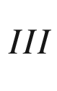

*-B*

$$_V$$

*-Verbindung mit Zonen verschiedenen Leitungstyps*, German patent DBP 976 791, 12c, 2 (1952)

H. Welker, *Semiconductor devices and methods of their manufacture*, US patent 2,798,989, filed 1952, awarded 1957

H. Welker, Über neue halbleitende Verbindungen. Z. Naturf. **7a**, 744–749 (1952). [10.​1515/​zna-1952-1110](https://doi.org/10.1515/zna-1952-1110)

W. Shockley, A unipolar “field-effect” transistor. Proc. IRE **40**, 1365–1376 (1952). [10.​1109/​JRPROC.​1952.​273964](https://doi.org/10.1109/JRPROC.1952.273964)

G.C. Dacey, I.M. Ross, Unipolar “field-effect” transistor. Proc. IRE **41**, 970–979 (1953). [10.​1109/​JRPROC.​1953.​274285](https://doi.org/10.1109/JRPROC.1953.274285)

D.M. Chapin, C.S. Fuller, G.L. Pearson, A new silicon p-n junction photocell for converting solar radiation into electrical power. J. Appl. Phys. **25**, 676–677 (1954). [10.​1063/​1.​1721711](https://doi.org/10.1063/1.1721711)

J.S. Kilby, *Miniaturized electronic circuits*, US patent 3,138,743, filed 1959, awarded 1964

R.N. Noyce, *Semiconductor device-and-lead structure*, US patent 2,981,877, filed 1959, awarded 1961

A.N. Saxena, *Invention of Integrated Circuits—Untold Important Facts* (World Scientific, Singapore, 2009). [10.​1142/​6850](https://doi.org/10.1142/6850)

G. Mortenson, D.O. Relin, *Three Cups of Tea: One Man’s Mission to Fight Terrorism and Build Nations*



*One School at a Time* (Viking Penguin, New York, 2006)

J.A. Hoerni, *Method of manufacturing semiconductor devices*, US patent 3,025,589, filed 1959, awarded 1962

J.A. Hoerni, *Semiconductor device*, US patent 3,064,167, filed 1959, awarded 1962

J.A. Hoerni, Planar silicon diodes and transistors, in *International Electron Devices Meeting* (Washington, D.C., 1960), p. 50. [10.​1109/​IEDM.​1960.​187178](https://doi.org/10.1109/IEDM.1960.187178)

J.A. Hoerni, Planar silicon diodes and transistors. IRE Trans. Electron Dev. **8**, 178 (1961). [10.​1109/​T-ED.​1961.​14755](https://doi.org/10.1109/T-ED.1961.14755)

M. Riordan, The silicon dioxide solution: How physicist Jean Hoerni built the bridge from the transistor to the integrated circuit. IEEE Spectrum **44**(12), 50–56 (2007). [10.​1109/​MSPEC.​2007.​4390023](https://doi.org/10.1109/MSPEC.2007.4390023)

Datasheet *2N1613, Silicon npn transistor*, Fairchild Semiconductor

D. Kahng, M.M. Atalla, Silicon-silicon dioxide field induced surface device, in *IRE Solid-State Device Research Conference* (Carnegie Institute of Technology, Pittsburgh, PA, 1960)

D. Kahng, *Electric field controlled semiconductor device*, US patent 3,102,230, filed 1960, awarded 1963

R.N. Hall, G.E. Fenner, J.D. Kingsley, T.J. Soltys, R.O. Carlson, Coherent light emission from GaAs junctions. Phys. Rev. Lett. **9**, 366–368 (1962). [10.​1103/​PhysRevLett.​9.​366](https://doi.org/10.1103/PhysRevLett.9.366)

R.N. Hall, *Stimulated Emission Semiconductor Devices*, US patent 3,245,002, filed 1962, awarded 1966

M.I. Nathan, W.P. Dumke, G. Burns, F.H. Dill Jr., G. Lasher, Stimulated emission of radiation from GaAs p-n junctions. Appl. Phys. Lett. **1**, 62–64 (1962). [10.​1063/​1.​1777371](https://doi.org/10.1063/1.1777371)

T.M. Quist, R.H. Rediker, R.J. Keyes, W.E. Krag, B. Lax, A.L. McWhorter, H.J. Zeigler, Semiconductor maser in GaAs. Appl. Phys. Lett. **1**, 91–92 (1962). [10.​1063/​1.​1753710](https://doi.org/10.1063/1.1753710)

N. Holonyak Jr., S.F. Bevacqua, Coherent (visible) light emission from Ga(As

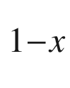

P

$$_x$$

) junctions. Appl. Phys. Lett. **1**, 82–83 (1962). [10.​1063/​1.​1753706](https://doi.org/10.1063/1.1753706)

Remembering the laser diode. Nat. Photon. **6**, 795 (2012). [10.​1038/​nphoton.​2012.​310](https://doi.org/10.1038/nphoton.2012.310)

J.J. Coleman, The development of the semiconductor laser diode after the first demonstration in 1962. Semicond. Sci. Technol. **27**, 090207:1–10 (2012). [10.​1088/​0268-1242/​27/​9/​090207](https://doi.org/10.1088/0268-1242/27/9/090207)

Zh.I. Alferov, R.F. Kasarinov, *Semiconductor laser with electric pumping*, Inventor’s Certificate No. 181737 (in Russian), Application No. 950840 (1963)

ZhI Alferov, Nobel Lecture: The double heterostructure concept and its applications in physics, electronics, and technology. Rev. Mod. Phys. **73**, 767–782 (2001). [10.​1103/​RevModPhys.​73.​767](https://doi.org/10.1103/RevModPhys.73.767)

H. Kroemer, A proposed class of heterojunction injection lasers. Proc. IEEE **51**, 1782–1783 (1963). [10.​1109/​PROC.​1963.​2706](https://doi.org/10.1109/PROC.1963.2706)

H. Kroemer, Nobel Lecture: Quasielectric fields and band offsets: teaching electrons new tricks. Rev. Mod. Phys. **73**, 783 (2001). [10.​1103/​RevModPhys.​73.​783](https://doi.org/10.1103/RevModPhys.73.783)

J.B. Gunn, Microwave oscillations of current in III-V semiconductors. Solid State Commun. **1**, 88–91 (1963). [10.​1016/​0038-1098(93)90262-L](https://doi.org/10.1016/0038-1098(93)90262-L)

C.A. Mead, Schottky barrier gate field effect transistor. Proc. IEEE **54**, 307–308 (1966). [10.​1109/​PROC.​1966.​4661](https://doi.org/10.1109/PROC.1966.4661)

Zh.I. Alferov, V.I. Korol’kov, V.I. Maslov, A.V. Lishina, M.K. Trukan, A.A. Yakovenko, Investigation of current-voltage characteristics of diffused p-n junctions in GaAs

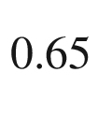

P

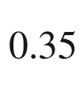

, Fizika i Tekn. Poluprovodn. **1**, 260–264 (1967) [Sov. Phys. Semicond. **1**, 206–209 (1967)]

Zh.I. Alferov, D.Z. Garbuzov, V.S. Grigor’ev, Yu.V. Zhilyaev, L.V. Kradinova, V.I. Korol’kov, E.P. Morozov, O.A. Ninua, E.L. Portnoy, V.D. Prochukhan, M.K. Trukan, Injection luminescence of epitaxial heterojunctions in the GaP–GaAs system. Fiz. Tverd. Tela **9**, 279–282 (1967) [Sov. Phys. Solid State **9**, 208–210 (1967)]

W.W. Hooper, W.I. Lehrer, An epitaxial GaAs field effect transistor. Proc. IEEE **55**, 1237–1238 (1967). [10.​1109/​PROC.​1967.​5817](https://doi.org/10.1109/PROC.1967.5817)

Zh.I. Alferov, V.M. Andreev, E.L. Portnoi, M.K. Trukan, AlAs–GaAs heterojunction injection lasers with a low room-temperature threshold. Fizika i. Tekn. Poluprovodn. **3**, 1328-1332 (1969) [Sov. Phys. Semicond. **3**, 1107–1110 (1970)]

I. Hayashi, Heterostructure lasers. IEEE Trans. Electron Dev. **31**, 1630–1642 (1984). [10.​1109/​T-ED.​1984.​21764](https://doi.org/10.1109/T-ED.1984.21764)

R.A. Logan, H.G. White, W. Wiegmann, Efficient green electroluminescence in nitrogen-doped GaP p-n junctions. Appl. Phys. Lett. **13**, 139–141 (1968). [10.​1063/​1.​1652543](https://doi.org/10.1063/1.1652543)

R.M. Potter, J.M. Blank, A. Addamiano, Silicon carbide light-emitting diodes. J. Appl. Phys. **40**, 2253–2257 (1969). [10.​1063/​1.​1657967](https://doi.org/10.1063/1.1657967)

W.S. Boyle, G.E. Smith, Charge coupled semiconductor devices. Bell Syst. Tech. J. **49**, 587–593 (1970). [10.​1002/​j.​1538-7305.​1970.​tb01790.​x](https://doi.org/10.1002/j.1538-7305.1970.tb01790.x)

G.F. Amelio, M.F. Tompsett, G.E. Smith, Experimental verification of the charge coupled device concept. Bell Syst. Tech. J. **49**, 593–600 (1970). [10.​1002/​j.​1538-7305.​1970.​tb01791.​x](https://doi.org/10.1002/j.1538-7305.1970.tb01791.x)

R.F. Kazarinov, R.A. Suris, Possibility of the Amplification of Electromagnetic Waves in a Semiconductor with a Superlattice. Fiz. Tekh. Poluprovodn. **5**, 797–800 (1971) [Sov. Phys. Semicond. **5**, 707–709 (1971)]

R.S. Pengelly, J.A. Turner, Monolithic broadband GaAs F.E.T. amplifiers. Electron. Lett. **12**, 251–252 (1976). [10.​1049/​el:​19760193](https://doi.org/10.1049/el:19760193)

S. Nakamura, *Crystal Growth Method for Gallium Nitride-Based Compound Semiconductor*, US patent 5,290,393, filed 1992, awarded 1994

S. Nakamura, M. Senoh, N. Iwasa, S. Nagahama, High-brightness InGaN blue, green and yellow light-emitting diodes with quantum-well structures. Jpn. J. Appl. Phys. **34**, L797–L799 (1995). [10.​1143/​JJAP.​34.​L797](https://doi.org/10.1143/JJAP.34.L797)

J. Faist, F. Capasso, D.L. Sivco, C. Sirtori, A.L. Hutchinson, A.Y. Cho, Quantum cascade laser. Science **264**, 553–556 (1994). [10.​1126/​science.​264.​5158.​553](https://doi.org/10.1126/science.264.5158.553)

N. Kirstaedter, N.N. Ledentsov, M. Grundmann, D. Bimberg, V.M. Ustinov, S.S. Ruvimov, M.V. Maximov, P.S. Kop’ev, ZhI Alferov, U. Richter, P. Werner, U. Gösele, J. Heydenreich, Low threshold, large T

$$_0$$

injection laser emission from (InGa)As quantum dots. Electron. Lett. **30**, 1416 (1994). [10.​1049/​el:​19940939](https://doi.org/10.1049/el:19940939)

K. Nomura, H. Ohta, A. Takagi, T. Kamiya, M. Hirano, H. Hosono, Room-temperature fabrication of transparent flexible thin-film transistors using amorphous oxide semiconductors. Nature **432**, 488–492 (2004). [10.​1038/​nature03090](https://doi.org/10.1038/nature03090)

A.J. Moses, Optical materials properties, in *Handbook of Electronic Materials*, vol. 1 (Plenum, New York, 1971). [10.​1007/​978-1-4684-6159-6](https://doi.org/10.1007/978-1-4684-6159-6)

M. Neuberger, III–V Semiconducting Compounds, in *Handbook of Electronic Materials*, vol. 2 (Plenum, New York, 1971). [10.​1007/​978-1-4615-9606-6](https://doi.org/10.1007/978-1-4615-9606-6)

J.T. Milek, Silicon nitride for microelectronic applications. Part 1 Preparation and properties, in *Handbook of Electronic Materials*, vol. 3 (Plenum, New York, 1971). [10.​1007/​978-1-4684-6162-6](https://doi.org/10.1007/978-1-4684-6162-6)

M. Neuberger, D.L. Grigsby, W.H. Veazie Jr., Niobium alloys and compounds, in *Handbook of Electronic Materials*, vol. 4 (Plenum, New York, 1972). [10.​1007/​978-1-4757-6001-9](https://doi.org/10.1007/978-1-4757-6001-9)

M. Neuberger, Group IV semiconducting materials, in *Handbook of Electronic Materials*, vol. 5 (Plenum, New York, 1972). [10.​1007/​978-1-4684-7917-1](https://doi.org/10.1007/978-1-4684-7917-1)

J.T. Milek, Silicon nitride for microelectronic applications. Part 2 Applications and devices, in *Handbook of Electronic Materials*, vol. 6 (Plenum, New York, 1972). [10.​1007/​978-1-4615-9609-7](https://doi.org/10.1007/978-1-4615-9609-7)

O. Madelung: *Semiconductors: Data Handbook*, 3rd edn. (Springer, Berlin, 2004). [10.​1007/​978-3-642-18865-7](https://doi.org/10.1007/978-3-642-18865-7)

W. Martienssen, Semiconductors, in *Springer Handbook of Condensed Matter and Materials Data*, eds. by W. Martienssen, H. Warlimont (Springer, Berlin, 2005), pp. 575–694. [10.​1007/​3-540-30437-1\_​9](https://doi.org/10.1007/3-540-30437-1%255F9)

S. Adachi, *Handbook on Physical Properties of Semiconductors*, vol. 1 (Group IV Elemental Semiconductors) (Kluwer, New York, 2004)

S. Adachi, *Handbook on Physical Properties of Semiconductors*, vol. 2 (III-V Compound Semiconductors) (Kluwer, New York, 2004)

S. Adachi: *Handbook on Physical Properties of Semiconductors*, vol. 3 (II–VI Compound Semiconductors) (Kluwer, New York, 2004). [10.​1007/​1-4020-7821-8](https://doi.org/10.1007/1-4020-7821-8)

S. Adachi: *Optical Constants of Crystalline and Amorphous Semiconductors. Numerical Data and Graphical Information* (Springer, New York, 1999). [10.​1007/​978-1-4615-5247-5](https://doi.org/10.1007/978-1-4615-5247-5)

Landolt-Börnstein: *Numerical Data and Functional Relationships in Science and Technology*, New Series, vol. 17, *Semiconductors*, eds. by O. Madelung, M. Schulz, H. Weiss (Springer, Berlin, 1982)

S. Adachi, *Properties of Group-IV, III-V and II-VI Semiconductors* (Wiley, Chichester, 2005). [10.​1002/​0470090340](https://doi.org/10.1002/0470090340)

S. Adachi, *Properties of Semiconductor Alloys: Group-IV, III-V and II-VI Semiconductors* (Wiley, Chichester, 2009). [10.​1002/​9780470744383](https://doi.org/10.1002/9780470744383)

M. Dayah, [www.​dayah.​com](http://www.dayah.com)

B. Bryson, *A Short History of Nearly Everything* (Doubleday, London, 2003)

J.C. Phillips, *Bonds and Bands in Semiconductors* (Academic Press. New York, 1973). [10.​1016/​B978-0-12-553350-8.​X5001-5](https://doi.org/10.1016/B978-0-12-553350-8.X5001-5)

J.C. Phillips, G. Lucovsky, *Bonds and Bands in Semiconductors*, 2nd edn. (Momentum Press, New York, 2009)

P. Evers, *Die wundersame Welt der Atomis: 10 Jahre in den Physikalischen Blättern* (Wiley-VCH, Weinheim, 2002)

M.T. Yin, M.L. Cohen, Microscopic theory of the phase transformation and lattice dynamics of Si. Phys. Rev. Lett. **45**, 1004–1007 (1980). [10.​1103/​PhysRevLett.​45.​1004](https://doi.org/10.1103/PhysRevLett.45.1004)

J. Bardeen, W. Shockley, Deformation potentials and mobilities in non-polar crystals. Phys. Rev. **80**, 72–80 (1950). [10.​1103/​PhysRev.​80.​72](https://doi.org/10.1103/PhysRev.80.72)

G.E. Kimball, The electronic structure of diamond. J. Chem. Phys. **3**, 560–564 (1935). [10.​1063/​1.​1749729](https://doi.org/10.1063/1.1749729)

N. Bernstein, M.J. Mehl, D.A. Papaconstantopoulos, N.I. Papanicolaou, M.Z. Bazant, E. Kaxiras, Energetic, vibrational, and electronic properties of silicon using a nonorthogonal tight-binding model. Phys. Rev. B **62**, 4477–4487 (2000). [10.​1103/​PhysRevB.​65.​249902](https://doi.org/10.1103/PhysRevB.65.249902) Erratum: Phys. Rev. B **65**, 249902 (2002). [10.​1103/​PhysRevB.​62.​4477](https://doi.org/10.1103/PhysRevB.62.4477)

R.M. Roberts, *Serendipity, Accidental Discoveries in Science* (Wiley, New York, 1989), pp. 75–81

Y. Liu, P. Kilby, T.J. Frankcombe, T.W. Schmidt, The electronic structure of benzene from a tiling of the correlated 126-dimensional wavefunction. Nat. Commun. **11**, 1210:1–5 (2020). [10.​1038/​s41467-020-15039-9](https://doi.org/10.1038/s41467-020-15039-9)

H.J.F. Jansen, A.J. Freeman, Structural properties and electron density of NaCl. Phys. Rev. B **33**, 8629–8631 (1986). [10.​1103/​PhysRevB.​33.​8629](https://doi.org/10.1103/PhysRevB.33.8629)

T. Soma, T. Umenai, Madelung energies of tetragonal and orthorhombic systems. Phys. Status Solidi B **78**, 229–240 (1976). [10.​1002/​pssb.​2220780122](https://doi.org/10.1002/pssb.2220780122)

J.A. Van Vechten, Quantum dielectric theory of electronegativity in covalent systems. I. electronic dielectric constant. Phys. Rev. **182**, 891–905 (1969). [10.​1103/​PhysRev.​182.​891](https://doi.org/10.1103/PhysRev.182.891)

J.C. Phillips, J.A. Van Vechten, Dielectric classification of crystal structures, ionization potentials, and band structures. Phys. Rev. Lett. **22**, 705–708 (1969). [10.​1103/​PhysRevLett.​22.​705](https://doi.org/10.1103/PhysRevLett.22.705)

C.R.A. Catlow, A.M. Stoneham, Ionicity in solids. J. Phys. C: Solid State Phys. **16**, 4321–4338 (1983). [10.​1088/​0022-3719/​16/​22/​010](https://doi.org/10.1088/0022-3719/16/22/010)

H.B. Callen, Electric breakdown in ionic solids. Phys. Rev. **76**, 1394–1402 (1949). [10.​1103/​PhysRev.​76.​1394](https://doi.org/10.1103/PhysRev.76.1394)

J.C. Phillips, J.A. Van Vechten, Charge redistribution and piezoelectric constants. Phys. Rev. Lett. **23**, 1115–1117 (1969). [10.​1103/​PhysRevLett.​23.​1115](https://doi.org/10.1103/PhysRevLett.23.1115)

S. Takeuchi, K. Suzuki, Stacking fault energies of tetrahedrally coordinated crystals. Phys. Status Solidi A **171**, 99–103 (1999). [10.​1002/​(SICI)1521-396X(199901)171:​1<99:​:​AID-PSSA99>3.​0.​CO;2-B](https://doi.org/10.1002/(SICI)1521-396X(199901)171:1%253C99::AID-PSSA99%253E3.0.CO%3B2-B)

J.-B. Romé de l’Isle, *Cristallographie, ou Description Des Formes Propre a Tous les Corps du Regne Minéral*, vol. 1, p. 91 (1783)

M.S. Dresselhaus, G. Dresselhaus, A. Jorio, *Group Theory, Application to the Physics of Condensed Matter* (Springer, Berlin, 2008). [10.​1007/​978-3-540-32899-5](https://doi.org/10.1007/978-3-540-32899-5)

M.A. Bravais, Mémoire sur les systèmes formés par des points distribués régulièrement sur un plan ou dans l’éspace. J. L’Ecole Polytechnique **19**, 1–128 (1850)

M.A. Bravais, *Études Cristallographiques* (Gauthier-Villars, Paris, 1866)

H.G.F. Winkler, Hundert Jahre Bravais Gitter. Die Naturwissenschaften **37**, 385–390 (1950). [10.​1007/​BF00738360](https://doi.org/10.1007/BF00738360)

D. Shechtman, I. Blech, D. Gratias, J.W. Cahn, Metallic phase with long-range orientational order and no translational symmetry. Phys. Rev. Lett. **53**, 1951–1953 (1984). [10.​1103/​PhysRevLett.​53.​1951](https://doi.org/10.1103/PhysRevLett.53.1951)

I.R. Fisher, K.O. Cheon, A.F. Panchula, P.C. Canfield, M. Chernikov, H.R. Ott, K. Dennis, Magnetic and transport properties of single-grain R-Mg-Zn icosahedral quasicrystals [R=Y, (Y

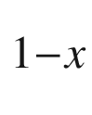

Gd

$$_x$$

), (Y

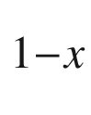

Tb

$$_x$$

), Tb, Dy, Ho, and Er]. Phys. Rev. B **59**, 308–321 (1999). [10.​1103/​PhysRevB.​59.​308](https://doi.org/10.1103/PhysRevB.59.308)

K. Kimura, A. Hori, M. Takeda, H. Yamashita, H. Ino, Possibility of semiconducting quasicrystal in boron-rich solids. J. Non-Cryst. Solids **153&154**, 398–402 (1993). [10.​1016/​0022-3093(93)90382-8](https://doi.org/10.1016/0022-3093(93)90382-8)

K. Kirihara, K. Kimura, Covalency, semiconductor-like and thermoelectric properties of Al-based quasicrystals: icosahedral cluster solids. Sci. Technol. Adv. Mat. **1**, 227–236 (2000). [10.​1016/​S1468-6996(00)00021-8](https://doi.org/10.1016/S1468-6996(00)00021-8)

G. Burns, A.M. Glazer: *Space Groups for Solid State Scientists*, 3rd edn. (Academic Press, San Diego, 2013). [10.​1016/​C2011-0-05712-5](https://doi.org/10.1016/C2011-0-05712-5)

R.E. Proano, D.G. Ast, Effects of the presence/absence of HCl during gate oxidation on the electrical and structural properties of polycrystalline silicon thin film transistors. J. Appl. Phys. **66**, 2189–2199 (1989). [10.​1063/​1.​344317](https://doi.org/10.1063/1.344317)

A.H. Clark, Electrical and optical properties of amorphous germanium. Phys. Rev. **154**, 750–757 (1967). [10.​1103/​PhysRev.​154.​750](https://doi.org/10.1103/PhysRev.154.750)

R.C. Chittick, J.H. Alexander, H.F. Sterling, The preparation and properties of amorphous silicon. J. Electrochem. Soc. **116**, 77–81 (1969). [10.​1149/​1.​2411779](https://doi.org/10.1149/1.2411779)

E.P. Denton, H. Rawson, J.E. Stanworth, Vanadate glasses. Nature **173**, 1030–1032 (1954). [10.​1038/​1731030b0](https://doi.org/10.1038/1731030b0)

H. Hosono, Ionic amorphous oxide semiconductors: Material design, carrier transport, and device application. J. Non-Cryst. Solids **352**, 851–858 (2006). [10.​1016/​j.​jnoncrysol.​2006.​01.​073](https://doi.org/10.1016/j.jnoncrysol.2006.01.073)

C.S. Schnohr, M.C. Ridgway, eds., *X-Ray Absorption Spectroscopy of Semiconductors* (Springer, Heidelberg, 2015). [10.​1007/​978-3-662-44362-0](https://doi.org/10.1007/978-3-662-44362-0)

D.E. Sayers, F.W. Lytle, E.A. Stern, Structure determination of amorphous Ge, GeO

$$_2$$

and GeSe by Fourier analysis of extended X-ray absorption fine structure (EXAFS). J. Non-Cryst. Solids **8–10**, 401–447 (1972). [10.​1016/​0022-3093(72)90167-6](https://doi.org/10.1016/0022-3093(72)90167-6)

M.H. Brodsky, ed., *Amorphous Semiconductors*, Topics in Applied Physics 36 (Springer, Berlin, 1979). [10.​1007/​3-540-16008-6](https://doi.org/10.1007/3-540-16008-6)

B. Kramer, Electronic structure and optical properties of amorphous semiconductors. Adv. Solid State Phys. (Festkörperprobleme) **12**, 133–182 (1972). [10.​1007/​BFb0107701](https://doi.org/10.1007/BFb0107701)

R. Hull, ed., *Properties of Crystalline Silicon* (IET, London, 1999)

A.J. Haq, P.R. Munroe, Phase transformations in (111) Si after spherical indentation. J. Mater. Res. **24**, 1967–1975 (2009). [10.​1557/​jmr.​2009.​0249](https://doi.org/10.1557/jmr.2009.0249)

G.A. Busch, R. Kern, Semiconducting properties of gray tin. Solid State Phys. **11**, 1–40 (1960). [10.​1016/​S0081-1947(08)60166-6](https://doi.org/10.1016/S0081-1947(08)60166-6)

J.R. Chelikowski, Chemical trends in the structural stability of binary crystals. Phys. Rev. B **34**, 5295–5304 (1986). [10.​1103/​PhysRevB.​34.​5295](https://doi.org/10.1103/PhysRevB.34.5295)

J.M. Besson, J.P. Itié, A. Polian, G. Weill, J.L. Mansot, J. Gonzalez, High-pressure phase transition and phase diagram of gallium arsenide. Phys. Rev. B **44**, 4214–4234 (1991). [10.​1103/​PhysRevB.​44.​4214](https://doi.org/10.1103/PhysRevB.44.4214)

P. Lawaetz, Stability of the wurtzite structure. Phys. Rev. B **5**, 4039–4045 (1972). [10.​1103/​PhysRevB.​5.​4039](https://doi.org/10.1103/PhysRevB.5.4039)

R.F. Davis, M.S. Shur, *GaN-based Materials And Devices: Growth, Fabrication, Characterization and Performance* (World Scientific, Singapore, 2004). [10.​1142/​5539](https://doi.org/10.1142/5539)

C. Jagadish, S.J. Pearton, eds., *Zinc Oxide Bulk, Thin Films and Nanostructures: Processing, Properties and Applications* (Elsevier, Amsterdam, 2006). [10.​1016/​B978-0-08-044722-3.​X5000-3](https://doi.org/10.1016/B978-0-08-044722-3.X5000-3)

M. Shur, S. Rumyantsev, M. Levinshtein, eds., *SiC Materials And Devices*, vol. 1 (World Scientific, Singapore, 2006). [10.​1142/​S012915640500339​9](https://doi.org/10.1142/S0129156405003399) also: Int. J. High Speed Electronics and Systems **15**(4), 705–1033 (2005)]; M. Shur, S. Rumyantsev, M. Levinshtein, eds., *SiC Materials And Devices*, vol. 2 (World Scientific, Singapore, 2007). [10.​1142/​S012915640600400​4](https://doi.org/10.1142/S0129156406004004) also: Int. J. High Speed Electronics and Systems **16**(3), 751–881 (2006)] [10.​1142/​6134](https://doi.org/10.1142/6134), [10.​1142/​6311](https://doi.org/10.1142/6311)

S. Siebentritt, U. Rau, eds., *Wide-Gap Chalcopyrites* (Springer, Berlin, 2006). [10.​1007/​b105644](https://doi.org/10.1007/b105644)

J.L. Shay, J.H. Wernick, *Ternary Chalcopyrites* (Pergamon, Oxford, 1975)

A. Zunger, Order-disorder transformation in ternary tetrahedral semiconductors. Appl. Phys. Lett. **50**, 164–166 (1987). [10.​1063/​1.​97649](https://doi.org/10.1063/1.97649)

J.E. Jaffe, A. Zunger, Theory of the band-gap anomaly in ABC

$$_2$$

chalcopyrite semiconductors. Phys. Rev. B **29**, 1882–1906 (1984). [10.​1103/​PhysRevB.​29.​1882](https://doi.org/10.1103/PhysRevB.29.1882)

H.F. Liu, A.S.W. Wong, G.X. Hu, H. Gong, Observation of interfacial reactions and recrystallization of extrinsic phases in epitaxial grown ZnO/GaAs heterostructures. J. Cryst. Growth **310**, 4305–4308 (2008). [10.​1016/​j.​jcrysgro.​2008.​07.​062](https://doi.org/10.1016/j.jcrysgro.2008.07.062)

K.-W. Park, Y.-H. Yun, S.-C. Choi, Photoluminescence characteristics of ZnGa

$$_2$$

O

$$_4$$

thin films prepared by chemical solution method. Solid State Ionics **177**, 1875–1878 (2006). [10.​1016/​j.​ssi.​2006.​05.​049](https://doi.org/10.1016/j.ssi.2006.05.049)

T. Maitra, R. Valentí, Ferromagnetism in the Fe-substituted spinel semiconductor ZnGa

$$_2$$

O

$$_4$$

, J. Phys.: Cond. Matter **17**, 7417–7431 (2005). [10.​1088/​0953-8984/​17/​46/​025](https://doi.org/10.1088/0953-8984/17/46/025)

K.E. Sickafus, J.M. Wills, N.W. Grimes, Structure of Spinel. J. Am. Ceram. Soc. **82**, 3279–3292 (1999). [10.​1111/​j.​1151-2916.​1999.​tb02241.​x](https://doi.org/10.1111/j.1151-2916.1999.tb02241.x)

H.St.C. O’Neill, A. Navrotsky, Simple spinels: crystallographic parameters, cation radii, lattice energies, and cation distribution. Am. Mineralogist. **68**, 181–194 (1983)

J.E. Jaffe, R.A. Bachorz, M. Gutowski, Low-temperature polymorphs of ZrO

$$_2$$

and HfO

$$_2$$

: A density-functional theory study. Phys. Rev. B **72**, 144107:1–9 (2005). [10.​1103/​PhysRevB.​72.​144107](https://doi.org/10.1103/PhysRevB.72.144107)

P. Duwez, F.H. Brown Jr., F. Odell, The Zirconia-Yttria System. J. Electrochem. Soc. **98**, 356–362 (1951). [10.​1149/​1.​2778219](https://doi.org/10.1149/1.2778219)

R. Ruh, K.S. Mazdiyasni, P.G. Valentine, H.O. Bielstein, Phase relations in the system

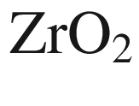

–

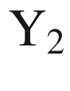

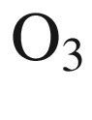

at low

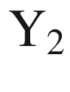

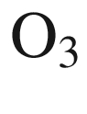

contents. J. Am. Ceram. Soc. **67**, C-190–C-192 (1984). [10.​1111/​j.​1151-2916.​1984.​tb19618.​x](https://doi.org/10.1111/j.1151-2916.1984.tb19618.x)

X. Nie, S.-H. Wei, S.B. Zhang, Bipolar doping and band-gap anomalies in delafossite transparent conductive oxides. Phys. Rev. Lett. **88**, 066405, 1–4 (2002). [10.​1103/​PhysRevLett.​88.​066405](https://doi.org/10.1103/PhysRevLett.88.066405)

C.Y. Yang, Z.R. Huang, W.H. Yang, Y.Q. Zhou, K.K. Fung, Crystallographic study of lanthanum aluminate by convergent-beam electron diffraction. Acta Cryst. A **47**, 703–706 (1991). [10.​1107/​S010876739100560​3](https://doi.org/10.1107/S0108767391005603)

M.M. Lee, J. Teuscher, T. Miyasaka, T.N. Murakami, H.J. Snaith, Efficient hybrid solar cells based on meso-superstructured organometal halide perovskites. Science **338**, 643–647 (2012). [10.​1126/​science.​1228604](https://doi.org/10.1126/science.1228604)

A. Fakharuddin, U. Shabbir, W. Qiu, T. Iqbal, M. Sultan, P. Heremans, L. Schmidt-Mende, Inorganic and layered perovskites for optoelectronic devices. Adv. Mater. **31**, 1807095:1–39 (2019). [10.​1002/​adma.​201807095](https://doi.org/10.1002/adma.201807095)

J. Deng, J. Li, Z. Yang, M. Wang, All-inorganic lead halide perovskites: a promising choice for photovoltaics and detectors. J. Mater. Chem. C **7**, 12415–12440 (2019). [10.​1039/​c9tc04164h](https://doi.org/10.1039/c9tc04164h)

Q. Sun, W.-J. Yin, Thermodynamic stability trend of cubic perovskites. J. Am. Chem. Soc. **139**, 14905–14908 (2017). [10.​1021/​jacs.​7b09379](https://doi.org/10.1021/jacs.7b09379)

B. Parida, S. Yoon, S.M. Jeong, J.S. Cho, J.-K. Kim, D.-W. Kang, Recent progress on cesium lead/tin halide-based inorganic perovskites for stable and efficient solar cells: A review. Solar Energy Mater. Solar Cells **204**, 110212:1–29 (2020). [10.​1016/​j.​solmat.​2019.​110212](https://doi.org/10.1016/j.solmat.2019.110212)

A. Guivarc’h, R. Guérin, J. Caulet, A. Poudoulec, J. Fontanille, Metallurgical study of Ni/GaAs contacts. II. Interfacial reactions of Ni thin films on (111) and (001) GaAs. J. Appl. Phys. **66**, 2129–2136 (1989). [10.​1063/​1.​344308](https://doi.org/10.1063/1.344308)

S. Yoshioka, H. Hayashi, A. Kuwabara, F. Oba, K. Matsunaga, I. Tanaka, Structures and energetics of Ga

$$_2$$

O

$$_3$$

polymorphs. J. Phys.: Cond. Matter **19**, 346211:1–11 (2007). [10.​1088/​0953-8984/​19/​34/​346211](https://doi.org/10.1088/0953-8984/19/34/346211)

M. Higashiwaki, S. Fujita, eds., *Gallium Oxide. Materials Properties, Crystal Growth, and Devices* (Springer, Cham, 2020). [10.​1007/​978-3-030-37153-1](https://doi.org/10.1007/978-3-030-37153-1)

E.S. Dana, W.E. Ford, *A Textbook of Mineralogy with an Extended Treatise on Crystallography and Physical Mineralogy*, 3rd edn. (Wiley, New York, 1922)

W. Borchardt-Ott: *Kristallographie: Eine Einführung für Naturwissenschaftler*, 8th edn. (Springer, Berlin, 2013). [10.​1007/​978-3-662-22076-4](https://doi.org/10.1007/978-3-662-22076-4)

W. Borchardt-Ott, R.O. Gould: *Crystallography*, 3rd edn. (Springer, Berlin, 2012). [10.​1007/​978-3-642-16452-1](https://doi.org/10.1007/978-3-642-16452-1)

*International Tables for Crystallography, Volume A: Space-Group Symmetry*, 5th edn., Th. Hahn, ed., (Springer, Dordrecht, 2002).

10.​1107/​9780955360206000​0100

Naval Research Laboratory

Thomas Höche, private communication (2008)

Y. Lifshitz, X.F. Duan, N.G. Shang, Q. Li, L. Wan, I. Bello, S.T. Lee, Epitaxial diamond polytypes on silicon. Nature **412**, 404 (2001). [10.​1038/​35086656](https://doi.org/10.1038/35086656)

M.J. Kozielski, Polytype single crystals of Zn

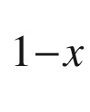

Cd

$$_x$$

S and ZnS

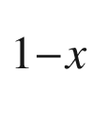

Se

$$_x$$

solid solutions grown from the melt under high argon pressure by Bridgman’s method. J. Cryst. Growth **30**, 86–92 (1975). [10.​1016/​0022-0248(75)90203-1](https://doi.org/10.1016/0022-0248(75)90203-1)

S.J. Pearton, J. Yang, P.H. Cary, F. Ren, J. Kim, M.J. Tadjer, M.A. Mastro, A review of Ga

$$_2$$

O

$$_3$$

materials, processing, and devices. Appl. Phys. Rev. **5**, 011301:1–56 (2018). [10.​1063/​1.​5006941](https://doi.org/10.1063/1.5006941)

P.F. Fewster, *X-Ray Scattering from Semiconductors* (Imperial College Press. London (2003). [10.​1142/​p289](https://doi.org/10.1142/p289)

W.H. Miller, *Treatise on Crystallography* (Deighton, Cambridge, 1839)

J.F. Zheng, J.D. Walker, M.B. Salmeron, E.R. Weber, Interface segregation and clustering in strained-layer InGaAs/GaAs heterostructures studied by cross-section scanning tunneling microscopy. Phys. Rev. Lett. **72**, 2414–2417 (1994). [10.​1103/​PhysRevLett.​72.​2414](https://doi.org/10.1103/PhysRevLett.72.2414)

K.-J. Chao, Ch-K Shih, D.W. Gotthold, B.G. Streeman, Determination of 2D pair correlations and pair interaction energies of in atoms in molecular beam epitaxially grown InGaAs alloys. Phys. Rev. Lett. **79**, 4822–4825 (1997). [10.​1103/​PhysRevLett.​79.​4822](https://doi.org/10.1103/PhysRevLett.79.4822)

C. Bundesmann, M. Schubert, D. Spemann, A. Rahm, H. Hochmuth, M. Lorenz, M. Grundmann, Infrared dielectric function and phonon modes of Mg-rich cubic Mg

$$_x$$

Zn

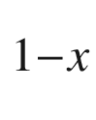

O (

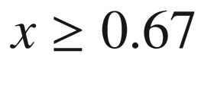

) thin films on sapphire (0001). Appl. Phys. Lett. **85**, 905–907 (2004). [10.​1063/​1.​1777797](https://doi.org/10.1063/1.1777797)

M.M. Kreitman, D.L. Barnett, Probability tables for clusters of foreign atoms in simple lattices assuming next-nearest-neighbor interactions. J. Chem. Phys. **43**, 364–371 (1965). [10.​1063/​1.​1696753](https://doi.org/10.1063/1.1696753)

O. Okada, Magnetic Susceptibilities of Mg

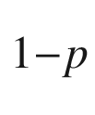

Mn

$$_p$$

Te

$$_2$$

. J. Phys. Soc. Jpn. **48**, 391–398 (1980). [10.​1143/​JPSJ.​48.​391](https://doi.org/10.1143/JPSJ.48.391)

S.-H. Wei, L.G. Ferreira, A. Zunger, First-principles calculation of temperature-composition phase diagrams of semiconductor alloys. Phys. Rev. B **41**, 8240–8269 (1990). [10.​1103/​PhysRevB.​41.​8240](https://doi.org/10.1103/PhysRevB.41.8240)

I.-H. Ho, G.B. Stringfellow, Solid phase immiscibility in GaInN. Appl. Phys. Lett. **69**, 2701–2703 (1996). [10.​1063/​1.​117683](https://doi.org/10.1063/1.117683)

I.V. Maznichenko, A. Ernst, M. Bouhassoune, J. Henk, M. Däne, M. Lüders, P. Bruno, W. Hergert, I. Mertig, Z. Szotek, W.M. Temmerman, Structural phase transitions and fundamental band gaps of Mg

$$_x$$

Zn

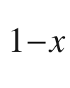

O alloys from first principles. Phys. Rev. B **80**, 144101:1–11 (2009). [10.​1103/​PhysRevB.​80.​144101](https://doi.org/10.1103/PhysRevB.80.144101)

J.C. Mikkelsen Jr., J.B. Boyce, Atomic-scale structure of random solid solutions: extended X-ray absorption fine-structure study of Ga

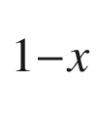

In

$$_x$$

As. Phys. Rev. Lett. **49**, 1412–1415 (1982). [10.​1103/​PhysRevLett.​49.​1412](https://doi.org/10.1103/PhysRevLett.49.1412)

J.C. Mikkelsen Jr., J.B. Boyce, Extended x-ray absorption fine-structure study of Ga

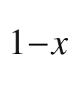

In

$$_x$$

As random solid solutions. Phys. Rev. B **28**, 7130–7140 (1983). [10.​1103/​PhysRevB.​28.​7130](https://doi.org/10.1103/PhysRevB.28.7130)

O. Ambacher, M. Eickhoff, A. Link, M. Hermann, M. Stutzmann, F. Bernardini, V. Fiorentini, Y. Smorchkova, J. Speck, U. Mishra, W. Schaff, V. Tilak, L.F. Eastman, Electronics and sensors based on pyroelectric AlGaN/GaN heterostructures, Part A: Polarization and pyroelectronics. Phys. Status Solidi C **0**, 1878–1907 (2003). [10.​1002/​pssc.​200303138](https://doi.org/10.1002/pssc.200303138)

A. Zunger, S. Mahajan, *Atomic Ordering and Phase Separation in III-V Alloys, Handbook on Semiconductors*, vol. 3 (Elsevier, Amsterdam, 1994), pp. 1399–1513

H.S. Lee, J.Y. Lee, T.W. Kim, D.U. Lee, D.C. Choo, H.L. Park, Coexistence behavior of the CuPt

$$_{\rm B}$$

-type and the CuAu-I-type ordered structures in highly strained Cd

$$_x$$

Zn

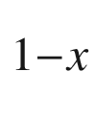

Te/GaAs heterostructures. Appl. Phys. Lett. **79**, 1637–1639 (2001). [10.​1063/​1.​1398617](https://doi.org/10.1063/1.1398617)

C.J. Humphreys, STEM imaging of crystals and defects, in *Introduction to Analytical Electron Microscopy*, eds. by J.J. Hren, J.I. Goldstein, D.C. Joy (Springer, New York, 1979). [10.​1007/​978-1-4757-5581-7](https://doi.org/10.1007/978-1-4757-5581-7)

C. Domke, Ph Ebert, M. Heinrich, K. Urban, Direct determination of the interaction between vacancies on InP(110) surfaces. Phys. Rev. B **54**, 10288–10291 (1996). [10.​1103/​PhysRevLett.​76.​2089](https://doi.org/10.1103/PhysRevLett.76.2089)

Ph Ebert, X. Chen, M. Heinrich, M. Simon, K. Urban, M.G. Lagally, Direct determination of the interaction between vacancies on InP(110) surfaces. Phys. Rev. Lett. **76**, 2089–2092 (1996). [10.​1103/​PhysRevLett.​76.​2089](https://doi.org/10.1103/PhysRevLett.76.2089)

R.M. Feenstra, J.M. Woodall, G.D. Pettit, Observation of bulk defects by scanning tunneling microscopy and spectroscopy: arsenic antisite defects in GaAs. Phys. Rev. Lett. **71**, 1176–1179 (1993). [10.​1103/​PhysRevLett.​71.​1176](https://doi.org/10.1103/PhysRevLett.71.1176)

R.B. Capaz, K. Cho, J.D. Joannopoulos, Signatures of bulk and surface arsenic antisite defects in GaAs(110). Phys. Rev. Lett. **75**, 1811–1814 (1995). [10.​1103/​PhysRevLett.​75.​1811](https://doi.org/10.1103/PhysRevLett.75.1811)

R. Jones, A. Carvalho, J.P. Goss, P.R. Briddon, The self-interstitial in silicon and germanium. Mater. Sci. Eng. B **159**, 112–116 (2008). [10.​1016/​j.​mseb.​2008.​09.​013](https://doi.org/10.1016/j.mseb.2008.09.013)

S.J. Clark, *Complex structure in tetrahedral semiconductors*, Ph.D. Thesis, University of Edinburgh (1994)

M. Lannoo, J. Bourgoin, *Point Defects in Semiconductors I* (Springer, Berlin, 1981). [10.​1007/​978-3-642-81574-4](https://doi.org/10.1007/978-3-642-81574-4)

H. Bracht, N.A. Stolwijk, H. Mehrer, Properties of intrinsic point defects in silicon determined by zinc diffusion experiments under nonequilibrium conditions. Phys. Rev. B **52**, 16542–16560 (1995). [10.​1103/​PhysRevB.​52.​16542](https://doi.org/10.1103/PhysRevB.52.16542)

V. Ranki, K. Saarinen, Formation of thermal vacancies in highly As and P doped Si. Phys. Rev. Lett. **93**, 255502:1–4 (2004). [10.​1103/​PhysRevLett.​93.​255502](https://doi.org/10.1103/PhysRevLett.93.255502)

J. Gebauer, M. Lausmann, F. Redmann, R. Krause-Rehberg, H.S. Leipner, E.R. Weber, Ph. Ebert, Determination of the Gibbs free energy of formation of Ga vacancies in GaAs by positron annihilation. Phys. Rev. B **67**, 235207:1–8 (2003). [10.​1103/​PhysRevB.​67.​235207](https://doi.org/10.1103/PhysRevB.67.235207)

F. Morehead, N. Stolwijk, W. Meyberg, U. Gösele, Self-interstitial and vacancy contributions to silicon self-diffusion determined from the diffusion of gold in silicon. Appl. Phys. Lett. **42**, 690–692 (1983). [10.​1063/​1.​94074](https://doi.org/10.1063/1.94074)

S. Dannefaer, P. Mascher, D. Kerr, Monovacancy formation enthalpy in silicon. Phys. Rev. Lett. **56**, 2195–2198 (1986). [10.​1103/​PhysRevLett.​56.​2195](https://doi.org/10.1103/PhysRevLett.56.2195)

P.M. Fahey, P.B. Griffin, J.D. Plummer, Point defects and dopant diffusion in silicon. Rev. Mod. Phys. **61**, 289–384 (1989). [10.​1103/​RevModPhys.​61.​289](https://doi.org/10.1103/RevModPhys.61.289)

P. Pichler, *Intrinsic Point Defects, Impurities, and Their Diffusion in Silicon* (Springer, Berlin, 2004). [10.​1007/​978-3-7091-0597-9](https://doi.org/10.1007/978-3-7091-0597-9)

G.D. Watkins, The vacancy in silicon: Identical diffusion properties at cryogenic and elevated temperatures. J. Appl. Phys. **103**, 106106:1–2 (2008). [10.​1063/​1.​2937198](https://doi.org/10.1063/1.2937198)

Y. Shimizu, M. Uematsu, K.M. Itoh, Experimental evidence of the vacancy-mediated silicon self-diffusion in single-crystalline silicon. Phys. Rev. Lett. **98**, 095901:1–4 (2007). [10.​1103/​PhysRevLett.​98.​095901](https://doi.org/10.1103/PhysRevLett.98.095901)

C.S. Nichols, C.G. Van der Walle, S.T. Pantelides, Mechanisms of dopant impurity diffusion in silicon. Phys. Rev. B **40**, 5484–5496 (1989). [10.​1103/​PhysRevB.​40.​5484](https://doi.org/10.1103/PhysRevB.40.5484)

A. Ural, P.B. Griffin, J.D. Plummer, Fractional contributions of microscopic diffusion mechanisms for common dopants and self-diffusion in silicon. J. Appl. Phys. **85**, 6440–6446 (1999). [10.​1063/​1.​370285](https://doi.org/10.1063/1.370285)

J.-W. Jeong, A. Oshiyama, Atomic and electronic structures of a boron impurity and its diffusion pathways in crystalline Si. Phys. Rev. B **64**, 235204:1–9 (2001). [10.​1103/​PhysRevB.​64.​235204](https://doi.org/10.1103/PhysRevB.64.235204)

W. Windl, Concentration dependence of self-interstitial and boron diffusion in silicon. Appl. Phys. Lett. **92**, 202104:1–3 (2008). [10.​1063/​1.​2936081](https://doi.org/10.1063/1.2936081)

K.-S. Yoon, C.-O. Wang, J.-H. Yoo, T. Won, First-principles investigation of indium diffusion in a silicon substrate. J. Korean Phys. Soc. **48**, 535–539 (2006)

X.-Y. Liu, W. Windl, K.M. Beardmore, M.P. Masquelier, First-principles study of phosphorus diffusion in silicon: Interstitial- and vacancy-mediated diffusion mechanisms. Appl. Phys. Lett. **82**, 1839–1841 (2003). [10.​1063/​1.​1562342](https://doi.org/10.1063/1.1562342)

L. Rayleigh, On the distillation of binary mixtures. Philos. Mag. **4**, 521–537 (1902). [10.​1080/​1478644020946287​6](https://doi.org/10.1080/14786440209462876)

C.H. Li, Normal freezing of ideal ternary liquid solutions of the pseudobinary type. J. Phys. D: Appl. Phys. **7**, 2003–2008 (1974). [10.​1088/​0022-3727/​7/​14/​319](https://doi.org/10.1088/0022-3727/7/14/319)

W. Zulehner, The growth of highly pure silicon crystals. Metrologia **31**, 255–261 (1994). [10.​1088/​0026-1394/​31/​3/​012](https://doi.org/10.1088/0026-1394/31/3/012)

I. Yonenaga, T. Ayuzawa, Segregation coefficients of various dopants in Si

$$_x$$

Ge

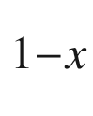

(0.93

$$&lt;$$

x

$$&lt;$$

 0.96) single crystals. J. Cryst. Growth **297**, 14–19 (2006). [10.​1016/​j.​jcrysgro.​2006.​08.​044](https://doi.org/10.1016/j.jcrysgro.2006.08.044)

W.C. O’Mara, R.B. Herring, L.P. Hunt, eds., *Handbook of Semiconductor Silicon Technology* (Noyes, Berkshire, 1990)

J.J. Dowd, R.L. Rouse, Distribution coefficient of indium in germanium on crystallization. Proc. Phys. Soc. B **66**, 60–61 (1953). [10.​1088/​0370-1301/​66/​1/​110](https://doi.org/10.1088/0370-1301/66/1/110)

W.W. Tyler, R. Newman, H.H. Woodbury, Properties of germanium doped with nickel. Phys. Rev. **98**, 461–465 (1955). [10.​1103/​PhysRev.​98.​461](https://doi.org/10.1103/PhysRev.98.461)

W.C. Dunlap Jr., Gold as acceptor in germanium. Phys. Rev. **97**, 614–629 (1955). [10.​1103/​PhysRev.​97.​614](https://doi.org/10.1103/PhysRev.97.614)

W.G. Pfann, Techniques of zone melting and crystal growing. Solid State Phys. **4**, 423–521 (1957). [10.​1016/​S0081-1947(08)60158-7](https://doi.org/10.1016/S0081-1947(08)60158-7)

M. Nastasi, J.W. Mayer, *Ion Implantation and Synthesis of Materials* (Springer, Berlin, 2006). [10.​1007/​978-3-540-45298-0](https://doi.org/10.1007/978-3-540-45298-0)

A. Benninghoven, F.G. Rudenauer, H.W. Werner, eds., *Secondary Ion Mass Spectrometry* (Wiley, New York, 1987)

P. van der Heide, *Secondary Ion Mass Spectrometry: An Introduction to Principles and Practices* (Wiley, New York, 2014)

S. Uppal, A.F.W. Willoughby, J.M. Bonar, A.G.R. Evans, N.E.B. Cowern, R. Morris, M.G. Dowsett, Diffusion of ion-implanted boron in germanium. J. Appl. Phys. **90**, 4293–4295 (2001). [10.​1063/​1.​1402664](https://doi.org/10.1063/1.1402664)

R.F. Lever, K.W. Brannon, A low energy limit to boron channeling in silicon. J. Appl. Phys. **69**, 6369–6372 (1991). [10.​1063/​1.​348838](https://doi.org/10.1063/1.348838)

[www.​srim.​org](http://www.srim.org)

J.F. Ziegler, M.D. Ziegler, J.P. Biersack, SRIM—the stopping and range of ions in matter. Nucl. Instrum. Meth. B **218**, 1818–1823 (2010). [10.​1016/​j.​nimb.​2010.​02.​091](https://doi.org/10.1016/j.nimb.2010.02.091)

K. Kimura, Y. Oota, K. Nakajima, T.H. Büyüklimanli, High-resolution depth profiling of ultrashallow boron implants in silicon using high-resolution RBS. Current Appl. Phys. **3**, 9–11 (2003). [10.​1016/​S1567-1739(02)00227-4](https://doi.org/10.1016/S1567-1739(02)00227-4)

R. Wittmann, *Miniaturization Problems in CMOS Technology: Investigation of Doping Profiles and Reliability*, Ph.D. Thesis, Technische Universität Wien (2007)

J. Yokota, Lattice distorsion around charged impurities in semiconductors. J. Phys. Soc. Jpn. **19**, 1487 (1964). [10.​1143/​JPSJ.​19.​1487](https://doi.org/10.1143/JPSJ.19.1487)

J.A. Vergés, D. Glötzel, M. Cardona, O.K. Andersen, Absolute hydrostatic deformation potentials of tetrahedral semiconductors. Phys. Status Solidi B **113**, 519–534 (1982). [10.​1002/​pssb.​2221130217](https://doi.org/10.1002/pssb.2221130217)

M. Cardona, N.E. Christensen, Acoustic deformation potentials and heterostructure band offsets in semiconductors. Phys. Rev. B **35**, 6182–6194 (1987). [10.​1103/​PhysRevB.​35.​6182](https://doi.org/10.1103/PhysRevB.35.6182)

D.A.W. Soarez, C.A. Pimentel, Precision interplanar spacing measurements of boron-doped silicon. J. Appl. Cryst. **16**, 486–492 (1983). [10.​1107/​S002188988301087​0](https://doi.org/10.1107/S0021889883010870)

J.L. Hastings, S.K. Estreicher, P.A. Fedders, Vacancy aggregates in silicon. Phys. Rev. B **56**, 10215–10220 (1997). [10.​1103/​PhysRevB.​56.​10215](https://doi.org/10.1103/PhysRevB.56.10215)

M. Albrecht, R. Schewski, K. Irmscher, Z. Galazka, T. Markurt, M. Naumann, T. Schulz, R. Uecker, R. Fornari, S. Meuret, M. Kociak, Coloration and oxygen vacancies in wide band gap oxide semiconductors: Absorption at metallic nanoparticles induced by vacancy clustering—a case study on indium oxide. J. Appl. Phys. **115**, 053504:1–12 (2014). [10.​1063/​1.​4863211](https://doi.org/10.1063/1.4863211)

S. Lee, G.S. Hwang, Theoretical determination of stable fourfold coordinated vacancy clusters in silicon. Phys. Rev. B **78**, 125310:1–6 (2008). [10.​1103/​PhysRevB.​78.​125310](https://doi.org/10.1103/PhysRevB.78.125310)

H.R. Vydyanath, J.S. Lorenzo, F.A. Kröger, Defect pairing diffusion, and solubility studies in selenium-doped silicon. J. Appl. Phys. **49**, 5928–5937 (1978). [10.​1063/​1.​324560](https://doi.org/10.1063/1.324560)

P. Deák, A. Gali, A. Sólynom, A. Buruzs, Th. Fraunheim, Electronic structure of boron-interstitial clusters in silicon. J. Phys.: Cond. Matter **17**, S2141–S2153 (2005) and references therein. [10.​1088/​0953-8984/​17/​22/​001](https://doi.org/10.1088/0953-8984/17/22/001)

B.P. Uberuaga, G. Henkelman, H. Jónsson, S.T. Dunham, W. Windl, R. Stumpf, Theoretical studies of self-diffusion and dopant clustering in semiconductors. Phys. Status Solidi B **233**, 24–30 (2002). [10.​1002/​1521-3951(200209)233:​1%3C24:​:​AID-PSSB24%3E3.​0.​CO;2-5](https://doi.org/10.1002/1521-3951(200209)233:1%253C24::AID-PSSB24%253E3.0.CO%3B2-5)

M.J. Caturla, M.D. Johnson, T.D. de la Rubia, The fraction of substitutional boron in silicon during ion implantation and thermal annealing. Appl. Phys. Lett. **72**, 2736–2738 (1998). [10.​1063/​1.​121075](https://doi.org/10.1063/1.121075)

F.A. Trumbore, Solid solubilities of impurity elements in germanium and silicon. Bell Syst. Tech. J. **39**, 205–233 (1960). [10.​1002/​j.​1538-7305.​1960.​tb03928.​x](https://doi.org/10.1002/j.1538-7305.1960.tb03928.x)

V.E. Borisenko, S.G. Yudin, Steady-state solubility of substitutional impurities in silicon. Phys. Status Solidi A **101**, 123–127 (1987). [10.​1002/​pssa.​2211010113](https://doi.org/10.1002/pssa.2211010113)

H.-J. Queisser, Deep impurities. Adv. Solid State Phys. (Festkörperprobleme) **11**, 45–64 (1971). [10.​1007/​BFb0107682](https://doi.org/10.1007/BFb0107682)

J. Adey, R. Jones, P.R. Briddon, Enhanced dopant solubility in strained silicon. J. Phys.: Cond. Matter **16**, 9117–9126 (2004). [10.​1088/​0953-8984/​16/​50/​002](https://doi.org/10.1088/0953-8984/16/50/002)

S. Fischler, Correlation between maximum solid solubility and distribution coefficient for impurities in Ge and Si. J. Appl. Phys. **33**, 1615 (1962). [10.​1063/​1.​1728792](https://doi.org/10.1063/1.1728792)

F.S. Shishiyanu, V.G. Gheorghiu, S.K. Palazov, Diffusion, solubility, and electrical activity of Co and Fe in InP. Phys. Status Solidi A **40**, 29–35 (1977). [10.​1002/​pssa.​2210400103](https://doi.org/10.1002/pssa.2210400103)

M. Luysberg, R. Göbel, H. Janning, FeP precipitates in hydride-vapor phase epitaxially grown InP:Fe. J. Vac. Sci. Technol. B **12**, 2305–2309 (1994). [10.​1116/​1.​587757](https://doi.org/10.1116/1.587757)

N.A. Smith, I.R. Harris, B. Cockayne, W.R. MacEwan, The identification of precipitate phases in Fe-Doped InP single crystals. J. Cryst. Growth **68**, 517–522 (1984). [10.​1016/​0022-0248(84)90458-5](https://doi.org/10.1016/0022-0248(84)90458-5)

J.P. Hirth, A brief history of dislocation theory. Metall. Mat. Trans. A **16**, 2085–2090 (1985). [10.​1007/​BF02670413](https://doi.org/10.1007/BF02670413)

S. Kret, Pawel Dłużewski, Piotr Dłużewski, J.-Y. Laval, On the measurement of dislocation core distributions in a GaAs/ZnTe/CdTe heterostructure by high-resolution transmission electron microscopy. Philos. Mag. **83**, 231–244 (2003). [10.​1080/​0141861021000020​095](https://doi.org/10.1080/0141861021000020095)

A.R. Smith, V. Ramachandran, R.M. Feenstra, D.W. Greve, M.-S. Shin, M. Skowronski, J. Neugebauer, J.E. Northrup, Wurtzite GaN surface structures studied by scanning tunneling microscopy and reflection high energy electron diffraction. J. Vac. Sci. Technol. A **16**, 1641–1645 (1998). [10.​1080/​0141861021000020​095](https://doi.org/10.1080/0141861021000020095)

S.N.G. Chu, W.T. Tsang, T.H. Chiu, A.T. Macrander, Lattice-mismatch-generated dislocation structures and their confinement using superlattices in heteroepitaxial GaAs/InP and InP/GaAs grown by chemical beam epitaxy. J. Appl. Phys. **66**, 520–530 (1989). [10.​1063/​1.​343568](https://doi.org/10.1063/1.343568)

A.M. Smirnov, E.C. Young, V.E. Bougrov, J.S. Speck, A.E. Romanov, Critical thickness for the formation of misfit dislocations originating from prismatic slip in semipolar and nonpolar III-nitride heterostructures. APL Mater. **4**, 016105:1–8 (2016). [10.​1063/​1.​4939907](https://doi.org/10.1063/1.4939907)

M. Grundmann, Universal Relation for the Orientation of Dislocations from Prismatic Slip Systems in Hexagonal and Rhombohedral Strained Heterostructures. Appl. Phys. Lett. **116**, 082104:1–3 (2020). [10.​1063/​1.​5140977](https://doi.org/10.1063/1.5140977)

M. Grundmann, M. Lorenz, Epitaxial growth and strain relaxation of corundum-phase (Al,Ga)

$$_2$$

O

$$_3$$

thin films from pulsed laser deposition at 1000

$$^{\circ }$$

C on r-plane Al

$$_2$$

O

$$_3$$

. Appl. Phys. Lett. **117**, 242102:1–4 (2020). [10.​1063/​5.​0030675](https://doi.org/10.1063/5.0030675)

M. Horn-von Hoegen, F.K. LeGoues, M. Copel, M.C. Reuter, R.M. Tromp, Defect self-annihilation in surfactant-mediated epitaxial growth. Phys. Rev. Lett. **67**, 1130–1133 (1991). [10.​1103/​PhysRevLett.​67.​1130](https://doi.org/10.1103/PhysRevLett.67.1130)

R.B. Heimann, Auflösung von Kristallen, Theorie und technische Anwendung, in *Applied Mineralogy*, vol. 8 (Springer, Wien, 1975). [10.​1007/​978-3-7091-3402-3](https://doi.org/10.1007/978-3-7091-3402-3)

K. Sato, M. Shikida, T. Yamashiro, K. Asaumi, Y. Iriye, M. Yamamoto, Anisotropic etching rates of single-crystal silicon for TMAH water solution as a function of crystallographic orientation. Sens. Actuators **73**, 131–137 (1999). [10.​1016/​S0924-4247(98)00271-4](https://doi.org/10.1016/S0924-4247(98)00271-4)

J.G. Grabmaier, C.B. Watson, Dislocation etch pits in single crystal GaAs. Phys. Status Solidi **32**, K13–K15 (1969). [10.​1002/​pssb.​19690320155](https://doi.org/10.1002/pssb.19690320155)

H. Richter, M. Schulz, Versetzungsnachweis auf

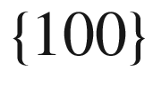

-Flächen von GaAs-Einkristallen. Kristall und Technik **9**, 1041–1050 (1974). [10.​1002/​crat.​19740090909](https://doi.org/10.1002/crat.19740090909) [Crossref](https://doi.org/10.1002/crat.19740090909)

K. Ishida, H. Kawano, Different etch pit shapes revealed by molten KOH etching on the (001) GaAs surface and their dependence on the Burgers vectors. Phys. Status Solidi A **98**, 175–181 (1986). [10.​1002/​pssa.​2210980119](https://doi.org/10.1002/pssa.2210980119)

J.L. Weyher, J. van de Ven, Selective etching and photoetching of GaAs in CrO

$$_3$$

–HF aqueous solutions. III. Interpretation of defect-related etch figures. J. Cryst. Growth **78**, 191–217 (1986). [10.​1016/​0022-0248(86)90055-2](https://doi.org/10.1016/0022-0248(86)90055-2)

A.F. Bogenschütz, *Ätzpraxis für Halbleiter* (Carl Hanser, München, 1967)

M. Köhler, *Etching in Microsystem Technology* (Wiley-VCH, Weinheim, 1999). [10.​1002/​9783527613786](https://doi.org/10.1002/9783527613786)

A.R. Clawson, Guide to references on III-V semiconductor chemical etching. Mater. Sci. Eng. **31**, 1–438 (2001). [10.​1016/​S0927-796X(00)00027-9](https://doi.org/10.1016/S0927-796X(00)00027-9)

J. Frühauf, *Shape and Functional Elements of the Bulk Silicon Microtechnique: A Manual of Wet-Etched Silicon Structures* (Springer, Berlin, 2005). [10.​1007/​b138230](https://doi.org/10.1007/b138230)

D.M. Manos, D.L. Flamm, eds., *Plasma Etching: An Introduction* (Academic Press, San Diego, 1989)

G.S. May, C.J. Spanos, *Fundamentals of Semiconductor Manufacturing and Process Control* (Wiley, Hoboken, 2006). [10.​1002/​0471790281](https://doi.org/10.1002/0471790281)

J.W. Coburn, *Plasma Etching and Reactive Ion Etching: Fundamentals and Applications, American Vacuum Society Monograph Series* (AVS, New York, 1982)

V.M. Donnelly, A. Kornblit, Plasma etching: Yesterday, today, and tomorrow. J. Vac. Sci. Technol. A **31**, 050825:1–47 (2013). [10.​1116/​1.​4819316](https://doi.org/10.1116/1.4819316)

V. Smaminathan, A.S. Jordan, Dislocations in III/V compounds. Semicond. Semimet. **38**, 293–341 (1993). [10.​1016/​S0080-8784(08)62803-3](https://doi.org/10.1016/S0080-8784(08)62803-3)

T. Kamejima, J. Matsui, Y. Seki, H. Watanabe, Transmission electron microscopy study of microdefects in dislocation-free GaAs and InP crystals. J. Appl. Phys. **50**, 3312–3321 (1979). [10.​1063/​1.​326372](https://doi.org/10.1063/1.326372)

L. Wang, W. Jie, Y. Yang, G. Xu, L. Fu, Defect characterization and composition distributions of mercury indium telluride single crystals. J. Cryst. Growth **310**, 2810–2814 (2008). [10.​1016/​j.​jcrysgro.​2008.​01.​060](https://doi.org/10.1016/j.jcrysgro.2008.01.060)

NREL, [www.​nrel.​gov/​measurements/​trans.​html](http://www.nrel.gov/measurements/trans.html)

Z. Liliental-Weber, H. Sohn, J. Washburn, Structural defects in epitaxial III/V layers. Semicond. Semimet. **38**, 397–447 (1993). [10.​1016/​S0080-8784(08)62805-7](https://doi.org/10.1016/S0080-8784(08)62805-7)

Y. Hao, G. Meng, ZhL Wang, Ch. Ye, L. Zhang, Periodically twinned nanowires and polytypic nanobelts of ZnS: the role of mass diffusion in vapor-liquid-solid growth. Nano Lett. **6**, 1650–1655 (2006). [10.​1021/​nl060695n](https://doi.org/10.1021/nl060695n)

S. Mader, A.E. Blakeslee, Extended dislocations in GaAs

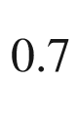

P

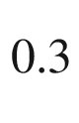

. Appl. Phys. Lett. **25**, 365–367 (1974). [10.​1063/​1.​1655510](https://doi.org/10.1063/1.1655510)

M. Sato, K. Sumino, K. Hiraga, Impurity effect in stacking fault energy of silicon crystals studied by high resolution electron microscopy. Phys. Status Solidi A **68**, 567–577 (1981). [10.​1002/​pssa.​2210680228](https://doi.org/10.1002/pssa.2210680228)

A. Gomez, D.J.H. Cockayne, P.B. Hirsch, V. Vitek, Dissociation of near-screw dislocations in germanium and silicon. Philos. Mag. **31**, 105–113 (1975). [10.​1080/​1478643750822928​9](https://doi.org/10.1080/14786437508229289)

D. Gerthsen, C.B. Carter, Stacking-fault energies of GaAs. Phys. Status Solidi A **136**, 29–43 (1993). [10.​1002/​pssa.​2211360104](https://doi.org/10.1002/pssa.2211360104)

P. Pirouz, D.J.H. Cockayne, N. Shimada, P. Hirsch, A.R. Lang, Dissociation of dislocations in diamond. Proc. Roy. Soc. Lond. A **386**, 241–249 (1983). [10.​1098/​rspa.​1983.​0034](https://doi.org/10.1098/rspa.1983.0034)

H. Gottschalk, G. Patzer, H. Alexander, Stacking fault energy and ionicity of cubic III-V compounds. Phys. Status Solidi A **45**, 207–217 (1978). [10.​1002/​pssa.​2210450125](https://doi.org/10.1002/pssa.2210450125)

S. Takeuchi, K. Suzuki, K. Maeda, Stacking-fault energy of II-VI compounds. Philos. Mag. A **50**, 171–178 (1984). [10.​1080/​0141861840824422​0](https://doi.org/10.1080/01418618408244220)

S. Amelinckx, W. Dekeyser, The structure and properties of grain boundaries. Solid State Phys. **8**, 325–499 (1959). [10.​1016/​S0081-1947(08)60482-8](https://doi.org/10.1016/S0081-1947(08)60482-8)

C.R.M. Grovenor, Grain boundaries in semiconductors. J. Phys. C: Solid State Phys. **18**, 4079–4119 (1985). [10.​1088/​0022-3719/​18/​21/​008](https://doi.org/10.1088/0022-3719/18/21/008)

C. Fontaine, D.A. Smith, On the atomic structure of the

$$\Sigma $$

=3 112 twin in silicon. Appl. Phys. Lett. **40**, 153–154 (1982). [10.​1063/​1.​93019](https://doi.org/10.1063/1.93019)

H. Sawada, H. Ichinose, M. Kohyama, Imaging of a single atomic column in silicon grain boundary. J. Electron Microscopy **51**, 353–357 (2002). [10.​1093/​jmicro/​51.​6.​353](https://doi.org/10.1093/jmicro/51.6.353)

F.L. Vogel, W.G. Pfann, H.E. Corey, E.E. Thomas, Observations of dislocations in lineage boundaries in germanium. Phys. Rev. **90**, 489–490 (1953). [10.​1103/​PhysRev.​90.​489](https://doi.org/10.1103/PhysRev.90.489)

H. Föll, Universität Kiel. [http://​www.​tf.​uni-kiel.​de/​matwis/​amat/​def\_​en/​kap\_​7/​backbone/​r7\_​2\_​2.​html](http://www.tf.uni-kiel.de/matwis/amat/def_en/kap_7/backbone/r7_2_2.html)

H. Föll, D. Ast, TEM observations on grain boundaries in sintered silicon. Philos. Mag. A **40**, 589–610 (1979). [10.​1080/​0141861790823486​1](https://doi.org/10.1080/01418617908234861)

M. Grundmann, A. Krost, D. Bimberg, LP-MOVPE growth of antiphase domain free InP on (001) Si using low temperature processing. J. Cryst. Growth **107**, 494–495 (1991). [10.​1016/​0022-0248(91)90509-4](https://doi.org/10.1016/0022-0248(91)90509-4)

Wolfgang Mader, private communication (2006)

F. Wolf, W. Mader, Microdomain structure in Fe

$$_2$$

O

$$_3$$

-doped ZnO and the formation of spinel. Optik **110**(Suppl. 8), 66 (1999)

F. Wolf, B.H. Freitag, W. Mader, Inversion domain boundaries in ZnO with additions of Fe

$$_2$$

O

$$_3$$

studied by high-resolution ADF imaging. Micron **38**, 549–552 (2007). [10.​1016/​j.​micron.​2006.​07.​021](https://doi.org/10.1016/j.micron.2006.07.021)

G.P. Srivastava, *The Physics of Phonons* (Taylor and Francis, New York, 1990)

N. Ashcroft, D. Mermin, *Solid State Physics* (Harcourt College Publishers, Fort Worth, 1976)

C. Kittel, *Introduction to Solid State Physics*, 8th edn. (Wiley, Chichester, 2004)

M.V. Berry, Quantal phase factors accompanying adiabatic changes. Proc. Roy. Soc. Lond. A **392**, 45–57 (1984). [10.​1098/​rspa.​1984.​0023](https://doi.org/10.1098/rspa.1984.0023)

J.K. Asbóth, L. Oroszlány, A. Pályi, A short course on topological insulators, band-structure topology and edge states in one and two dimensions, in *Lecture Notes in Physics*, vol. 919 (Springer, 2016). [10.​1007/​978-3-319-25607-8](https://doi.org/10.1007/978-3-319-25607-8)

R. Süsstrunk, S.D. Huber, Classification of topological phonons in linear mechanical metamaterials. PNAS **113**, E4767–E4775 (2016). [10.​1073/​pnas.​1605462113](https://doi.org/10.1073/pnas.1605462113)

H. Montgomery, The symmetry of lattice vibrations in the zincblende and diamond structures. Proc. Roy. Soc. Lond. A **309**, 521–549 (1969). [10.​1098/​rspa.​1969.​0055](https://doi.org/10.1098/rspa.1969.0055)

J.L.T. Waugh, G. Dolling, Crystal dynamics of gallium arsenide. Phys. Rev. **132**, 2410–2412 (1963). [10.​1103/​PhysRev.​132.​2410](https://doi.org/10.1103/PhysRev.132.2410)

P.H. Borcherds, K. Kunc, G.F. Alfrey, R.L. Hall, The lattice dynamics of gallium phosphide. J. Phys. C: Solid State Phys. **12**, 4699–4706 (1979). [10.​1088/​0022-3719/​12/​22/​012](https://doi.org/10.1088/0022-3719/12/22/012)

J.L.Yarnell, J.L.Warren, R.G.Wenzel, P.J.Dean, Lattice dynamics of gallium phosphide, in *Neutron Inelastic Scattering*, vol. 1 (IAEA, Vienna, 1968), pp. 301–313

S. Bağcı, S. Duman, H.M. Tütüncü, G.P. Srivastava, G. Uğur, Ab initio calculation of the structural and dynamical properties of the zinc-blende BN and its (110) surface. Diamond Rel. Mater. **15**, 1161–1165 (2006). [10.​1016/​j.​diamond.​2005.​10.​038](https://doi.org/10.1016/j.diamond.2005.10.038)

T. Tomoyose, A. Fukuchi, M. Kobayashi, Influence of quadrupolar deformability on phonon dispersion in silver and copper halides. Solid State Ionics **167**, 83–90 (2004). [10.​1016/​j.​ssi.​2003.​12.​007](https://doi.org/10.1016/j.ssi.2003.12.007)

E. Ruiz, S. Alvarez, P. Alemany, Electronic structure and properties of AlN. Phys. Rev. B **49**, 7115–7123 (1994). [10.​1103/​PhysRevB.​49.​7115](https://doi.org/10.1103/PhysRevB.49.7115)

A. Göbel, T. Ruf, A. Fischer, K. Eberl, M. Cardona, J.P. Silveira, F. Briones, Optical phonons in isotope superlattices of GaAs, GaP, and GaSb studied by Raman scattering. Phys. Rev. B **59**, 12612–12621 (1999). [10.​1103/​PhysRevB.​59.​12612](https://doi.org/10.1103/PhysRevB.59.12612)

Mathias Schubert, private communication (2006)

A.S. Barker Jr., A.J. Sievers, Optical studies of the vibrational properties of disordered solids. Rev. Mod. Phys. **47**, Suppl. No. 2, S1–S179 (1975). [10.​1103/​RevModPhys.​47.​S1.​2](https://doi.org/10.1103/RevModPhys.47.S1.2)

R.C. Newman, Local Vibrational mode spectroscopy of defects in III/V compounds. Semicond. Semimet. **38**, 117–187 (1993). [10.​1016/​S0080-8784(08)62800-8](https://doi.org/10.1016/S0080-8784(08)62800-8)

M. Stavola, Vibrational spectroscopy of light element impurities in semiconductors. Semicond. Semimet. **51B**, 153–224 (1999). [10.​1016/​S0080-8784(08)62976-2](https://doi.org/10.1016/S0080-8784(08)62976-2)

M.D. McCluskey, Local vibrational modes of impurities in semiconductors. J. Appl. Phys. **87**, 3593–3617 (2000). [10.​1063/​1.​372453](https://doi.org/10.1063/1.372453)

L. Hoffmann, J.C. Bach, B. Bech Nielsen, P. Leary, R. Jones, S. Öberg, Substitutional carbon in germanium. Phys. Rev. B **55**, 11167–11173 (1997). [10.​1103/​PhysRevB.​55.​11167](https://doi.org/10.1103/PhysRevB.55.11167)

F. Thompson, R.C. Newman, Localized vibrational modes of light impurities in gallium phosphide. J. Phys. C: Solid State Phys. **4**, 3249–3257 (1971). [10.​1088/​0022-3719/​4/​18/​030](https://doi.org/10.1088/0022-3719/4/18/030)

M. Vandevyver, D.N. Talwar, Green’s-function theory of impurity vibrations due to defect complexes in elemental and compound semiconductors. Phys. Rev. B **21**, 3405–3431 (1980). [10.​1103/​PhysRevB.​21.​3405](https://doi.org/10.1103/PhysRevB.21.3405)

L. Genzel, T.P. Martin, C.H. Perry, Model for long-wavelength optical-phonon modes of mixed crystals. Phys. Status Solidi B **62**, 83–92 (1974). [10.​1002/​pssb.​2220620108](https://doi.org/10.1002/pssb.2220620108)

I.F. Chang, S.S. Mitra, Application of a modified random-element-isodisplacement model to long-wavelength optic phonons of mixed crystals. Phys. Rev. **172**, 924–933 (1968). [10.​1103/​PhysRev.​172.​924](https://doi.org/10.1103/PhysRev.172.924)

L.I. Deych, A. Yamilov, A.A. Lisyansky, Concept of local polaritons and optical properties of mixed polar crystals. Phys. Rev. B **62**, 6301–6316 (2000). [10.​1103/​PhysRevB.​62.​6301](https://doi.org/10.1103/PhysRevB.62.6301)

H. von Wenckstern, R. Schmidt-Grund, C. Bundesmann, A. Müller, C.P. Dietrich, M. Stölzel, M. Lange, M. Grundmann, The (Mg,Zn)O alloy, in *Handbook of Zinc Oxide and Related Materials*, vol. 1 Materials, ed. by Z.C. Feng (Taylor and Francis/CRC Press, Florida, USA, 2012), pp. 257–320. [10.​1201/​b13072-14](https://doi.org/10.1201/b13072-14)

Z.G. Hu, M. Strassburg, N. Dietz, A.G.U. Perera, A. Asghar, I.T. Ferguson, Composition dependence of the infrared dielectric functions in Si-doped hexagonal Al

$$_x$$

Ga

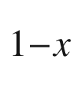

N films on c-plane sapphire substrates. Phys. Rev. B **72**, 245326:1–10 (2005). [10.​1103/​PhysRevB.​72.​24532610.​1103/​PhysRevB.​72.​245326](https://doi.org/10.1103/PhysRevB.72.24532610.1103/PhysRevB.72.245326)

M. Grundmann, Topological states of the diatomic linear chain: effect of impedance matching to the fixed ends. New J. Phys. **22**, 083076:1–7 (2020). [10.​1088/​1367-2630/​aba918](https://doi.org/10.1088/1367-2630/aba918)

H.M. Kayaga, T. Soma, Temperature dependence of the linear thermal expansion coefficient for Si and Ge. Phys. Status Solidi B **129**, K5–K8 (1985). [10.​1002/​pssb.​2221290149](https://doi.org/10.1002/pssb.2221290149)

A.S. Saada, *Elasticity, Theory and Applications* (Pergamon, New York, 1974)

P.N. Keating, Effect of invariance requirements on the elastic strain energy of crystals with application to the diamond structure. Phys. Rev. **145**, 637–645 (1966). [10.​1103/​PhysRev.​145.​637](https://doi.org/10.1103/PhysRev.145.637)

A.-B. Chen, A. Sher, W.T. Yost, Elastic constants and related properties of semiconductor compounds and their alloys. Semicond. Semimet. **37**, 1–77 (1992). [10.​1016/​S0080-8784(08)62513-2](https://doi.org/10.1016/S0080-8784(08)62513-2)

R.S. Lakes, Foam structures with a negative Poisson’s ratio. Science **235**, 1038–1040 (1987). [10.​1126/​science.​235.​4792.​1038](https://doi.org/10.1126/science.235.4792.1038)

K.E. Evans, M.A. Nkansah, I.J. Hutchinson, S.C. Rogers, Molecular network design. Nature **353**, 124 (1991). [10.​1038/​353124a0](https://doi.org/10.1038/353124a0)

R.H. Baughman, Auxetic materials: avoiding the shrink. Nature **425**, 667 (2003). [10.​1038/​425667a](https://doi.org/10.1038/425667a)

R. Gatt, J.N. Grima, Negative compressibility. Phys. Status Solidi RRL **2**, 236–238 (2008). [10.​1002/​pssr.​200802101](https://doi.org/10.1002/pssr.200802101)

R.M. Martin, Elastic properties of ZnS structure semiconductors. Phys. Rev. B **1**, 4005–4011 (1970). [10.​1103/​PhysRevB.​1.​4005](https://doi.org/10.1103/PhysRevB.1.4005)

R.M. Martin, Relation between elastic tensors of wurtzite and zinc-blende structure material. Phys. Rev. B **6**, 4546–4553 (1972). [10.​1103/​PhysRevB.​20.​818.​2](https://doi.org/10.1103/PhysRevB.20.818.2) Erratum: Phys. Rev. B **20**, 818 (1979). [10.​1103/​PhysRevB.​6.​4546](https://doi.org/10.1103/PhysRevB.6.4546)

K. Kim, W.R.L. Lambrecht, B. Segall, Elastic constants and related properties of tetrahedrally bonded BN, AlN, GaN, and InN. Phys. Rev. B **53**, 16310–16326 (1996). [10.​1103/​PhysRevB.​53.​16310](https://doi.org/10.1103/PhysRevB.53.16310)

A. Polian, M. Grimsditch, I. Grzegory, Elastic constants of gallium nitride. J. Appl. Phys. **79**, 3343–3344 (1996). [10.​1063/​1.​361236](https://doi.org/10.1063/1.361236)

L.E. McNeil, M. Grimsditch, R.H. French, Vibrational spectroscopy of aluminum nitride. J. Am. Ceram. Soc. **76**, 1132–1136 (1993). [10.​1111/​j.​1151-2916.​1993.​tb03730.​x](https://doi.org/10.1111/j.1151-2916.1993.tb03730.x)

C.F. Cline, H.L. Dunegan, G.W. Henderson, Elastic constants of hexagonal BeO, ZnS, and CdSe. J. Appl. Phys. **38**, 1944–1948 (1967). [10.​1063/​1.​1709787](https://doi.org/10.1063/1.1709787)

G. Carlotti, D. Fioretto, G. Socino, E. Verona, Brillouin scattering determination of the whole set of elastic constants of a single transparent film of hexagonal symmetry. J. Phys.: Cond. Matter **7**, 9147–9153 (1995). [10.​1088/​0953-8984/​7/​48/​006](https://doi.org/10.1088/0953-8984/7/48/006)

Ch.G. Van de Walle, Band lineups and deformation potentials in the model-solid theory. Phys. Rev. B **39**, 1871–1883 (1989). [10.​1103/​PhysRevB.​39.​1871](https://doi.org/10.1103/PhysRevB.39.1871)

A.E. Romanov, T.J. Baker, S. Nakamura, J.S. Speck, Strain-induced polarization in wurtzite III-nitride semipolar layers. J. Appl. Phys. **100**, 023522:1–10 (2006). [10.​1063/​1.​2218385](https://doi.org/10.1063/1.2218385)

M. Grundmann, J. Zúñiga-Pérez, Pseudomorphic ZnO-based heterostructures: from polar through all semipolar to nonpolar orientations. Phys. Status Solidi B **253**, 351–360 (2016). [10.​1002/​pssb.​201552535](https://doi.org/10.1002/pssb.201552535)

M. Grundmann, Elastic Theory of pseudomorphic monoclinic and rhombohedral heterostructures. J. Appl. Phys. **124**, 185302:1–10 (2018). [10.​1063/​1.​5045845](https://doi.org/10.1063/1.5045845)

M. Lorenz, S. Hohenberger, E. Rose, M. Grundmann, Atomically stepped, pseudomorphic, corundum-phase (Al

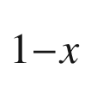

Ga

$$_x$$

)

$$_2$$

O

$$_3$$

thin films (0

$$\le $$

x

$$&lt;$$

0.08) grown on R-plane sapphire. Appl. Phys. Lett. **113**, 231902:1–5 (2018). [10.​1063/​1.​5059374](https://doi.org/10.1063/1.5059374)

M. Grundmann, Strain in pseudomorphic monoclinic Ga

$$_2$$

O

$$_3$$

-based heterostructures. Phys. Status Solidi B **254**, 1700134:1–7 (2017). [pssb.​201700134](https://doi.org/pssb.201700134)

M. Grundmann, A most general and facile recipe for the calculation of heteroepitaxial strain. Phys. Status Solidi B **257**, 2000323:1–5 (2020). [10.​1002/​pssb.​202000323](https://doi.org/10.1002/pssb.202000323)

J.D. Eshelby, The determination of the elastic field of an ellipsoidal inclusion and related problems. Proc. Roy. Soc. Lond. A **241**, 376–396 (1957). [10.​1098/​rspa.​1957.​0133](https://doi.org/10.1098/rspa.1957.0133)

M. Grundmann, O. Stier, D. Bimberg, InAs/GaAs pyramidal quantum dots: Strain distribution, optical phonons, and electronic structure. Phys. Rev. B **52**, 11969–11981 (1995). [10.​1103/​PhysRevB.​52.​11969](https://doi.org/10.1103/PhysRevB.52.11969)

L.B. Freund, J.A. Floro, E. Chason, Extensions of the Stoney formula for substrate curvature to configurations with thin substrates or large deformations. Appl. Phys. Lett. **74**, 1987–1989 (1999). [10.​1063/​1.​123722](https://doi.org/10.1063/1.123722)

M. Grundmann, Nanoscroll formation from strained layer heterostructures. Appl. Phys. Lett. **83**, 2444–2446 (2003). [10.​1063/​1.​1613366](https://doi.org/10.1063/1.1613366)

G.G. Stoney, The tension of metallic films deposited by electrolysis. Proc. Roy. Soc. Lond. A **82**, 172–175 (1909). [10.​1098/​rspa.​1909.​0021](https://doi.org/10.1098/rspa.1909.0021)

R. Beresford, J. Yin, K. Tetz, E. Chason, Real-time measurements of stress relaxation in InGaAs/GaAs. J. Vac. Sci. Technol. B **18**, 1431–1434 (2000). [10.​1116/​1.​591397](https://doi.org/10.1116/1.591397)

A. Krost, A. Dadgar, F. Schulze, R. Clos, K. Haberland, T. Zettler, Heteroepitaxy of GaN on silicon: In Situ measurements. Mat. Sci. Forum **483–485**, 1051–1056 (2005). [10.​4028/​www.​scientific.​net/​MSF.​483-485.​1051](https://doi.org/10.4028/www.scientific.net/MSF.483-485.1051)

V.Y. Prinz, V.A. Seleznev, A.K. Gutakovsky, Self-formed InGaAs/GaAs nanotubes: concept, fabrication, properties, in *Proceedings 24th International Conference Physics of Semiconductors* (Jerusalem, Israel, 1998) (World Scientific, Singapore, 1998), Th3-D5

X. Li, Strain induced semiconductor nanotubes: from formation process to device applications. J. Phys. C: Solid State Phys. **41**, 193001:1–12 (2008). [10.​1088/​0022-3727/​41/​19/​193001](https://doi.org/10.1088/0022-3727/41/19/193001)

B. Schmidt, Minimal energy configurations of strained multi-layers. Calc. Var. **30**, 477–497 (2007). [10.​1007/​s00526-007-0099-4](https://doi.org/10.1007/s00526-007-0099-4)

O.G. Schmidt, N. Schmarje, C. Deneke, C. Müller, N.-Y. Jin-Phillipp, Three-dimensional nano-objects evolving from a two-dimensional layer technology. Adv. Mater. **13**, 756–759 (2001). [10.​1002/​1521-4095(200105)13:​10%3C756:​:​AID-ADMA756%3E3.​0.​CO;2-F](https://doi.org/10.1002/1521-4095(200105)13:10%253C756::AID-ADMA756%253E3.0.CO%3B2-F)

L. Zhang, E. Ruh, D. Grützmacher, L. Dong, D.J. Bell, B.J. Nelson, C. Schönenberger, Anomalous coiling of SiGe/Si and SiGe/Si/Cr helical nanobelts. Nano Lett. **6**, 1311–1317 (2006). [10.​1021/​nl052340u](https://doi.org/10.1021/nl052340u)

J. Zang, F. Liu, Modified Timoshenko formula for bending of ultrathin strained bilayer films. Appl. Phys. Lett. **92**, 021905:1–3 (2008). [10.​1063/​1.​2828043](https://doi.org/10.1063/1.2828043)

Stefan Mendach, private communication (2006)

J.C. Bean, L.C. Feldman, A.T. Fiory, S. Nakahara, I.K. Robinson, Ge

$$_x$$

Si

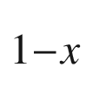

/Si strained-layer superlattice grown by molecular beam epitaxy. J. Vac. Sci. Technol. A **2**, 436–440 (1984). [10.​1116/​1.​572361](https://doi.org/10.1116/1.572361)

R. Hull, J.C. Bean, Nucleation of misfit dislocations in strained-layer epitaxy in the Ge

$$_x$$

Si

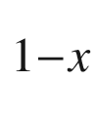

/Si system. J. Vac. Sci. Technol. A **7**, 2580–2585 (1989). [10.​1116/​1.​575800](https://doi.org/10.1116/1.575800)

J.W. Matthews, A.E. Blakeslee, Defects in epitaxial multilayers. I. Misfit dislocations. J. Cryst. Growth **27**, 118–125 (1974). [10.​1016/​S0022-0248(74)80055-2](https://doi.org/10.1016/S0022-0248(74)80055-2)

J.W. Matthews, A.E. Blakeslee, Defects in epitaxial multilayers. II. Dislocation pile-ups, threading dislocations, slip lines and cracks. J. Cryst. Growth **29**, 273–280 (1975). [10.​1016/​0022-0248(75)90171-2](https://doi.org/10.1016/0022-0248(75)90171-2)

R. People, J.C. Bean, Calculation of critical layer thickness versus lattice mismatch for Ge

$$_x$$

Si

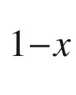

/Si strained-layer heterostructures. Appl. Phys. Lett. **47**, 322–324 (1985). [10.​1063/​1.​96206](https://doi.org/10.1063/1.96206)

F.C. Frank, J. van der Merwe, One-dimensional dislocations. I. Static theory. Proc. Roy. Soc. Lond. A **198**, 205–216 (1949). [10.​1098/​rspa.​1949.​0095](https://doi.org/10.1098/rspa.1949.0095)

F.C. Frank, J. van der Merwe, One-dimensional dislocations. II. Misfitting monolayers and oriented overgrowth. Proc. Roy. Soc. Lond. A **198**, 216–225 (1949). [10.​1098/​rspa.​1949.​0096](https://doi.org/10.1098/rspa.1949.0096)

J.H. van der Merwe, Crystal interfaces. Part II. Finite overgrowths. J. Appl. Phys. **34**, 123–127 (1962). [10.​1063/​1.​1729218](https://doi.org/10.1063/1.1729218) Erratum: J. Appl. Phys. **34**, 3420 (1963). [10.​1063/​1.​1729051](https://doi.org/10.1063/1.1729051)

J.R. Willis, S.C. Jain, R. Bullough, The energy of an array of dislocations: implications for strain relaxation in semiconductor heterostructures. Philos. Mag. A **62**, 115–129 (1990). [10.​1080/​0141861900824433​9](https://doi.org/10.1080/01418619008244339)

B.W. Dodson, J.Y. Tsao, Relaxation of strained-layer semiconductor structures via plastic flow. Appl. Phys. Lett. **51**, 1325–1327 (1987). [10.​1063/​1.​98667](https://doi.org/10.1063/1.98667)

E. Kasper, H.J. Herzog, H. Kibbel, A one-dimensional SiGe superlattice grown by UHV epitaxy. Appl. Phys. **8**, 199–205 (1975). [10.​1007/​BF00896611](https://doi.org/10.1007/BF00896611)

K.L. Kavanagh, M.A. Capano, L.W. Hobbs, J.C. Barbour, P.M.J. Marée, W. Schaff, J.W. Mayer, D. Pettit, J.M. Woodall, J.A. Stroscio, R.M. Feenstra, Asymmetries in dislocation densities, surface morphology, and strain of GalnAs/GaAs single heterolayers. J. Appl. Phys. **64**, 4843–4852 (1988). [10.​1063/​1.​341232](https://doi.org/10.1063/1.341232)

M. Grundmann, U. Lienert, D. Bimberg, A. Fischer-Colbrie, J.N. Miller, Anisotropic and inhomogeneous strain relaxation in pseudomorphic In

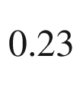

Ga

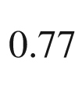

As/GaAs quantum wells. Appl. Phys. Lett. **55**, 1765–1767 (1989). [10.​1063/​1.​102212](https://doi.org/10.1063/1.102212)

M. Grundmann, Universal relation for the orientation of dislocations from prismatic glide systems in hexagonal and rhombohedral strained heterostructures. Appl. Phys. Lett. **116**, 082104:1–3 (2020). [10.​1063/​1.​5140977](https://doi.org/10.1063/1.5140977)

P. Quadbeck, Ph Ebert, K. Urban, J. Gebauer, R. Krause-Rehberg, Effect of dopant atoms on the roughness of III-V semiconductor cleavage surfaces. Appl. Phys. Lett. **76**, 300–302 (2000). [10.​1063/​1.​125726](https://doi.org/10.1063/1.125726)

J.E. Ayers, Compliant substrates for heteroepitaxial semiconductor devices: theory, experiment, and current directions. J. Electr. Mater. **37**, 1511–1523 (2008). [10.​1007/​s11664-008-0504-6](https://doi.org/10.1007/s11664-008-0504-6)

Eike Weber, private communication

X.F. Brun, S.N. Melkote, Analysis of stresses and breakage of crystalline silicon wafers during handling and transport. Solar Energy Mater. Solar Cells **93**, 1238–1247 (2009). [10.​1016/​j.​solmat.​2009.​01.​016](https://doi.org/10.1016/j.solmat.2009.01.016)

H.J. Möller, C. Funke, M. Rinio, S. Scholz, Multicrystalline silicon for solar cells. Thin Solid Films **487**, 179–187 (2005). [10.​1016/​j.​tsf.​2005.​01.​061](https://doi.org/10.1016/j.tsf.2005.01.061)

P.S. Dominguez, J.M. Fernandez, Introduction of thinner monocrystalline silicon wafers in an industrial cell-manufacturing facility, in *Proceedings 20th EU PVSEC* (Barcelona, Spain, 2005), pp. 903–905

P.-Y. Chen, M.-H. Tsai, W.-K. Yeh, M.-H. Jing, Y. Chang, Investigation of the relationship between whole-wafer strength and control of its edge engineering. Jpn. J. Appl. Phys. **48**, 126503:1–6 (2009). [10.​1143/​JJAP.​48.​126503](https://doi.org/10.1143/JJAP.48.126503)

C. Kittel, *Quantum Theory of Solids*, 2nd edn. (Wiley, New York, 1987)

G. Dresselhaus, Spin-orbit coupling effects in zinc blende structures. Phys. Rev. **100**, 580–586 (1955). [10.​1103/​PhysRev.​100.​580](https://doi.org/10.1103/PhysRev.100.580)

J.-W. Luo, G. Bester, A. Zunger, Full-zone spin splitting for electrons and holes in bulk GaAs and GaSb. Phys. Rev. Lett. **102**, 056405:1–4 (2009). [10.​1103/​PhysRevLett.​102.​056405](https://doi.org/10.1103/PhysRevLett.102.056405)

E.I. Rashba, Properties of semiconductors with an extremum loop. I. Cyclotron and combinatorial resonance in a magnetic field perpendicular to the plane of the loop. Fiz. Tverd. Tela **2**, 1224–1238 (1960) [Sov. Phys. Solid State **2**, 1109–1122 (1960)]

Yu.A. Bychkov, É.I. Rashba, Properties of a 2D electron gas with lifted spectral degeneracy. Pis’ma Zh. Èksp. Teor. Fiz. **39**, 66 (1984) [JETP Lett. **39**, 78–81 (1984)]

S.G. Ganichev, L.E. Golub, Interplay of Rashba/Dresselhaus spin splittings probed by photogalvanic spectroscopy—A review. Phys. Status Solidi B **251**, 1801–1823 (2014). [10.​1002/​pssb.​201350261](https://doi.org/10.1002/pssb.201350261)

G.F. Koster, J.O. Dimmock, R.G. Wheeler, H. Statz, *Properties of the Thirty-Two Point Groups* (MIT, Cambridge, 1963)

D.G. Bell, Group theory and crystal lattices. Rev. Mod. Phys. **26**, 311–320 (1954). [10.​1103/​RevModPhys.​26.​311](https://doi.org/10.1103/RevModPhys.26.311)

R.H. Parmentier, Symmetry properties of the energy bands of the zinc blende structure. Phys. Rev. **100**, 573–579 (1955). [10.​1103/​PhysRev.​100.​573](https://doi.org/10.1103/PhysRev.100.573)

M. Glasser, Symmetry properties of the wurtzite structure. J. Phys. Chem. Solids **10**, 229–241 (1959). [10.​1016/​0022-3697(59)90080-0](https://doi.org/10.1016/0022-3697(59)90080-0)

L.C.L.Y. Voon, M. Willatzen, *The*

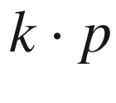

*Method* (Springer, Berlin, 2009). [10.​1007/​978-3-540-92872-0](https://doi.org/10.1007/978-3-540-92872-0)

L.P. Bouckaert, R. Smoluchowski, E. Wigner, Theory of Brillouin zones and symmetry properties of wave functions in crystals. Phys. Rev. **50**, 58–67 (1936). [10.​1103/​PhysRev.​50.​58](https://doi.org/10.1103/PhysRev.50.58)

M.Z. Hasan, C.L. Kane, Topological insulators. Rev. Mod. Phys. **82**, 3045–3067 (2010). [10.​1103/​RevModPhys.​82.​3045](https://doi.org/10.1103/RevModPhys.82.3045)

S.-Q. Shen: *Topological Insulators, Dirac Equation in Condensed Matter*, 2nd edn. (Springer Nature, Singapore, 2017). [10.​1007/​978-981-10-4606-3](https://doi.org/10.1007/978-981-10-4606-3)

J. Zak, Berry’s phase for energy bands in solids. Phys. Rev. Lett. **62**, 2747–2750 (1989). [10.​1103/​PhysRevLett.​62.​2747](https://doi.org/10.1103/PhysRevLett.62.2747)

D. Shin, S.A. Sato, H. Hübener, U. De Giovannini, J. Kima, N. Park, A. Rubio, Unraveling materials Berry curvature and Chern numbers from real-time evolution of Bloch states. PNAS **116**, 4135–4140 (2019). [10.​1073/​pnas.​1816904116](https://doi.org/10.1073/pnas.1816904116)

J.R. Chelikowsky, M.L. Cohen, Nonlocal pseudopotential calculations for the electronic structure of eleven diamond and zinc-blende semiconductors. Phys. Rev. B **14**, 556–582 (1976). [10.​1103/​PhysRevB.​14.​556](https://doi.org/10.1103/PhysRevB.14.556)

R. Dalven, Electronic structure of PbS, PbSe, and PbTe. Solid State Phys. **28**, 179–224 (1973). [10.​1016/​S0081-1947(08)60203-9](https://doi.org/10.1016/S0081-1947(08)60203-9)

A. Schleife, F. Fuchs, J. Furthmüller, F. Bechstedt, First-principles study of ground- and excited-state properties of MgO, ZnO, and CdO polymorphs. Phys. Rev. B **73**, 245212:1–14 (2006). [10.​1103/​PhysRevB.​73.​245212](https://doi.org/10.1103/PhysRevB.73.245212)

H. Dixit, R. Saniz, S. Cottenier, D. Lamoen, B. Partoens, Electronic structure of transparent oxides with the Tran–Blaha modified Becke–Johnson potential. J. Phys.: Cond. Matter **24**, 205503:1–9 (2012). [10.​1088/​0953-8984/​24/​20/​205503](https://doi.org/10.1088/0953-8984/24/20/205503)

J.E. Jaffe, A. Zunger, Electronic structure of the ternary chalcopyrite semiconductors CuAlS

$$_2$$

, CuGaS

$$_2$$

, CuInS

$$_2$$

, CuAlSe

$$_2$$

, CuGaSe

$$_2$$

, and CuInSe

$$_2$$

. Phys. Rev. B **28**, 5822–5847 (1983). [10.​1103/​PhysRevB.​28.​5822](https://doi.org/10.1103/PhysRevB.28.5822)

S. Limpijumnong, S.N. Rashkeev, W.R.L. Lambrecht, Electronic structure and optical properties of ZnGeN

$$_2$$

. MRS Internet J. Nitride Semicond. Res. **4**(S1), 600–605 (1999). [10.​1557/​S109257830000311​2](https://doi.org/10.1557/S1092578300003112)

W. Rehwald, Band structure of spinel-type semiconductors. Phys. Rev. **155**, 861–868 (1967). [10.​1103/​PhysRev.​155.​861](https://doi.org/10.1103/PhysRev.155.861)

H. Dixit, N. Tandon, S. Cottenier, R. Saniz, D. Lamoen, B. Partoens, V. Van Speybroeck, M. Waroquier, Electronic structure and band gap of zinc spinel oxides beyond LDA: ZnAl

$$_2$$

O

$$_4$$

, ZnGa

$$_2$$

O

$$_4$$

and ZnIn

$$_2$$

O

$$_4$$

. New J. Phys. **13**, 063002:1–11 (2011). [10.​1088/​1367-2630/​13/​6/​063002](https://doi.org/10.1088/1367-2630/13/6/063002)

R. Ahuja, O. Eriksson, B. Johansson, Electronic and optical properties of BaTiO

$$_3$$

and SrTiO

$$_3$$

. J. Appl. Phys. **90**, 1854–1859 (2001). [10.​1063/​1.​1384862](https://doi.org/10.1063/1.1384862)

E.D. Indari, T.D.K. Wungu, R. Hidayat, Ab-Initio calculation of electronic structure of lead halide perovskites with formamidinium cation as an active material for perovskite solar cells. IOP Conf Ser.: J. Phys.: Conf. Ser. **877**, 012054:1–6 (2017). [10.​1088/​1742-6596/​877/​1/​012054](https://doi.org/10.1088/1742-6596/877/1/012054)

P. Pitriana, T.D.K. Wungu, Herman, R. Hidayat, The characteristics of band structures and crystal binding in all-inorganic perovskite APbBr

$$_3$$

studied by the first principle calculations using the Density Functional Theory (DFT) method. Results Phys. **15**, 102592:1–7 (2019). [10.​1016/​j.​rinp.​2019.​102592](https://doi.org/10.1016/j.rinp.2019.102592)

S. Tao, I. Schmidt, G. Brocks, J. Jiang, I. Tranca, K. Meerholz, S. Olthof, Absolute energy level positions in tin- and lead-based halide perovskites. Nature Commun. **10**, 2560:1–10 (2019). [10.​1038/​s41467-019-10468-7](https://doi.org/10.1038/s41467-019-10468-7)

L. Protesescu, S. Yakunin, M.I. Bodnarchuk, F. Krieg, R. Caputo, C.H. Hendon, R.X. Yang, A. Walsh, M.V. Kovalenko, Nanocrystals of cesium lead halide perovskites (CsPbX

$$_3$$

, X=Cl, Br, and I): novel optoelectronic materials showing bright emission with wide color gamut. Nano Lett. **15**, 3592–3696 (2015). [10.​1021/​nl5048779](https://doi.org/10.1021/nl5048779)

Y. Iso, T. Isobe, Review - Synthesis, luminescent properties, and stabilities of cesium lead halide perovskite nanocrystals. ECS. J. Solid State Sci. Technol. **7**, R3040–R3045 (2018). [10.​1149/​2.​0101801jss](https://doi.org/10.1149/2.0101801jss)

B. Seraphin, Über ein ein-dimensionales Modell halbleitender Verbindungen vom Typus A

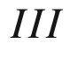

B

$$^{V}$$

, Z. Naturf. **9a**, 450–456 (1954). [10.​1515/​zna-1954-0511](https://doi.org/10.1515/zna-1954-0511)

D.S. Saxon, R.A. Hutner, Some electronic properties of a one-dimensional crystal model. Philips Res. Rep. **4**, 81–122 (1949)

I. Adawi, One-dimensional treatment of the effective mass in semiconductors. Phys. Rev. **105**, 789–792 (1957). [10.​1103/​PhysRev.​105.​789](https://doi.org/10.1103/PhysRev.105.789)

J. Wu, W. Walukiewicz, Band gaps of InN and group III nitride alloys. Superlatt. Microstruct. **34**, 63–75 (2003). [10.​1016/​j.​spmi.​2004.​03.​069](https://doi.org/10.1016/j.spmi.2004.03.069)

J.E. Bernard, A. Zunger, Electronic Structure of ZnS, ZnSe, ZnTe, and their pseudobinary alloys. Phys. Rev. B **36**, 3199–3228 (1987). [10.​1103/​PhysRevB.​36.​3199](https://doi.org/10.1103/PhysRevB.36.3199)

E.W. Williams, V. Rehn, Electroreflectance Studies of InAs, GaAs and (Ga, In)As alloys. Phys. Rev. **172**, 798–810 (1968). [10.​1103/​PhysRev.​172.​798](https://doi.org/10.1103/PhysRev.172.798)

K.-R. Schulze, H. Neumann, K. Unger, Band structure of Ga



In

$$_x$$

As. Phys. Status Solidi B **75**, 493–500 (1976). [10.​1002/​pssb.​2220750211](https://doi.org/10.1002/pssb.2220750211)

J. Wu, W. Walukiewicz, K.M. Yu, J.W. Ager III, S.X. Li, E.E. Haller, H. Lu, W.J. Schaff, Universal bandgap bowing in group-III nitride alloys. Solid State Commun. **127**, 411–414 (2003). [10.​1016/​S0038-1098(03)00457-5](https://doi.org/10.1016/S0038-1098(03)00457-5)

R. Braunstein, A.R. Moore, F. Herman, Intrinsic optical absorption in germanium-silicon alloys. Phys. Rev. **109**, 695–710 (1958). [10.​1103/​PhysRev.​109.​695](https://doi.org/10.1103/PhysRev.109.695)

D.J. Wolford, W.Y. Hsu, J.D. Dow, B.G. Streetman, Nitrogen trap in the semiconductor alloys GaAs



P

$$_x$$

and Al

$$_x$$

Ga



As. J. Lumin. **18**(19), 863–867 (1979). [10.​1016/​0022-2313(79)90252-7](https://doi.org/10.1016/0022-2313(79)90252-7)

R. Schmidt, B. Rheinländer, M. Schubert, D. Spemann, T. Butz, J. Lenzner, E.M. Kaidashev, M. Lorenz, M. Grundmann, Dielectric functions (1 to 5 eV) of wurtzite Mg

$$_x$$

Zn

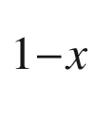

O (

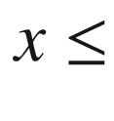

0.29) thin films. Appl. Phys. Lett. **82**, 2260–2262 (2003). [10.​1063/​1.​1565185](https://doi.org/10.1063/1.1565185)

R. Schmidt-Grund, A. Carstens, B. Rheinländer, D. Spemann, H. Hochmut, G. Zimmermann, M. Lorenz, M. Grundmann, C.M. Herzinger, M. Schubert, Refractive indices and band-gap properties of rocksalt Mg

$$_x$$

Zn



O (0.68

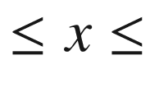

1). J. Appl. Phys. **99**, 123701:1–7 (2006). [10.​1063/​1.​2205350](https://doi.org/10.1063/1.2205350)

S. Larach, R.E. Shrader, C.F. Stocker, Anomalous variation of band gap with composition in zinc sulfo- and seleno-tellurides. Phys. Rev. **108**, 587–589 (1957). [10.​1103/​PhysRev.​108.​587](https://doi.org/10.1103/PhysRev.108.587)

S. Merita, T. Krämer, B. Mogwitz, B. Franz, A. Polity, B.K. Meyer, Oxygen in sputter-deposited ZnTe thin films. Phys. Status Solidi C **3**, 960–963 (2006). [10.​1002/​pssc.​200564637](https://doi.org/10.1002/pssc.200564637)

B. Kramer, A pseudopotential approach for the green’s function of electrons in amorphous solids. Phys. Status Solidi **41**, 649–658 (1970). [10.​1002/​pssb.​19700410220](https://doi.org/10.1002/pssb.19700410220)

B. Kramer, Electronic structure and optical properties of amorphous germanium and silicon. Phys. Status Solidi B **47**, 501–510 (1971). [10.​1002/​pssb.​2220470215](https://doi.org/10.1002/pssb.2220470215)

J.A. van Vechten, *A Simple Man’s View of the Thermochemistry of Semiconductors, Handbook on Semiconductors*, vol. 3 (North Holland, Amsterdam, 1980), pp. 1–111

J. Hartung, L.Å. Hansson, J. Weber, Temperature dependence of the indirect gap in silicon, in *Proceedings of the 20th International Conference on the Physics of Semiconductors Thessaloniki, Greece*, eds. by E.M. Anastassakis, J.D. Joannopoulos (World Scientific, Singapore, 1990), pp. 1875–1878

Y.W. Tsang, M.L. Cohen, Calculation of the temperature dependence of the energy gaps of PbTe and SnTe. Phys. Rev. B **3**, 1254–1261 (1971). [10.​1103/​PhysRevB.​3.​1254](https://doi.org/10.1103/PhysRevB.3.1254)

I. Tanaka, K. Sugimoto, D. Kim, H. Nishimura, M. Nakayama, Control of temperature dependence of exciton energies in CuI-CuBr alloy thin films grown by vacuum deposition. Int. J. Mod. Phys. B **15**, 3977–3980 (2001). [10.​1142/​S021797920100914​1](https://doi.org/10.1142/S0217979201009141)

J. Serrano, Ch. Schweitzer, C.T. Lin, K. Reinmann, M. Cardona, D. Fröhlich, Electron-phonon renormalization of the absorption edge of the cuprous halides. Phys. Rev. B **65**, 125110:1–7 (2002). [10.​1103/​PhysRevB.​65.​125110](https://doi.org/10.1103/PhysRevB.65.125110)

J. Bhosale, A.K. Ramdas, A. Burger, A. Muñoz, A.H. Romero, M. Cardona, R. Lauck, R.K. Kremer, Temperature dependence of band gaps in semiconductors: Electron-phonon interaction. Phys. Rev. B **86**, 195208:1–10 (2012). [10.​1103/​PhysRevB.​86.​195208](https://doi.org/10.1103/PhysRevB.86.195208)

Y. Varshni, Temperature dependence of the energy gap in semiconductors. Physica **34**, 149–154 (1967). [10.​1016/​0031-8914(67)90062-6](https://doi.org/10.1016/0031-8914(67)90062-6)

L. Viña, S. Logothetidis, M. Cardona, Temperature dependence of the dielectric function of germanium. Phys. Rev. B **30**, 1979–1991 (1984). [10.​1103/​PhysRevB.​30.​1979](https://doi.org/10.1103/PhysRevB.30.1979)

K.P. O’Donnell, X. Chen, Temperature dependence of semiconductor band gaps. Appl. Phys. Lett. **58**, 2924–2926 (1991). [10.​1063/​1.​104723](https://doi.org/10.1063/1.104723)

R. Pässler, Dispersion-related description of temperature dependencies of band gaps in semiconductors. Phys. Rev. B **66**, 085201:1–18 (2002) [10.​1103/​PhysRevB.​66.​085201](https://doi.org/10.1103/PhysRevB.66.085201)

D. Brunner, H. Angerer, E. Bustarret, F. Freudenberg, R. Höpler, R. Dimitrov, O. Ambacher, M. Stutzmann, Optical constants of epitaxial AlGaN films and their temperature dependence. J. Appl. Phys. **82**, 5090–5096 (1997). [10.​1063/​1.​366309](https://doi.org/10.1063/1.366309)

R. Schmidt-Grund, N. Ashkenov, M.M. Schubert, W. Czakai, D. Faltermeier, G. Benndorf, H. Hochmuth, M. Lorenz, M. Grundmann, Temperature-dependence of the refractive index and the optical transitions at the fundamental band-gap of ZnO. AIP Conf. Proc. **893**, 271–272 (2007). [10.​1063/​1.​2729872](https://doi.org/10.1063/1.2729872)

N. Garro, A. Cantarero, M. Cardona, A. Göbel, T. Ruf, K. Eberl, Dependence of the lattice parameters and the energy gap of zinc-blende-type semiconductors on isotopic masses. Phys. Rev. B **54**, 4732–4740 (1996). [10.​1103/​PhysRevB.​54.​4732](https://doi.org/10.1103/PhysRevB.54.4732)

E.O. Kane, Band structure of indium antimonide. J. Phys. Chem. Solids **1**, 249–261 (1957). [10.​1016/​0022-3697(57)90013-6](https://doi.org/10.1016/0022-3697(57)90013-6)

C. Hermann, C. Weisbuch,

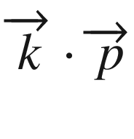

perturbation theory in III-V compounds and alloys: a reexamination. Phys. Rev. B **15**, 823–833 (1977). [10.​1103/​PhysRevB.​15.​823](https://doi.org/10.1103/PhysRevB.15.823)

Y.-N. Xu, W.Y. Ching, Electronic, optical, and structural properties of some wurtzite crystals. Phys. Rev. B **48**, 4335–4351 (1993). [10.​1103/​PhysRevB.​48.​4335](https://doi.org/10.1103/PhysRevB.48.4335)

M. Oshikiri, F. Aryasetiawan, Y. Imanaka, G. Kido, Quasiparticle effective-mass theory in semiconductors. Phys. Rev. B **66**, 125204:1–4 (2002). [10.​1103/​PhysRevB.​66.​125204](https://doi.org/10.1103/PhysRevB.66.125204)

F. Nava, C. Canali, C. Jacoboni, L. Reggiani, S.F. Kozlov, Electron effective masses and lattice scattering in natural diamond. Solid State Commun. **33**, 475–477 (1980). [10.​1016/​0038-1098(80)90447-0](https://doi.org/10.1016/0038-1098(80)90447-0)

G. Dresselhaus, A.F. Kip, C. Kittel, Cyclotron resonance of electrons and holes in silicon and germanium crystals. Phys. Rev. **98**, 368–384 (1955). [10.​1103/​PhysRev.​98.​368](https://doi.org/10.1103/PhysRev.98.368)

S. Shokhovets, G. Gobsch, O. Ambacher, Conduction band parameters of ZnO. Superlatt. Microstruct. **39**, 299–305 (2006). [10.​1016/​j.​spmi.​2005.​08.​052](https://doi.org/10.1016/j.spmi.2005.08.052)

W.S. Baer, R.N. Dexter, Electron cyclotron resonance in CdS. Phys. Rev. **135**, A1388–A1393 (1964). [10.​1103/​PhysRev.​135.​A1388](https://doi.org/10.1103/PhysRev.135.A1388)

W. Shockley, Cyclotron resonance, magnetoresistance, and Brillouin zones in semiconductors. Phys. Rev. **90**, 491 (1953). [10.​1103/​PhysRev.​90.​491](https://doi.org/10.1103/PhysRev.90.491)

P. Pfeffer, W. Zawadzki, Conduction electrons in GaAs: five-level

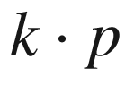

theory and polaron effects. Phys. Rev. B **41**, 1561–1576 (1990). [10.​1103/​PhysRevB.​41.​1561](https://doi.org/10.1103/PhysRevB.41.1561)

M. Cardona, N.E. Christensen, G. Fasol, Relativistic band structure and spin-orbit splitting of zinc-blende-type semiconductors. Phys. Rev. B **38**, 1806–1827 (1988). [10.​1103/​PhysRevB.​38.​1806](https://doi.org/10.1103/PhysRevB.38.1806)

Dieter Bimberg, private communication, original authorship unknown

G. Ottaviani, L. Reggiani, C. Canali, F. Nava, A. Alberigi-Quaranta, Hole drift velocity in silicon. Phys. Rev. B **12**, 3318–3329 (1975). [10.​1103/​PhysRevB.​12.​3318](https://doi.org/10.1103/PhysRevB.12.3318)

M. Cardona, F.H. Pollak, Energy-band structure of germanium and silicon: The

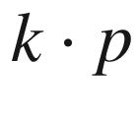

method. Phys. Rev. **142**, 530–543 (1966). [10.​1103/​PhysRev.​142.​530](https://doi.org/10.1103/PhysRev.142.530)

M.I. Eremets, Semiconducting diamond. Semicond. Sci. Technol. **6**, 439–444 (1991). [10.​1088/​0268-1242/​6/​6/​004](https://doi.org/10.1088/0268-1242/6/6/004)

J.J. Hopfield, Fine structure in the optical absorption edge of anisotropic crystals. J. Phys. Chem. Solids **15**, 97–107 (1960). [10.​1016/​0022-3697(60)90105-0](https://doi.org/10.1016/0022-3697(60)90105-0)

J.L. Shay, B. Tell, L.M. Schiavone, H.M. Kasper, F. Thiel, Energy bands of AgInS

$$_2$$

in the chalcopyrite and orthorhombic structures. Phys. Rev. B **9**, 1719–1723 (1974). [10.​1103/​PhysRevB.​9.​1719](https://doi.org/10.1103/PhysRevB.9.1719)

D.L. Carter, R.T. Bates, eds., *Physics of Semimetals and Narrow-Gap Semiconductors* (Pergamon Press, 1971)

G.A. Saunders, Semimetals and narrow gap semiconductors. Contemp. Phys. **14**, 149–166 (1973). [10.​1080/​0010751730821373​0](https://doi.org/10.1080/00107517308213730)

W. Feng, D. Xiao, J. Ding, Y. Yuo, Three-dimensional topological insulators in I–III–VI

$$_2$$

and II–IV–V

$$_2$$

chalcopyrite semiconductors. Phys. Rev. Lett. **106**, 016402:1–4 (2011). [10.​1103/​PhysRevLett.​106.​016402](https://doi.org/10.1103/PhysRevLett.106.016402)

G. Bastard, Dielectric anomalies in extremely non-parabolic zero-gap semiconductors. J. Phys. C: Solid State Phys. **14**, 839–845 (1981). [10.​1088/​0022-3719/​14/​6/​010](https://doi.org/10.1088/0022-3719/14/6/010)

F. Teppe, M. Marcinkiewicz, S.S. Krishtopenko, S. Ruffenach, C. Consejo, A.M. Kadykov, W. Desrat, D. But, W. Knap, J. Ludwig, S. Moon, D. Smirnov, M. Orlita, Z. Jiang, S.V. Morozov, V.I. Gavrilenko, N.N. Mikhailov, S.A. Dvoretskii, Temperature-driven massless Kane fermions in HgCdTe crystals. Nature Commun. **7**, 12576:1–6 (2016). [10.​1038/​ncomms12576](https://doi.org/10.1038/ncomms12576)

J.O. Dimmock, I. Melngailis, A.J. Strauss, Band structure and laser action in Pb

$$_x$$

Sn

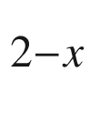

Te. Phys. Rev. Lett. **16**, 1193–1196 (1966). [10.​1103/​PhysRevLett.​16.​1193](https://doi.org/10.1103/PhysRevLett.16.1193)

G.L. Bir, G.E. Pikus, *Symmetry and Strain-induced Effects in Semiconductors* (Wiley, New York, 1974)

G.E. Pikus, G.L. Bir, Effect of Deformation on the Hole Energy Spectrum of Germanium and Silicon. Fiz. Tverd. Tela **1**, 1642–1658 (1956) [Sov. Phys. Solid State **1**, 1502–1517 (1959)]

N.E. Christensen, Electronic structure of GaAs under strain. Phys. Rev. B **30**, 5753–5765 (1984). [10.​1103/​PhysRevB.​30.​5753](https://doi.org/10.1103/PhysRevB.30.5753)

Y. Zhang, Motion of electrons in semiconductors under inhomogeneous strain with application to laterally confined quantum wells. Phys. Rev. B **49**, 14352–14366 (1994). [10.​1103/​PhysRevB.​49.​14352](https://doi.org/10.1103/PhysRevB.49.14352)

A.R. Goñi, K. Strössner, K. Syassen, M. Cardona, Pressure dependence of direct and indirect optical absorption in GaAs. Phys. Rev. B **36**, 1581–1587 (1987). [10.​1103/​PhysRevB.​36.​1581](https://doi.org/10.1103/PhysRevB.36.1581)

W. Shan, W. Walukiewicz, J.W. Ager III, E.E. Haller, J.F. Geisz, D.J. Friedman, J.M. Olson, S.R. Kurtz, Band Anticrossing in GaInNAs Alloys. Phys. Rev. Lett. **82**, 1221–1224 (1999). [10.​1103/​PhysRevLett.​82.​1221](https://doi.org/10.1103/PhysRevLett.82.1221)

S.L. Chuang, C.S. Chang,

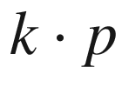

method for strained wurtzite semiconductors. Phys. Rev. B **54**, 2491–2504 (1996). [10.​1103/​PhysRevB.​54.​2491](https://doi.org/10.1103/PhysRevB.54.2491)

M. Kumagai, S.L. Chuang, H. Ando, Analytical solutions of the block-diagonalized Hamiltonian for strained wurtzite semiconductors. Phys. Rev. B **57**, 15303–15314 (1998). [10.​1103/​PhysRevB.​57.​15303](https://doi.org/10.1103/PhysRevB.57.15303)

C. Herring, E. Vogt, Transport and deformation-potential theory for many-valley semiconductors with anisotropic scattering. Phys. Rev. **101**, 944–961 (1956). [10.​1103/​PhysRev.​101.​944](https://doi.org/10.1103/PhysRev.101.944)

M.V. Fischetti, S.E. Laux, Band structure, deformation potentials, and carrier mobility in strained Si, Ge, and SiGe alloys. J. Appl. Phys. **80**, 2234–2252 (1996). [10.​1063/​1.​363052](https://doi.org/10.1063/1.363052)

D. Aspnes, M. Cardona, Strain dependence of effective masses in tetrahedral semiconductors. Phys. Rev. B **17**, 726–740 (1978). [10.​1103/​PhysRevB.​17.​726](https://doi.org/10.1103/PhysRevB.17.726)

P.R.C. Kent, A. Zunger, Theory of electronic structure evolution in GaAsN and GaPN alloys. Phys. Rev. B **64**, 115208:1–23 (2001). [10.​1103/​PhysRevB.​64.​115208](https://doi.org/10.1103/PhysRevB.64.115208)

J. Wu, W. Shan, W. Walukiewicz, Band anticrossing in highly mismatched III-V semiconductor alloys. Semicond. Sci. Technol. **17**, 860–869 (2002). [10.​1088/​0268-1242/​17/​8/​315](https://doi.org/10.1088/0268-1242/17/8/315)

J. Chelikowsky, D.J. Chadi, M.L. Cohen, Calculated valence-band densities of states and photoemission spectra of diamond and zinc-blende semiconductors. Phys. Rev. B **8**, 2786–2794 (1973). [10.​1103/​PhysRevB.​8.​2786](https://doi.org/10.1103/PhysRevB.8.2786)

N.F. Mott, Electrons in disordered structures. Advances in Phys. **16**, 49–144 (1967). [10.​1080/​0001873670010126​5](https://doi.org/10.1080/00018736700101265)

M.H. Cohen, H. Fritzsche, S.R. Ovshinsky, Simple band model for amorphous semiconductor alloys. Phys. Rev. Lett. **22**, 1065–1068 (1969). [10.​1103/​PhysRevLett.​22.​1065](https://doi.org/10.1103/PhysRevLett.22.1065)

E.A. Davis, N.F. Mott, Conduction in non-crystalline systems. V. Conductivity, optical absorption and photoconductivity in amorphous semiconductors, Philos. Mag. **22**, 903–922 (1970). [10.​1080/​1478643700822106​1](https://doi.org/10.1080/14786437008221061)

J.M. Marshall, A.E. Owen, Drift mobility studies in vitreous arsenic triselenide. Philos. Mag. **24**, 1281–1305 (1971). [10.​1080/​1478643710821741​3](https://doi.org/10.1080/14786437108217413)

D.A. Drabold, U. Stephan, J. Dong, S.M. Nakhmanson, The structure of electronic states in amorphous silicon. J. Molec. Graphics and Modelling **17**, 285–291, 330–332 (1999). [10.​1016/​S1093-3263(99)00036-4](https://doi.org/10.1016/S1093-3263(99)00036-4)

W. Körner, C. Elsässer, Density-functional theory study of stability and subgap states of crystalline and amorphous Zn-Sn-O. Thin Solid Films **555**, 81–86 (2014). [10.​1016/​j.​tsf.​2013.​05.​146](https://doi.org/10.1016/j.tsf.2013.05.146)

S. Sallis, K.T. Butler, N.F. Quackenbush, D.S. Williams, M. Junda, D.A. Fischer, J.C. Woicik, N.J. Podraza, B.E. White, Jr., A. Walsh, L.F.J. Piper, Origin of deep subgap states in amorphous indium gallium zinc oxide: Chemically disordered coordination of oxygen. Appl. Phys. Lett. **104**, 232108:1–4 (2014). [10.​1063/​1.​4883257](https://doi.org/10.1063/1.4883257)

W. Pauli 1931 in a letter from New York to R. Peierls, in: Wolfgang Pauli, Scientific Correspondence with Bohr, Einstein, Heisenberg a.o. Volume II: 1930–1939, K. von Meyenn, ed. (Springer, Berlin, 1985), Nr. 287, p. 94; Lateron Pauli complains to Peierls "... daß Sie immer noch nicht von der Physik des festen Körpers losgekommen sind." (ibid, Nr. 310, p. 163). [10.​1007/​978-3-540-78801-0](https://doi.org/10.1007/978-3-540-78801-0)

W. Shockley, *Electrons and Holes in Semiconductors with Applications to Transistor Electronics* (D. van Nostrand, New York, 1950)

D. Bednarczyk, J. Bernarczyk, The approximation of the Fermi-Dirac integral F

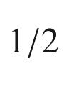

(

$$\eta $$

). Phys. Lett. **64A**, 409–401 (1978). [10.​1016/​0375-9601(78)90283-9](https://doi.org/10.1016/0375-9601(78)90283-9)

X. Aymerich-Humet, F. Serra-Mestres, J. Millán, An analytical approximation for the Fermi-Dirac integral F

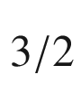

(

$$\eta $$

). Solid State Electron. **24**, 981–982 (1981). [10.​1016/​0038-1101(81)90121-0](https://doi.org/10.1016/0038-1101(81)90121-0)

X. Aymerich-Humet, F. Serra-Mestres, J. Millán, A generalized approximation of the Fermi-Dirac integrals. J. Appl. Phys. **54**, 2850–2851 (1983). [10.​1063/​1.​332276](https://doi.org/10.1063/1.332276)

K. Unger, Reversible formulae to approximate Fermi integrals. Phys. Status Solidi B **149**, K141–K144 (1988). [10.​1002/​pssb.​2221490254](https://doi.org/10.1002/pssb.2221490254)

J. McDougall, E.C. Stoner, The computation of Fermi-Dirac functions. Phil. Trans. Roy. Soc. Lond.**237**, 67–104 (1938). [10.​1098/​rsta.​1938.​0004](https://doi.org/10.1098/rsta.1938.0004)

A.J. MacLeod, Algorithm 779: Fermi-Dirac functions of order

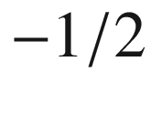

,

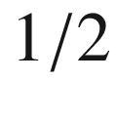

,

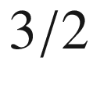

,

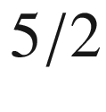

. ACM Trans. Math. Softw. **24**, 1–12 (1998). [10.​1145/​285861.​285862](https://doi.org/10.1145/285861.285862)

A.B. Sproul, M.A. Green, J. Zhao, Improved value for the silicon intrinsic carrier concentration at 300 K. Appl. Phys. Lett. **57**, 255–257 (1990). [10.​1063/​1.​349645](https://doi.org/10.1063/1.349645)

A.B. Sproul, M.A. Green, Intrinsic carrier concentration and minority-carrier mobility of silicon from 77 to 300 K. J. Appl. Phys. **73**, 1214–1225 (1993). [10.​1063/​1.​353288](https://doi.org/10.1063/1.353288)

M.A. Green, Intrinsic concentration, effective densities of states, and effective mass in silicon. J. Appl. Phys. **67**, 2944–2954 (1990). [10.​1063/​1.​345414](https://doi.org/10.1063/1.345414)

K. Misiakos, D. Tsamakis, Accurate measurements of the silicon intrinsic carrier density from 78 to 340 K. J. Appl. Phys. **74**, 3293–3297 (1993). [10.​1063/​1.​354551](https://doi.org/10.1063/1.354551)

B. Gudden, *Über die Elektrizitätsleitung in Halbleitern*, Sitzungsber. Phys.-Med. Soz. Erlangen **62**, 289–302 (1930)

B. Gudden, Elektrische Leitfähigkeit elektronischer Halbleiter, in: *Ergebnisse der Exakten Naturwissenschaften*, ed. by Schriftleitung der “Naturwissenschaften” (Springer, Berlin, 1934), pp. 223–256. [10.​1007/​978-3-642-94250-1\_​5](https://doi.org/10.1007/978-3-642-94250-1%255F5)

M. Grundmann, F.-L. Schein, M. Lorenz, T. Böntgen, J. Lenzner, H. von Wenckstern, Cuprous iodide - a p-type transparent semiconductor: history and novel applications. Phys. Status Solidi A **210**, 1671–1703 (2013). [10.​1002/​pssa.​201329349](https://doi.org/10.1002/pssa.201329349)

A. Zunger, Practical doping principles. Appl. Phys. Lett. **83**, 57–59 (2003). [10.​1063/​1.​1584074](https://doi.org/10.1063/1.1584074)

M. Ramamoorthy, S.T. Pantelides, Complex dynamical phenomena in heavily arsenic doped silicon. Phys. Rev. Lett. **76**, 4753–4756 (1996). [10.​1103/​PhysRevB.​75.​241203](https://doi.org/10.1103/PhysRevB.75.241203)

S. Lany, J. Osorio-Guillén, A. Zunger, Origins of the doping asymmetry in oxides: Hole doping in NiO versus electron doping in ZnO. Phys. Rev. B **75**, 241203:1–4 (2007). [10.​1103/​PhysRevB.​75.​241203](https://doi.org/10.1103/PhysRevB.75.241203)

W. Kohn, Shallow impurity states in semiconductors—the early years. Physica B **146**, 1–5 (1987). [10.​1016/​0378-4363(87)90046-5](https://doi.org/10.1016/0378-4363(87)90046-5)

A.K. Ramdas, Spectroscopy of shallow centers in semiconductors: Progress since 1960. Physica B **146**, 6–18 (1987). [10.​1016/​0378-4363(87)90047-7](https://doi.org/10.1016/0378-4363(87)90047-7)

S.M. Sze, K.K. Ng, *Physics of Semiconductor Devices*, 3rd edn. (Wiley, New York, 2007)

E.F. Schubert: *Doping in III–V Semiconductors* (Cambridge University Press, Cambridge, 1993). [10.​1017/​CBO9780511599828​](https://doi.org/10.1017/CBO9780511599828)

H.A. Bethe, Theory of the boundary layer of crystal rectifiers. MIT Radiation Lab. Rep. **43–12**, 1–26 (1942)

U. Heim, Evidence for donor-acceptor recombination in InP by time-resolved photoluminescence spectroscopy. Solid State Commun. **7**, 445–447 (1969). [10.​1016/​0038-1098(69)90893-X](https://doi.org/10.1016/0038-1098(69)90893-X)

W. Kohn, J.M. Luttinger, Theory of donor states in silicon. Phys. Rev. **98**, 915–922 (1955). [10.​1103/​PhysRev.​98.​915](https://doi.org/10.1103/PhysRev.98.915)

G. Feher, D.K. Wilson, E.A. Gere, Electron spin resonance experiments on shallow donors in germanium. Phys. Rev. Lett. **3**, 25–28 (1959). [10.​1103/​PhysRevLett.​3.​25](https://doi.org/10.1103/PhysRevLett.3.25)

R. Kalish, The search for donors in diamond. Diamond Rel. Mater. **10**, 1749–1755 (2001). [10.​1016/​S0925-9635(01)00426-5](https://doi.org/10.1016/S0925-9635(01)00426-5)

V.A. Karasyuk, D.G.S. Beckett, M.K. Nissen, A. Villemarie, T.W. Steiner, M.L.W. Thewalt, Fourier-transform magnetoluminescence spectroscopy of donor-bound excitons in GaAs. Phys. Rev. B **49**, 16381–16397 (1994). [10.​1103/​PhysRevB.​49.​16381](https://doi.org/10.1103/PhysRevB.49.16381)

U. Kaufmann, J. Schneider, Point defects in GaP, GaAs, and InP. Adv. Electron. Electr. Phys. **58**, 81–141 (1982). [10.​1016/​S0065-2539(08)61022-7](https://doi.org/10.1016/S0065-2539(08)61022-7)

W. Götz, N.M. Johnson, C. Chen, H. Liu, C. Kuo, W. Imler, Activation energies of Si donors in GaN. Appl. Phys. Lett. **68**, 3144–3146 (1996). [10.​1063/​1.​115805](https://doi.org/10.1063/1.115805)

A.J. Ptak, L.J. Holbert, L. Ting, C.H. Swartz, M. Moldovan, N.C. Giles, T.H. Myersa, P. Van Lierde, C. Tian, R.A. Hockett, S. Mitha, A.E. Wickenden, D.D. Koleske, R.L. Henry, Controlled oxygen doping of GaN using plasma assisted molecular-beam epitaxy. Appl. Phys. Lett. **79**, 2740–2742 (2001). [10.​1063/​1.​1403276](https://doi.org/10.1063/1.1403276)

S. Teitler, R.F. Wallis, Note on semiconductor statistics. J. Phys. Chem. Solids **16**, 71–75 (1960). [10.​1016/​0022-3697(60)90074-3](https://doi.org/10.1016/0022-3697(60)90074-3)

B. Šantić, On the determination of the statistical characteristics of the magnesium acceptor in GaN. Superlatt. Microstruct. **36**, 445–453 (2004). [10.​1016/​j.​spmi.​2004.​09.​008](https://doi.org/10.1016/j.spmi.2004.09.008)

R.M. Dickstein, S.L. Titcomb, R.L. Anderson, Carrier concentration model for n-type silicon at low temperatures. J. Appl. Phys. **66**, 2437–2441 (1989). [10.​1063/​1.​344253](https://doi.org/10.1063/1.344253)

J.S. Blakemore, Radiative Capture by Impurities in Semiconductors. Phys. Rev. **163**, 809–815 (1967). [10.​1103/​PhysRev.​163.​809](https://doi.org/10.1103/PhysRev.163.809)

H.B. Bebb, Comments on radiative capture by impurities in semiconductors. Phys. Rev. B **5**, 4201–4203 (1972). [10.​1103/​PhysRevB.​5.​4201](https://doi.org/10.1103/PhysRevB.5.4201)

J.W. Harrison, J.R. Hauser, Alloy scattering in ternary III-V compounds. Phys. Rev. B **13**, 5347–5350 (1976). [10.​1103/​PhysRevB.​13.​5347](https://doi.org/10.1103/PhysRevB.13.5347)

V.W.L. Chin, T.L. Tansley, Alloy scattering and lattice strain effects on the electron mobility in In

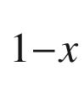

Ga

$$_x$$

As. Solid State Electron. **34**, 1055–1063 (1991). [10.​1016/​0038-1101(91)90100-D](https://doi.org/10.1016/0038-1101(91)90100-D)

W. Zhao, D. Jena, Dipole scattering in highly polar semiconductor alloys. J. Appl. Phys. **96**, 2095–2101 (2004). [10.​1063/​1.​1767615](https://doi.org/10.1063/1.1767615)

R. Stratton, Dipole scattering from ion pairs in compensated semiconductors. J. Phys. Chem. Solids **23**, 1011–1017 (1962). [10.​1016/​0022-3697(62)90159-2](https://doi.org/10.1016/0022-3697(62)90159-2)

P.P. Debye, E.M. Conwell, Electrical properties of n-type germanium. Phys. Rev. **93**, 693–706 (1954). [10.​1103/​PhysRev.​93.​693](https://doi.org/10.1103/PhysRev.93.693)

G.W. Brown, H. Grube, M.E. Hawley, Observation of buried phosphorus dopants near clean Si(100)-(2

$$\times $$

1) surfaces with scanning tunneling microscopy. Phys. Rev. B **70**, 121301:1–4 (2004). [10.​1103/​PhysRevB.​70.​121301](https://doi.org/10.1103/PhysRevB.70.121301)

A.T. Collins, A.W.S. Williams, The nature of the acceptor centre in semiconducting diamond. J. Phys. C: Solid State Phys. **4**, 1789–1800 (1971). [10.​1088/​0022-3719/​4/​13/​030](https://doi.org/10.1088/0022-3719/4/13/030)

K. Thonke, The boron acceptor in diamond. Semicond. Sci. Technol. **18**, S20–S26 (2003). [10.​1088/​0268-1242/​18/​3/​303](https://doi.org/10.1088/0268-1242/18/3/303)

H. Alves, *Defects, Doping and Compensation in Wide Bandgap Semiconductors*, Ph.D. Thesis, Universität Giessen (2003)

S. Fischer, C. Wetzel, E.E. Haller, B.K. Meyer, On p-type doping in GaN—acceptor binding energies. Appl. Phys. Lett. **67**, 1298–1300 (1995). [10.​1063/​1.​114403](https://doi.org/10.1063/1.114403)

W. Kohn, Shallow impurity states in silicon and germanium. Solid State Phys. **5**, 257–320 (1957). [10.​1016/​S0081-1947(08)60104-6](https://doi.org/10.1016/S0081-1947(08)60104-6)

K.Ya. Shtivel’man, R.G. Useinov, Degeneracy multiplicity of the states of two-charge acceptors in semiconductors. Soviet Phys. J. **17**, 1439–1440 (1974). [10.​1007/​BF00891303](https://doi.org/10.1007/BF00891303)

D.C. Look, *Electrical Characterization of GaAs Materials and Devices* (Wiley, New York, 1989)

E.M. Conwell, Hall effect and density of states in germanium. Phys. Rev. **99**, 1195–1198 (1955). [10.​1103/​PhysRev.​99.​1195](https://doi.org/10.1103/PhysRev.99.1195)

E.E. Haller, W.L. Hansen, F.S. Goulding, Physics of ultra-pure germanium. Adv. Phys. **30**, 93–138 (1981). [10.​1080/​0001873810010135​7](https://doi.org/10.1080/00018738100101357)

M.B. Johnson, O. Albrektsen, R.M. Feenstra, H.W.M. Salemink, Direct imaging of dopants in GaAs with cross-sectional scanning tunneling microscopy. Appl. Phys. Lett. **63**, 2923–2925 (1993). [10.​1063/​1.​111999](https://doi.org/10.1063/1.111999) Erratum: Appl. Phys. Lett. **64**, 1454 (1994). [10.​1063/​1.​110274](https://doi.org/10.1063/1.110274)

A.M. Yakunin, A.Yu. Silov, P.M. Koenraad, J.H. Wolter, W. Van Roy, J. De Boeck, J.-M. Tang, M.E. Flatté, Spatial Structure of an Individual Mn Acceptor in GaAs. Phys. Rev. Lett. **92**, 216806:1–4 (2004). [10.​1103/​PhysRevLett.​92.​216806](https://doi.org/10.1103/PhysRevLett.92.216806)

J.-M. Tang, M. Flatté, Multiband tight-binding model of local magnetism in Ga



Mn

$$_x$$

As. Phys. Rev. Lett. **92**, 047201:1–4 (2004). [10.​1103/​PhysRevLett.​92.​047201](https://doi.org/10.1103/PhysRevLett.92.047201)

J.S. Blakemore, *Semiconductor Statistics* (Pergamon Press, Oxford, 1962)

N.B. Hannay ed., *Semiconductors* (Reinhold Publ. Corp, New York, 1959)

G. Leibiger, *A*

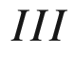

*B*

$$^{V}$$

*-Mischkristallbildung mit Stickstoff und Bor*, Ph.D. Thesis, Universität Leipzig (2003)

E. Ziegler, W. Siegel, Determination of two donor (majority) levels in semiconductors from Hall effect measurements. Crystal Res. Technol. **17**, 1015–1024 (1982). [10.​1002/​crat.​2170170822](https://doi.org/10.1002/crat.2170170822)

H.-J. Hoffmann, Defect-level analysis of semiconductors by a new differential evaluation of

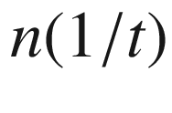

-characteristics. Appl. Phys. **19**, 307–312 (1979). [10.​1007/​BF00900474](https://doi.org/10.1007/BF00900474)

M. Tao, A kinetic model for metalorganic chemical vapor deposition from trimethylgallium and arsine. J. Appl. Phys. **87**, 3554–3562 (2000). [10.​1063/​1.​372380](https://doi.org/10.1063/1.372380)

G. Weyer, J.W. Petersen, S. Damgaard, H.L. Nielsen, J. Heinemeier, Site-selective doping of compound semiconductors by ion implantation of radioactive nuclei. Phys. Rev. Lett. **44**, 155–157 (1980). [10.​1103/​PhysRevLett.​44.​155](https://doi.org/10.1103/PhysRevLett.44.155)

E. Antoncik, B.L. Gu, On the Mössbauer isomer shift studies of the electronic structure of Sn implanted A

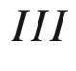

B

$$^V$$

compounds. Hyperfine Interactions **14**, 257–269 (1983). [10.​1007/​BF02043477](https://doi.org/10.1007/BF02043477)

R. Noufi, R. Axton, C. Herrington, S.K. Deb, Electronic properties versus composition of thin films of CuInSe

$$_2$$

. Appl. Phys. Lett. **45**, 668–670 (1994). [10.​1063/​1.​95350](https://doi.org/10.1063/1.95350)

T.R. Paudel, A. Zakutayev, S. Lany, M. d’Avezac, A. Zunger, Doping rules and doping prototypes in A

$$_2$$

BO

$$_4$$

spinel oxides. Adv. Funct. Mater. **21**, 4493–4501 (2011). [10.​1002/​adfm.​201101469](https://doi.org/10.1002/adfm.201101469)

J.D. Perkins, T.R. Paudel, A. Zakutayev, P. Ndione, P.A. Parilla, S. Lany, D.S. Ginley, Y. Shi, J.S. Bettinger, M.F. Toney, Inverse design approach to hole doping in ternary oxides: Enhancing p-type conductivity in cobalt oxide spinels. Phys. Rev. B **84**, 205207:1–8 (2011). [10.​1103/​PhysRevB.​84.​205207](https://doi.org/10.1103/PhysRevB.84.205207)

N.F. Mott, *Metal-insulator Transitions* (Taylor and Francis, London, 1990)

V.I. Fistul, *Highly Doped Semiconductors* (Springer, New York, 1969). [10.​1007/​978-1-4684-8821-0](https://doi.org/10.1007/978-1-4684-8821-0)

B.L. Crowder, W.N. Hammer, Shallow acceptor states in ZnTe and CdTe. Phys. Rev. **150**, 541–545 (1966). [10.​1103/​PhysRev.​150.​541](https://doi.org/10.1103/PhysRev.150.541)

G.L. Pearson, J. Bardeen, electrical properties of pure silicon and silicon alloys containing boron and phosphorous. Phys. Rev. **75**, 865–883 (1949). [10.​1103/​PhysRev.​75.​865](https://doi.org/10.1103/PhysRev.75.865)

G.E. Stillman, L.W. Cook, T.J. Roth, T.S. Low, B.J. Skromme, High-purity material, in *GaInAsP Alloy Semiconductors*, ed. by T.P. Pearsall (Wiley, New York, 1982), pp. 121–166

T.F. Lee, T.C. McGill, Variation of impurity-to-band activation energies with impurity density. J. Appl. Phys. **46**, 373–380 (1975). [10.​1063/​1.​321346](https://doi.org/10.1063/1.321346)

M.L. Young, S.J. Bass, The electrical properties of undoped and oxygen- doped GaP grown by the liquid encapsulation technique. J. Phys. D: Appl. Phys. **4**, 995–1005 (1971). [10.​1088/​0022-3727/​4/​7/​317](https://doi.org/10.1088/0022-3727/4/7/317)

H.C. Casey Jr., F. Ermanis, K.B. Wolfstirn, Variation of electrical properties with Zn concentration in GaP. J. Appl. Phys. **40**, 2945–2958 (1969). [10.​1063/​1.​1658106](https://doi.org/10.1063/1.1658106)

K. Pakula, M. Wojdak, M. Palczewska, B. Suchanek, J.M. Baranowski, Luminescence and ESR spectra of GaN:Si below and above Mott transition. MRS Internet J. Nitride Semicond. Res. **3**, e34:1–4 (1998). [10.​1557/​S109257830000106​X](https://doi.org/10.1557/S109257830000106X)

G.R. James, A.W.R. Leitch, F. Omnès, M.C. Wagener, M. Leroux, Correlation of transport and optical properties of Si-doped Al

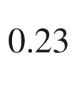

Ga

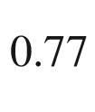

N. J. Appl. Phys. **96**, 1047–1052 (2004) (The printed paper title reads ’Al

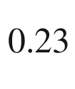

G

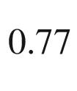

N’). [10.​1063/​1.​1760235](https://doi.org/10.1063/1.1760235)

M. Brandt, H. von Wenckstern, C. Meinecke, T. Butz, H. Hochmuth, M. Lorenz, M. Grundmann, Dopant activation in homoepitaxial MgZnO:P thin films. J. Vac. Sci. Technol. B **27**, 1604–1608 (2009). [10.​1116/​1.​3086657](https://doi.org/10.1116/1.3086657)

H. Kato, M. Sano, K. Miyamoto, T. Yao, Growth and characterization of Ga-doped ZnO layers on a-plane sapphire substrates grown by molecular beam epitaxy. J. Cryst. Growth **237–239**, 538–543 (2002). [10.​1016/​S0022-0248(01)01972-8](https://doi.org/10.1016/S0022-0248(01)01972-8)

H. Kato, A. Ogawa, H. Kotani, M. Sano, T. Yao, Effects of polarity on MBE growth of undoped, Ga- and N-doped ZnO films, MRS Fall Meeting 2006, Boston, Symp. K (’Zinc Oxide and Related Materials’), K5.6 (2006)

Z.-L. Lu, W.-Q. Zou, M.-X. Xu, F.-M. Zhang, Y.-W. Du, Structural and electrical properties of single crystalline Ga-doped ZnO thin films grown by molecular beam epitaxy. Chin. Phys. Lett. **26**, 116102:1–4 (2009). [10.​1088/​0256-307X/​26/​11/​116102](https://doi.org/10.1088/0256-307X/26/11/116102)

M.C. Wu, Y.K. Su, K.Y. Cheng, C.Y. Chang, Electrical and optical properties of heavily doped Mg- and Te-GaAs grown by liquid-phase epitaxy. Solid State Electron. **31**, 251–256 (1988). [10.​1016/​0038-1101(88)90137-2](https://doi.org/10.1016/0038-1101(88)90137-2)

M. Ogawa, T. Baba, Heavily Si-doped GaAs and AlAs/n-GaAs superlattice grown by molecular epitaxy. Jpn. J. Appl. Phys. **24**, L572–L574 (1985). [10.​1143/​JJAP.​24.​L572](https://doi.org/10.1143/JJAP.24.L572)

T. Yamada, E. Tokumitsu, K. Saito, T. Akatsuka, M. Miyauchi, M. Konagai, K. Takahashi, Heavily carbon doped p-Type GaAs and GaAlAs grown by metalorganic molecular beam epitaxy. J. Cryst. Growth **95**, 145–149 (1989). [10.​1016/​0022-0248(89)90369-2](https://doi.org/10.1016/0022-0248(89)90369-2)

J.L. Liévin, F. Alexandre, C. Dubon-Chevallier, Molecular beam epitaxy of Ga

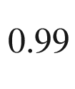

Be

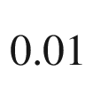

As for very high speed heterojunction bipolar transistors, in: *Properties of Impurity States in Superlattice Semiconductors*, NATO ASI Series B: Physics, Vol. 183, eds. by C.Y. Fong, I.P. Batra, S. Ciraci (Plenum, New York, 1988), pp. 19–28. [10.​1007/​978-1-4684-5553-3\_​3](https://doi.org/10.1007/978-1-4684-5553-3%255F3)

W. Yang, J. Mathews, J.S. Williams, Hyperdoping of Si by ion implantation and pulsed laser melting. Mat. Sci. Semicond. Processing **62**, 103–114 (2017). [10.​1016/​j.​mssp.​2016.​11.​005](https://doi.org/10.1016/j.mssp.2016.11.005)

S. Zhou, F. Liu, S. Prucnal, K. Gao, M. Khalid, C. Baehtz, M. Posselt, W. Skorupa, M. Helm, Hyperdoping silicon with selenium: solid versus liquid phase epitaxy. Sci. Rep. **5**, 8329:1–7 (2015). [10.​1038/​srep08329](https://doi.org/10.1038/srep08329)

J. Bourgoin, M. Lannoo, *Point Defects in Semiconductors II* (Springer, Berlin, 1983). [10.​1007/​978-3-642-81832-5](https://doi.org/10.1007/978-3-642-81832-5)

S.T. Pantelides, ed., *Deep Centers in Semiconductors* (Gordon and Breach, New York, 1986)

J.-W. Chen, A.G. Milnes, Energy levels in silicon. Ann. Rev. Mat. Sci. **10**, 157–228 (1980). [10.​1146/​annurev.​ms.​10.​080180.​001105](https://doi.org/10.1146/annurev.ms.10.080180.001105)

K. Lischka, Deep level defects in narrow gap semiconductors. Phys. Status Solidi B **133**, 17–46 (1986). [10.​1002/​pssb.​2221330104](https://doi.org/10.1002/pssb.2221330104)

J.-M. Spaeth, H. Overhof, P*oint Defects in Semiconductors and Insulators, Determination of Atomic and Electronic Structure from Paramagnetic Hyperfine Interactions* (Springer, Berlin, 2003). [10.​1007/​978-3-642-55615-9](https://doi.org/10.1007/978-3-642-55615-9)

P.T. Landsberg, Degeneracy factors of traps from solubility data for semiconductors. J. Phys. D: Appl. Phys. **10**, 2467–2471 (1977). [10.​1088/​0022-3727/​10/​18/​011](https://doi.org/10.1088/0022-3727/10/18/011)

H.I. Ralph, The degeneracy factor of the gold acceptor level in silicon. J. Appl. Phys. **49**, 672–675 (1978). [10.​1063/​1.​324642](https://doi.org/10.1063/1.324642)

R. Kassing, L. Cohausz, P. van Staa, W. Mackert, H.J. Hoffman, Determination of the entropy-factor of the gold donor level in silicon by resistivity and DLTS measurements. Appl. Phys. A **34**, 41–47 (1984). [10.​1007/​BF00617573](https://doi.org/10.1007/BF00617573)

H.H. Woodbury, G.W. Ludwig, Spin resonance of transition metals in silicon. Phys. Rev. **117**, 102–108 (1960). [10.​1103/​PhysRev.​117.​102](https://doi.org/10.1103/PhysRev.117.102)

S. Greulich-Weber, J.R. Niklas, E.R. Weber, J.M. Spaeth, Electron nuclear double resonance of interstitial iron in silicon. Phys. Rev. B **30**, 6292–6299 (1984). [10.​1103/​PhysRevB.​30.​6292](https://doi.org/10.1103/PhysRevB.30.6292)

H. Feichtinger, J. Waltl, A. Gschwandtner, Localization of the Fe

$$^{\circ }$$

-level in silicon. Solid State Commun. **27**, 867–871 (1978). [10.​1016/​0038-1098(78)90194-1](https://doi.org/10.1016/0038-1098(78)90194-1)

Y.H. Lee, R.L. Kleinhenz, J.W. Corbett, EPR of a thermally induced defect in silicon. Appl. Phys. Lett. **31**, 142–144 (1977). [10.​1063/​1.​89630](https://doi.org/10.1063/1.89630)

H.G. Grimmeiss, E. Janzén, H. Ennen, O. Schirmer, J. Schneider, R. Wörner, C. Holm, E. Sirtl, P. Wagner, Tellurium donors in silicon. Phys. Rev. B **24**, 4571–4586 (1981). [10.​1103/​PhysRevB.​24.​4571](https://doi.org/10.1103/PhysRevB.24.4571)

H.G. Grimmeiss, L. Montelius, K. Larsson, Chalcogens in germanium. Phys. Rev. B **37**, 6916–6928 (1988). [10.​1103/​PhysRevB.​37.​6916](https://doi.org/10.1103/PhysRevB.37.6916)

R.K. Franks, J.B. Robertson, Magnesium as a donor impurity in silicon. Solid State Commun. **5**, 479–481 (1967). [10.​1016/​0038-1098(67)90598-4](https://doi.org/10.1016/0038-1098(67)90598-4)

U. Kaufmann, J. Schneider, R. Wörner, T.A. Kennedy, N.D. Wilsey, The deep double donor P

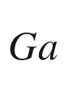

in GaP. J. Phys. C: Solid State Phys. **14**, L951–L955 (1981). [10.​1088/​0022-3719/​14/​31/​005](https://doi.org/10.1088/0022-3719/14/31/005)

R.J. Wagner, J.J. Krebs, G.H. Strauss, A.M. White, Submillimeter EPR evidence for the As antisite defect in GaAs. Solid State Commun. **36**, 15–17 (1980). [10.​1016/​0038-1098(93)90263-M](https://doi.org/10.1016/0038-1098(93)90263-M)

C.H. Champness, The statistics of divalent impurity centres in a semiconductor. Proc. Phys. Soc. B **69**, 1335–1339 (1956). [10.​1088/​0370-1301/​69/​12/​421](https://doi.org/10.1088/0370-1301/69/12/421)

R. Schaub, G. Pensl, M. Schulz, C. Holm, Donor states in tellurium-doped silicon. Appl. Phys. A **34**, 215–222 (1984). [10.​1007/​BF00616575](https://doi.org/10.1007/BF00616575)

R.O. Carlson, Double-acceptor behavior of zinc in silicon. Phys. Rev. **108**, 1390–1393 (1957). [10.​1103/​PhysRev.​108.​1390](https://doi.org/10.1103/PhysRev.108.1390)

W.W. Tyler, H.H. Woodbury, Scattering of carriers from doubly charged impurity sites in germanium. Phys. Rev. **102**, 647–655 (1956). [10.​1103/​PhysRev.​102.​647](https://doi.org/10.1103/PhysRev.102.647)

M.D. Sturge, The Jahn-Teller effect in solids. Solid State Phys. **20**, 91–211 (1968). [10.​1016/​S0081-1947(08)60218-0](https://doi.org/10.1016/S0081-1947(08)60218-0)

G.D. Watkins, Negative-U properties for defects in solids. Adv. Solid State Phys. (Festkörperprobleme) **24**, 163–189 (1984). [10.​1007/​BFb0107450](https://doi.org/10.1007/BFb0107450)

G.D. Watkins, J.R. Troxell, Negative-U properties for point defects in silicon. Phys. Rev. Lett. **44**, 593–596 (1980). [10.​1103/​PhysRevLett.​44.​593](https://doi.org/10.1103/PhysRevLett.44.593)

P.W. Anderson, Model for the electronic structure of amorphous semiconductors. Phys. Rev. Lett. **34**, 953–955 (1975). [10.​1103/​PhysRevLett.​34.​953](https://doi.org/10.1103/PhysRevLett.34.953)

R.D. Harris, J.L. Newton, G.D. Watkins, Negative-



defect: Interstitial boron in silicon. Phys. Rev. B **36**, 1094–1104 (1987). [10.​1103/​PhysRevB.​36.​1094](https://doi.org/10.1103/PhysRevB.36.1094)

G.A. Baraff, E.O. Kane, M. Schlüter, Theory of the silicon vacancy: An Anderson negative-



system. Phys. Rev. B **21**, 5662–5686 (1980). [10.​1103/​PhysRevB.​21.​5662](https://doi.org/10.1103/PhysRevB.21.5662)

M. Sprenger, S.H. Muller, E.G. Sieverts, C.A.J. Ammerlaan, Vacancy in silicon: Hyperfine interactions from electron-nuclear double resonance measurements. Phys. Rev. B **35**, 1566–1581 (1987). [10.​1103/​PhysRevB.​35.​1566](https://doi.org/10.1103/PhysRevB.35.1566)

A.F. Wright, Density-functional-theory calculations for the silicon vacancy. Phys. Rev. B **74**, 165116:1–8 (2006). [10.​1103/​PhysRevB.​74.​165116](https://doi.org/10.1103/PhysRevB.74.165116)

A. Fazzio, A. Janotti, A.J.R. da Silva, Microscopic picture of the single vacancy in germanium. Phys. Rev. B **61**, R2401–R2404 (2000). [10.​1103/​PhysRevB.​61.​R2401](https://doi.org/10.1103/PhysRevB.61.R2401)

P.M. Mooney, N.S. Caswell, S.L. Wright, The capture barrier of the DX center in Si-doped Al

$$_x$$

Ga

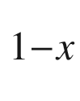

As. J. Appl. Phys. **62**, 4786–4797 (1987). [10.​1063/​1.​338981](https://doi.org/10.1063/1.338981)

P.M. Mooney, Deep donor levels (DX centers) in III-V semiconductors. J. Appl. Phys. **67**, R1–R26 (1990). [10.​1063/​1.​345628](https://doi.org/10.1063/1.345628)

J.C. Bourgoin, ed., *Physics of DX Centers in GaAs Alloys* (Sci-Tech, Lake Isabella, CA, 1990). [10.​4028/​www.​scientific.​net/​SSP.​10](https://doi.org/10.4028/www.scientific.net/SSP.10)

D.V. Lang, R.A. Logan, Large-lattice-relaxation model for persistent photoconductivity in compound semiconductors. Phys. Rev. Lett. **39**, 635–639 (1977). [10.​1103/​PhysRevLett.​39.​635](https://doi.org/10.1103/PhysRevLett.39.635)

J. Mäkinen, T. Laine, K. Saarinen, P. Hautojärvi, C. Corbel, V.M. Airaksinen, J. Nagle, Microscopic structure of the DX center in Si-doped Al

$$_x$$

Ga

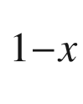

As: Observation of a vacancy by positron-annihilation spectroscopy. Phys. Rev. B **52**, 4870–4883 (1995). [10.​1103/​PhysRevB.​52.​4870](https://doi.org/10.1103/PhysRevB.52.4870)

J. Dabrowski, M. Scheffler, Isolated arsenic-antisite defect in GaAs and the properties of EL2. Phys. Rev. B **40**, 10391–10401 (1989). [10.​1103/​PhysRevB.​40.​10391](https://doi.org/10.1103/PhysRevB.40.10391)

G.M. Martin, Optical assessment of the main electron trap in bulk semi-insulating GaAs. Appl. Phys. Lett. **39**, 747–748 (1981). [10.​1063/​1.​92852](https://doi.org/10.1063/1.92852)

J.S. Blakemore, Semiconducting and other major properties of gallium arsenide. J. Appl. Phys. **53**, R123–R181 (1982). [10.​1063/​1.​331665](https://doi.org/10.1063/1.331665)

A. Rohatgi, R.H. Hopkins, J.R. Davis, R.B. Campbell, H.C. Mollenkopf, J.R. McCormick, The impact of molybdenum on silicon and silicon solar cell performance. Solid State Electron. **23**, 1185–1190 (1980). [10.​1016/​0038-1101(80)90032-5](https://doi.org/10.1016/0038-1101(80)90032-5)

D.C. Look, The electrical characterization of semi-insulating GaAs: A correlation with mass-spectrographic analysis. J. Appl. Phys. **48**, 5141–5148 (1977). [10.​1063/​1.​323593](https://doi.org/10.1063/1.323593)

O. Mizuno, H. Watanabe, Semi-insulating properties of Fe-doped InP. Electron. Lett. **11**, 118–119 (1975). [10.​1049/​el:​19750089](https://doi.org/10.1049/el:19750089)

Y. Toudic, B. Lambert, R. Coquille, G. Grandpierre, M. Gauneau, Chromium-doped p-type semi-insulating InP. Semicond. Sci. Technol. **3**, 464–468 (1988). [10.​1088/​0268-1242/​3/​5/​008](https://doi.org/10.1088/0268-1242/3/5/008)

R.P. Tapster, M.S. Skolnick, R.G. Humphreys, P.J. Dean, B. Cockayne, W.T. MacEwan, Optical and capacitance spectroscopy of InP:Fe. J. Phys. C: Solid State Phys. **14**, 5069–5079 (1981). [10.​1088/​0022-3719/​14/​33/​016](https://doi.org/10.1088/0022-3719/14/33/016)

A. Juhl, A. Hoffmann, D. Bimberg, H.J. Schulz, Bound-exciton-related fine structure in charge transfer spectra of InP:Fe detected by calorimetric absorption spectroscopy. Appl. Phys. Lett. **50**, 1292–1294 (1987). [10.​1063/​1.​97888](https://doi.org/10.1063/1.97888)

A.M. Hennel, Transition metals in III/V compounds. Semicond. Semimet. **38**, 189–234 (1993). [10.​1016/​S0080-8784(08)62801-X](https://doi.org/10.1016/S0080-8784(08)62801-X)

H.J. Schulz, Optical properties of 3d transition metals in II-VI compounds. J. Cryst. Growth **59**, 65–80 (1982). [10.​1016/​0022-0248(82)90308-6](https://doi.org/10.1016/0022-0248(82)90308-6)

J. Cheng, S.R. Forrest, B. Tell, D. Wilt, B. Schwartz, P.D. Wright, Semi-insulating properties of Fe-implanted InP. I. Current-limiting properties of

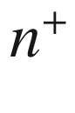

-semi-insulating-

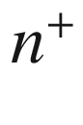

structures. J. Appl. Phys. **58**, 1780–1786 (1985). [10.​1063/​1.​336028](https://doi.org/10.1063/1.336028)

D.G. Knight, W.T. Moore, R. Bruce, Growth of semi-insulating InGaAsP alloys using low-pressure MOCVD. J. Cryst. Growth **124**, 352–357 (1992). [10.​1016/​0022-0248(92)90483-Y](https://doi.org/10.1016/0022-0248(92)90483-Y)

A. Dadgar, O. Stenzel, A. Näser, M. Zafar Iqbal, D. Bimberg, H. Schumann, Ruthenium: A superior compensator of InP. Appl. Phys. Lett. **73**, 3878–3880 (1998) [10.​1063/​1.​122898](https://doi.org/10.1063/1.122898)

D. Söderström, G. Fornuto, A. Buccieri, Studies on InP:Fe growth in a close-spaced showerhead MOVPE reactor, in *Proceedings 10th European Workshop on MOVPE* (Lecce, Italy, 2003), PS.IV.01:1–4. [10.​1285/​i9788883050088p1​53](https://doi.org/10.1285/i9788883050088p153)

R.A. Faulkner, Toward a theory of isoelectronic impurities in semiconductors. Phys. Rev. **175**, 991–1009 (1968). [10.​1103/​PhysRev.​175.​991](https://doi.org/10.1103/PhysRev.175.991)

P.J. Dean, Recombination processes associated with “Deep States” in gallium phosphide. J. Lumin. **1–2**, 398–419 (1970). [10.​1016/​0022-2313(70)90054-2](https://doi.org/10.1016/0022-2313(70)90054-2)

R. Schwabe, W. Seifert, F. Bugge, R. Bindemann, V.F. Agekyan, S.V. Pogarev, Photoluminescence of nitrogen-doped VPE GaAs. Solid State Commun. **55**, 167–173 (1985). [10.​1016/​0038-1098(85)90272-8](https://doi.org/10.1016/0038-1098(85)90272-8)

X. Liu, M.-E. Pistol, L. Samuelson, Excitons bound to nitrogen pairs in GaAs. Phys. Rev. B **42**, 7504–7512 (1990). [10.​1103/​PhysRevB.​42.​7504](https://doi.org/10.1103/PhysRevB.42.7504)

B. Gil, J.P. Albert, J. Camassel, H. Mathieu, C. Benoit à la Guillaume, Model calculation of nitrogen properties in III–V compounds. Phys. Rev. B **33**, 2701–2712 (1986). [10.​1103/​PhysRevB.​33.​2701](https://doi.org/10.1103/PhysRevB.33.2701)

D.G. Thomas, J.J. Hopfield, Isoelectronic traps due to nitrogen in gallium phosphide. Phys. Rev. **150**, 680–689 (1966). [10.​1103/​PhysRev.​150.​680](https://doi.org/10.1103/PhysRev.150.680)

W. Mönch, *Semiconductor Surfaces and Interfaces* (Springer, Berlin, 2001). [10.​1007/​978-3-662-04459-9](https://doi.org/10.1007/978-3-662-04459-9)

Y. Rosenwaks, R. Shikler, Th. Glatzel, S. Sadewasser, Kelvin probe force microscopy of semiconductor surface defects. Phys. Rev. B **70**, 085320:1–7 (2004). [10.​1103/​PhysRevB.​70.​085320](https://doi.org/10.1103/PhysRevB.70.085320)

W. Mönch, Branch-point energies and the band-structure lineup at Schottky contacts and heterostrucures. J. Appl. Phys. **109**, 113724:1–10 (2011). [10.​1063/​1.​3592978](https://doi.org/10.1063/1.3592978)

J. Tersoff, Theory of semiconductor heterojunctions: The role of quantum dipoles. Phys. Rev. B **30**, 4874–4877 (1984). [10.​1103/​PhysRevB.​30.​4874](https://doi.org/10.1103/PhysRevB.30.4874)

E.P. Shapera, A. Schleife, Database-driven materials selection for semiconductor heterojunction design. Adv. Theory and Simul. **2018**, 1800075:1–13 (2018). [10.​1002/​adts.​201800075](https://doi.org/10.1002/adts.201800075)

W. Walukiewicz, Amphoteric native defects in semiconductors. Appl. Phys. Lett. **54**, 2094–2096 (1989). [10.​1063/​1.​101174](https://doi.org/10.1063/1.101174)

E. Mollwo, Die Wirkung von Wasserstoff auf die Leitfähigkeit und Lumineszenz von Zinkoxydkristallen. Z. Phys. **138**, 478–488 (1954). [10.​1007/​BF01340694](https://doi.org/10.1007/BF01340694)

J.I. Pankove, N.M. Johnson, eds., Hydrogen in Semiconductors. Semicond. Semimet. **34**, (1991). [10.​1016/​S0080-8784(08)62855-0](https://doi.org/10.1016/S0080-8784(08)62855-0)

S.J. Pearton, J.W. Corbett, M. Stavola, *Hydrogen in Crystalline Semiconductors* (Springer, Berlin, 1992). [10.​1007/​978-3-642-84778-3](https://doi.org/10.1007/978-3-642-84778-3)

T. Sakurai, H.D. Hagstrum, Hydrogen chemisorption on the silicon (110)

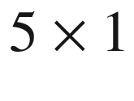

surface. J. Vac. Sci. Technol. **13**, 807–809 (1976). [10.​1116/​1.​568994](https://doi.org/10.1116/1.568994)

J.I. Pankove, Photoluminescence recovery in rehydrogenated amorphous silicon. Appl. Phys. Lett. **32**, 812–813 (1978). [10.​1063/​1.​89925](https://doi.org/10.1063/1.89925)

M.H. Brodsky, M. Cardona, J.J. Cuomo, Infrared and Raman spectra of the silicon-hydrogen bonds in amorphous silicon prepared by glow discharge and sputtering. Phys. Rev. B **16**, 3556–3571 (1977). [10.​1103/​PhysRevB.​16.​3556](https://doi.org/10.1103/PhysRevB.16.3556)

P.J.H. Denteneer, C.G. Van de Walle, S.T. Pantelides, Microscopic structure of hydrogen-boron complex in crystalline silicon. Phys. Rev. B **39**, 10809–10824 (1989). [10.​1103/​PhysRevB.​39.​10809](https://doi.org/10.1103/PhysRevB.39.10809)

C.P. Herrero, M. Stutzmann, Microscopic structure of boron-hydrogen complexes in crystalline silicon. Phys. Rev. B **38**, 12668–12671 (1988). [10.​1103/​PhysRevB.​38.​12668](https://doi.org/10.1103/PhysRevB.38.12668)

M. Stavola, K. Bergmann, S.J. Pearton, J. Lopata, Hydrogen motion in defect complexes: reorientation kinetics of the B-H complex in silicon. Phys. Rev. Lett. **61**, 2786–2789 (1988). [10.​1103/​PhysRevLett.​61.​2786](https://doi.org/10.1103/PhysRevLett.61.2786)

V.P. Markevich, A.R. Peaker, J. Coutinho, R. Jones, V.J.B. Torres, S. Öberg, P.R. Briddon, L.I. Murin, L. Dobaczewski, N.V. Abrosimov, Structure and properties of vacancy-oxygen complexes in Si



Ge

$$_x$$

alloys. Phys. Rev. B **69**, 125218:1–11 (2004). [10.​1103/​PhysRevB.​69.​125218](https://doi.org/10.1103/PhysRevB.69.125218)

V.P. Markevich, L.I. Murin, M. Suezawa, J.L. Lindström, J. Coutinho, R. Jones, P.R. Briddon, S. Öberg, Observation and theory of the V-O-H

$$_2$$

complex in silicon. Phys. Rev. B **61**, 12964–12969 (2000). [10.​1103/​PhysRevB.​61.​12964](https://doi.org/10.1103/PhysRevB.61.12964)

A.S. Yapsir, P. Deák, R.K. Singh, L.C. Snyder, J.W. Corbett, T.-M. Lu, Hydrogen passivation of a substitutional sulfur defect in silicon. Phys. Rev. B **38**, 9936–9940 (1988). [10.​1103/​PhysRevB.​38.​9936](https://doi.org/10.1103/PhysRevB.38.9936)

K. Seeger, *Semiconductor Physics, An Introduction*, 9th edn. (Springer, Berlin, 2004). [10.​1007/​978-3-662-09855-4](https://doi.org/10.1007/978-3-662-09855-4)

M. Lundstrom, *Fundamentals of Carrier Transport*, 2nd edn. (Cambridge University Press, Cambridge, 2000). [10.​1017/​CBO9780511618611​](https://doi.org/10.1017/CBO9780511618611)

H.-D. Liu, Y.-P. Zhao, G. Ramanath, S.P. Murarka, G.-C. Wang, Thickness dependent electrical resistivity of ultrathin (

$$&lt;$$

40 nm) Cu films. Thin Solid Films **384**, 151–156 (2001). [10.​1016/​S0040-6090(00)01818-6](https://doi.org/10.1016/S0040-6090(00)01818-6)

C. Jacoboni, L. Reggiani, Bulk hot-electron properties of cubic semiconductors. Adv. Phys. **28**, 493–553 (1979). [10.​1080/​0001873790010140​5](https://doi.org/10.1080/00018737900101405)

E.M. Conwell, V. Weisskopf, Theory of impurity scattering in semiconductors. Phys. Rev. **77**, 388–390 (1950). [10.​1103/​PhysRev.​77.​388](https://doi.org/10.1103/PhysRev.77.388)

H. Brooks, Scattering by ionized impurities in semiconductors. Phys. Rev. **83**, 879 (1951). [10.​1103/​PhysRev.​83.​868](https://doi.org/10.1103/PhysRev.83.868)

B.K. Ridley, Reconciliation of the Conwell-Weisskopf and Brooks-Herring formulae for charged-impurity scattering in semiconductors: Third-body interference. J. Phys. C: Solid State Phys. **10**, 1589–1593 (1977). [10.​1088/​0022-3719/​10/​10/​003](https://doi.org/10.1088/0022-3719/10/10/003)

D.C. Chattopadhyay, H.J. Queisser, Electron scattering by ionized impurities in semiconductors. Rev. Mod. Phys. **53**, 745–768 (1981). [10.​1103/​RevModPhys.​53.​745](https://doi.org/10.1103/RevModPhys.53.745)

B.K. Ridley, *Quantum Processes in Semiconductors*, 5th edn. (Clarendon Press, Oxford, 2013). [10.​1093/​acprof:​oso/​9780199677214.​001.​0001](https://doi.org/10.1093/acprof:oso/9780199677214.001.0001)

D.B.M. Klaasen, A unified model for device simulation-I. Model equations and concentration dependence. Solid State Electron. **35**, 953–959 (1992). [10.​1016/​0038-1101(92)90325-7](https://doi.org/10.1016/0038-1101(92)90325-7)

D.B.M. Klaasen, A unified model for device simulation-II. Temperature dependence of carrier mobility and lifetime. Solid State Electron. **35**, 961–967 (1992). [10.​1016/​0038-1101(92)90326-8](https://doi.org/10.1016/0038-1101(92)90326-8)

J.H. You, H.T. Johnson, Effect of dislocations on electrical and optical properties of GaAs and GaN. Solid State Phys. **61**, 143–261 (2009). [10.​1016/​S0081-1947(09)00003-4](https://doi.org/10.1016/S0081-1947(09)00003-4)

G.L. Pearson, W.T. Read, F.J. Morin, Dislocations in plastically deformed germanium. Phys. Rev. **93**, 666–667 (1954). [10.​1103/​PhysRev.​93.​666](https://doi.org/10.1103/PhysRev.93.666)

W.T. Read, Theory of dislocations in germanium. Philos. Mag. **45**, 775–796 (1954). [10.​1080/​1478644080852049​1](https://doi.org/10.1080/14786440808520491)

W.T. Read, Scattering of electrons by charged dislocations in semiconductors. Philos. Mag. **46**, 111–131 (1954). [10.​1080/​1478644020852055​6](https://doi.org/10.1080/14786440208520556)

B. Pödör, Electron mobility in plastically deformed germanium. Phys. Status Solidi **16**, K167–K170 (1966). [10.​1002/​pssb.​19660160264](https://doi.org/10.1002/pssb.19660160264)

H.W. Choi, J. Zhang, S.J. Chua, Dislocation scattering in n-GaN. Mat. Sci. Semicond. Processing **4**, 567–570 (2001). [10.​1016/​S1369-8001(02)00019-7](https://doi.org/10.1016/S1369-8001(02)00019-7)

J.Y.W. Seto, The electrical properties of polycrystalline silicon films. J. Appl. Phys. **46**, 5247–5254 (1975). [10.​1063/​1.​321593](https://doi.org/10.1063/1.321593)

C.H. Seager, T.G. Castner, Zero-bias resistance of grain boundaries in neutron-transmutation-doped polycrystalline silicon. J. Appl. Phys. **49**, 3879–3889 (1978). [10.​1063/​1.​325394](https://doi.org/10.1063/1.325394)

M.R. Murti, K.V. Reddy, Grain boundary effects on the carrier mobility of polysilicon. Phys. Status Solidi A **119**, 237–240 (1990). [10.​1002/​pssa.​2211190128](https://doi.org/10.1002/pssa.2211190128)

J.W. Orton, M.J. Powell, The Hall effect in polycrystalline and powdered semiconductors. Rep. Prog. Phys. **43**, 1263–1307 (1980). [10.​1088/​0034-4885/​43/​11/​001](https://doi.org/10.1088/0034-4885/43/11/001)

N. Gupta, B.P. Tyagi, An analytical model of the influence of grain size on the mobility and transfer characteristics of polysilicon Thin-Film Transistors (TFTs). Physica Scripta **71**, 225–228 (2005). [10.​1238/​Physica.​Regular.​071a00225](https://doi.org/10.1238/Physica.Regular.071a00225)

R.L. Petritz, Theory of photoconductivity in semiconductor films. Phys. Rev. **104**, 1508–1516 (1956). [10.​1103/​PhysRev.​104.​1508](https://doi.org/10.1103/PhysRev.104.1508)

C.M. Wolfe, G.E. Stillman, W.T. Lindley, Electron mobility in high-purity GaAs. J. Appl. Phys. **41**, 3088–3091 (1970). [10.​1063/​1.​1659368](https://doi.org/10.1063/1.1659368)

H. v. Wenckstern, S. Weinhold, G. Biehne, R. Pickenhain, H. Schmidt, H. Hochmuth, M. Grundmann, Donor levels in ZnO. Adv. Solid State Phys. (Festkörperprobleme) **45**, 263–274 (2006). [10.​1007/​11423256\_​21](https://doi.org/10.1007/11423256%255F21)

H.K. Sy, D.K. Desai, C.K. Ong, Electron screening and mobility in heavily doped silicon. Phys. Status Solidi B **130**, 787–792 (1985). [10.​1002/​pssb.​2221300244](https://doi.org/10.1002/pssb.2221300244)

G. Masetti, M. Severi, S. Solmi, Modeling of carrier mobility against carrier concentration in arsenic-, phosphorus-, and boron-doped silicon. IEEE Trans. Electron Devices **30**, 764–769 (1983). [10.​1109/​T-ED.​1983.​21207](https://doi.org/10.1109/T-ED.1983.21207)

V.L. Gurevich, A.I. Larkin, Yu.A. Firsov, Possibility of superconductivity in semiconductors. Fiz. Tverd. Tela (Leningrad) **4**, 185 (1962) [Sov. Phys. Solid State **4**, 131 (1962)]

M.L. Cohen, Superconductivity in many-valley semiconductors and in semimetals. Phys. Rev. **134**, A511–A521 (1964). [10.​1103/​PhysRev.​134.​A511](https://doi.org/10.1103/PhysRev.134.A511)

C.S. Koonce, M.L. Cohen, Theory of superconducting semiconductors and semimetals. Phys. Rev. **177**, 707–719 (1969). [10.​1103/​PhysRev.​177.​707](https://doi.org/10.1103/PhysRev.177.707)

J.K. Hulm, M. Ashkin, D.W. Deis, C.K. Jones, Superconductivity in semiconductors and semi-metals. Prog. Low Temp. Physics **6**, 205–242 (1970). [10.​1016/​S0079-6417(08)60064-5](https://doi.org/10.1016/S0079-6417(08)60064-5)

E. Bustarret, Superconductivity in doped semiconductors. Physica C **514**, 36–45 (2005). [10.​1016/​j.​physc.​2015.​02.​021](https://doi.org/10.1016/j.physc.2015.02.021)

X. Blase, E. Bustarret, C. Chapelier, T. Klein, C. Marcenat, Superconducting group-IV semiconductors. Nat. Mater. **8**, 375–382 (2009). [10.​1038/​nmat2425](https://doi.org/10.1038/nmat2425)

E. Ekimov, V. Sidorov, E. Bauer, N.N. Mel’nik, N.J. Curro, J.D. Thompson, S.M. Stishov, Superconductivity in diamond. Nature **428**, 542–545 (2004). [10.​1038/​nature02449](https://doi.org/10.1038/nature02449)

E. Bustarret, C. Marcenat, P. Achatz, J. Kačmarčik, F. Lévy, A. Huxley, L. Ortéga, E. Bourgeois, X. Blase, D. Débarre, J. Boulmer, Superconductivity in doped cubic silicon. Nature **444**, 465–468 (2006). [10.​1038/​nature05340](https://doi.org/10.1038/nature05340)

T. Herrmannsdörfer, V. Heera, O. Ignatchik, M. Uhlarz, A. Mücklich, M. Posselt, H. Reuther, B. Schmidt, K.-H. Heinig, W. Skorupa, M. Voelskow, C. Wündisch, R. Skrotzki, M. Helm, J. Wosnitza, Superconducting state in a gallium-doped germanium layer at low temperatures. Phys. Rev. Lett. **102**, 217003:1–4 (2009). [10.​1103/​PhysRevLett.​102.​217003](https://doi.org/10.1103/PhysRevLett.102.217003)

C.S. Smith, Piezoresistance effect in germanium and silicon. Phys. Rev. **94**, 42–49 (1954). [10.​1103/​PhysRev.​94.​42](https://doi.org/10.1103/PhysRev.94.42)

R.W. Keyes, The effect of elastic deformation on the electrical conductivity of semiconductors. Solid State Phys. **11**, 149–221 (1960). [10.​1016/​S0081-1947(08)60168-X](https://doi.org/10.1016/S0081-1947(08)60168-X)

Y. Ohmura, Piezoresistance effect in p-type Si. Phys. Rev. B **42**, 9178–9181 (1990). [10.​1103/​physrevb.​42.​9178](https://doi.org/10.1103/physrevb.42.9178)

Y. Kanda, A graphical representation of the piezoresistance coefficients in silicon. IEEE Trans. Electron Dev. **29**, 64–70 (1982). [10.​1109/​T-ED.​1982.​20659](https://doi.org/10.1109/T-ED.1982.20659)

M. Zerbst, Piezowiderstandseffekt in Galliumarsenid. Z. Naturf. **17a**, 649–651 (1962). [10.​1515/​zna-1962-0804](https://doi.org/10.1515/zna-1962-0804)

A. Sagar, Piezoresistance in n-Type GaAs. Phys. Rev. **112**, 1533 (1958). [10.​1103/​PhysRev.​112.​1533](https://doi.org/10.1103/PhysRev.112.1533)

G. Bauer, Determination of electron temperatures and of hot electron distribution functions in semiconductors. Solid-State Phys., Springer Tracts Modern Phys. **74**, 1–106 (1974). [10.​1007/​BFb0041386](https://doi.org/10.1007/BFb0041386)

T. Kunikiyo, M. Takenaka, Y. Kamakura, M. Yamaji, H. Mizuno, M. Morifuji, K. Taniguchi, C. Hamaguchi, A Monte Carlo simulation of anisotropic electron transport in silicon including full band structure and anisotropic impact-ionization model. J. Appl. Phys. **75**, 297–312 (1994). [10.​1063/​1.​355849](https://doi.org/10.1063/1.355849)

E.M. Conwell, *High Field Transport in Semiconductors* (Academic Press, New York, 1967)

C. Canali, C. Jacoboni, F. Nava, G. Ottaviani, A. Alberigi-Quaranta, Electron drift velocity in silicon. Phys. Rev. B **12**, 2265–2284 (1975). [10.​1103/​PhysRevB.​12.​2265](https://doi.org/10.1103/PhysRevB.12.2265)

C. Jacoboni, C. Canali, G. Ottaviani, A. Alberigi-Quaranta, A review of some charge transport properties of silicon. Solid State Electron. **20**, 77–89 (1977). [10.​1016/​0038-1101(77)90054-5](https://doi.org/10.1016/0038-1101(77)90054-5)

C. Jacoboni, F. Nava, C. Canali, G. Ottaviani, Electron drift velocity and diffusivity in germanium. Phys. Rev. B **24**, 1014–1026 (1981). [10.​1103/​PhysRevB.​24.​1014](https://doi.org/10.1103/PhysRevB.24.1014)

T. González Sánchez, J.E. Velázquez Pérez, P.M. Gutiérrez Conde, D. Pardo Collantes, Electron transport in InP under high electric field conditions. Semicond. Sci. Technol. **7**, 31–36 (1992). [10.​1088/​0268-1242/​7/​1/​006](https://doi.org/10.1088/0268-1242/7/1/006)

V. Balynas, A. Krotkus, A. Stalnionis, A.T. Gorelionok, N.M. Shmidt, J.A. Tellefsen, Time-resolved, hot-electron conductivity measurement using an electro-optic sampling technique. Appl. Phys. A **51**, 357–360 (1990). [10.​1007/​BF00324321](https://doi.org/10.1007/BF00324321)

J.D. Albrecht, P.P. Ruden, S. Limpijumnong, W.R. Lambrecht, K.F. Brennan, High field electron transport properties of bulk ZnO. J. Appl. Phys. **86**, 6864–6867 (1999). [10.​1063/​1.​371764](https://doi.org/10.1063/1.371764)

B.K. Ridley, T.B. Watkins, The possibility of negative resistance effects in semiconductors. Proc. Phys. Soc. **78**, 293–304 (1961). [10.​1088/​0370-1328/​78/​2/​315](https://doi.org/10.1088/0370-1328/78/2/315)

P.N. Butcher, The Gunn effect. Rep. Prog. Phys. **30**, 97–148 (1967). [10.​1088/​0034-4885/​30/​1/​303](https://doi.org/10.1088/0034-4885/30/1/303)

T.K. Ishii, ed., *Handbook of Microwave Technology* (Academic Press, San Diego, 1995) (Two volumes, Vol. 1: *Components and Devices*, Vol. 2: *Applications*)

J. Požela, A. Reklaitis, Electron transport properties in GaAs at high electric fields. Solid State Electron. **23**, 927–933 (1980). [10.​1016/​0038-1101(80)90057-X](https://doi.org/10.1016/0038-1101(80)90057-X)

B. Kramer, A. Mircea, Determination of saturated electron velocity in GaAs. Appl. Phys. Lett. **26**, 623–625 (1975). [10.​1063/​1.​88001](https://doi.org/10.1063/1.88001)

S. Sridharan, P.D. Yoder, Anisotropic transient and stationary electron velocity in bulk wurtzite GaN. IEEE Electr. Dev. Lett. **29**, 1190–1192 (2008). [10.​1109/​LED.​2008.​2005433](https://doi.org/10.1109/LED.2008.2005433)

C.L. Anderson, C.R. Crowell, Threshold energies for electron-hole pair production by impact ionization in semiconductors. Phys. Rev. B **5**, 2267–2272 (1972). [10.​1103/​PhysRevB.​5.​2267](https://doi.org/10.1103/PhysRevB.5.2267)

T. Pearsall, Threshold energies for impact ionization by electrons and holes in InP. Appl. Phys. Lett. **35**, 168–170 (1979). [10.​1063/​1.​91068](https://doi.org/10.1063/1.91068)

Y. Kamakura, H. Mizuno, M. Yamaji, M. Morifuji, K. Taniguchi, C. Hamaguchi, T. Kunikiyo, M. Takenaka, Impact ionization model for full band Monte Carlo simulation. J. Appl. Phys. **75**, 3500–3506 (1994). [10.​1063/​1.​356112](https://doi.org/10.1063/1.356112)

T. Kunikiyo, M. Takenaka, M. Morifuji, K. Taniguchi, C. Hamaguchi, A model of impact ionization due to the primary hole in silicon for a full band Monte Carlo simulation. J. Appl. Phys. **79**, 7718–7725 (1996). [10.​1063/​1.​362375](https://doi.org/10.1063/1.362375)

A. Kuligk, N. Fitzer, R. Redmer, Ab initio impact ionization rate in GaAs, GaN, and ZnS. Phys. Rev. B **71**, 085201:1–6 (2005). [10.​1103/​PhysRevB.​71.​085201](https://doi.org/10.1103/PhysRevB.71.085201)

C.S. Hung, J.R. Gliessman, The resistivity and Hall effect of germanium at low temperatures. Phys. Rev. **96**, 726–727 (1950). [10.​1103/​PhysRev.​79.​726](https://doi.org/10.1103/PhysRev.79.726)

C.S. Hung, Theory of resistivity and Hall effect at very low temperatures. Phys. Rev. **79**, 727–728 (1950). [10.​1103/​PhysRev.​79.​727](https://doi.org/10.1103/PhysRev.79.727)

C.S. Hung, J.R. Gliessman, Resistivity and Hall effect of germanium at low temperatures. Phys. Rev. **96**, 1226–1236 (1954). [10.​1103/​PhysRev.​96.​1226](https://doi.org/10.1103/PhysRev.96.1226)

T. Słupiński, J. Caban, K. Moskalik, Hole transport in impurity band and valence bands studied in moderately doped GaAs:Mn single crystals. Acta Phys. Polon. **112**, 325–330 (2007). [10.​12693/​APhysPolA.​112.​325](https://doi.org/10.12693/APhysPolA.112.325)

Z. Kabilova, C. Kurdak, R.L. Peterson, Observation of impurity band conduction and variable range hopping in heavily doped (010)

$$\beta $$

-Ga

$$_2$$

O

$$_3$$

. Semicond. Sci. Technol. **34**, 03LT02:1–7 (2019). [10.​1103/​PhysRev.​96.​1226](https://doi.org/10.1103/PhysRev.96.1226)

D.J. Thouless, Electrons in disordered systems and the theory of localization. Phys. Rep. **13**, 93–142 (1974). [10.​1016/​0370-1573(74)90029-5](https://doi.org/10.1016/0370-1573(74)90029-5)

T.F. Rosenbaum, K. Andres, G.A. Thomas, R.N. Bhatt, Sharp metal-insulator transition in a random solid. Phys. Rev. Lett. **45**, 1723–1726 (1980). [10.​1103/​PhysRevLett.​45.​1723](https://doi.org/10.1103/PhysRevLett.45.1723)

P.W. Anderson, Absence of diffusion in certain random lattices. Phys. Rev. **109**, 1492–1505 (1958). [10.​1103/​PhysRev.​109.​1492](https://doi.org/10.1103/PhysRev.109.1492)

N.F. Mott, The metal-insulator transition in an impurity band. J. Phys. Colloques **37** C4-301–C4-306 (1976). [10.​1051/​jphyscol:​1976453](https://doi.org/10.1051/jphyscol:1976453)

J.T. Devreese, Polarons, digital Encycl. Appl. Phys. 383–413 (2003). [10.​1002/​3527600434.​eap347](https://doi.org/10.1002/3527600434.eap347)

D. Emin, *Polarons* (Cambridge University Press, Cambridge, 2013)

J. Appel, Polarons. Solid State Phys. **21**, 193–391 (1968). [10.​1016/​S0081-1947(08)60741-9](https://doi.org/10.1016/S0081-1947(08)60741-9)

R.P. Feynman, Slow electrons in a polar crystal. Phys. Rev. **97**, 660–665 (1955). [10.​1103/​PhysRev.​97.​660](https://doi.org/10.1103/PhysRev.97.660)

G.D. Mahan, *Many-Particle Physics* (Springer. New York, 2000). [10.​1007/​978-1-4757-5714-9](https://doi.org/10.1007/978-1-4757-5714-9)

H. Fröhlich, H. Pelzer, S. Zienau, Properties of slow electrons in polar materials. Philos. Mag. **41**, 221–242 (1950). [10.​1080/​1478644500852179​4](https://doi.org/10.1080/14786445008521794)

T.D. Schultz, Slow electrons in polar crystals: self-energy, mass, and mobility. Phys. Rev. **116**, 526–543 (1959). [10.​1103/​PhysRev.​116.​526](https://doi.org/10.1103/PhysRev.116.526)

O.F. Schirmer, O

$$^-$$

bound small polarons in oxide materials. J. Phys.: Cond. Matter **18**, R667–R704 (2006). [10.​1088/​0953-8984/​18/​43/​R01](https://doi.org/10.1088/0953-8984/18/43/R01)

M. Albrecht, J. Varley, T. Remmele, Z. Gałaska, R. Uecker, C. Van de Walle, R. Fornari, In-situ observation of small polarons in gallium oxide by aberration corrected high resolution transmission electron microscopy, in *15th European Microscopy Congress* (Manchester, UK, 2012). PS2.3:1–2

B.J. Morgan, D.O. Scanlon, G.W. Watson, Small polarons in Nb- and Ta-doped rutile and anatase TiO

$$_2$$

. J. Mater. Chem. **19**, 5175–5178 (2009). [10.​1039/​B905028K](https://doi.org/10.1039/B905028K)

S.J.F. Byrnes, *Basic Theory and Phenomenology of Polarons* (2008). online at [http://​sjbyrnes.​com/​FinalPaper--Polarons.​pdf](http://sjbyrnes.com/FinalPaper--Polarons.pdf)

N.F. Mott, E.A. Davis, *Electronic Properties in Non-Crystalline Materials* (Clarendon Press, Oxford, 1971)

A.L. Efros, B.I. Shklovskii, *Electronic Properties of Doped Semiconductors* (Springer, Berlin, 1984). [10.​1007/​978-3-662-02403-4](https://doi.org/10.1007/978-3-662-02403-4)

M. Pollak, B.I. Shklovskii, eds., *Hopping Transport in Solids* (Elsevier/North-Holland, Amsterdam, 1990)

J.J. Hauser, Electrical properties and anisotropy in amorphous Si and Si

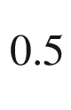

Ge

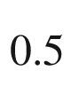

alloy. Phys. Rev. B **8**, 3817–3823 (1973). [10.​1103/​PhysRevB.​8.​3817](https://doi.org/10.1103/PhysRevB.8.3817)

N.F. Mott, Conduction in glasses containing transition metal ions. J. Non-Cryst. Solids **1**, 1–17 (1968). [10.​1016/​0022-3093(68)90002-1](https://doi.org/10.1016/0022-3093(68)90002-1)

A.L. Efros, B.I. Shklovskii, Coulomb gap and low temperature conductivity of disordered system. J. Phys. C: Solid State Phys. **8**, L49–L51 (1975). [10.​1088/​0022-3719/​8/​4/​003](https://doi.org/10.1088/0022-3719/8/4/003)

A. Yildiz, N. Serin, T. Serin, M. Kasap, Crossover from nearest-neighbor hopping conduction to Efros–Shklovskii variable-range hopping conduction in hydrogenated amorphous silicon films. Jpn. J. Appl. Phys. **48**, 111203:1–5 (2009). [10.​1143/​JJAP.​48.​111203](https://doi.org/10.1143/JJAP.48.111203)

N. Mott, The mobility edge since 1967. J. Phys. C: Solid State Phys. **20**, 3075–3102 (1987). [10.​1088/​0022-3719/​20/​21/​008](https://doi.org/10.1088/0022-3719/20/21/008)

B.C.H. Steele, A. Heinzel, Materials for fuel-cell technologies. Nature **414**, 345–352 (2001). [10.​1038/​35104620](https://doi.org/10.1038/35104620)

N. Sata, K. Eberman, K. Eberl, J. Maier, Mesoscopic fast ion conduction in nanometre-scale planar heterostructures. Nature **408**, 946–949 (2000). [10.​1038/​35050047](https://doi.org/10.1038/35050047)

J. Garcia-Barriocanal, A. Rivera-Calzada, M. Varela, Z. Sefrioui, E. Iborra, C. Leon, S.J. Pennycook, J. Santamaria, Colossal ionic conductivity at interfaces of epitaxial ZrO

$$_2$$

:Y

$$_2$$

O

$$_3$$

/SrTiO

$$_3$$

Heterostructures. Science **321**, 676–680 (2008). [10.​1126/​science.​1156393](https://doi.org/10.1126/science.1156393)

J.X.M. Zheng-Johansson, R.L. McGreevy, A molecular dynamics study of ionic conduction in CuI. II. Local ionic motion and conduction mechanisms. Solid State Ionics **83**, 35–48 (1996). [10.​1016/​0167-2738(95)00218-9](https://doi.org/10.1016/0167-2738(95)00218-9)

M. Yashima, Q. Xu, A. Yoshiasa, S. Wada, Crystal structure, electron density and diffusion path of the fast-ion conductor copper iodide CuI. J. Mater. Chem. **16**, 4393–4396 (2006). [10.​1039/​B610127E](https://doi.org/10.1039/B610127E)

T. Jow, J.B. Wagner, On the electrical properties of cuprous iodide. J. Electrochem. Soc. **125**, 613–620 (1978). [10.​1149/​1.​2131511](https://doi.org/10.1149/1.2131511)

P.T. Landsberg, On the diffusion theory of rectification. Proc. Roy. Soc. Lond. A **213**, 226–237 (1952). [10.​1098/​rspa.​1952.​0122](https://doi.org/10.1098/rspa.1952.0122)

A.N. Chakravarti, B.R. Nag, Generalized Einstein relation for degenerate semiconductors having non-parabolic energy bands. Int. J. Electr. **37**, 281–284 (1974). [10.​1080/​0020721740890052​1](https://doi.org/10.1080/00207217408900521)

N.G. Nilsson, An accurate approximation of the generalized einstein relation for degenerate semiconductors. Phys. Status Solidi A **19**, K75–K78 (1973). [10.​1002/​pssa.​2210190159](https://doi.org/10.1002/pssa.2210190159)

E. Spenke, *Elektronische Halbleiter, Eine Einführung in die Physik der Gleichrichter und Transistoren* (Springer, Berlin, 1955). [10.​1007/​978-3-662-01338-0](https://doi.org/10.1007/978-3-662-01338-0)

F.A. Lindholm, R.W. Ayers, Generalized Einstein relation for degenerate semiconductors. Proc. IEEE **56**, 371–372 (1968). [10.​1109/​PROC.​1968.​6320](https://doi.org/10.1109/PROC.1968.6320)

H.S. Carslaw, J.C. Jaeger, *Conduction of Heat in Solids* (Clarendon Press, Oxford, 1959)

T.H. Geballe, G.W. Hull, Isotopic and other types of thermal resistance in germanium. Phys. Rev. **110**, 773–775 (1958). [10.​1103/​PhysRev.​110.​773](https://doi.org/10.1103/PhysRev.110.773)

H.B.G. Casimir, Note on the conduction of heat in crystals. Physica **5**, 495–500 (1938). [10.​1016/​S0031-8914(38)80162-2](https://doi.org/10.1016/S0031-8914(38)80162-2)

W.S. Capinski, H.J. Maris, E. Bauser, I. Silier, M. Asen-Palmer, T. Ruf, M. Cardona, E. Gmelin, Thermal conductivity of isotopically enriched Si. Appl. Phys. Lett. **71**, 2109–2111 (1997). [10.​1063/​1.​119384](https://doi.org/10.1063/1.119384)

T. Ruf, R.W. Henn, M. Asen-Palmer, E. Gmelin, M. Cardona, H.J. Pohl, G.G. Devyatykh, P.G. Sennikov, Thermal conductivity of isotopically enriched silicon. Solid State Commun. **115**, 243–247 (2000). [10.​1016/​S0038-1098(00)00172-1](https://doi.org/10.1016/S0038-1098(00)00172-1)

G.O. Mahan, Good thermoelectrics. Solid State Phys. **51**, 81–157 (1997). [10.​1016/​S0081-1947(08)60190-3](https://doi.org/10.1016/S0081-1947(08)60190-3)

H. Böttner, G. Chen, R. Venkatasubramanian, Aspects of thin-film superlattice thermoelectric materials, devices, and applications. Dev. Appl. MRS Bull. **31**, 211–217 (2006). [10.​1557/​mrs2006.​47](https://doi.org/10.1557/mrs2006.47)

V.A. Johnson, K. Lark-Horowitz, Theory of thermoelectric power in semiconductors with applications to germanium. Phys. Rev. **92**, 226–232 (1953). [10.​1103/​PhysRev.​92.​226](https://doi.org/10.1103/PhysRev.92.226)

T.H. Geballe, G.W. Hull, Seebeck effect in silicon. Phys. Rev. **98**, 940–947 (1955). [10.​1103/​PhysRev.​98.​940](https://doi.org/10.1103/PhysRev.98.940)

H. Fritzsche, A general expression for the thermoelectric power. Solid State Commun. **9**, 1813–1815 (1971). [10.​1016/​0038-1098(71)90096-2](https://doi.org/10.1016/0038-1098(71)90096-2)

Z. Wang, S. Wang, S. Obukhov, N. Vast, J. Sjakste, V. Tjuterev, N. Mingo, Thermoelectric transport properties of silicon: Toward an ab initio approach. Phys. Rev. B **83**, 205208:1–5 (2011). [10.​1103/​PhysRevB.​83.​205208](https://doi.org/10.1103/PhysRevB.83.205208)

G.D. Mahan, L. Lindsay, D.A. Broido, The Seebeck coefficient and phonon drag in silicon. J. Appl. Phys. **116**, 245102:1–7 (2014). [10.​1063/​1.​4904925](https://doi.org/10.1063/1.4904925)

I. Newton, *Opticks* (London, 1704), Book 3, Query 5, p. 133

C. Kranert, C. Sturm, R. Schmidt-Grund, M. Grundmann, Raman tensor formalism for optically anisotropic crystals. Phys. Rev. Lett. **116**, 127401:1–5 (2016). [10.​1103/​PhysRevLett.​116.​127401](https://doi.org/10.1103/PhysRevLett.116.127401)

C. Sturm, J. Furthmüller, F. Bechstedt, R. Schmidt-Grund, M. Grundmann, Dielectric tensor of monoclinic Ga

$$_2$$

O

$$_3$$

single crystals in the spectral range 0.5–8.5 eV. APL Mater. **3**, 106106:1–9 (2015). [10.​1063/​1.​4934705](https://doi.org/10.1063/1.4934705)

C. Sturm, R. Schmidt-Grund, C. Kranert, J. Furthmüller, F. Bechstedt, M. Grundmann, Dipole analysis of the dielectric function of color dispersive materials: Application to monoclinic Ga

$$_2$$

O

$$_3$$

. Phys. Rev. B **94**, 035148:1–11 (2016). [10.​1103/​PhysRevB.​94.​035148](https://doi.org/10.1103/PhysRevB.94.035148)

W. Voigt, Beiträge zur Aufklärung der Eigenschaften pleochroitischer Kristalle. Ann. Physik **314**, 367–416 (1902). [10.​1002/​andp.​19023141006](https://doi.org/10.1002/andp.19023141006)

C. Sturm, M. Grundmann, The singular optical axes in biaxial crystals and analysis of their spectral dispersion effects in

$$\beta $$

-Ga

$$_2$$

O

$$_3$$

. Phys. Rev. A **93**, 053839:1–8 (2016). [10.​1103/​PhysRevA.​93.​053839](https://doi.org/10.1103/PhysRevA.93.053839)

C. Sturm, V. Zviagin, M. Grundmann, Applicability of the constitutive equations for the determination of the material properties of optically active materials. Opt. Lett. **44**, 1351–1354 (2019). [10.​1364/​OL.​44.​001351](https://doi.org/10.1364/OL.44.001351)

A. Kwan, J. Dudley, E. Lantz, Who really discovered Snell’s law? Physics World **15**, 64 (2002). [10.​1088/​2058-7058/​15/​4/​44](https://doi.org/10.1088/2058-7058/15/4/44)

A. Fresnel, *Œuvres complètes d’Augustin Fresnel*, eds. by H. de Senarmont, É. Verdet, L. Fresnel (Imprimerie Impériale, Paris, 1866-1870, 3 vols.)

M. Bouguer, *Essai d’optique sur la gradation de la lumière* (Claude Jombert, Paris, 1729)

A. Beer, Bestimmung der Absorption des rothen Lichts in farbigen Flüssigkeiten. Ann. Phys. Chem. **162**, 78–88 (1852). [10.​1002/​andp.​18521620505](https://doi.org/10.1002/andp.18521620505)

Ch.M. Wolfe, N. Holonyak Jr., G.E. Stillman, *Physical Properties of Semiconductors* (Prentice Hall, Englewood Cliffs, NJ, 1989)

M. Born, K. Huang, *Dynamical Theory of Crystal Lattices* (Clarendon Press, Oxford, 1954)

R.H. Lyddane, R.G. Sachs, E. Teller, On the polar vibrations of alkali halides. Phys. Rev. **59**, 673–676 (1941). [10.​1103/​PhysRev.​59.​673](https://doi.org/10.1103/PhysRev.59.673)

B. Jogai, Absorption coefficient of wurtzite GaN calculated from an empirical tight binding model. Solid State Commun. **116**, 153–157 (2000). [10.​1016/​S0038-1098(00)00305-7](https://doi.org/10.1016/S0038-1098(00)00305-7)

M. Cardona, Modulation spectroscopy of semiconductors. Adv. Solid State Phys. (Festkörperprobleme) **10**, 125–173 (1970). [10.​1007/​BFb0108433](https://doi.org/10.1007/BFb0108433)

M.D. Sturge, Optical absorption of gallium arsenide between 0.6 and 2.75 eV. Phys. Rev. **127**, 768–773 (1962). [10.​1103/​PhysRev.​129.​2835.​3](https://doi.org/10.1103/PhysRev.129.2835.3) Erratum: Phys. Rev. **129**, 2835 (1963). [10.​1103/​PhysRev.​127.​768](https://doi.org/10.1103/PhysRev.127.768)

R.G. Ulbrich, Band edge spectra of highly excited gallium arsenide. Adv. Solid State Phys. (Festkörperprobleme) **25**, 299–307 (1985). [10.​1007/​BFb0108162](https://doi.org/10.1007/BFb0108162)

T. Matsuyama, H. Horinaka, K. Wada, T. Kondo, M. Hangyo, T. Nakanishi, S. Okumi, K. Togowa, Spin-dependent luminescence of highly polarized electrons generated by two-photon absorption in semiconductors. Jpn. J. Appl. Phys. **40**, L555–L557 (2001). [10.​1143/​JJAP.​40.​L555](https://doi.org/10.1143/JJAP.40.L555)

P.J. Dean, D.G. Thomas, Intrinsic absorption-edge spectrum of gallium phosphide. Phys. Rev. **150**, 690–703 (1966). [10.​1103/​PhysRev.​150.​690](https://doi.org/10.1103/PhysRev.150.690)

L.H. Hall, J. Bardeen, F.J. Blatt, Infrared absorption spectrum of germanium. Phys. Rev. **95**, 559–560 (1954). [10.​1103/​PhysRev.​95.​559](https://doi.org/10.1103/PhysRev.95.559)

J. Geist, A. Migdall, H.P. Baltes, Analytic representation of the silicon absorption coefficient in the indirect transition region. Appl. Optics **27**, 3777–3779 (1988). [10.​1364/​AO.​27.​003777](https://doi.org/10.1364/AO.27.003777)

G.G. Macfarlane, V. Roberts, Infrared absorption of germanium near the lattice edge. Phys. Rev. **97**, 1714–1716 (1955). [10.​1103/​PhysRev.​97.​1714.​2](https://doi.org/10.1103/PhysRev.97.1714.2)

G.G. Macfarlane, T.P. McLean, J.E. Quarrington, V. Roberts, Fine structure in the absorption-edge spectrum of Si. Phys. Rev. **111**, 1245–1254 (1958). [10.​1103/​PhysRev.​111.​1245](https://doi.org/10.1103/PhysRev.111.1245)

B.N. Brockhouse, Lattice vibrations in silicon and germanium. Phys. Rev. Lett. **2**, 256–258 (1959). [10.​1103/​PhysRevLett.​2.​256](https://doi.org/10.1103/PhysRevLett.2.256)

J.I. Pankove, P. Aigrain, Optical absorption of arsenic-doped degenerate germanium. Phys. Rev. **126**, 956–962 (1962). [10.​1103/​PhysRev.​126.​956](https://doi.org/10.1103/PhysRev.126.956)

G.A. Cox, G.G. Roberts, R.H. Tredgold, The optical absorption edge of barium titanate. Br. J. Appl. Phys. **17**, 743–745 (1966). [10.​1088/​0508-3443/​17/​6/​305](https://doi.org/10.1088/0508-3443/17/6/305)

F. Urbach, The long-wavelength edge of photographic sensitivity and of the electronic absorption of solids. Phys. Rev. **92**, 1324 (1953). [10.​1103/​PhysRev.​92.​1324](https://doi.org/10.1103/PhysRev.92.1324)

S.R. Johnson, T. Tiedje, Temperature dependence of the Urbach edge in GaAs. J. Appl. Phys. **78**, 5609–5613 (1995). [10.​1063/​1.​359683](https://doi.org/10.1063/1.359683)

M. Beaudoin, A.J.G. DeVries, S.R. Johnson, H. Laman, T. Tiedje, Optical absorption edge of semi-insulating GaAs and InP at high temperatures. Appl. Phys. Lett. **70**, 3540–3542 (1997). [10.​1063/​1.​119226](https://doi.org/10.1063/1.119226)

T.S. Moss, T.D.F. Hawking, Infrared absorption in gallium arsenide. Infrared Phys. **1**, 111–115 (1961). [10.​1016/​0020-0891(61)90014-8](https://doi.org/10.1016/0020-0891(61)90014-8)

J. Stuke, Review of optical and electrical properties of amorphous semiconductors. J. Non-Cryst. Solids **4**, 1–26 (1970). [10.​1016/​0022-3093(70)90015-3](https://doi.org/10.1016/0022-3093(70)90015-3)

A. Baldereschi, N.O. Lipari, Energy levels of direct excitons in semiconductors with degenerate bands. Phys. Rev. B **3**, 439–451 (1971). [10.​1103/​PhysRevB.​3.​439](https://doi.org/10.1103/PhysRevB.3.439)

N.O. Lipari, M. Altarelli, Theory of indirect excitons in semiconductors. Phys. Rev. B **15**, 4883–4897 (1977). [10.​1103/​PhysRevB.​15.​4883](https://doi.org/10.1103/PhysRevB.15.4883)

N.O. Lipari, Exciton energy levels in wurtzite-type crystals. Phys. Rev. B **4**, 4535–4538 (1971). [10.​1103/​PhysRevB.​4.​4535](https://doi.org/10.1103/PhysRevB.4.4535)

D. Birkedal, J. Singh, V.G. Lyssenko, J. Erland, J.M. Hvam, Binding of quasi-two-dimensional biexcitons. Phys. Rev. Lett. **76**, 672–675 (1996). [10.​1103/​PhysRevLett.​76.​672](https://doi.org/10.1103/PhysRevLett.76.672)

E.F. Gross, Excitons and their motion in crystal lattices. Usp. Fiz. Nauk **76**, 433–466 (1962) [Sov. Phys. Usp. **5**, 195–218 (1962)]. [10.​1070/​PU1962v005n02ABE​H003407](https://doi.org/10.1070/PU1962v005n02ABEH003407)

T. Kazimierczuk, D. Fröhlich, S. Scheel, H. Stolz, M. Bayer, Giant Rydberg excitons in the copper oxide Cu

$$_2$$

O. Nature **514**, 343–347 (2014). [10.​1038/​nature13832](https://doi.org/10.1038/nature13832)

Ch. Uihlein, D. Fröhlich, R. Kenklies, Investigation of exciton fine structure in Cu

$$_2$$

O. Phys. Rev. B **23**, 2731–2740 (1981). [10.​1103/​PhysRevB.​23.​2731](https://doi.org/10.1103/PhysRevB.23.2731)

R.J. Elliott, Intensity of optical absorption by excitons. Phys. Rev. **108**, 1384–1389 (1957). [10.​1103/​PhysRev.​108.​1384](https://doi.org/10.1103/PhysRev.108.1384)

A. Shikanai, T. Azuhata, T. Sota, S. Chichibu, A. Kuramata, K. Horino, S. Nakamura, Biaxial strain dependence of exciton resonance energies in wurtzite GaN. J. Appl. Phys. **81**, 417–424 (1997). [10.​1063/​1.​364074](https://doi.org/10.1063/1.364074)

S. Rudin, T.L. Reinecke, B. Segall, Temperature-dependent exciton linewidths in semiconductors. Phys. Rev. B **42**, 11218–11231 (1990). [10.​1103/​PhysRevB.​42.​11218](https://doi.org/10.1103/PhysRevB.42.11218)

A.J. Fischer, W. Shan, J.J. Song, Y.C. Chang, R. Horning, B. Goldenberg, Temperature-dependent absorption measurements of excitons in GaN epilayers. Appl. Phys. Lett. **71**, 1981–1983 (1997). [10.​1063/​1.​119761](https://doi.org/10.1063/1.119761)

A.J. Fischer, D.S. Kim, J. Hays, W. Shan, J.J. Song, D.B. Eason, J. Ren, J.F. Schetzina, H. Luo, J.K. Furdyna, Z.Q. Zhu, T. Yao, W. Schäfer, Femtosecond coherent spectroscopy of bulk ZnSe and ZnCdSe/ZnSe quantum wells. Phys. Rev. Lett. **73**, 2368–2371 (1994). [10.​1103/​PhysRevLett.​73.​2368](https://doi.org/10.1103/PhysRevLett.73.2368)

A.K. Viswanath, J.I. Lee, D. Kim, C.R. Lee, J.Y. Leem, Exciton-phonon interactions, exciton binding energy, and their importance in the realization of room-temperature semiconductor lasers based on GaN. Phys. Rev. B **58**, 16333–16339 (1998). [10.​1103/​PhysRevB.​58.​16333](https://doi.org/10.1103/PhysRevB.58.16333)

D.-S. Kim, J. Shah, J.E. Cunnigham, T.C. Damen, W. Schäfer, M. Hartmann, S. Schmitt-Rink, Giant exciton resonance in time-resolved four-wave mixing in quantum wells. Phys. Rev. Lett. **68**, 1006–1009 (1992). [10.​1103/​PhysRevLett.​68.​1006](https://doi.org/10.1103/PhysRevLett.68.1006)

R. Hauschild, H. Priller, M. Decker, J. Brückner, H. Kalt, C. Klingshirn, Temperature dependent band gap and homogeneous line broadening of the exciton emission in ZnO. Phys. Status Solidi C **3**, 976–979 (2006). [10.​1002/​pssc.​200564643](https://doi.org/10.1002/pssc.200564643)

J.J. Hopfield, D.G. Thomas, Polariton absorption lines. Phys. Rev. Lett. **15**, 22–25 (1965). [10.​1103/​PhysRevLett.​15.​22](https://doi.org/10.1103/PhysRevLett.15.22)

J.J. Hopfield, Resonant scattering of polaritons as composite particles. Phys. Rev. **182**, 945–952 (1969). [10.​1103/​PhysRev.​182.​945](https://doi.org/10.1103/PhysRev.182.945)

A.A. Maradudin, D.L. Mills, Effect of spatial dispersion on the properties of a semi-infinite dielectric. Phys. Rev. B **7**, 2787–2810 (1973). [10.​1103/​PhysRevB.​7.​2787](https://doi.org/10.1103/PhysRevB.7.2787)

Y. Toyozawa, On the dynamical behavior of an exciton. Prog. Theor. Phys., Suppl. **12**, 111–140 (1959). [10.​1143/​PTPS.​12.​111](https://doi.org/10.1143/PTPS.12.111)

U. Heim, P. Wiesner, Direct evidence for a bottleneck of exciton-polariton relaxation in CdO. Phys. Rev. Lett. **30**, 1205–1207 (1973). [10.​1103/​PhysRevLett.​30.​1205](https://doi.org/10.1103/PhysRevLett.30.1205)

B. Gil, Oscillator strengths of A, B, and C excitons in ZnO films. Phys. Rev. B **64**, 201310:1–3 (2001). [10.​1103/​PhysRevB.​64.​201310](https://doi.org/10.1103/PhysRevB.64.201310)

T. Soma, H.-M. Kagaya, The metallic and ionic contributions to lattice vibrations of III-V covalent crystals. Phys. Status Solidi B **118**, 245–254 (1983). [10.​1002/​pssb.​2221180130](https://doi.org/10.1002/pssb.2221180130)

A. Göldner, *Nichtstrahlende Relaxationsprozesse bandkantennaher Zustände in II-VI- und III-V-Halbleiterstrukturen*, Ph.D. Thesis, Technische Universität Berlin (2000) (Wissenschaft und Technik Verlag, Berlin, 2000)

I. Broser, M. Rosenzweig, Determination of excitonic parameters of the A polariton in CdS from magnetoreflectance spectroscopy. Phys. Rev. B **22**, 2000–2007 (1980). [10.​1103/​PhysRevB.​22.​2000](https://doi.org/10.1103/PhysRevB.22.2000)

M. Rosenzweig, *Exzitonische Polaritonen in CdS—Optische Eigenschaften räumlich dispersiver Medien*, Ph.D. Thesis, Technische Universität Berlin (1982)

G. Blattner, G. Kurtze, G. Schmieder, C. Klingshirn, Influence of magnetic fields up to 20 T on excitons and polaritons in CdS and ZnO. Phys. Rev. B **25**, 7413–7427 (1982). [10.​1103/​PhysRevB.​25.​7413](https://doi.org/10.1103/PhysRevB.25.7413)

B. Gil, S. Clur, O. Briot, The exciton-polariton effect on the photoluminescence of GaN on sapphire. Solid State Commun. **104**, 267–270 (1997). [10.​1016/​S0038-1098(97)00284-6](https://doi.org/10.1016/S0038-1098(97)00284-6)

A.E. Yunovich, Radiative recombination and optical properties of GaP, in *Radiative Recombination in Semiconductors*, ed. by Ya. E. Pokrovskii (Moscow, 1972) (in Russian). A.E. Yunovich, Strahlende Rekombination und optische Eigenschaften von GaP. Fortschritte der Physik **23**, 317–398 (1975). [10.​1002/​prop.​19750230602](https://doi.org/10.1002/prop.19750230602)

V. Vashishta, R.K. Kalia, Universal behavior of exchange-correlation energy in electron-hole liquid. Phys. Rev. B **25**, 6492–6495 (1982). [10.​1103/​PhysRevB.​25.​6492](https://doi.org/10.1103/PhysRevB.25.6492)

R. Zimmermann, Nonlinear optics and the Mott transition in semiconductors. Phys. Status Solidi B **146**, 371–384 (1988). [10.​1002/​pssb.​2221460140](https://doi.org/10.1002/pssb.2221460140)

H.-E. Swoboda, M. Sence, F.A. Majumder, M. Rinker, J.-Y. Bigot, J.B. Grun, C. Klingshirn, Properties of electron-hole plasma in II-VI compounds as a function of temperature. Phys. Rev. B **39**, 11019–11027 (1989). [10.​1103/​PhysRevB.​39.​11019](https://doi.org/10.1103/PhysRevB.39.11019)

J.P. Löwenau, S. Schmitt-Rink, H. Haug, Many-body theory of optical bistability in semiconductors. Phys. Rev. Lett. **49**, 1511–1514 (1982). [10.​1103/​PhysRevLett.​49.​1511](https://doi.org/10.1103/PhysRevLett.49.1511)

L.V. Keldysh, Concluding remarks [for IXth International Conference on the Physics of Semiconductors], in *Proceedings of the 9th International Conference on the Physics of Semiconductors* (Moscow, Nauka, Leningrad, 1968), pp. 1303–1312

W.F. Brinkman, T.M. Rice, P.W. Anderson, S.T. Chui, Metallic state of the electron-hole liquid, particularly in germanium. Phys. Rev. Lett. **28**, 961–964 (1972). [10.​1103/​PhysRevLett.​28.​961](https://doi.org/10.1103/PhysRevLett.28.961)

G.A. Thomas, T.M. Rice, J.C. Hensel, Liquid-gas phase diagram of an electron-hole fluid. Phys. Rev. Lett. **33**, 219–222 (1974). [10.​1103/​PhysRevLett.​33.​219](https://doi.org/10.1103/PhysRevLett.33.219)

T.L. Reinecke, S.C. Ying, Droplet model of electron-hole liquid condensation in semiconductors. Phys. Rev. Lett. **35**, 311–315 (1975). [10.​1103/​PhysRevLett.​35.​547.​2](https://doi.org/10.1103/PhysRevLett.35.547.2)

R.S. Markiewicz, J.P. Wolfe, C.D. Jeffries, Strain-confined electron-hole liquid in germanium. Phys. Rev. B **15**, 1988–2005 (1977). [10.​1103/​PhysRevB.​15.​1988](https://doi.org/10.1103/PhysRevB.15.1988)

L.V. Butov, C.W. Lai, A.L. Ivanov, A.C. Gossard, D.S. Chemla, Towards Bose-Einstein condensation of excitons in potential traps. Nature **417**, 47–52 (2002). [10.​1038/​417047a](https://doi.org/10.1038/417047a)

L.V. Butov, A.C. Gossard, D.S. Chemla, Macroscopically ordered state in an exciton system. Nature **418**, 751–754 (2002). [10.​1038/​nature00943](https://doi.org/10.1038/nature00943)

K.E. O’Hara, L.Ó. Súilleabháin, J.P. Wolfe, Strong nonradiative recombination of excitons in Cu

$$_2$$

O and its impact on Bose-Einstein statistics. Phys. Rev. B **60**, 10565–10568 (1999). [10.​1103/​PhysRevB.​60.​10565](https://doi.org/10.1103/PhysRevB.60.10565)

M. Skolnick, A.I. Tartakovskii, R. Butté, R.M. Stevenson, J.J. Baumberg, D.M. Whittaker, High occupancy effects and condensation phenomena in semiconductor microcavities and bulk semiconductors, in *Nano-Optoelectronics, Concepts, Physics and Devices*, ed. by M. Grundmann (Springer, Berlin, 2002), pp. 273–296. [10.​1007/​978-3-642-56149-8\_​11](https://doi.org/10.1007/978-3-642-56149-8%255F11)

H. Mahr, Two-photon absorption spectroscopy, in *Quantum Electronics: A Treatise*, eds. by H. Rabin, C.L. Tang, vol. I, Part A (Academic, New York, 1975), pp. 285–361. [10.​1016/​B978-0-12-574001-2.​50010-1](https://doi.org/10.1016/B978-0-12-574001-2.50010-1)

H.J. Fossum, D.B. Chang, Two-photon excitation rate in indium antimonide. Phys. Rev. B **8**, 2842–2849 (1973). [10.​1103/​PhysRevB.​8.​2842](https://doi.org/10.1103/PhysRevB.8.2842)

J.P. van der Ziel, Two-photon absorption spectra of GaAs with

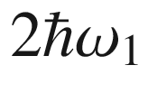

near the direct band gap. Phys. Rev. B **16**, 2775–2780 (1977). [10.​1103/​PhysRevB.​16.​2775](https://doi.org/10.1103/PhysRevB.16.2775)

C.J. Summers, R. Dingle, D.E. Hill, Far-infrared donor absorption and photoconductivity in epitaxial n-type GaAs. Phys. Rev. B **1**, 1603–1606 (1970). [10.​1103/​PhysRevB.​1.​1603](https://doi.org/10.1103/PhysRevB.1.1603)

ShM Kogan, T.M. Lifshits, Photoelectric spectroscopy—a new method of analysis of impurities in semiconductors. Phys. Status Solidi A **39**, 11–39 (1977). [10.​1002/​pssa.​2210390102](https://doi.org/10.1002/pssa.2210390102)

L.T. Ho, A.K. Ramdas, Excitation spectra and piezospectroscopic effects of magnesium donors in silicon. Phys. Rev. B **5**, 462–474 (1972). [10.​1103/​PhysRevB.​5.​462](https://doi.org/10.1103/PhysRevB.5.462)

R.A. Cooke, R.A. Hoult, R.F. Kirkman, R.A. Stradling, The characterisation of the donors in GaAs epitaxial films by far-infrared photoconductive techniques. J. Phys. D: Appl. Phys. **11**, 945–953 (1978). [10.​1088/​0022-3727/​11/​6/​014](https://doi.org/10.1088/0022-3727/11/6/014)

B.L. Cardozo, E.E. Haller, L.A. Reichertz, J.W. Beemann, Far-infrared absorption in GaAs:Te liquid phase epitaxial films. Appl. Phys. Lett. **83**, 3990–3992 (2003). [10.​1063/​1.​1624491](https://doi.org/10.1063/1.1624491)

M. Kleverman, K. Bergmann, H.G. Grimmeiss, Photothermal investigations of magnesium-related donors in silicon. Semicond. Sci. Technol. **1**, 49–52 (1986). [10.​1088/​0268-1242/​1/​1/​006](https://doi.org/10.1088/0268-1242/1/1/006)

U. Fano, Sullo spettro di assorbimento dei gas nobili presso il limite dello spettro d’arco. Nuovo Cimento **12**, 154–160 (1935). [10.​6028/​jres.​110.​083](https://doi.org/10.6028/jres.110.083) English translation: U. Fano, G. Pupillo, A. Zannoni, C.W. Clark, On the absorption spectrum of noble gases at the arc spectrum limit, J. Res. NIST 110, 583-587 (2005). [10.​1007/​BF02958288](https://doi.org/10.1007/BF02958288)

G. Breit, E. Wigner, Capture of slow neutrons. Phys. Rev. **49**, 519–531 (1936). [10.​1103/​PhysRev.​49.​519](https://doi.org/10.1103/PhysRev.49.519)

G. Lucovsky, On the photoionization of deep impurity centers in semiconductors. Solid State Commun. **3**, 299–302 (1965). [10.​1016/​0038-1098(65)90039-6](https://doi.org/10.1016/0038-1098(65)90039-6)

P. Drude, Zur Ionentheorie der Metalle. Z. Phys. **1**, 161–165 (1900)

C.R. Pidgeon, *Free Carrier Optical Properties of Semiconductors, Handbook on Semiconductors*, vol. 2 (North Holland, Amsterdam, 1980), pp. 223–328

H.Y. Fan, Effects of free carriers on the optical properties. Semicond. Semimet. **3**, 405–419 (1967). [10.​1016/​S0080-8784(08)60321-X](https://doi.org/10.1016/S0080-8784(08)60321-X)

W.P. Dumke, Quantum theory of free carrier absorption. Phys. Rev. **124**, 1813 (1961). [10.​1103/​PhysRev.​124.​1813](https://doi.org/10.1103/PhysRev.124.1813)

R. von Baltz, W. Escher, Quantum theory of free carrier absorption. Phys. Status Solidi B **51**, 499–507 (1972). [10.​1002/​pssb.​2220510209](https://doi.org/10.1002/pssb.2220510209)

P. Kleinert, M. Giehler, Theory of free-carrier infrared absorption in GaAs. Phys. Status Solidi B **136**, 763–777 (1986). [10.​1002/​pssb.​2221360246](https://doi.org/10.1002/pssb.2221360246)

Z.G. Hu, M.B.M. Rinzan, S.G. Matsik, A.G.U. Perera, G. Von Winckel, A. Stintz, S. Krishna, Optical characterizations of heavily doped p-type Al

$$_x$$

Ga

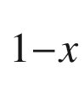

As and GaAs epitaxial films at terahertz frequencies. J. Appl. Phys. **97**, 093529:1–7 (2005). [10.​1063/​1.​1894581](https://doi.org/10.1063/1.1894581)

H.R. Chandrasekhar, A.K. Ramdas, Nonparabolicity of the conduction band and the coupled plasmon-phonon modes in n-GaAs. Phys. Rev. B **21**, 1511–1515 (1980). [10.​1103/​PhysRevB.​21.​1511](https://doi.org/10.1103/PhysRevB.21.1511)

E. Burstein, Anomalous optical absorption limit in InSb. Phys. Rev. **93**, 632–633 (1954). [10.​1103/​PhysRev.​93.​632](https://doi.org/10.1103/PhysRev.93.632)

T.S. Moss, The interpretation of the properties of indium antimonide. Proc. Phys. Soc. B **76**, 775–782 (1954). [10.​1088/​0370-1301/​67/​10/​306](https://doi.org/10.1088/0370-1301/67/10/306)

T.J. Coutts, D.L. Young, X. Li, Characterization of transparent conducting oxides. MRS Bull. **25**, 58–65 (2000). [10.​1557/​mrs2000.​152](https://doi.org/10.1557/mrs2000.152)

S. Kim, J. Park, S. Kim, Y. Lee, S. Ahn, J. Cho, M. Ju, N. Lakshminarayan, V.A. Dao, J. Yi, Free-carrier absorption and Burstein-Moss shift effect on quantum efficiency in heterojunction silicon solar cells. Vacuum **108**, 39–44 (2014). [10.​1016/​j.​vacuum.​2014.​05.​015](https://doi.org/10.1016/j.vacuum.2014.05.015)

G.N. Childs, S. Brand, R.A. Abram, Intervalence band absorption in semiconductor laser materials. Semicond. Sci. Technol. **1**, 116–120 (1986). [10.​1088/​0268-1242/​1/​2/​004](https://doi.org/10.1088/0268-1242/1/2/004)

J. Taylor, V. Tolstikhin, Intervalence band absorption in InP and related materials for optoelectronic device modeling. J. Appl. Phys. **87**, 1054–1059 (2000). [10.​1063/​1.​371979](https://doi.org/10.1063/1.371979)

R. Braunstein, E.O. Kane, The valence band structure of the III-V compounds. J. Phys. Chem. Solids **23**, 1423–1431 (1962). [10.​1016/​0022-3697(62)90195-6](https://doi.org/10.1016/0022-3697(62)90195-6)

A. Chandola, R. Pino, P.S. Dutta, Below bandgap optical absorption in tellurium-doped GaSb. Semicond. Sci. Technol. **20**, 886–893 (2005). [10.​1088/​0268-1242/​20/​8/​046](https://doi.org/10.1088/0268-1242/20/8/046)

W.P. Dumke, M.R. Lorenz, G.D. Pettit, Intra- and interband free-carrier absorption and the fundamental absorption edge in n-type InP. Phys. Rev. B **1**, 4668–4673 (1970). [10.​1103/​PhysRevB.​1.​4668](https://doi.org/10.1103/PhysRevB.1.4668)

H. Peelaers, E. Kioupakis, C.G. Van de Walle, Fundamental limits on optical transparency of transparent conducting oxides: Free-carrier absorption in SnO

$$_2$$

. Appl. Phys. Lett. **100**, 011914:1–3 (2012) [10.​1063/​1.​3671162](https://doi.org/10.1063/1.3671162)

A. Schleife, J.B. Varley, F. Fuchs, C. Rödl, F. Bechstedt, P. Rinke, A. Janotti, C.G. Van de Walle, Tin dioxide from first principles: Quasiparticle electronic states and optical properties. Phys. Rev. B **83**, 035116:1–9 (2011). [10.​1103/​PhysRevB.​83.​035116](https://doi.org/10.1103/PhysRevB.83.035116)

H. Peelaers, C.G. Van de Walle, Sub-band-gap absorption in Ga

$$_2$$

O

$$_3$$

. Appl. Phys. Lett. **111**, 182104:1–5 (2017). [10.​1063/​1.​5001323](https://doi.org/10.1063/1.5001323)

R. Zallen, *Crystal Structures, Handbook on Semiconductors*, vol. 1 (North Holland, Amsterdam, 1980), pp. 1–27

R.J. Collins, H.Y. Fan, Infrared lattice absorption bands in germanium, silicon, and diamond. Phys. Rev. **93**, 674–678 (1954). [10.​1103/​PhysRev.​93.​674](https://doi.org/10.1103/PhysRev.93.674)

F.A. Johnson, Lattice absorption bands in silicon. Proc. Phys. Soc. **73**, 265–272 (1959). [10.​1088/​0370-1328/​73/​2/​315](https://doi.org/10.1088/0370-1328/73/2/315)

W.G. Spitzer, Multiphonon lattice absorption. Semicond. Semimet. **3**, 17–69 (1967). [10.​1016/​S0080-8784(08)60314-2](https://doi.org/10.1016/S0080-8784(08)60314-2)

E.S. Koteles, W.R. Datars, Two-phonon absorption in InSb, InAs, and GaAs. Can. J. Phys. **54**, 1676–1682 (1976). [10.​1139/​p76-199](https://doi.org/10.1139/p76-199)

A. Mooradian, G.B. Wright, Observation of the interaction of plasmons with longitudinal optical phonons in GaAs. Phys. Rev. Lett. **16**, 999–1001 (1966). [10.​1103/​PhysRevLett.​16.​999](https://doi.org/10.1103/PhysRevLett.16.999)

P.T. Landsberg: *Recombination in Semiconductors* (Cambridge Univ. Press, Cambridge, 1992). [10.​1017/​CBO9780511470769​](https://doi.org/10.1017/CBO9780511470769)

G. Göbel, Recombination without

$$k$$

-selection rules in dense electron-hole plasmas in high-purity GaAs lasers. Appl. Phys. Lett. **24**, 492–494 (1974). [10.​1063/​1.​1655025](https://doi.org/10.1063/1.1655025)

X. Sun, J. Liu, L.C. Kimerling, J. Michel, Direct gap photoluminescence of n-type tensile-strained Ge-on-Si. Appl. Phys. Lett. **95**, 011911:1–3 (2009). [10.​1063/​1.​3170870](https://doi.org/10.1063/1.3170870)

J. Shah, R.C.C. Leite, Radiative recombination from photoexcited hot carriers in GaAs. Phys. Rev. Lett. **22**, 1304–1307 (1969). [10.​1103/​PhysRevLett.​22.​1304](https://doi.org/10.1103/PhysRevLett.22.1304)

W. Michaelis, M. Pilkuhn, Radiative recombination in silicon p-n junctions. Phys. Status Solidi **36**, 311–319 (1969). [10.​1002/​pssb.​19690360132](https://doi.org/10.1002/pssb.19690360132)

W. Shockley, W.T. Read Jr., Statistics of the recombination of holes and electrons. Phys. Rev. **87**, 835–842 (1952). [10.​1103/​PhysRev.​87.​835](https://doi.org/10.1103/PhysRev.87.835)

R.N. Hall, Electron-hole recombination in germanium. Phys. Rev. **87**, 387 (1952). [10.​1103/​PhysRev.​87.​387](https://doi.org/10.1103/PhysRev.87.387)

V.K. Malyutenko, Negative luminescence in semiconductors: A retrospective view. Physica E **20**, 553–557 (2004). [10.​1016/​j.​physe.​2003.​09.​008](https://doi.org/10.1016/j.physe.2003.09.008)

J.F. Muth, J.H. Lee, I.K. Shmagin, R.M. Kolbas, H.C. Casey Jr., B.P. Keller, U.K. Mishra, S.P. DenBaars, Absorption coefficient, energy gap, exciton binding energy, and recombination lifetime of GaN obtained from transmission measurements. Appl. Phys. Lett. **71**, 2572–2774 (1997). [10.​1063/​1.​120191](https://doi.org/10.1063/1.120191)

W. Gerlach, H. Schlangenotto, H. Maeder, On the radiative recombination rate in silicon. Phys. Status Solidi A **13**, 277–283 (1972). [10.​1002/​pssa.​2210130129](https://doi.org/10.1002/pssa.2210130129)

A. Galeckas, J. Linnros, V. Grivickas, U. Lindefelt, C. Hallin, Auger recombination in 4H-SiC: Unusual temperature behavior. Appl. Phys. Lett. **71**, 3269–3271 (1997). [10.​1063/​1.​120309](https://doi.org/10.1063/1.120309)

V. Palankovski, *Simulation of Heterojunction Bipolar Transistors*, Ph.D. Thesis, Technische Universität Wien (2002)

R.K. Akrenkiel, Minority-carrier lifetime in III-V semiconductors. Semicond. Semimet. **39**, 39–150 (1993). [10.​1016/​S0080-8784(08)62594-6](https://doi.org/10.1016/S0080-8784(08)62594-6)

P.J. Dean, J.R. Haynes, W.F. Flood, New radiative recombination processes involving neutral donors and acceptors in silicon and germanium. Phys. Rev. **161**, 711–729 (1967). [10.​1103/​PhysRev.​161.​711](https://doi.org/10.1103/PhysRev.161.711)

G. Davies, The optical properties of luminescence centres in silicon. Phys. Rep. **176**, 83–188 (1989). [10.​1016/​0370-1573(89)90064-1](https://doi.org/10.1016/0370-1573(89)90064-1)

G.D. Gilliland, Photoluminescence spectroscopy of crystalline semiconductors. Mater. Sci. Engin. R **18**, 99–400 (1997). [10.​1016/​S0927-796X(97)80003-4](https://doi.org/10.1016/S0927-796X(97)80003-4)

P.J. Dean, D.C. Herbert, *Bound Excitons in Semiconductors*, in: *Excitons*, K. Cho, ed. (Springer, Berlin, 1979), pp. 55–182 [10.​1007/​978-3-642-81368-9\_​3](https://doi.org/10.1007/978-3-642-81368-9%255F3)

P.J. Dean, Lithium donors and the binding of excitons at neutral donors and acceptors in gallium phosphide, in *Luminescence of Crystals, Molecules and Solutions*, ed. by F. Williams (Plenum, New York, 1973), pp. 538–552. [10.​1007/​978-1-4684-2043-2\_​75](https://doi.org/10.1007/978-1-4684-2043-2%255F75)

S. Permogorov, A. Reznitsky, A. Naumov, H. Stolz, W. von der Osten, Localisation of excitons at small Te clusters in diluted ZnSe



Te

$$_x$$

solid solutions. J. Phys.: Cond. Matter **1**, 5125–5137 (1989). [10.​1088/​0953-8984/​1/​31/​011](https://doi.org/10.1088/0953-8984/1/31/011)

T. Skettrup, M. Suffczynski, W. Gorzkowski, Properties of excitons bound to ionized donors. Phys. Rev. B **4**, 512–517 (1971). [10.​1103/​PhysRevB.​4.​512](https://doi.org/10.1103/PhysRevB.4.512)

R.G. Ulbrich, Low density photoexcitation phenomena in semiconductors: aspects of theory and experiment. Solid State Electron. **21**, 51–59 (1978). [10.​1016/​0038-1101(78)90114-4](https://doi.org/10.1016/0038-1101(78)90114-4)

D.E. Hill, Exciton recombination radiation of GaAs:Zn. Phys. Rev. B **1**, 1863–1864 (1970). [10.​1103/​PhysRevB.​1.​1863](https://doi.org/10.1103/PhysRevB.1.1863)

D.C. Reynolds, D.C. Look, B. Jogai, V.M. Phanse, R.P. Vaudo, Identification of an ionized-donor-bound-exciton transition in GaN. Solid State Commun. **103**, 533–535 (1997). [10.​1016/​S0038-1098(97)00231-7](https://doi.org/10.1016/S0038-1098(97)00231-7)

N. Nepal, M.L. Nakarmi, K.B. Nam, J.Y. Lin, H.X. Jiang, Acceptor-bound exciton transition in Mg-doped AlN epilayer. Appl. Phys. Lett. **85**, 2271–2273 (2004). [10.​1063/​1.​1796521](https://doi.org/10.1063/1.1796521)

D.G. Thomas, J.J. Hopfield, Optical properties of bound exciton complexes in cadmium sulfide. Phys. Rev. **128**, 2135–2148 (1962). [10.​1103/​PhysRev.​128.​2135](https://doi.org/10.1103/PhysRev.128.2135)

J.L. Merz, H. Kukimoto, K. Nassau, J.W. Shiever, Optical properties of substitutional donors in ZnSe. Phys. Rev. B **6**, 545–556 (1972). [10.​1103/​PhysRevB.​6.​545](https://doi.org/10.1103/PhysRevB.6.545)

P.J. Dean, D.C. Herbert, C.J. Werkhoven, B.J. Fitzpatrick, R.N. Bhargava, Donor bound-exciton excited states in zinc selenide. Phys. Rev. B **23**, 4888–4901 (1981). [10.​1103/​PhysRevB.​23.​4888](https://doi.org/10.1103/PhysRevB.23.4888)

B.K. Meyer, J. Sann, S. Lautenschläger, M.R. Wagner, A. Hoffmann, Ionized and neutral donor-bound excitons in ZnO. Phys. Rev. B **76**, 184120:1–4 (2007). [10.​1103/​PhysRevB.​76.​184120](https://doi.org/10.1103/PhysRevB.76.184120)

J.R. Haynes, Experimental proof of the existence of a new electronic complex in silicon. Phys. Rev. Lett. **4**, 361–363 (1960). [10.​1103/​PhysRevLett.​4.​361](https://doi.org/10.1103/PhysRevLett.4.361)

B.K. Meyer, H. Alves, D.M. Hofmann, W. Kriegseis, D. Forster, F. Bertram, J. Christen, A. Hoffmann, M. Straßburg, M. Dworzak, U. Haboeck, A.V. Rodina, Bound exciton and donor-acceptor pair recombinations in ZnO. Phys. Status Solidi B **241**, 231–260 (2004). [10.​1002/​pssb.​200301962](https://doi.org/10.1002/pssb.200301962)

S. Müller, D. Stichtenoth, M. Uhrmacher, H. Hofsäss, C. Ronning, J. Röder, Unambiguous identification of the PL-I

$$_9$$

line in zinc oxide. Appl. Phys. Lett. **90**, 012107:1–3 (2007). [10.​1063/​1.​2430483](https://doi.org/10.1063/1.2430483)

P.J. Dean, M. Skolnick, Donor discrimination and bound exciton spectra in InP. J. Appl. Phys. **54**, 346–359 (1983). [10.​1063/​1.​331709](https://doi.org/10.1063/1.331709)

F.A.J.M. Driessen, H.G.M. Lochs, S.M. Olsthoorn, L.J. Giling, An analysis of the two electron satellite spectrum of GaAs in high magnetic fields. J. Appl. Phys. **69**, 906–912 (1991). [10.​1063/​1.​347332](https://doi.org/10.1063/1.347332)

D. Karaiskaj, M.L.W. Thewalt, T. Ruf, M. Cardona, H.-J. Pohl, G.G. Deviatych, P.G. Senniko, H. Riemann, Photoluminescence of isotopically purified silicon: How sharp are bound exciton transitions? Phys. Rev. Lett. **86**, 6010–6013 (2001). [10.​1103/​PhysRevLett.​86.​6010](https://doi.org/10.1103/PhysRevLett.86.6010)

D. Karaiskaj, M.L.W Thewalt, T. Ruf, M. Cardona, M. Konuma, “Intrinsic” acceptor ground state splitting in silicon: an isotopic effect. Phys. Rev. Lett. **89**, 016401:1–4 (2002). [10.​1103/​PhysRevLett.​89.​016401](https://doi.org/10.1103/PhysRevLett.89.016401)

V.A. Karasyuk, M.L.W. Thewalt, S. An, E.C. Lightowlers, A.S. Kaminskii, Fourier-transform photoluminescence spectroscopy of excitons bound to group-III acceptors in silicon: Zeeman effect. Phys. Rev. B **54**, 10543–10558 (1996). [10.​1103/​PhysRevB.​54.​10543](https://doi.org/10.1103/PhysRevB.54.10543)

M.L.W. Thewalt, A. Yang, M. Steger, D. Karaiskaj, M. Cardona, H. Riemann, N.V. Abrosimov, A.V. Gusev, A.D. Bulanov, I.D. Kovalev, A.K. Kaliteevskii, O.N. Godisov, P. Becker, H.J. Pohl, E.E. Haller, J.W. Ager III, K.M. Itoh, Direct observation of the donor nuclear spin in a near-gap bound exciton transition:

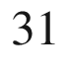

P in highly enriched

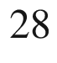

Si. J. Appl. Phys. **101**, 081724:1–5 (2007). [10.​1063/​1.​2723181](https://doi.org/10.1063/1.2723181)

J.D. Cuthbert, D.G. Thomas, Fluorescent decay times of excitons bound to isoelectronic traps in GaP and ZnTe. Phys. Rev. **154**, 763–771 (1967). [10.​1103/​PhysRev.​154.​763](https://doi.org/10.1103/PhysRev.154.763)

J.P. Laurenti, P. Roentgen, K. Wolter, K. Seibert, H. Kurz, J. Camassel, Indium-doped GaAs: a very dilute alloy system. Phys. Rev. B **37**, 4155–4163 (1988). [10.​1103/​PhysRevB.​37.​4155](https://doi.org/10.1103/PhysRevB.37.4155)

D. Bimberg, M. Sondergeld, E. Grobe, Thermal dissociation of excitons bound to neutral acceptors in high-purity GaAs. Phys. Rev. B **4**, 3451–3455 (1971). [10.​1103/​PhysRevB.​4.​3451](https://doi.org/10.1103/PhysRevB.4.3451)

M. Grundmann, C.P. Dietrich, Lineshape theory of photoluminescence from semiconductor alloys. J. Appl. Phys. **106**, 123521:1–10 (2009). [10.​1063/​1.​3267875](https://doi.org/10.1063/1.3267875)

D.G. Chtchekine, Z.C. Feng, S.J. Chua, G.D. Gilliland, Temperature-varied photoluminescence and magnetospectroscopy study of near-band-edge emissions in GaN. Phys. Rev. B **63**, 125211:1–7 (2001). [10.​1103/​PhysRevB.​63.​125211](https://doi.org/10.1103/PhysRevB.63.125211)

V.D. Kulakovskiǐ, G.E. Pikus, V.B. Timofeev, Multiexciton complexes in semiconductors. Usp. Fiz. Nauk **135**, 237–284 (1981) [Sov. Phys. Usp. **24**, 815–840 (1981)]. [10.​1070/​PU1981v024n10ABE​H004805](https://doi.org/10.1070/PU1981v024n10ABEH004805)

A.S. Kaminskiǐ, Ya.E. Pokrovskiǐ, Recombination radiation of the condensed phase on nonequilibrium carriers in silicon. Pis’ma Zh. Eksp. Teor. Fiz. **11**, 381 (1970) [JETP Lett. **11**, 255–257 (1970)]

M.L.W. Thewalt, Details of the structure of bound excitons and bound multiexciton complexes in Si. Can. J. Phys. **55**, 1463–1480 (1977). [10.​1139/​p78-038](https://doi.org/10.1139/p78-038) Erratum: Can. J. Phys. **56**, 310 (1978). [10.​1139/​p77-186](https://doi.org/10.1139/p77-186)

M.L.W. Thewalt, J.A. Rostworowski, G. Kirczenow, Piezospectroscopic studies of phosphorus-, boron-, and lithium-doped silicon. Can. J. Phys. **57**, 1898–1923 (1979). [10.​1139/​p79-262](https://doi.org/10.1139/p79-262)

O. Goede, L. John, D. Hennig, Compositional disorder-induced broadening for free excitons in II-VI semiconducting mixed crystals. Phys. Status Solidi B **89**, K183–K186 (1978). [10.​1002/​pssb.​2220890262](https://doi.org/10.1002/pssb.2220890262)

E.F. Schubert, E.O. Göbel, Y. Horikoshi, K. Ploog, H.J. Queisser, Alloy broadening in photoluminescence spectra of Al

$$_x$$

Ga

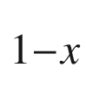

As. Phys. Rev. B **30**, 813–820 (1984). [10.​1103/​PhysRevB.​30.​813](https://doi.org/10.1103/PhysRevB.30.813)

S. Heitsch, G. Zimmermann, D. Fritsch, C. Sturm, R. Schmidt-Grund, C. Schulz, H. Hochmuth, D. Spemann, G. Benndorf, B. Rheinländer, Th. Nobis, M. Lorenz, M. Grundmann, Luminescence and surface properties of Mg

$$_x$$

Zn

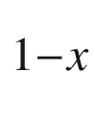

O thin films grown by pulsed laser deposition. J. Appl. Phys. **101**, 083521:1–6 (2007). [10.​1063/​1.​2719010](https://doi.org/10.1063/1.2719010)

R. Zimmermann, Theory of the exciton linewidth in II-VI semiconductor mixed crystals. J. Cryst. Growth **101**, 346–349 (1990). [10.​1016/​0022-0248(90)90993-U](https://doi.org/10.1016/0022-0248(90)90993-U)

J.M. Langer, R. Buczko, A.M. Stoneham, Alloy broadening of the near-gap luminescence and the natural band offset in semiconductor alloys. Semicond. Sci. Technol. **7**, 547–551 (1992). [10.​1088/​0268-1242/​7/​4/​018](https://doi.org/10.1088/0268-1242/7/4/018)

A. Müller, M. Stölzel, G. Benndorf, M. Lorenz, M. Grundmann, Origin of the near-band-edge luminescence in Mg

$$_x$$

Zn

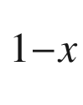

O alloys. J. Appl. Phys. **107**, 013704:1–6 (2010). [10.​1063/​1.​3270431](https://doi.org/10.1063/1.3270431)

M.C. Wagener, G.R. James, A.W.R. Leitch, F. Omnès, On the nature of Si-doping in AlGaN alloys. Phys. Status Solidi C **1**, 2322–2327 (2004). [10.​1002/​pssc.​200404838](https://doi.org/10.1002/pssc.200404838)

B. Segall, G.D. Mahan, Phonon-assisted recombination of free excitons in compound semiconductors. Phys. Rev. **171**, 935–948 (1968). [10.​1103/​PhysRev.​171.​935](https://doi.org/10.1103/PhysRev.171.935)

J. Conradi, R.R. Haering, Oscillatory exciton emission in CdS. Phys. Rev. Lett. **20**, 1344–1346 (1968). [10.​1103/​PhysRevLett.​20.​1344](https://doi.org/10.1103/PhysRevLett.20.1344)

Y.S. Park, J.R. Schneider, Oscillations in exciton emission in the excitation spectra of ZnSe and CdS. Phys. Rev. Lett. **21**, 798–800 (1968). [10.​1103/​PhysRevLett.​21.​798](https://doi.org/10.1103/PhysRevLett.21.798)

D. Kovalev, B. Averboukh, D. Volm, B.K. Meyer, H. Amano, I. Akasaki, Free exciton emission in GaN. Phys. Rev. B **54**, 2518–2522 (1996). [10.​1103/​PhysRevB.​54.​2518](https://doi.org/10.1103/PhysRevB.54.2518)

S. Permogorov, Optical emission due to exciton scattering by LO phonons in semiconductors, in *Excitons*, eds. by E.I. Rashba, M.D. Sturge (North-Holland, 1982)

M. Wojdak, A. Wysmołek, K. Pakuła, J.M. Baranowski, emission due to exciton scattering by LO-phonons in gallium nitride. Phys. Status Solidi B **216**, 95–99 (1999). [10.​1002/​(SICI)1521-3951(199911)216:​1%3C95:​:​AID-PSSB95%3E3.​0.​CO;2-R](https://doi.org/10.1002/(SICI)1521-3951(199911)216:1%253C95::AID-PSSB95%253E3.0.CO%3B2-R)

R. Dingle, Luminescent transitions associated with divalent copper impurities and the green emission from semiconducting zinc oxide. Phys. Rev. Lett. **23**, 579–581 (1969). [10.​1103/​PhysRevLett.​23.​579](https://doi.org/10.1103/PhysRevLett.23.579)

Th Agne, *Identifikation und Untersuchung von Defekten in ZnO Einkristallen*. Ph.D. Thesis (Universität des Saarlandes, Saarbrücken, 2004)

K. Huang, A. Rhys, Theory of light absorption and non-radiative transitions in F-centres. Proc. Roy. Soc. Lond. A **204**, 406–423 (1950). [10.​1098/​rspa.​1950.​0184](https://doi.org/10.1098/rspa.1950.0184)

J.J. Hopfield, A theory of edge-emission phenomena in CdS, ZnS and ZnO. J. Phys. Chem. Solids **10**, 110–119 (1959). [10.​1016/​0022-3697(59)90064-2](https://doi.org/10.1016/0022-3697(59)90064-2)

M. Lax, The Franck-Condon principle and its application to crystals. J. Chem. Phys. **20**, 1752–1760 (1952). [10.​1063/​1.​1700283](https://doi.org/10.1063/1.1700283)

J.L. Merz, Isoelectronic oxygen trap in ZnTe. Phys. Rev. **176**, 961–968 (1968). [10.​1103/​PhysRev.​176.​961](https://doi.org/10.1103/PhysRev.176.961)

C. Klingshirn, The luminescence of ZnO under high one- and two-quantum excitation. Phys. Status Solidi B **71**, 547–556 (1975). [10.​1002/​pssb.​2220710216](https://doi.org/10.1002/pssb.2220710216)

P.J. Dean, C.H. Henry, C.J. Frosch, Infrared donor-acceptor pair spectra involving the deep oxygen donor in gallium phosphide. Phys. Rev. **168**, 812–816 (1968). [10.​1103/​PhysRev.​168.​812](https://doi.org/10.1103/PhysRev.168.812)

A. Juhl, *Calorimetrische Absorptionsspektroskopie (CAS)—Eine neue Methode zur Charakterisierung der optischen Eigenschaften von Halbleitersystemen*, Ph.D. Thesis, Technische Universität Berlin (1987)

W.H. Koschel, U. Kaufmann, S.G. Bishop, Optical an ESR analysis of the fe acceptor in InP. Solid State Commun. **21**, 1069–1072 (1977). [10.​1016/​0038-1098(77)90308-8](https://doi.org/10.1016/0038-1098(77)90308-8)

F. Jelezko J. Wrachtrup, Single defect centres in diamond: a review. Phys. Status Solidi A **203**, 3207–3225 (2006). [10.​1002/​pssa.​200671403](https://doi.org/10.1002/pssa.200671403)

R. Schirhagl, K. Chang, M. Loretz, C.L. Degen, Nitrogen-vacancy centers in diamond: nanoscale sensors for physics and biology. Ann. Rev. Phys. Chem. **65**, 83–105 (2014). [10.​1146/​annurev-physchem-040513-103659](https://doi.org/10.1146/annurev-physchem-040513-103659)

G. Balasubramanian, I.Y. Chan, R. Kolesov, M. Al-Hmoud, J. Tisler, C. Shin, C. Kim, A. Wojcik, P.R. Hemmer, A. Krueger, T. Hanke, A. Leitenstorfer, R. Bratschitsch, F. Jelezko, J. Wrachtrup, Nanoscale imaging magnetometry with diamond spins under ambient conditions. Nature **455**, 648–651 (2008). [10.​1038/​nature07278](https://doi.org/10.1038/nature07278)

E. Abe, K. Sasaki, Tutorial: Magnetic resonance with nitrogen-vacancy centers in diamond—microwave engineering, materials science, and magnetometry. J. Appl. Phys. **123**, 161101:1–14 (2018). [10.​1063/​1.​5011231](https://doi.org/10.1063/1.5011231)

W. Lochmann, A. Haug, Phonon-assisted auger recombination in Si with direct calculation of the overlap integrals. Solid State Commun. **35**, 553–556 (1980). [10.​1016/​0038-1098(80)90896-0](https://doi.org/10.1016/0038-1098(80)90896-0)

M. Takeshima, Theory of phonon-assisted Auger recombination in semiconductors. Phys. Rev. B **23**, 6625–6637 (1981). [10.​1103/​PhysRevB.​23.​6625](https://doi.org/10.1103/PhysRevB.23.6625)

M. Takeshima, Phonon-assisted Auger recombination in a quasi-two-dimensional structure semiconductor. Phys. Rev. B **30**, 3302–3308 (1984). [10.​1103/​PhysRevB.​30.​3302](https://doi.org/10.1103/PhysRevB.30.3302)

P.C. Findlay, C.R. Pidgeon, H. Pellemans, R. Kotitschke, B.N. Murdin, T. Ashley, A.D. Johnson, A.M. White, C.T. Elliott, Auger recombination dynamics of In

$$_x$$

Ga



Sb. Semicond. Sci. Technol. **14**, 1026–1030 (1999). [10.​1088/​0268-1242/​14/​12/​302](https://doi.org/10.1088/0268-1242/14/12/302)

D. Vignaud, J.F. Lampin, E. Lefebvre, M. Zaknoune, F. Mollot, Electron lifetime of heavily Be-doped In

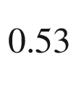

Ga

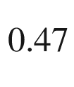

As as a function of growth temperature and doping density. Appl. Phys. Lett. **80**, 4151–4153 (2002). [10.​1063/​1.​1483126](https://doi.org/10.1063/1.1483126)

D.B. Laks, G.F. Neumark, S.T. Pantelides, Accurate interband-Auger-recombination rates in silicon. Phys. Rev. B **42**, 5176–5185 (1990). [10.​1103/​PhysRevB.​42.​5176](https://doi.org/10.1103/PhysRevB.42.5176)

P. Blood, J.W. Orton, The electrical characterization of semiconductors. Rep. Progress Phys. **41**, 157–257 (1978). [10.​1088/​0034-4885/​41/​2/​001](https://doi.org/10.1088/0034-4885/41/2/001)

P. Blood, J.W. Orton, *The Electrical Characterization of Semiconductors: Majority Carriers and Electron States* (Academic Press, San Diego, 1992)

D. Macdonald, A. Cuevas, Validity of simplified Shockley-Read-Hall statistics for modeling carrier lifetimes in crystalline silicon. Phys. Rev. B **67**, 075203:1–7 (2003). [10.​1103/​PhysRevB.​67.​075203](https://doi.org/10.1103/PhysRevB.67.075203)

D.H. Auston, Picosecond photoconductivity: High-speed measurements of devices and materials. Semicond. Semimet. **28**, 85–134 (1990). [10.​1016/​S0080-8784(08)62785-4](https://doi.org/10.1016/S0080-8784(08)62785-4)

A.A. Istratov, E.R. Weber, Electrical properties and recombination activity of copper, nickel and cobalt in silicon. Appl. Phys. A **66**, 123–136 (1998). [10.​1007/​s003390050649](https://doi.org/10.1007/s003390050649)

A.A. Istratov, H. Hieslmair, E.R. Weber, Iron and its complexes in silicon. Appl. Phys. A **69**, 13–44 (1999). [10.​1007/​s003390050968](https://doi.org/10.1007/s003390050968)

A.A. Istratov, H. Hieslmair, E.R. Weber, Iron contamination in silicon technology. Appl. Phys. A **70**, 489–534 (2000). [10.​1007/​s003390051074](https://doi.org/10.1007/s003390051074)

J.S. Blakemore, Lifetime in p-type silicon. Phys. Rev. **110**, 1301–1308 (1958). [10.​1103/​PhysRev.​110.​1301](https://doi.org/10.1103/PhysRev.110.1301)

M.S. Tyagi, R. van Overstraeten, Minority carrier recombination in heavily doped silicon. Solid State Electron. **26**, 577–597 (1983). [10.​1016/​0038-1101(83)90174-0](https://doi.org/10.1016/0038-1101(83)90174-0)

G. Bemski, Lifetime of electrons in p-type silicon. Phys. Rev. **100**, 523–524 (1955). [10.​1103/​PhysRev.​100.​523](https://doi.org/10.1103/PhysRev.100.523)

Q. Dai, Q. Shan, J. Wang, S. Chhajed, J. Cho, E.F. Schubert, M.H. Crawford, D.D. Koleske, M.-H. Kim, Y. Park, Carrier recombination mechanisms and efficiency droop in GaInN/GaN light-emitting diodes. Appl. Phys. Lett. 97, 133507:1–3 (2010). [10.​1063/​1.​3493654](https://doi.org/10.1063/1.3493654)

S. Karpov, ABC-model for interpretation of internal quantum efficiency and its droop in III-nitride LEDs: a review. Opt. Quant. Electron. **47**, 1293–1303 (2015). [10.​1007/​s11082-014-0042-9](https://doi.org/10.1007/s11082-014-0042-9)

J. Frenkel, On pre-breakdown phenomena in insulators and electronic semi-conductors. Phys. Rev. **54**, 647–648 (1938). [10.​1103/​PhysRev.​54.​647](https://doi.org/10.1103/PhysRev.54.647)

R.D. Harris, J.L. Newton, G.D. Watkins, Negative-



properties for interstitial boron in silicon. Phys. Rev. Lett. **48**, 1271–1274 (1982). [10.​1103/​PhysRevLett.​48.​1271](https://doi.org/10.1103/PhysRevLett.48.1271)

S. Bothra, S. Tyagi, S.K. Chandhi, J.M. Borrego, Surface recombination velocity and lifetime in InP. Solid State Electron. **34**, 47–50 (1991). [10.​1016/​0038-1101(91)90199-9](https://doi.org/10.1016/0038-1101(91)90199-9)

J. Schmidt, A.G. Aberle, Accurate method for the determination of bulk minority-carrier lifetimes of mono- and multicrystalline silicon wafers. J. Appl. Phys. **81**, 6186–6199 (1997). [10.​1063/​1.​364403](https://doi.org/10.1063/1.364403)

M.J. Kerr, J. Schmidt, A. Cuevas, J.H. Bultman, Surface recombination velocity of phosphorus-diffused silicon solar cell emitters passivated with plasma enhanced chemical vapor deposited silicon nitride and thermal silicon oxide. J. Appl. Phys. **89**, 3821–3826 (2001). [10.​1063/​1.​1350633](https://doi.org/10.1063/1.1350633)

O. Hahneiser, M. Kunst, Theoretical and experimental study of charge carrier kinetics in crystalline silicon. J. Appl. Phys. **85**, 7741–7754 (1999). [10.​1063/​1.​370579](https://doi.org/10.1063/1.370579)

D.E. Aspnes, Recombination at semiconductor surfaces and interfaces. Surf. Sci. **132**, 406–421 (1983). [10.​1016/​0039-6028(83)90550-2](https://doi.org/10.1016/0039-6028(83)90550-2)

L. Zhou, B. Bo, X. Yan, C. Wang, Y. Chi, X. Yang, Brief review of surface passivation on III-V semiconductor. Crystals **8**, 226:1–14 (2018). [10.​3390/​cryst8050226](https://doi.org/10.3390/cryst8050226)

C. Donolato, Theory of beam induced current characterization of grain boundaries in polycrystalline solar cells. J. Appl. Phys. **54**, 1314–1322 (1983). [10.​1063/​1.​332205](https://doi.org/10.1063/1.332205)

T. Kieliba, S. Riepe, W. Warta, Effect of dislocations on minority carrier diffusion length in practical silicon solar cells. J. Appl. Phys. **100**, 063706:1–12 (2006). [10.​1063/​1.​2338126](https://doi.org/10.1063/1.2338126)

J. Palm, Local investigation of recombination at grain boundaries in silicon by grain boundary-electron beam induced current. J. Appl. Phys. **74**, 1169–1178 (1993). [10.​1063/​1.​354917](https://doi.org/10.1063/1.354917)

T.F. Ciszek, T.H. Wang, R.W. Burrows, X. Wu, J. Alleman, Y.S. Tsuo, T. Bekkedahl, Grain boundary and dislocation effects on the PV performance of high-purity silicon, in *23th IEEE Photovoltaic Specialists Conference Rec.* (IEEE, New York, 1993), pp. 101–105. [10.​1109/​PVSC.​1993.​347071](https://doi.org/10.1109/PVSC.1993.347071)

R. Corkish, T. Puzzer, A.B. Sproul, K.L. Luke, Quantitative interpretation of electron-beam-induced current grain boundary contrast profiles with application to silicon. J. Appl. Phys. **84**, 5473–5481 (1998). [10.​1063/​1.​368310](https://doi.org/10.1063/1.368310)

J.D. Major, Grain boundaries in CdTe thin film solar cells: a review. Semicond. Sci. Technol. **31**, 093001:1–19 (2016). [10.​1088/​0268-1242/​31/​9/​093001](https://doi.org/10.1088/0268-1242/31/9/093001)

A.D. Kurtz, S.A. Kulin, B.L. Averbach, Effect of dislocations on the minority carrier lifetime in semiconductors. Phys. Rev. **101**, 1285–1291 (1956). [10.​1103/​PhysRev.​101.​1285](https://doi.org/10.1103/PhysRev.101.1285)

E.A. Fitzgerald, D.G. Ast, P.D. Kirchner, G.D. Pettit, J.M. Woodall, Structure and recombination in InGaAs/GaAs heterostructures. J. Appl. Phys. **63**, 693–703 (1988). [10.​1063/​1.​340059](https://doi.org/10.1063/1.340059)

M. Grundmann, J. Christen, D. Bimberg, A. Fischer-Colbrie, R. Hull, Misfit dislocations in pseudomorphic In



Ga

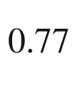

As/GaAs quantum wells: Influence on lifetime and diffusion of excess excitons. J. Appl. Phys. **66**, 2214–2216 (1989). [10.​1063/​1.​344288](https://doi.org/10.1063/1.344288)

H. Dember, Über eine photoelektronische Kraft in Kupferoxydul-Kristallen. Phys. Zeitschrift **32**, 554–556 (1931)

H. Dember, Über eine Kristallphotozelle. Phys. Zeitschrift **32**, 856–858 (1931)

H. Dember, Über die Vorwärtsbewegung von Elektronen durch Licht. Phys. Zeitschrift **33**, 207–208 (1932)

M. Krc̆mar, W.M. Saslow, Exact surface solutions for semiconductors: The Dember effect and partial currents. Phys. Rev. B **65**, 233313:1–4 (2002). [10.​1103/​PhysRevB.​65.​233313](https://doi.org/10.1103/PhysRevB.65.233313)

S.R. Goldman, K. Kalikstein, B. Kramer, Dember-effect theory. J. Appl. Phys. **49**, 2849–2854 (1978). [10.​1063/​1.​325166](https://doi.org/10.1063/1.325166)

S.K. Chattopadhyaya, V.K. Mathur, Normal and anomalous Dember effect. J. Appl. Phys. **40**, 1930–1933 (1969). [10.​1063/​1.​1657868](https://doi.org/10.1063/1.1657868)

M. Ni, M.K.H. Leung, D.Y.C. Leung, K. Sumathy, A review and recent developments in photocatalytic water-splitting using TiO

$$_2$$

for hydrogen production. Renew. Sustain. Energy Rev. **11**, 401–425 (2007). [10.​1016/​j.​rser.​2005.​01.​009](https://doi.org/10.1016/j.rser.2005.01.009)

S. Cho, J.-W. Jang, K.-H. Lee, J.S. Lee, Research update: strategies for efficient photoelectrochemical water splitting using metal oxide photoanodes. APL Mater. **2**, 010703:1–14 (2014). [10.​1063/​1.​4861798](https://doi.org/10.1063/1.4861798)

J. Watson, The tin oxide gas sensor and its applications. Sens. Act. **5**, 29–42 (1984). [10.​1016/​0250-6874(84)87004-3](https://doi.org/10.1016/0250-6874(84)87004-3)

G. Eranna, B.C. Joshi, D.P. Runthala, R.P. Gupta, Oxide materials for development of integrated gas sensors—a comprehensive review. Crit. Rev. Solid State Mater. Sci. **29**, 111–188 (2004). [10.​1080/​1040843049088897​7](https://doi.org/10.1080/10408430490888977)

X. Liu, S. Cheng, H. Liu, S. Hu, D. Zhang, H. Ning, A survey on gas sensing technology. Sensors **12**, 9635–9665 (2012). [10.​3390/​s120709635](https://doi.org/10.3390/s120709635)

H. Ibach, *Physics of Surfaces and Interfaces* (Springer, Berlin, 2006). [10.​1007/​3-540-34710-0](https://doi.org/10.1007/3-540-34710-0)

A. Zangwill, *Physics at Surfaces* (Cambridge University Press, Cambridge, 2012). [10.​1017/​CBO9780511622564​](https://doi.org/10.1017/CBO9780511622564)

R.H. Kingston, *Semiconductor Surface Physics* (Literary Licensing, Whitefish, 2012)

P.J. Morandi, *Symmetry Groups: The Classification of Wallpaper Patterns* (New Mexico State University, From Group Cohomology to Escher’s Tessellations, 2007)

A.A. Stekolnikov, F. Bechstedt, Shape of free and constrained group-IV crystallites: Influence of surface energies. Phys. Rev. B **72**, 125326:1–9 (2005). [10.​1103/​PhysRevB.​72.​125326](https://doi.org/10.1103/PhysRevB.72.125326)

J.M. Bermond, J.J. Métois, X. Egéa, F. Floret, The equilibrium shape of silicon. Surf. Sci. **330**, 48–60 (1995). [10.​1016/​0039-6028(95)00230-8](https://doi.org/10.1016/0039-6028(95)00230-8)

C.B. Duke, Semiconductor surface reconstruction: the structural chemistry of two-dimensional surface compounds. Chem. Rev. **96**, 1237–1259 (1996). [10.​1021/​cr950212s](https://doi.org/10.1021/cr950212s)

J. Fritsch, U. Schröder, Density functional calculation of semiconductor surface phonons. Phys. Reports **309**, 209–331 (1999). [10.​1016/​S0370-1573(98)00034-9](https://doi.org/10.1016/S0370-1573(98)00034-9)

K. Hermann, *Fritz-Haber-Institut* (Berlin)

W.G. Schmidt, F. Bechstedt, J. Bernholc, GaAs(001) surface reconstructions: geometries, chemical bonding and optical properties. Appl. Surf. Sci. **190**, 264–268 (2002). [10.​1016/​S0169-4332(01)00862-5](https://doi.org/10.1016/S0169-4332(01)00862-5)

K. Takayanagi, Y. Tanishiro, S. Takahashi, M. Takahashi, Surface analysis of Si(111)-7

$$\times $$

7. Surf. Sci. **164**, 367–392 (1985). [10.​1016/​0039-6028(85)90753-8](https://doi.org/10.1016/0039-6028(85)90753-8)

R. Wiesendanger, G. Tarrach, L. Scandella, H.-J. Güntherodt, Scanning tunneling microscopy on laser- and thermal-annealed Si(111): Transitions from 7

$$\times $$

7 reconstructed to disordered surface structures. Ultramicroscopy **32**, 291–295 (1990). [10.​1016/​0304-3991(90)90006-8](https://doi.org/10.1016/0304-3991(90)90006-8)

F.J. Giessibl, S. Hembacher, H. Bielefeldt, J. Mannhart, Subatomic features on the silicon (111)-(7

$$\times $$

7) surface observed by atomic force microscopy. Science **289**, 422–425 (2000). [10.​1126/​science.​289.​5478.​422](https://doi.org/10.1126/science.289.5478.422)

B.S. Swartzentruber, N. Kitamura, M.G. Lagally, M.B. Webb, Behavior of steps on Si(001) as a function of vicinality. Phys. Rev. B **47**, 13432–13441 (1993). [10.​1103/​PhysRevB.​47.​13432](https://doi.org/10.1103/PhysRevB.47.13432)

O. Dulub, L.A. Boatner, U. Diebold, STM study of the geometric and electronic structure of ZnO

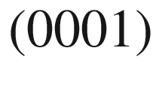

-Zn,

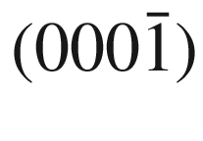

-O,

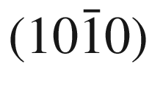

, and

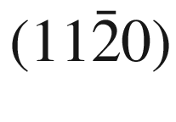

surfaces. Surf. Sci. **519**, 201–217 (2002). [10.​1016/​S0039-6028(02)02211-2](https://doi.org/10.1016/S0039-6028(02)02211-2)

J.J. Métois, A. Saúl, P. Müller, Measuring the surface stress polar dependence. Nature Mater. **4**, 238–242 (2005). [10.​1038/​nmat1328](https://doi.org/10.1038/nmat1328)

M. Syväjärvi, R. Yakimova, E. Janzén, Step-bunching in SiC epitaxy: anisotropy and influence of growth temperature. J. Cryst. Growth **236**, 297–304 (2002). [10.​1016/​S0022-0248(01)02331-4](https://doi.org/10.1016/S0022-0248(01)02331-4)

A.A. Baski, S.C. Erwin, L.J. Whitman, The structure of silicon surfaces from (001) to (111). Surf. Sci. **392**, 69–85 (1997). [10.​1016/​S0039-6028(97)00499-8](https://doi.org/10.1016/S0039-6028(97)00499-8)

R.H. Ritchie, Plasma losses by fast electrons in thin films. Phys. Rev. **106**, 874–881 (1957). [10.​1103/​PhysRev.​106.​874](https://doi.org/10.1103/PhysRev.106.874)

J.M. Pitarke, V.M. Silkin, E.V. Chulkov, P.M. Echenique, Theory of surface plasmons and surface-plasmon polaritons. Rep. Prog. Phys. **70**, 1–87 (2007). [10.​1088/​0034-4885/​70/​1/​R01](https://doi.org/10.1088/0034-4885/70/1/R01)

J. Zhang, L. Zhang, W. Xu, Surface plasmon polaritons: physics and applications. J. Phys. D: Appl. Phys. **45**, 113001:1–19 (2012). [10.​1088/​0022-3727/​45/​11/​113001](https://doi.org/10.1088/0022-3727/45/11/113001)

[https://​www.​wikipedia.​de](https://www.wikipedia.de)

S. Kalusniak, S. Sadofev, F. Henneberger, ZnO as a tunable metal: new types of surface plasmon polaritons. Phys. Rev. Lett. **112**, 137401 (2014). [10.​1103/​PhysRevLett.​112.​137401](https://doi.org/10.1103/PhysRevLett.112.137401)

J.E. Northrup, M.S. Hybertsen, S.G. Louie, Many-body calculation of the surface-state energies for Si(111)2

$$\times $$

1. Phys. Rev. Lett. **66**, 500–503 (1991). [10.​1103/​PhysRevLett.​66.​500](https://doi.org/10.1103/PhysRevLett.66.500)

I. Ivanov, A. Mazur, J. Pollmann, The ideal (111), (110), and (100) surfaces of Si, Ge and GaAs: a comparison of their electronic structure. Surf. Sci. **92**, 365–384 (1980). [10.​1016/​0039-6028(80)90209-5](https://doi.org/10.1016/0039-6028(80)90209-5)

R.I.G. Uhrberg, G.V. Hansson, Electronic structure of silicon surfaces: clean and with ordered overlayers. Crit. Rev. Solid State Mater. Sci. **17**, 133–186 (1991). [10.​1080/​1040843910824219​1](https://doi.org/10.1080/10408439108242191)

P. Mårtensson, W.-X. Ni, G.V. Hansson, J.M. Nicholls, B. Reihl, Surface electronic structure of Si(111)7

$$\times $$

7-Ge and Si(111)5

$$\times $$

5-Ge studied with photoemission and inverse photoemission. Phys. Rev. B **36**, 5974–5981 (1987). [10.​1103/​PhysRevB.​36.​5974](https://doi.org/10.1103/PhysRevB.36.5974)

S.R. Varier, P.S. Mandal, N. Sahadev, D.N. Biswas, K. Maiti, Study of the surface electronic structure of Si(111) surface using spin and angle resolved photoemission spectroscopy. AIP Conf. Proc. **1512**, 818–819 (2013). [10.​1063/​1.​4791289](https://doi.org/10.1063/1.4791289)

Z. Zhu, Y. Cheng, U. Schwingenschlögl, Band inversion mechanism in topological insulators: A guideline for materials design. Phys. Rev. B **85**, 235401:1–5 (2012). [10.​1103/​PhysRevB.​85.​235401](https://doi.org/10.1103/PhysRevB.85.235401)

L. Fu, C.L. Kane, E.J. Mele, Topological insulators in three dimensions. Phys. Rev. Lett. **98**, 106803:1–4 (2007). [10.​1103/​PhysRevLett.​98.​106803](https://doi.org/10.1103/PhysRevLett.98.106803)

H. Zhang, C.-X. Liu, X.-L. Qi, X. Dai, Zh Fang, S-Ch. Zhang, Topological insulators in Bi

$$_2$$

Se

$$_3$$

, Bi

$$_2$$

Te

$$_3$$

and Sb

$$_2$$

Te

$$_3$$

with a single Dirac cone on the surface. Nature Physics **5**, 438–442 (2009). [10.​1038/​nphys1270](https://doi.org/10.1038/nphys1270)

Y. Xia, D. Qian, D. Hsieh, L. Wray, A. Pal, H. Lin, A. Bansil, D. Grauer, Y.S. Hor, R.J. Cava, M.Z. Hasan, Observation of a large-gap topological-insulator class with a single Dirac cone on the surface. Nat. Phys. **5**, 398–402 (2009). [10.​1038/​nphys1274](https://doi.org/10.1038/nphys1274)

Y. Xia, *Photoemission studies of a new topological insulator class: Experimental discovery of the Bi*

$$_2$$

*X*

$$_3$$

*topological insulator class*, Ph.D. Thesis, Princeton University (2010)

J.E. Ayers, T. Kujofsa, P. Rago, J. Raphael, *Heteroepitaxy of Semiconductors: Theory, Growth, and Characterization*, 2nd edn. (CRC Press, Boca Raton, 2016)

U. Pohl, *Epitaxy of Semiconductors* (Springer, Berlin, 2013). [10.​1007/​978-3-642-32970-8](https://doi.org/10.1007/978-3-642-32970-8)

G. Dhanaraj, K. Byrappa, V. Prasad, M. Dudley, eds., *Springer Handbook of Crystal Growth* (Springer, Heidelberg, 2010). [10.​1007/​978-3-540-74761-1](https://doi.org/10.1007/978-3-540-74761-1)

J.Y. Tsao, *Materials Fundamentals of Molecular Beam Epitaxy* (Academic Press, San Diego, 1993). [10.​1016/​C2009-0-22426-3](https://doi.org/10.1016/C2009-0-22426-3)

M.L. Hitchman, K.F. Jensen, eds., *Chemical Vapor Deposition* (Academic Press, San Diego, 1993)

P. George, *Chemical Vapor Deposition: Simulation and Optimization* (VDM Verlag Dr. Mueller, Saarbrücken, 2008)

G. Stringfellow, *Organometallic Vapor-Phase Epitaxy: Theory and Practice* (Academic Press, San Diego, 1999). [10.​1016/​B978-0-12-673842-1.​X5000-5](https://doi.org/10.1016/B978-0-12-673842-1.X5000-5)

C.S. Hwang, C.Y. Yoo, eds., *Atomic Layer Deposition for Semiconductors* (Springer, Berlin, 2014). [10.​1007/​978-1-4614-8054-9](https://doi.org/10.1007/978-1-4614-8054-9)

J. Valdez, ed., *Atomic Layer Deposition (ALD)* (Nova Science Publ., Hauppauge, 2015)

R. Eason, ed., *Pulsed Laser Deposition of Thin Films: Applications-Led Growth of Functional Materials* (Wiley, Hoboken, 2006). [10.​1002/​0470052120](https://doi.org/10.1002/0470052120)

P. Capper, M. Mauk, eds., *Liquid Phase Epitaxy of Electronic, Optical and Optoelectronic Materials* (Wiley, Chichester, 2007). [10.​1002/​9780470319505](https://doi.org/10.1002/9780470319505)

B.A. Joyce, J.H. Neave, P.J. Dobson, P.K. Larsen, Analysis of reflection high-energy electron-diffraction data from reconstructed semiconductor surfaces. Phys. Rev. B **29**, 814–819 (1984). [10.​1103/​PhysRevB.​29.​814](https://doi.org/10.1103/PhysRevB.29.814)

J.-T. Zettler, W. Richter, K. Ploska, M. Zorn, J. Rumberg, C. Meyne, M. Pristovsek, Real time diagnostics of semiconductor surface modifications by reflectance anisotropy spectroscopy, in *Semiconductor Characterization—Present Status and Future Needs*, eds. by W.M. Bullis, D.G. Seiler, A.C. Diebold (AIP Press, Woodbury, 1996), pp. 537–543

J.-T. Zettler, Characterization of epitaxial semiconductor growth by reflectance anisotropy spectroscopy and ellipsometry. Prog. Cryst. Growth Charact. Mater. **35**, 27–98 (1997). [10.​1016/​S0960-8974(97)00024-7](https://doi.org/10.1016/S0960-8974(97)00024-7)

W. Zulehner, Status and future of silicon crystal growth. Mater. Sci. Engin. B **4**, 1–10 (1989). [10.​1016/​0921-5107(89)90207-9](https://doi.org/10.1016/0921-5107(89)90207-9)

W. Zulehner, Historical overview of silicon crystal pulling development. Mater. Sci. Engin. B **73**, 7–15 (2000). [10.​1016/​S0921-5107(99)00427-4](https://doi.org/10.1016/S0921-5107(99)00427-4)

B. Depuydt, A. Theuwis, I. Romandie, Germanium: From the first application of Czochralski crystal growth to large diameter dislocation-free wafers. Mat. Sci. Semicond. Process. **9**, 437–443 (2006). [10.​1016/​j.​mssp.​2006.​08.​002](https://doi.org/10.1016/j.mssp.2006.08.002)

Virgina Semiconductor, [www.​virginiasemi.​com](http://www.virginiasemi.com)

J. Czochralski, Ein neues Verfahren zur Messung der Kristallisationsgeschwindigkeit der Metalle. Z. Phys. Chem. **92**, 219–221 (1918). [10.​1515/​zpch-1918-9212](https://doi.org/10.1515/zpch-1918-9212)

R. Uecker, The historical development of the Czochralski method. J. Cryst. Growth **401**, 7–24 (2014). [10.​1016/​j.​jcrysgro.​2013.​11.​095](https://doi.org/10.1016/j.jcrysgro.2013.11.095)

G.K. Teal, J.B. Little, Growth of germanium single crystals. Phys. Rev. **78**, 647 (1950). [10.​1103/​PhysRev.​78.​637](https://doi.org/10.1103/PhysRev.78.637)

G.K. Teal, M. Sparks, E. Buehler, Growth of germanium single crystals containing p-n junctions. Phys. Rev. **81**, 637 (1951). [10.​1103/​PhysRev.​81.​637](https://doi.org/10.1103/PhysRev.81.637)

W.R. Runyan, Growth of large diameter silicon and germanium crystals by the Teal-Little method. Rev. Sci. Instr. **30**, 535–540 (1959). [10.​1063/​1.​1716676](https://doi.org/10.1063/1.1716676)

W.G. Pfann, *Zone Melting* (Wiley, New York, 1966)

H.J. Scheel, T. Fukuda, eds., *Crystal Growth Technology* (Wiley, New York, 2004)

Siltronic AG

K.A. Reinhardt, W. Kern, *Handbook of Silicon Wafer Cleaning Technology*, 3rd edn. (William Andrew, New York, 2018)

J. Ruzyllo, Semiconductor cleaning technology: forty years in the making. Interface **19**, 44–46 (2010). [10.​1149/​2.​F05101if](https://doi.org/10.1149/2.F05101if)

W. Kern, Purifying Si and SiO

$$_2$$

surfaces with hydrogen peroxide, in *Semiconductor International* (1984), pp. 94–99

A. Ishizaka, Y. Shiraki, Low temperature surface cleaning of silicon and its application to silicon MBE. J. Electrochem. Soc. **133**, 666–671 (1986). [10.​1149/​1.​2108651](https://doi.org/10.1149/1.2108651)

J.C. Kim, J.-Y. Ji, J.S. Kline, J.R. Tucker, T.-C. Shen, Preparation of atomically clean and flat Si(100) surfaces by low-energy ion sputtering and low-temperature annealing. Appl. Surf. Sci. **220**, 293–297 (2003). [10.​1016/​S0169-4332(03)00826-2](https://doi.org/10.1016/S0169-4332(03)00826-2)

H. Hartnagel, B.L. Weiss, A contribution to etch polishing of GaAs. J. Mat. Sci. **8**, 1061–1063 (1973). [10.​1007/​BF00756642](https://doi.org/10.1007/BF00756642)

Z.F. Tomashik, N.V. Kusyak, V.N. Tomashik, Chemical etching of InAs, InSb, and GaAs in H

$$_2$$

O

$$_2$$

-HBr solutions. Inorg. Mat. **38**, 434–437 (2002). [10.​1023/​A:​1015402501421](https://doi.org/10.1023/A:1015402501421)

H. von Wenckstern, H. Schmidt, C. Hanisch, M. Brandt, C. Czekalla, G. Benndorf, G. Biehne, A. Rahm, H. Hochmuth, M. Lorenz, M. Grundmann, Homoepitaxy of ZnO by pulsed-laser deposition. Phys. Status Solidi RRL **1**, 129–131 (2007). [10.​1002/​pssr.​200701052](https://doi.org/10.1002/pssr.200701052)

C. Weisbuch, Fundamental properties of III-V semiconductor two-dimensional quantized structures: the basis for optical and electronic device applications. Semicond. Semimet. **24**, 1–133 (1987). [10.​1016/​S0080-8784(08)62448-5](https://doi.org/10.1016/S0080-8784(08)62448-5)

C.H.J. van den Brekel, Growth rate anisotropy and morphology of autoepitaxial silicon films from SiCl

$$_4$$

. J. Cryst. Growth **23**, 259–266 (1974). [10.​1016/​0022-0248(74)90067-0](https://doi.org/10.1016/0022-0248(74)90067-0)

J.-I. Nishizawa, T. Terasaki, M. Shimbo, Layer growth in silicon epitaxy. J. Cryst. Growth **13**(14), 297–301 (1972). [10.​1016/​0022-0248(72)90173-X](https://doi.org/10.1016/0022-0248(72)90173-X)

J.G.E. Gardiniers, C.H. Klein Douwel, L.J. Giling, Reduced pressure silicon CVD on hemispherical substrates. J. Cryst. Growth **108**, 319–334 (1991). [10.​1016/​0022-0248(91)90380-N](https://doi.org/10.1016/0022-0248(91)90380-N)

S. Nishino, Y. Nishio, Y. Masuda, Y. Chen, C. Jacob, Morphological stability of 6H-SiC epitaxial layer on hemispherical substrates prepared by chemical vapor deposition. Mat. Sci. Forum **338–342**, 197–200 (2000). [10.​4028/​www.​scientific.​net/​MSF.​338-342.​197](https://doi.org/10.4028/www.scientific.net/MSF.338-342.197)

L. Hollan, C. Schiller, Étude de l’anisotropie de la croissance épitaxiale de GaAs en phase vapeur. J. Cryst. Growth **13**(14), 319–324 (1972). [10.​1016/​0022-0248(72)90177-7](https://doi.org/10.1016/0022-0248(72)90177-7)

K. Morizane, Antiphase domain structures in GaP and GaAs epitaxial layers grown on Si and Ge. J. Cryst. Growth **38**, 249–254 (1977). [10.​1016/​0022-0248(77)90305-0](https://doi.org/10.1016/0022-0248(77)90305-0)

M. Volmer, A. Weber, Keimbildung in übersättigten Gebilden. Z. Physikal. Chem. **119U**, 277–301 (1926). [10.​1515/​zpch-1926-11927](https://doi.org/10.1515/zpch-1926-11927)

I.N. Stranski, Zur Theorie der isomorphen Fortwachsung (orientierter Ausscheidung) von Ionenkristallen aufeinander. Z. Physikal. Chemie **142A**, 453–466 (1929). [10.​1515/​zpch-1929-14232](https://doi.org/10.1515/zpch-1929-14232)

I.N. Stranski, L. Krastanow, Zur Theorie der orientierten Ausscheidung von Ionenkristallen aufeinander, Monatshefte f. Chemie u. verwandte Teile anderer Wissenschaften **71**, 351–364 (1937). [10.​1515/​zpch-1929-14232](https://doi.org/10.1515/zpch-1929-14232)

E. Bauer, Phänomenologische Theorie der Kristallabscheidung an Oberflächen. I. Z. Kristallogr. **110**, 372–394 (1958). [10.​1524/​zkri.​1958.​110.​16.​372](https://doi.org/10.1524/zkri.1958.110.16.372)

T. Shitara, D.D. Vvedensky, M.R. Wilby, J. Zhang, J.H. Neave, B.A. Joyce, Step-density variations and reflection high-energy electron-diffraction intensity oscillations during epitaxial growth on vicinal GaAs(001). Phys. Rev. B **46**, 6815–6824 (1992). [10.​1103/​PhysRevB.​46.​6815](https://doi.org/10.1103/PhysRevB.46.6815)

A. Pimpinelli, J. Villain, *Physics of Crystal Growth* (Cambridge Univ. Press, Cambridge, 1999). [10.​1017/​CBO9780511622526​](https://doi.org/10.1017/CBO9780511622526)

E. Ohshima, H. Ogino, I. Niikura, K. Maeda, M. Sato, M. Ito, T. Fukuda, Growth of the 2-in-size bulk ZnO single crystals by the hydrothermal method. J. Cryst. Growth **260**, 166–170 (2004). [10.​1016/​j.​jcrysgro.​2003.​08.​019](https://doi.org/10.1016/j.jcrysgro.2003.08.019)

F. Scholz, U. Kaiser, Universität Ulm

S. Heitsch, C. Bundesmann, G. Wagner, G. Zimmermann, A. Rahm, H. Hochmuth, G. Benndorf, H. Schmidt, M. Schubert, M. Lorenz, M. Grundmann, Low temperature photoluminescence and infrared dielectric functions of pulsed laser deposited ZnO thin films on silicon. Thin Solid Films **496**, 234–239 (2006). [10.​1016/​j.​tsf.​2005.​08.​305](https://doi.org/10.1016/j.tsf.2005.08.305)

M. Grundmann, T. Böntgen, M. Lorenz, Occurrence of rotation domains in heteroepitaxy. Phys. Rev. Lett. **105**, 146102:1–4 (2010). [10.​1103/​PhysRevLett.​105.​146102](https://doi.org/10.1103/PhysRevLett.105.146102)

M. Grundmann, Formation of epitaxial domains: unified theory and survey of experimental results. Phys. Status Solidi B **248**, 805–824 (2011). [10.​1002/​pssb.​201046530](https://doi.org/10.1002/pssb.201046530)

Y. Zhang, C. McAleese, H. Xiu, C.J. Humphreys, R.R. Lieten, B. Degroote, G. Borghs, Misoriented domains in (0001)-GaN/(111)-Ge grown by molecular beam epitaxy. Appl. Phys. Lett. **91**, 092125:1–2 (2007) [10.​1063/​1.​2779099](https://doi.org/10.1063/1.2779099)

H. Kawanami, A. Hatayama, Y. Hayashi, Antiphase boundary of GaAs films grown on Si(001) substrates by molecular beam epitaxy. J. Electr. Mater. **17**, 341–349 (1988). [10.​1007/​BF02652116](https://doi.org/10.1007/BF02652116)

J. Ohta, H. Fujioka, M. Oshima, K. Fujiwara, A. Ishii, Experimental and theoretical investigation on the structural properties of GaN grown on sapphire. Appl. Phys. Lett. **83**, 3075–3077 (2003). [10.​1063/​1.​1618379](https://doi.org/10.1063/1.1618379)

H. Kato, M. Sano, K. Miyamoto, T. Yao, Polarity control of ZnO on c-plane sapphire by plasma-assisted MBE. J. Cryst. Growth **275**, e2459–e2465 (2005). [10.​1016/​j.​jcrysgro.​2004.​11.​377](https://doi.org/10.1016/j.jcrysgro.2004.11.377)

P.J. Schuck, M.D. Mason, R.D. Grober, O. Ambacher, A.P. Lima, C. Miskys, R. Dimitrov, M. Stutzmann, Spatially resolved photoluminescence of inversion domain boundaries in GaN-based lateral polarity heterostructures. Appl. Phys. Lett. **79**, 952–954 (2001). [10.​1063/​1.​1390486](https://doi.org/10.1063/1.1390486)

B.J. Rodriguez, A. Gruveman, A.I. Kingon, R.J. Nemanich, O. Ambacher, Piezoresponse force microscopy for polarity imaging of GaN. Appl. Phys. Lett. **80**, 4166–4168 (2002). [10.​1063/​1.​1483117](https://doi.org/10.1063/1.1483117)

T.S. Zheleva, S.A. Smith, D.B. Thomson, K.J. Linthicum, P. Rajagopal, R.F. Davis, Pendeo-epitaxy: A new approach for lateral growth of gallium nitride films. J. Electr. Mater. **28**, L5–L8 (1999). [10.​1007/​s11664-999-0239-z](https://doi.org/10.1007/s11664-999-0239-z)

A. Strittmatter, S. Rodt, L. Reißmann, D. Bimberg, H. Schröder, E. Obermeier, T. Riemann, J. Christen, A. Krost, Maskless epitaxial lateral overgrowth of GaN layers on structured Si(111) substrates. Appl. Phys. Lett. **78**, 727–729 (2001). [10.​1063/​1.​1347013](https://doi.org/10.1063/1.1347013)

H. Lahrèche, P. Vennéguès, B. Beaumont, P. Gibart, Growth of high-quality GaN by low-pressure metal-organic vapour phase epitaxy (LP-MOVPE) from 3D islands and lateral overgrowth. J. Cryst. Growth **205**, 245–252 (1999). [10.​1016/​S0022-0248(99)00299-7](https://doi.org/10.1016/S0022-0248(99)00299-7)

T. Riemann, T. Hempel, J. Christen, P. Veit, R. Clos, A. Dadgar, A. Krost, U. Haboeck, A. Hoffmann, Optical and structural microanalysis of GaN grown on SiN submonolayers. J. Appl. Phys. **99**, 123518:1–8 (2006). [10.​1063/​1.​2150589](https://doi.org/10.1063/1.2150589)

H.G. Chen, T.S. Ko, S.C. Ling, T.C. Lu, H.C. Kuo, S.C. Wang, Y.H. Wu, L. Chang, Dislocation reduction in GaN grown on stripe patterned r-plane sapphire substrates. Appl. Phys. Lett. **91**, 021914:1–3 (2007). [10.​1063/​1.​2754643](https://doi.org/10.1063/1.2754643)

N. Okada, K. Tadatomo, Characterization and growth mechanism of nonpolar and semipolar GaN layers grown on patterned sapphire substrates. Semicond. Sci. Technol. **27**, 024003:1–9 (2012). [10.​1088/​0268-1242/​27/​2/​024003](https://doi.org/10.1088/0268-1242/27/2/024003)

F. Tendille, P. De Mierry, P. Vennéguès, S. Chenot, M. Teisseire, Defect reduction method in (11–22) semipolar GaN grown on patterned sapphire substrate by MOCVD: Toward heteroepitaxial semipolar GaN free of basal stacking faults. J. Cryst. Growth **404**, 177–183 (2014). [10.​1016/​j.​jcrysgro.​2014.​07.​020](https://doi.org/10.1016/j.jcrysgro.2014.07.020)

Y.H. Lo, New approach to grow pseudomorphic structures over the critical thickness. Appl. Phys. Lett. **59**, 2311–2313 (2005). [10.​1063/​1.​106053](https://doi.org/10.1063/1.106053)

C. Lynch, E. Chason, R. Beresford, L.B. Freund, K. Tetz, K.W. Schwarz, Limits of strain relaxation in InGaAs/GaAs probed in real time by in situ wafer curvature measurement. J. Appl. Phys. **98**, 073532:1–7 (2005). [10.​1063/​1.​2060947](https://doi.org/10.1063/1.2060947)

A. Dadgar, J. Bläsing, A. Diez, A. Alam, M. Heuken, A. Krost, Metalorganic chemical vapor phase epitaxy of crack-free GaN on Si(111) exceeding 1

$$\mu $$

m thickness. Jpn. J. Appl. Phys. **39**, L1183–L1185 (2000). [10.​1143/​JJAP.​39.​L1183](https://doi.org/10.1143/JJAP.39.L1183)

J. Bläsing, A. Reiher, A. Dadgar, A. Dietz, A. Krost, The origin of stress reduction by low-temperature AlN interlayers. Appl. Phys. Lett. **81**, 2722–2724 (2002). [10.​1063/​1.​1512331](https://doi.org/10.1063/1.1512331)

K. Sakamoto, T. Sakamoto, S. Nagao, G. Hashiguchi, K. Kuniyoshi, Y. Bando, Reflection high-energy electron diffraction intensity oscillations during Ge

$$_x$$

Si

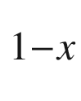

MBE growth on Si(001) substrates. Jpn. J. Appl. Phys. **26**, 666–670 (1987). [10.​1143/​JJAP.​26.​666](https://doi.org/10.1143/JJAP.26.666)

P.M.J. Marée, K. Nakagawa, F.M. Mulders, J.F. van der Veen, Thin epitaxial Ge-Si(111) films: study and control of morphology. Surf. Sci. **191**, 305–328 (1987). [10.​1016/​S0039-6028(87)81180-9](https://doi.org/10.1016/S0039-6028(87)81180-9)

M. Copel, M.C. Reuter, E. Kaxiras, R.M. Tromp, Surfactants in epitaxial growth. Phys. Rev. Lett. **63**, 632–635 (1989). [10.​1103/​PhysRevLett.​63.​632](https://doi.org/10.1103/PhysRevLett.63.632)

D. Kandel, E. Kaxiras, The surfactant effect in semiconductor thin-film growth. Solid State Phys. **54**, 219–262 (2000). [10.​1016/​S0081-1947(08)60249-0](https://doi.org/10.1016/S0081-1947(08)60249-0)

M. Ilg, D. Eißler, C. Lange, K. Ploog, Surfactant-mediated molecular beam epitaxy of high-quality (111)B-GaAs. Appl. Phys. A **56**, 397–399 (1993). [10.​1007/​BF00324362](https://doi.org/10.1007/BF00324362)

X. Yang, M.J. Jurkovic, J.B. Heroux, W.I. Wang, Low threshold InGaAsN/GaAs single quantum well lasers grown by molecular beam epitaxy using Sb surfactant. Electron. Lett. **35**, 1082–1083 (1999). [10.​1049/​el:​19990746](https://doi.org/10.1049/el:19990746)

T. Kageyama, T. Miyamoto, M. Ohta, T. Matsuura, Y. Matsui, T. Furuhata, F. Koyama, Sb surfactant effect on GaInAs/GaAs highly strained quantum well lasers emitting at 1200 nm range grown by molecular beam epitaxy. J. Appl. Phys. **96**, 44–48 (2004). [10.​1063/​1.​1760841](https://doi.org/10.1063/1.1760841)

H.J. Osten, J. Klatt, G. Lippert, B. Dietrich, E. Bugiel, Surfactant-controlled solid phase epitaxy of germanium and silicon. Phys. Rev. Lett. **69**, 450–453 (1992). [10.​1103/​PhysRevLett.​69.​450](https://doi.org/10.1103/PhysRevLett.69.450)

H. Kroemer, Heterostructure devices: a device physicist looks at interfaces. Surf. Sci. **132**, 543–576 (1983). [10.​1007/​978-94-009-3073-5\_​7](https://doi.org/10.1007/978-94-009-3073-5%255F7)

G. van der Ch, J. Walle, Neugebauer, Universal alignment of hydrogen levels in semiconductors, insulators and solutions. Nature **423**, 626–628 (2003). [10.​1038/​nature01665](https://doi.org/10.1038/nature01665)

K. Xu, H. Sio, O.A. Kirillov, L. Dong, M. Xu, P.D. Ye, D. Gundlach, N.V. Nguyen, Band offset determination of atomic-layer-deposited Al

$$_2$$

O

$$_3$$

and HfO

$$_2$$

on InP by internal photoemission and spectroscopic ellipsometry. J. Appl. Phys. **113**, 024504:1–5 (2013). [10.​1063/​1.​4774038](https://doi.org/10.1063/1.4774038)

K. Shi, D.B. Li, H.P. Song, Y. Guo, J. Wang, X.Q. Xu, J.M. Liu, A.L. Yang, H.Y. Wei, B. Zhang, S.Y. Yang, X.L. Liu, Q.S. Zhu, Z.G. Wang, Determination of InN/diamond heterojunction band offset by X-ray photoelectron spectroscopy. Nanoscale Res. Lett. **6**, 50:1–5 (2011). [10.​1007/​s11671-010-9796-6](https://doi.org/10.1007/s11671-010-9796-6)

P.F. Zhang, X.L. Liu, R.Q. Zhang, H.B. Fan, H.P. Song, H.Y. Wei, C.M. Jiao, S.Y. Yang, Q.S. Zhu, Z.G. Wang, Valence band offset of MgO/InN heterojunction measured by X-ray photoelectron spectroscopy. Appl. Phys. Lett. **92**, 042906 (2008). [10.​1063/​1.​2839611](https://doi.org/10.1063/1.2839611)

W. Wei, Z. Qin, S. Fan, Z. Li, K. Shi, Q. Zhu, G. Zhang, Valence band offset of

$$\beta $$

-Ga

$$_2$$

O

$$_3$$

wurtzite GaN heterostructure measured by X-ray photoelectron spectroscopy. Nanoscale Res. Lett. **7**, 562:1–5 (2013). [10.​1186/​1556-276X-7-562](https://doi.org/10.1186/1556-276X-7-562)

X. Zhang, Q. Zhang, F. Lu, Energy band alignment of an In

$$_2$$

O

$$_3$$

:Mo/Si heterostructure. Semicond. Sci. Technol. **22**, 900–904 (2007). [10.​1088/​0268-1242/​22/​8/​013](https://doi.org/10.1088/0268-1242/22/8/013)

A. Walsh, J.L.F. Da Silva, S.-H. Wei, C. Körber, A. Klein, L.F.J. Piper, A. DeMasi, K.E. Smith, G. Panaccione, P. Rorelli, D.J. Payne, A. Bourlange, R.G. Egdell, Nature of the band gap of In

$$_2$$

O

$$_3$$

revealed by first-principles calculations and X-ray spectroscopy. Phys. Rev. Lett. **100**, 167402:1–4 (2008). [10.​1103/​PhysRevLett.​100.​167402](https://doi.org/10.1103/PhysRevLett.100.167402)

P.D.C. King, T.D. Veal, C.E. Kendrick, L.R. Bailey, S.M. Durbin, C.F. McConville, InN/GaN valence band offset: High-resolution x-ray photoemission spectroscopy measurements. Phys. Rev. B **78**, 033308:1–4 (2008). [10.​1103/​PhysRevB.​78.​033308](https://doi.org/10.1103/PhysRevB.78.033308)

K. Muraki, S. Fukatsu, Y. Shiraki, R. Ito, Surface segregation of In atoms during molecular beam epitaxy and its influence on the energy levels in InGaAs/GaAs quantum wells. Appl. Phys. Lett. **61**, 557–559 (1992). [10.​1063/​1.​107835](https://doi.org/10.1063/1.107835)

D. Hernández-Maldonado, M. Herrera, P. Alonso-González, Y. González, L. González, J. Gazquez, M. Varela, S.J. Pennycook, M. de la Paz Guerrero-Lebrero, J. Pizarro, P.L. Galindo, S.I. Molina, Compositional analysis with atomic column spatial resolution by 5th-order aberration-corrected scanning transmission electron microscopy. Microsc. Microanal. **17**, 578–581 (2011). [10.​1017/​S143192761100021​3](https://doi.org/10.1017/S1431927611000213)

Volker Gottschalch, Günther Wagner, private communication (2006)

P. Offermans, *Study of III-V semiconductor nanostructures by cross-sectional scanning tunneling microscopy*, Ph.D. Thesis, Technische Universiteit Eindhoven (2005). [10.​6100/​IR595006](https://doi.org/10.6100/IR595006)

O. von Roos, Position-dependent effective masses in semiconductor theory. Phys. Rev. B **27**, 7547–7552 (1983). [10.​1103/​PhysRevB.​27.​7547](https://doi.org/10.1103/PhysRevB.27.7547)

D.J. BenDaniel, C.B. Duke, Space-charge effects on electron tunneling. Phys. Rev. **152**, 683–692 (1966). [10.​1103/​PhysRev.​152.​683](https://doi.org/10.1103/PhysRev.152.683)

P. Harrison, A. Valavanis, *Quantum Wells, Wires and Dots: Theoretical and Computational Physics of Semiconductor Nanostructures*, 4th edn. (Wiley, Chichester, 2016). [10.​1002/​9781118923337](https://doi.org/10.1002/9781118923337)

M. Ehrhardt, Th. Koprucki, eds., Multi-band effective mass approximations, in *Advanced Mathematical Models and Numerical Techniques*, vol. 94. *Lecture Notes in Computational Science and Engineering* (Springer, Heidelberg, 2014). [10.​1007/​978-3-319-01427-2](https://doi.org/10.1007/978-3-319-01427-2)

Y.C. Chang, J.N. Schulman, Interband optical transitions in GaAs/Ga

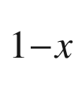

Al

$$_x$$

As and InAs-GaSb superlattices. Phys. Rev. B **31**, 2069–2079 (1985). [10.​1103/​PhysRevB.​31.​2069](https://doi.org/10.1103/PhysRevB.31.2069)

R.C. Miller, D.A. Kleinman, A.C. Gossard, Energy-gap discontinuities and effective masses for GaAs/Al

$$_x$$

Ga



As quantum wells. Phys. Rev. B **29**, 7085–7087 (1984). [10.​1103/​PhysRevB.​29.​7085](https://doi.org/10.1103/PhysRevB.29.7085)

S.L. Chuang, *Physics of Photonic Devices*, 2nd edn. (Wiley, New York, 2009)

R.C. Miller, A.C. Gossard, W.T. Tsang, O. Munteanu, Extrinsic luminescence from GaAs quantum wells. Phys. Rev. B **25**, 3871–3877 (1982). [10.​1103/​PhysRevB.​25.​3871](https://doi.org/10.1103/PhysRevB.25.3871)

W.T. Masselink, Y-Ch. Chang, H. Morkoç, Binding energy of acceptors in GaAs/Al

$$_x$$

Ga

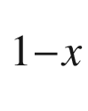

As quantum wells. Phys. Rev. B **28**, 7373–7376 (1983). [10.​1116/​1.​582827](https://doi.org/10.1116/1.582827)

D.B. Tran Thoai, R. Zimmermann, M. Grundmann, D. Bimberg, Image charges in semiconductor quantum wells: Effect on exciton binding energy. Phys. Rev. B **42**, 5906–5909 (1990). [10.​1103/​PhysRevB.​42.​5906](https://doi.org/10.1103/PhysRevB.42.5906)

M.J.L.S. Haines, N. Ahmed, S.J.A. Adams, K. Mitchell, I.R. Agool, C.R. Pidgeon, B.C. Cavenett, E.P. O’Reilly, A. Ghiti, M.T. Emeny, Exciton-binding-energy maximum in Ga

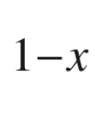

In

$$_x$$

As/GaAs quantum wells. Phys. Rev. B **43**, 11944–11949 (1991). [10.​1103/​PhysRevB.​43.​11944](https://doi.org/10.1103/PhysRevB.43.11944)

K.J. Moore, G. Duggan, K. Woodbridge, C. Roberts, Observations and calculations of the exciton binding energy in (In, Ga)As/GaAs strained-quantum-well heterostructures. Phys. Rev. B **41**, 1090–1094 (1990). [10.​1103/​PhysRevB.​41.​1090](https://doi.org/10.1103/PhysRevB.41.1090)

L. Esaki, A perspective in quantum-structure development, in *NATO ASI Series (Series B: Physics)*, eds. by E.E. Mendez, K. von Klitzing, vol. 170 (Springer, Boston, 1987). [10.​1007/​978-1-4684-5478-9\_​1](https://doi.org/10.1007/978-1-4684-5478-9%255F1)

R. Dingle, A.C. Gossard, W. Wiegmann, Direct observation of superlattice formation in a semiconductor heterostructure. Phys. Rev. Lett. **34**, 1327–1330 (1975). [10.​1103/​PhysRevLett.​34.​1327](https://doi.org/10.1103/PhysRevLett.34.1327)

F. Stern, S. Das Sarma, Electron energy in GaAs-Ga

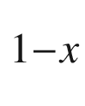

Al

$$_x$$

heterojunctions. Phys. Rev. B **30**, 840–848 (1984). [10.​1103/​PhysRevB.​30.​840](https://doi.org/10.1103/PhysRevB.30.840)

A.L. Efros, F.G. Pikus, G.G. Samsonidze, Maximum low-temperature mobility of two-dimensional electrons in heterojunctions with a thick spacer layer. Phys. Rev. B **41**, 8295–8301 (1990). [10.​1103/​PhysRevB.​41.​8295](https://doi.org/10.1103/PhysRevB.41.8295)

L. Pfeiffer, K.W. West, The role of MBE in recent quantum Hall effect physics discoveries. Physica E **20**, 57–64 (2003). [10.​1016/​j.​physe.​2003.​09.​035](https://doi.org/10.1016/j.physe.2003.09.035)

B.A. Bernevig, T.L. Hughes, S.-C. Zhang, Quantum spin Hall effect and topological phase transition in HgTe quantum wells. Science **314**, 1757–1761 (2006). [10.​1126/​science.​1133734](https://doi.org/10.1126/science.1133734)

M. König, S. Wiedmann, C. Brüne, A. Roth, H. Buhmann, L.W. Molenkamp, X.-L. Qi, S.-C. Zhang, Quantum spin Hall insulator state in HgTe quantum wells. Science **318**, 766–770 (2007). [10.​1126/​science.​1148047](https://doi.org/10.1126/science.1148047)

A. Roth, C. Brüne, H. Buhmann, L.W. Molenkamp, J. Maciejko, X.-L. Qi, S.-C. Zhang, Nonlocal transport in the quantum spin Hall state. Science **325**, 294–297 (2009). [10.​1126/​science.​1174736](https://doi.org/10.1126/science.1174736)

J. Christen, D. Bimberg, Line shapes of intersubband and excitonic recombination in quantum wells: Influence of final-state interaction, statistical broadening, and momentum conservation. Phys. Rev. B **42**, 7213–7219 (1990). [10.​1103/​PhysRevB.​42.​7213](https://doi.org/10.1103/PhysRevB.42.7213)

J. Feldmann, G. Peter, E.O. Göbel, P. Dawson, K. Moore, C. Foxon, R.J. Elliott, Linewidth dependence of radiative exciton lifetimes in quantum wells. Phys. Rev. Lett. **59**, 2337–2340 (1987). [10.​1103/​PhysRevLett.​60.​243.​4](https://doi.org/10.1103/PhysRevLett.60.243.4) Erratum: Phys. Rev. Lett. **60**, 243 (1988) [10.​1103/​PhysRevLett.​59.​2337](https://doi.org/10.1103/PhysRevLett.59.2337)

M.S. Skolnick, J.M. Rorison, K.J. Nash, D.J. Mowbray, P.R. Tapster, S.J. Bass, A.D. Pitt, Observation of a many-body edge singularity in quantum-well luminescence spectra. Phys. Rev. Lett. **58**, 2130–2133 (1987). [10.​1103/​PhysRevLett.​58.​2130](https://doi.org/10.1103/PhysRevLett.58.2130)

D. Gammon, S. Rudin, T.L. Reinecke, D.S. Katzer, C.S. Kyono, Phonon broadening of excitons in GaAs/Al

$$_x$$

Ga

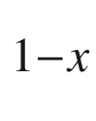

As quantum wells. Phys. Rev. B **51**, 16785–16789 (1995). [10.​1103/​PhysRevB.​51.​16785](https://doi.org/10.1103/PhysRevB.51.16785)

L. Béaur, T. Bretagnon, B. Gil, A. Kavokin, T. Guillet, C. Brimont, D. Tainoff, M. Teisseire, J.-M. Chauveau, Exciton radiative properties in nonpolar homoepitaxial ZnO/(Zn,Mg)O quantum wells. Phys. Rev. B **84**, 165312:1–8 (2011). [10.​1103/​PhysRevB.​84.​165312](https://doi.org/10.1103/PhysRevB.84.165312)

E. Runge, R. Zimmermann, Optical properties of localized excitons in nanostructures: theoretical aspects. Adv. Solid State Phys. (Festkörperprobleme) **38**, 251–263 (1999). [10.​1007/​BFb0107622](https://doi.org/10.1007/BFb0107622)

E. Runge, Excitons in semiconductor nanostructures. Solid State Phys. **57**, 149–305 (2002). [10.​1016/​S0081-1947(08)60180-0](https://doi.org/10.1016/S0081-1947(08)60180-0)

S.T. Davey, E.G. Scott, B. Wakefield, G.J. Davies, A photoluminescence study of Ga



In

$$_x$$

As/Al

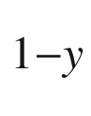

In

$$_y$$

As quantum wells grown by MBE. Semicond. Sci. Technol. **3**, 365–371 (1988). [10.​1088/​0268-1242/​3/​4/​014](https://doi.org/10.1088/0268-1242/3/4/014)

M. Grassi Alessi, F. Fragano, A. Patané, M. Capizzi, E. Runge, R. Zimmermann, Competition between radiative decay and energy relaxation of carriers in disordered In

$$_x$$

Ga

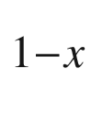

As/GaAs quantum wells. Phys. Rev. B **61**, 10985–10993 (2000). [10.​1103/​PhysRevB.​61.​10985](https://doi.org/10.1103/PhysRevB.61.10985)

Q. Li, S.J. Xu, W.C. Cheng, M.H. Xie, S.Y. Tong, C.M. Che, H. Yang, Thermal redistribution of localized excitons and its effect on the luminescence band in InGaN ternary alloys. Appl. Phys. Lett. **79**, 1810–1812 (2001). [10.​1063/​1.​1403655](https://doi.org/10.1063/1.1403655)

J. Hegarty, L. Goldner, M.D. Sturge, Localized and delocalized two-dimensional excitons in GaAs-AlGaAs multiple-quantum-well structures. Phys. Rev. B **30**, 7346–7348 (1984). [10.​1103/​PhysRevB.​30.​7346](https://doi.org/10.1103/PhysRevB.30.7346)

N.F. Mott, E.A. Davies, *Electronic Processes in Noncrystalline Materials*, 2nd edn. (Oxford University Press, New York, 1979)

T. Takeuchi, S. Sota, M. Katsuragawa, M. Komori, H. Takeuchi, H. Amano, I. Akasaki, Quantum-confined Stark effect due to piezoelectric fields in GaInN strained quantum wells. Jpn. J. Appl. Phys. **36**, Part 2, L382–L385 (1997). [10.​1143/​JJAP.​36.​L382](https://doi.org/10.1143/JJAP.36.L382)

S.F. Chichibu, A.C. Abare, M.S. Minsky, S. Keller, S.B. Fleischer, J.E. Bowers, E. Hu, U.K. Mishra, L.A. Coldren, S.P. DenBaars, Effective band gap inhomogeneity and piezoelectric field in InGaN/GaN multiquantum well structures. Appl. Phys. Lett. **73**, 2005–2008 (1998). [10.​1063/​1.​122350](https://doi.org/10.1063/1.122350)

C. Morhain, T. Bretagnon, P. Lefebvre, X. Tang, P. Valvin, T. Guillet, B. Gil, T. Taliercio, M. Teisseire-Doninelli, B. Vinter, C. Deparis, Internal electric field in wurtzite ZnO/Zn

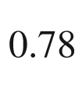

Mg

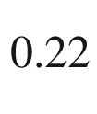

O quantum wells. Phys. Rev. B **72**, 241305(R):1–4 (2005). [10.​1103/​PhysRevB.​72.​241305](https://doi.org/10.1103/PhysRevB.72.241305)

J.A. Davis, L.V. Dao, X. Wen, C. Ticknor, P. Hannaford, V.A. Coleman, H.H. Tan, C. Jagadish, K. Koike, S. Sasa, M. Inoue, M. Yano, Suppression of the internal electric field effects in ZnO/Zn

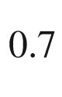

Mg

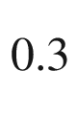

O quantum wells by ion-implantation induced intermixing. Nanotechnology **19**, 055205:1–4 (2008). [10.​1088/​0957-4484/​19/​05/​055205](https://doi.org/10.1088/0957-4484/19/05/055205)

E. Berkowicz, D. Gershoni, G. Bahir, E. Lakin, D. Shilo, E. Zolotoyabko, A.C. Abare, S.P. Denbaars, L.A. Coldren, Measured and calculated radiative lifetime and optical absorption of In

$$_x$$

Ga



N/GaN quantum structures. Phys. Rev. B **61**, 10994–11008 (2000). [10.​1103/​PhysRevB.​61.​10994](https://doi.org/10.1103/PhysRevB.61.10994)

N. Akopian, G. Bahir, D. Gershoni, M.D. Craven, J.S. Speck, S.P. DenBaars, Optical evidence for lack of polarization in

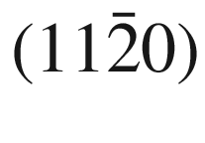

-oriented GaN/(AlGa)N quantum structures. Appl. Phys. Lett. **86**, 202104:1–3 (2005). [10.​1063/​1.​1926406](https://doi.org/10.1063/1.1926406)

J. Spitzer, T. Ruf, M. Cardona, W. Dondl, R. Schorer, G. Abstreiter, E.E. Haller, Raman scattering by optical phonons in isotopic

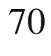

(Ge)

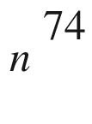

(Ge)

$$_n$$

superlattices. Phys. Rev. Lett. **72**, 1565–1568 (1994). [10.​1103/​PhysRevLett.​72.​1565](https://doi.org/10.1103/PhysRevLett.72.1565)

A. Reznicek, R. Scholz, S. Senz, U. Gösele, Comparative TEM study of bonded silicon/silicon interfaces fabricated by hydrophilic, hydrophobic and UHV wafer bonding. Mater. Chem. Phys. **81**, 277–280 (2003). [10.​1016/​S0254-0584(02)00601-6](https://doi.org/10.1016/S0254-0584(02)00601-6)

P. Kopperschmidt, S. Senz, G. Kästner, D. Hesse, U.M. Gösele, Materials integration of gallium arsenide and silicon by wafer bonding. Appl. Phys. Lett. **72**, 3181–3183 (1998). [10.​1063/​1.​121586](https://doi.org/10.1063/1.121586)

Q.-Y. Tong, U. Gösele, *Semiconductor Wafer Bonding: Science and Technology* (Wiley, New York, 1998)

U. Gösele, Q.-Y. Tong, Semiconductor Wafer Bonding. Ann. Rev. Mat. Sci. **28**, 215–241 (1998). [10.​1146/​annurev.​matsci.​28.​1.​215](https://doi.org/10.1146/annurev.matsci.28.1.215)

M. Alexe, U. Gösele, eds., *Wafer Bonding* (Springer, Berlin, 2004). [10.​1007/​978-3-662-10827-7](https://doi.org/10.1007/978-3-662-10827-7)

A.K. Geim, Nobel Lecture: Random walk to graphene. Rev. Mod. Phys. **83**, 851–862 (2011). [10.​1103/​RevModPhys.​83.​851](https://doi.org/10.1103/RevModPhys.83.851)

*2D Materials*, F. Iacopi, J.J. Boeckl, C. Jagadish, eds., Semicond. Semimet. **95** (2016).

10.​1016/​S0080-8784(16)30017-5

P. Avouris, T.F. Heinz, T. Low, eds., *2D Materials, Properties and Devices* (Cambridge Univ. Press, Cambridge, 2017). [10.​1017/​9781316681619](https://doi.org/10.1017/9781316681619)

J. Li, Z. Wei, J. Kang, *Two-Dimensional Semiconductors, Synthesis Physical Properties and Applications* (Wiley-VCH, Weinheim, 2020)

H.P. Boehm, R. Setton, E. Stumpp, Nomenclature and terminology of graphite intercalation compounds. Carbon **24**, 241–245 (1986). [10.​1016/​0008-6223(86)90126-0](https://doi.org/10.1016/0008-6223(86)90126-0)

A.H. Castro Neto, F. Guinea, N.M.R. Peres, K.S. Novoselov, A.K. Geim, The electronic properties of graphene. Rev. Mod. Phys. **81**, 109–162 (2009). [10.​1103/​RevModPhys.​81.​109](https://doi.org/10.1103/RevModPhys.81.109)

D.R. Dreyer, R.S. Ruoff, C.W. Bielawski, From conception to realization: an historial account of graphene and some perspectives for its future. Angew. Chemie Int. Ed. **49**, 9336–9344 (2010). [10.​1002/​anie.​201003024](https://doi.org/10.1002/anie.201003024)

*Ten years in two dimensions* (editorial), Nature Nanotechn. **9**, 725 (2014) and Focus issue ’Graphene applications’ of Nature Nanotechnology **9** (2014).

10.​1038/​nnano.​2014.​244

J. Yang, P. Hu, G. Yu, Perspective of graphene-based electronic devices: Graphene synthesis and diverse applications. APL Mater. **7**, 020901:1–7 (2019). [10.​1063/​1.​5054823](https://doi.org/10.1063/1.5054823)

W. Choi, I. Lahiri, R. Seelaboyina, Y.S. Kang, Synthesis of graphene and its applications: A review. Crit. Rev. Solid State Mater. Sci. **35**, 52–71 (2010). [10.​1063/​1.​5054823](https://doi.org/10.1063/1.5054823)

V.B. Mohan, K.-T. Lau, D. Hui, D. Battacharyya, Graphene-based materials and their composites: A review on production, applications and product limitations. Compos. B: Eng. **142**, 200–220 (2018). [10.​1016/​j.​compositesb.​2018.​01.​013](https://doi.org/10.1016/j.compositesb.2018.01.013)

R. Peierls, Bemerkungen über Umwandlungstemperaturen. Helvetica Phys. Acta **7**, 81–83 (1934). [10.​5169/​seals-110415](https://doi.org/10.5169/seals-110415)

N.D. Mermin, Crystalline order in two dimensions. Phys. Rev. **176**, 250–254 (1968), Errata: and [10.​1103/​PhysRev.​176.​250](https://doi.org/10.1103/PhysRev.176.250) Phys. Rev. B **20**, 4762 (1979) and [10.​1103/​PhysRevB.​20.​4762](https://doi.org/10.1103/PhysRevB.20.4762) Phys. Rev. B **74**, 149902(E) (2006). [10.​1103/​PhysRevB.​74.​149902](https://doi.org/10.1103/PhysRevB.74.149902)

J.C. Meyer, A.K. Geim, M.I. Katsnelson, K.S. Novoselov, T.J. Booth, S. Roth, The structure of suspended graphene sheets. Nature **446**, 60–63 (2007). [10.​1038/​nature05545](https://doi.org/10.1038/nature05545)

K.S. Novoselov, A.K. Geim, S.V. Morozov, D. Jiang, Y. Zhang, S.V. Dubonos, I.V. Grigorieva, A.A. Firsov, Electric field effect in atomically thin carbon films. Science **306**, 666–669 (2004). [10.​1126/​science.​1102896](https://doi.org/10.1126/science.1102896)

K.S. Novoselov, D. Jiang, F. Schedin, T.J. Booth, V.V. Khotkevich, S.V. Morozov, A.K. Geim, Two-dimensional atomic crystals. PNAS **102**, 10451–10453 (2005). [10.​1073/​pnas.​0502848102](https://doi.org/10.1073/pnas.0502848102)

G.R. Yazdi, T. Iakimov, R. Yakimova, Epitaxial graphene on SiC: a review of growth and characterization. Crystals **6**, 53:1–45 (2016). [10.​3390/​cryst6050053](https://doi.org/10.3390/cryst6050053)

University of Manchester, [www.​condmat.​physics.​manchester.​ac.​uk](http://www.condmat.physics.manchester.ac.uk)

A.M. Valencia, M.J. Caldas, Single vacancy defect in graphene: Insights into its magnetic properties from theoretical modeling. Phys. Rev. B **96**, 125431:1–9 (2017). [10.​1103/​PhysRevB.​96.​125431](https://doi.org/10.1103/PhysRevB.96.125431)

J.S. Bunch, A.M. van der Zande, S.S. Verbridge, I.W. Frank, D.M. Tanenbaum, J.M. Parpia, H.G. Craighead, P.L. McEuen, Electromechanical resonators from graphene sheets. Science **315**, 490–493 (2007). [10.​1126/​science.​1136836](https://doi.org/10.1126/science.1136836)

D.G. Papageorgiou, I.A. Kinloch, R.J. Young, Mechanical properties of graphene and graphene-based nanocomposites. Progr. Mat. Sci. **90**, 75–127 (2017). [10.​1016/​j.​pmatsci.​2017.​07.​004](https://doi.org/10.1016/j.pmatsci.2017.07.004)

L. Wirtz, A. Rubio, The phonon dispersion of graphite revisited. Solid State Commun. **131**, 141–152 (2004). [10.​1016/​j.​ssc.​2004.​04.​042](https://doi.org/10.1016/j.ssc.2004.04.042)

A.C. Ferrari, J.C. Meyer, V. Scardaci, C. Casiraghi, M. Lazzeri, F. Mauri, S. Piscanec, D. Jiang, K.S. Novoselov, S. Roth, A.K. Geim, Raman spectrum of graphene and graphene layers. Phys. Rev. Lett. **97**, 187401:1–4 (2006). [10.​1103/​PhysRevLett.​97.​187401](https://doi.org/10.1103/PhysRevLett.97.187401)

M. Machón, S. Reich, C. Thomsen, D. Sánchez-Portal, P. Ordejón, Ab initio calculations of the optical properties of 4-Å-diameter single-walled nanotubes. Phys. Rev. B **66**, 155410:1–5 (2002). [10.​1103/​PhysRevB.​66.​155410](https://doi.org/10.1103/PhysRevB.66.155410)

S. Reich, C. Thomsen, J. Maultzsch, *Carbon Nanotubes: Basic Concepts and Physical Properties* (Wiley-VCH. Berlin (2004). [10.​1002/​9783527618040](https://doi.org/10.1002/9783527618040)

Ch.L. Kane, Erasing electron mass. Nature **438**, 168–170 (2005). [10.​1038/​438168a](https://doi.org/10.1038/438168a)

K.S. Novoselov, A.K. Geim, S.V. Morozov, D. Jiang, M.I. Katsnelson, I.V. Grigorieva, S.V. Dubonos, A.A. Firsov, Two-dimensional gas of massless Dirac fermions in graphene. Nature **438**, 197–200 (2005). [10.​1038/​nature04233](https://doi.org/10.1038/nature04233)

P.R. Wallace, The band theory of graphite. Phys. Rev. **71**, 622–634 (1947). [10.​1103/​PhysRev.​71.​622](https://doi.org/10.1103/PhysRev.71.622)

C. Bena, G. Montambaux, Remarks on the tight-binding model of graphene. New J. Phys. **11**, 095003:1–15 (2009). [10.​1088/​1367-2630/​11/​9/​095003](https://doi.org/10.1088/1367-2630/11/9/095003)

S. Reich, J. Maultzsch, C. Thomsen, P. Ordejón, Tight-binding description of graphene. Phys. Rev. B **66**, 035412:1–5 (2002). [10.​1103/​PhysRevB.​66.​035412](https://doi.org/10.1103/PhysRevB.66.035412)

R.S. Deacon, K.-C. Chuang, R.J. Nicholas, K.S. Novoselov, A.K. Geim, Cyclotron resonance study of the electron and hole velocity in graphene monolayers. Phys. Rev. B **76**, 081406(R):1–4 (2007). [10.​1103/​PhysRevB.​76.​081406](https://doi.org/10.1103/PhysRevB.76.081406)

A. Bostwick, T. Ohta, Th. Seyller, K. Horn, E. Rotenberg, Quasiparticle dynamics in graphene. Nature Phys. **3**, 36–40 (2006). [10.​1038/​nphys477](https://doi.org/10.1038/nphys477)

P. Miró, M. Audiffred, T. Heine, An atlas of two-dimensional materials. Chem. Soc. Rev. **43**, 6537–6554 (2014). [10.​1039/​c4cs00102h](https://doi.org/10.1039/c4cs00102h)

B. Partoens, F.M. Peeters, From graphene to graphite: Electronic structure around the *K* point. Phys. Rev. B **74**, 075404:1–11 (2006). [10.​1103/​PhysRevB.​74.​075404](https://doi.org/10.1103/PhysRevB.74.075404)

M. Aoki, H. Amawashi, Dependence of band structures on stacking and field in layered graphene. Solid State Commun. **142**, 123–127 (2007). [10.​1016/​j.​ssc.​2007.​02.​013](https://doi.org/10.1016/j.ssc.2007.02.013)

T. Ohta, A. Bostwick, Th Seyller, K. Horn, E. Rotenberg, Controlling the electronic structure of bilayer graphene. Science **313**, 951–954 (2006). [10.​1126/​science.​1130681](https://doi.org/10.1126/science.1130681)

S.V. Vonsovsky, M.I. Katsnelson, *Quantum Solid-State Physics* (Springer, New York, 1989)

M.S. Sercheli, Y. Kopelevich, R. Ricardo da Silva, J.H.S. Torres, C. Rettori, Evidence for internal field in graphite: a conduction electron spin-resonance study. Solid State Commun. **121**, 579–583 (2002). [10.​1016/​S0038-1098(01)00465-3](https://doi.org/10.1016/S0038-1098(01)00465-3)

K.I. Bolotin, K.J. Sikes, Z. Jiang, M. Klima, G. Fudenberg, J. Hone, P. Kim, H.L. Störmer, Ultrahigh electron mobility in suspended graphene. Solid State Commun. **146**, 351–355 (2008). [10.​1016/​j.​ssc.​2008.​02.​024](https://doi.org/10.1016/j.ssc.2008.02.024)

K.S. Novoselov, Z. Jiang, Y. Zhang, S.V. Morozov, H.L. Störmer, U. Zeitler, J.C. Maan, G.S. Boebinger, P. Kim, A.K. Geim, Room-temperature quantum Hall effect in graphene. Science **315**, 1379 (2007). [10.​1126/​science.​1137201](https://doi.org/10.1126/science.1137201)

O. Klein, Die Reflexion von Elektronen an einem Potentialsprung nach der relativistischen Dynamik von Dirac. Z. Phys. **53**, 157–165 (1929). [10.​1007/​BF01339716](https://doi.org/10.1007/BF01339716)

A. Calogeracos, N. Dombey, History and physics of the Klein paradox. Contemporary Physics **40**, 313–321 (1999). [10.​1080/​001075199181387](https://doi.org/10.1080/001075199181387)

M.I. Katsnelson, K.S. Novoselov, A.K. Geim, Chiral tunnelling and the Klein paradox in graphene. Nat. Phys. **2**, 620–625 (2006). [10.​1038/​nphys384](https://doi.org/10.1038/nphys384)

R.R. Nair, P. Blake, A.N. Grigorenko, K.S. Novoselov, T.J. Booth, T. Stauber, N.M.R. Peres, A.K. Geim, Fine structure constant defines visual transparency of graphene. Science **320**, 1308 (2008). [10.​1126/​science.​1156965](https://doi.org/10.1126/science.1156965)

K.F. Mak, M.Y. Sfeir, Y. Wu, C.H. Lui, J.A. Misewich, T.F. Heinz, Measurement of the optical conductivity of graphene. Phys. Rev. Lett. **101**, 196405:1–4 (2008). [10.​1103/​PhysRevLett.​101.​196405](https://doi.org/10.1103/PhysRevLett.101.196405)

T. Ando, Y. Zheng, H. Suzuura, Dynamical conductivity and zero-mode anomaly in honeycomb lattices. J. Phys. Soc. Jpn. **71**, 1318–1324 (2002). [10.​1143/​JPSJ.​71.​1318](https://doi.org/10.1143/JPSJ.71.1318)

H. Falomir, M. Loewe, E. Muñoz, A. Raya, Optical conductivity and transparency in an effective model for graphene. Phys. Rev. B **98**, 195430:1–11 (2018). [10.​1103/​PhysRevB.​98.​195430](https://doi.org/10.1103/PhysRevB.98.195430)

B.G. Ghamsari, J. Tosado, M. Yamamoto, M.S. Fuhrer, S.M. Anlage, Measuring the complex optical conductivity of graphene by Fabry-Pérot reflectance spectroscopy. Sci. Rep. **6**(34166), 1–6 (2016). [10.​1038/​srep40973](https://doi.org/10.1038/srep40973). Erratum: Sci. Rep. 7, 40973 (2017). [10.​1038/​srep34166](https://doi.org/10.1038/srep34166)

C. Tusche, H.L. Meyerheim, J. Kirschner, Observation of depolarized ZnO(0001) monolayers: formation of unreconstructed planar sheets. Phys. Rev. Lett. **99**, 026102:1–4 (2007). [10.​1103/​PhysRevLett.​99.​026102](https://doi.org/10.1103/PhysRevLett.99.026102)

S. Das, J.A. Robinson, M. Dubey, H. Terrones, M. Terrones, Beyond graphene: progress in novel two-dimensional materials and van der Waals solids. Ann. Rev. Mater. Res. **45**, 1–27 (2015). [10.​1146/​annurev-matsci-070214-021034](https://doi.org/10.1146/annurev-matsci-070214-021034)

S. Manzeli, D. Ovchinnikov, D. Pasquier, O.V. Yazyev, A. Kis, 2D transition metal dichalcogenides. Nat. Rev. Mater. **2**, 17033:1–15 (2017) [10.​1038/​natrevmats.​2017.​33](https://doi.org/10.1038/natrevmats.2017.33)

J. Zhou, J. Lin, X. Huang, Y. Zhou, Y. Chen, J. Xia, H. Wang, Y. Xie, H. Yu, J. Lei, D. Wu, F. Liu, Q. Fu, Q. Zeng, C.-H. Hsu, C. Yang, L. Lu, T. Yu, Z. Shen, H. Lin, B.I. Yakobson, Q. Liu, K. Suenaga, G. Liu, Z. Liu, A library of atomically thin metal chalcogenides. Nature **556**, 355–359 (2018). [10.​1038/​s41586-018-0008-3](https://doi.org/10.1038/s41586-018-0008-3)

W. Zhou, X. Zou, S. Najmaei, Z. Liu, Y. Shi, J. Kong, J. Lou, P.M. Ajayan, B.I. Yakobson, J.-C. Idrobo, Intrinsic structural defects in monolayer molybdenum disulfide. Nano Lett. **13**, 2615–2622 (2013). [10.​1021/​nl4007479](https://doi.org/10.1021/nl4007479)

B. Ouyang, G. Lan, Y. Guo, Z. Mi, J. Song, Phase engineering of monolayer transition-metal dichalcogenide through coupled electron doping and lattice deformation. Appl. Phys. Lett. **107**, 191903:1–5 (2015). [10.​1063/​1.​4934836](https://doi.org/10.1063/1.4934836)

Y.C. Cheng, Z.Y. Zhu, M. Tahir, U. Schwingenschlögl, Spin-orbit induced spin splittings in polar transition metal dichalcogenide monolayers. EPL **102**, 57001:1–6 (2013). [10.​1209/​0295-5075/​102/​57001](https://doi.org/10.1209/0295-5075/102/57001)

H. Qiu, T. Xu, Z. Wang, W. Ren, H. Nan, Z. Ni, Q. Chen, S. Yuan, F. Miao, F. Song, G. Long, Y. Shi, L. Sun, J. Wang, X. Wang, Hopping transport through defect-induced localized states in molybdenum disulphide. Nature Commun. **4**, 2642:1–6 (2013). [10.​1038/​ncomms3642](https://doi.org/10.1038/ncomms3642)

Y. Chen, J. Xi, D.O. Dumcenco, Z. Liu, K. Suenaga, D. Wang, Z. Shuai, Y.-S. Huang, L. Xie, Tunable Band gap photoluminescence from atomically thin transition-metal dichalcogenide alloys. ACS Nano **7**, 4610–4616 (2013). [10.​1021/​nn401420h](https://doi.org/10.1021/nn401420h)

J. Hong, Z. Hu, M. Probert, K. Li, D. Lv, X. Yang, L. Gu, N. Mao, Q. Feng, L. Xie, J. Zhang, D. Wu, Z. Zhang, C. Jin, W. Ji, X. Zhang, J. Yuan, Z. Zhang, Exploring atomic defects in molybdenum disulphide monolayers. Nature Commun. **6**, 6293:1–8 (2015). [10.​1038/​ncomms7293](https://doi.org/10.1038/ncomms7293)

S. Najmaei, Z. Liu, W. Zhou, X. Zou, G. Shi, S. Lei, B.I. Yakobson, J.-C. Idrobo, P.M. Ajayan, J. Lou, Vapour phase growth and grain boundary structure of molybdenum disulphide atomic layers. Nat. Mater. **12**, 754–759 (2013). [10.​1038/​nmat3673](https://doi.org/10.1038/nmat3673)

Z. Li, X. Yan, Z. Tang, Z. Huo, G. Li, L. Jiao, L.-M. Liu, M. Zhang, J. Luo, J. Zhu, Direct observation of multiple rotational stacking faults coexisting in freestanding bilayer MoS

$$_2$$

, Sci. Rep. **7**, 8323:1–10 (2017). [10.​1038/​s41598-017-07615-9](https://doi.org/10.1038/s41598-017-07615-9)

X. Duan, C. Wang, Z. Fan, G. Hao, L. Kou, U. Halim, H. Li, X. Wu, Y. Wang, J. Jiang, A. Pan, Y. Huang, R. Yu, X. Duan, Synthesis of WS

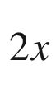

Se

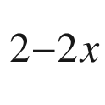

alloy nanosheets with composition-tunable electronic properties. Nano Lett. **16**, 264–269 (2016). [10.​1021/​acs.​nanolett.​5b03662](https://doi.org/10.1021/acs.nanolett.5b03662)

D.H. Kim, H.S. Kim, M.W. Song, S. Lee, S.Y. Lee, Geometric and electronic structures of monolayer hexagonal boron nitride with multi-vacancy. Nano Convergence **4**, 13:1–8 (2017). [10.​1186/​s40580-017-0107-0](https://doi.org/10.1186/s40580-017-0107-0)

Y. Miyamoto, M.L. Cohen, S.G. Louie, Ab initio calculation of phonon spectra for graphite, BN, and BC

$$_2$$

N sheets. Phys. Rev. B **52**, 14971–14975 (1995). [10.​1103/​PhysRevB.​52.​14971](https://doi.org/10.1103/PhysRevB.52.14971)

C. Lee, H. Yan, L.E. Brus, T.F. Heinz, J. Hone, S. Ryu, Anomalous lattice vibrations of single and few-layer MoS

$$_2$$

. ACS nano **4**, 2695–2700 (2010). [10.​1021/​nn1003937](https://doi.org/10.1021/nn1003937)

A. Molina-Sánchez, L. Wirtz, Phonons in single-layer and few-layer MoS

$$_2$$

and WS

$$_2$$

, Phys. Rev. B **84**, 155413:1–8 (2011). [10.​1103/​PhysRevB.​84.​155413](https://doi.org/10.1103/PhysRevB.84.155413)

K. Kaasbjerg, K.S. Thygesen, K.W. Jacobsen, Phonon-limited mobility in n-type single-layer MoS

$$_2$$

from first principles. Phys. Rev. B **85**, 115317:1–16 (2012). [10.​1103/​PhysRevB.​85.​115317](https://doi.org/10.1103/PhysRevB.85.115317)

H. Tornatzky, R. Gillen, H. Uchiyama, J. Maultzsch, Phonon dispersion in MoS

$$_2$$

, Phys. Rev. B **99**, 144309:1–13 (2019). [10.​1103/​PhysRevB.​99.​144309](https://doi.org/10.1103/PhysRevB.99.144309)

F. Ferreira, A.J. Chaves, N.M.R. Peres, R.M. Ribeiro, Excitons in hexagonal boron nitride single-layer: a new platform for polaritonics in the ultraviolet. J. Opt. Soc. Am. B **36**, 674–683 (2019). [10.​1364/​JOSAB.​36.​000674](https://doi.org/10.1364/JOSAB.36.000674)

K.F. Mak, C. Lee, J. Hone, J. Shan, T.F. Heinz, Atomically thin MoS

$$_2$$

: a new direct-gap semiconductor. Phys. Rev. Lett. **105**, 136805:1–4 (2010). [10.​1103/​PhysRevLett.​105.​136805](https://doi.org/10.1103/PhysRevLett.105.136805)

K. Kośmider, J.W. González, J. Fernández-Rossier, Large spin splitting in the conduction band of transition metal dichalcogenide monolayers. Phys. Rev. B **88**, 245436:1–7 (2013). [10.​1103/​PhysRevB.​88.​245436](https://doi.org/10.1103/PhysRevB.88.245436)

A. Kormányos, G. Burkard, M. Gmitra, J. Fabian, V. Zólyomi, N.D. Drummond, V. Fal’ko, **k**

$$\cdot $$

**p** theory for two-dimensional transition metal dichalcogenide semiconductors, 2D Mater. **2**, 02211:1–31 (2015). [10.​1088/​2053-1583/​2/​2/​022001](https://doi.org/10.1088/2053-1583/2/2/022001). Erratum: 2D Mater. **2**, 049501 (2015). [10.​1088/​2053-1583/​2/​4/​049501](https://doi.org/10.1088/2053-1583/2/4/049501)

G.-B. Liu, W.-Y. Shan, Y. Yao, W. Yao, D. Yiao, Three-band tight-binding model for monolayers of group-VIB transition metal dichalcogenides. Phys. Rev. B **88**(085433), 1–10 (2013). [10.​1103/​PhysRevB.​88.​085433](https://doi.org/10.1103/PhysRevB.88.085433). Erratum: Phys. Rev. B 89, 039901 (2014). [10.​1103/​PhysRevB.​89.​039901](https://doi.org/10.1103/PhysRevB.89.039901)

J. Kang, S. Tongay, J. Zhou, J. Li, J. Wu, Band offsets and heterostructures of two- dimensional semiconductors. Appl. Phys. Lett. **102**, 012111:1–4 (2013). [10.​1063/​1.​4774090](https://doi.org/10.1063/1.4774090)

Z.Y. Zhu, Y.C. Cheng, U. Schwingenschlögl, Giant spin-orbit-induced spin splitting in two-dimensional transition-metal dichalcogenide semiconductors. Phys. Rev. B **84**, 153402:1–5 (2011). [10.​1103/​PhysRevB.​84.​153402](https://doi.org/10.1103/PhysRevB.84.153402)

D. Le, A. Barinov, E. Preciado, M. Isarraraz, I. Tanabe, T. Komesu, C. Troha, L. Bartels, T.S. Rahman, P.A. Dowben, Spin-orbit coupling in the band structure of monolayer WSe

$$_2$$

. J. Phys.: Cond. Matter **27**, 182201:1–5 (2015). [10.​1088/​0953-8984/​27/​18/​182201](https://doi.org/10.1088/0953-8984/27/18/182201)

A. Arora, M. Koperski, K. Nogajewski, J. Marcus, C. Faugeras, M. Potemski, Excitonic resonances in thin films of WSe

$$_2$$

: from monolayer to bulk material. Nanoscale **7**, 10421–10429 (2015). [10.​1039/​c5nr01536g](https://doi.org/10.1039/c5nr01536g)

D.Y. Qiu, F.H. da Jornada, S.G. Louie, Optical spectrum of MoS

$$_2$$

: many-body effects and diversity of exciton states. Phys. Rev. Lett. **111**(216805), 1–5 (2013). [10.​1103/​PhysRevLett.​111.​216805](https://doi.org/10.1103/PhysRevLett.111.216805). Erratum: Phys. Rev. Lett. 115, 119901:1-2 (2015). [10.​1103/​PhysRevLett.​115.​119901](https://doi.org/10.1103/PhysRevLett.115.119901)

Cedric Robert, private communication (2019)

D. Xiao, G.-B. Liu, W. Feng, X. Xu, W. Yao, Coupled spin and valley physics in monolayers of MoS

$$_2$$

and other group-VI dichalcogenides. Phys. Rev. Lett. **108**, 196802:1–5 (2012). [10.​1103/​PhysRevLett.​108.​196802](https://doi.org/10.1103/PhysRevLett.108.196802)

T. Cao, G. Wang, W. Han, H. Ye, C. Zhu, J. Shi, Q. Niu, P. Tan, E. Wang, B. Liu, J. Feng, Valley-selective circular dichroism of monolayer molybdenum disulphide. Nature Commun. **3**, 887:1–5 (2012). [10.​1038/​ncomms1882](https://doi.org/10.1038/ncomms1882)

M.M. Glazov, E.L. Ivchenko, G. Wang, T. Amand, X. Marie, B. Urbaszek, B.L. Liu, Spin and valley dynamics of excitons in transition metal dichalcogenide monolayers. Phys. Status Solidi B **252**, 2349–2362 (2015). [10.​1002/​pssb.​201552211](https://doi.org/10.1002/pssb.201552211)

A. Srivastava, M. Sidler, A.V. Allain, D.S. Lembke, A. Kis, A. Imamoğlu, Valley Zeeman effect in elementary optical excitations of monolayer WSe

$$_2$$

. Nature Phys. **11**, 141–147 (2015). [10.​1038/​NPHYS3203](https://doi.org/10.1038/NPHYS3203)

G. Aivazian, Z. Gong, A.M. Jones, R.-L. Chu, J. Yan, D.G. Mandrus, C. Zhang, D. Cobden, W. Yao, X. Xu, Magnetic control of valley pseudospin in monolayer WSe

$$_2$$

. Nat. Phys. **11**, 148–152 (2015). [10.​1038/​NPHYS3201](https://doi.org/10.1038/NPHYS3201)

X. L. Yang, S. H. Guo, F. T. Chan, K. W. Wong, and W. Y. Ching, Analytic solution of a two-dimensional hydrogen atom. I. Nonrelativistic theory. Phys. Rev. A **43**, 1186–1196 (1991). [10.​1103/​PhysRevA.​43.​1186](https://doi.org/10.1103/PhysRevA.43.1186)

D.G.W. Parfitt, M.E. Portnoi, The two-dimensional hydrogen atom revisited. J. Math. Phys. **43**, 4681–4691 (2002). [10.​1063/​1.​1503868](https://doi.org/10.1063/1.1503868)

N.S. Rytova, The screened potential of a point charge in a thin film. Moscow Univ. Phys. Bull. **3**, 30–37 (1967) (in Russian), English translation at [arXiv:​1806.​00976](http://arxiv.org/abs/1806.00976)

L.V. Keldysh, Coulomb interaction in thin semiconductor and semimetal films. JETP Lett. **29**, 658–660 (1979)

D. Felbacq, E. Rousseau, Rigorous asymptotic study of the screened electrostatic potential in a thin dielectric slab. Ann. Physik **513**, 1800486:1–7 (2019). [10.​1002/​andp.​201800486](https://doi.org/10.1002/andp.201800486)

A. Chernikov, T.C. Berkelbach, H.M. Hill, A. Rigosi, Y. Li, O.B. Aslan, D.R. Reichman, M.S. Hybertsen, T.F. Heinz, Exciton binding energy and nonhydrogenic Rydberg series in monolayer WS

$$_2$$

. Phys. Rev. Lett. **113**, 076802:1–5 (2014). [10.​1103/​PhysRevLett.​113.​076802](https://doi.org/10.1103/PhysRevLett.113.076802)

M.R. Molas, A.O. Slobodeniuk, K. Nogajewski, M. Bartos, Ł. Bala, A. Babiński, K. Watanabe, T. Taniguchi, C. Faugeras, M. Potemski, Energy spectrum of two-dimensional excitons in a nonuniform dielectric medium. Phys. Rev. Lett. **123**, 136801:1–6 (2019). [10.​1103/​PhysRevLett.​123.​136801](https://doi.org/10.1103/PhysRevLett.123.136801)

M. Goryca, J. Li, A.V. Stier, T. Taniguchi, K. Watanabe, B. Urbaszek, X. Marie, S.A. Crooker, Revealing exciton masses and dielectric properties of monolayer semiconductors with high magnetic fields. Nature Commun. **10**, 4172:1–12 (2019). [10.​1038/​s41467-019-12180-y](https://doi.org/10.1038/s41467-019-12180-y)

F.S. Ham, The quantum defect method. Solid State Phys. **1**, 127–192 (1955). [10.​1016/​S0081-1947(08)60678-5](https://doi.org/10.1016/S0081-1947(08)60678-5)

M. Koperski, M.R. Molas, A. Arora, K. Nogajewski, M. Bartos, J. Wyzula, D. Vaclavkova, P. Kossacki, M. Potemski, Orbital, spin and valley contributions to Zeeman splitting of excitonic resonances in MoSe

$$_2$$

, WSe

$$_2$$

and WS

$$_2$$

monolayers. 2D Mater. **6**, 015001:1–10 (2019). [10.​1088/​2053-1583/​aae14b](https://doi.org/10.1088/2053-1583/aae14b)

D.V. Rybkovskiy, I.C. Gerber, M.V. Durnev, Atomically inspired

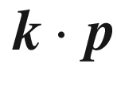

approach and valley Zeeman effect in transition metal dichalcogenide monolayers. Phys. Rev. B **95**, 155406:1–9 (2017). [10.​1103/​PhysRevB.​95.​155406](https://doi.org/10.1103/PhysRevB.95.155406)

B. Zhu, X. Chen, X. Cui, Exciton binding energy of monolayer WS

$$_2$$

, Sci. Rep. **5**, 9218:1–5 (2015). [10.​1038/​srep09218](https://doi.org/10.1038/srep09218)

T.P. Lyons, S. Dufferwiel, M. Brooks, F. Withers, T. Taniguchi, K. Watanabe, K.S. Novoselov, G. Burkard, A.I. Tartakovskii, The valley Zeeman effect in inter- and intra-valley trions in monolayer WSe

$$_2$$

. Nat. Commun. **10**, 2330:1–8 (2019). [10.​1038/​s41467-019-10228-7](https://doi.org/10.1038/s41467-019-10228-7)

I.C. Gerber, X. Marie, Dependence of band structure and exciton properties of encapsulated WSe

$$_2$$

monolayers on the hBN-layer thickness. Phys. Rev. B **98**, 245126:1–7 (2018). [10.​1103/​PhysRevB.​98.​245126](https://doi.org/10.1103/PhysRevB.98.245126)

A.V. Stier, N.P. Wilson, G. Clark, X. Xu, S.A. Crooker, Probing the influence of dielectric environment on excitons in monolayer WSe

$$_2$$

: insight from high magnetic fields. Nano Lett. **16**, 7054–7060 (2016). [10.​1021/​acs.​nanolett.​6b03276](https://doi.org/10.1021/acs.nanolett.6b03276)

J.M.B. Lopes dos Santos, N.M.R. Peres, A.H. Castro Neto, Graphene bilayer with a twist: electronic structure. Phys. Rev. Lett. **99**, 256802:1–4 (2007). [10.​1103/​PhysRevLett.​99.​256802](https://doi.org/10.1103/PhysRevLett.99.256802)

E.J. Mele, Commensuration and interlayer coherence in twisted bilayer graphene. Phys. Rev. B **81**, 161405(R):1–4 (2010). [10.​1103/​PhysRevB.​81.​161405](https://doi.org/10.1103/PhysRevB.81.161405)

R. Bistritzer, A.H. MacDonald, Moiré bands in twisted double-layer graphene. PNAS **108**, 12233–12237 (2011). [10.​1073/​pnas.​1108174108](https://doi.org/10.1073/pnas.1108174108)

G. Jeong, B. Choi, D.-S. Kim, S. Ahn, B. Park, J.H. Kang, H. Min, B.H. Hong, Z.H. Kim, Mapping of Bernal and non-Bernal stacking domains in bilayer graphene using infrared nanoscopy. Nanoscale **9**, 4191–4195 (2017). [10.​1039/​c7nr00713b](https://doi.org/10.1039/c7nr00713b)

J. Liu, Z. Huang, F. Lai, L. Lin, Y. Xu, C. Zuo, W. Zheng, Y. Qu, Controllable growth of the graphene from millimeter-sized monolayer to multilayer on Cu by chemical vapor deposition. Nanoscale Res. Lett. **10**, 455:1–8 (2015). [10.​1186/​s11671-015-1164-0](https://doi.org/10.1186/s11671-015-1164-0)

A.K. Geim, I.V. Griegorieva, Van der Waals heterostructures. Nature **499**, 419–425 (2013). [10.​1038/​nature12385](https://doi.org/10.1038/nature12385)

K.S. Novoselov, A. Mishchenko, A. Carvalho, A.H. Castro Neto, 2D materials and van der Waals heterostructures. Science **353**, 461 (2016) and Science **353**, aac9439:1-11 (2016). [10.​1126/​science.​aac9439](https://doi.org/10.1126/science.aac9439)

J.C.W. Song, N.M. Gabor, Electron quantum metamaterials in van der Waals heterostructures. Nature Nanotechn. **13**, 986–993 (2018). [10.​1038/​s41565-018-0294-9](https://doi.org/10.1038/s41565-018-0294-9)

S.J. Liang, B. Cheng, X. Cui, F. Miao, Van der Waals heterostructures for high-performance device applications: challenges and opportunities. Adv. Mater. **2019**, 1903800:1–27 (2019). [10.​1002/​adma.​201903800](https://doi.org/10.1002/adma.201903800)

W. Liao, Y. Huang, H. Wang, H. Zhang, Van der Waals heterostructures for optoelectronics: progress and prospects. Appl. Mater. Today **16**, 435–455 (2019). [10.​1016/​j.​apmt.​2019.​07.​004](https://doi.org/10.1016/j.apmt.2019.07.004)

L. Wang, I. Meric, P.Y. Huang, Q. Gao, Y. Gao, H. Tran, T. Taniguchi, K. Watanabe, L.M. Campos, D.A. Muller, J. Guo, P. Kim, J. Hone, K.L. Shepard, C.R. Dean, One-dimensional electrical contact to a two-dimensional material. Science **342**, 614–617 (2013). [10.​1126/​science.​1244358](https://doi.org/10.1126/science.1244358)

M. Yankowitz, Q. Ma, P. Jarillo-Herrero, B.L. LeRoy, Van der Waals heterostructures combining graphene and hexagonal boron nitride. Nat. Rev. Phys. **1**, 112–125 (2019). [10.​1038/​s42254-018-0016-0](https://doi.org/10.1038/s42254-018-0016-0)

Z. Qiu, M. Trushin, H. Fang, I. Verzhbitskiy, S. Gao, E. Laksono, M. Yang, P. Lyu, J. Li, J. Su, M. Telychko, K. Watanabe, T. Taniguchi, J. Wu, A.H. Castro Neto, L. Yang, G, Eda, S. Adam, J. Lu, Giant gate-tunable bandgap renormalization and excitonic effects in a 2D semiconductor. Sci. Adv. **5**, eaaw2347:1–6 (2019). [10.​1126/​sciadv.​aaw2347](https://doi.org/10.1126/sciadv.aaw2347)

Y. Fu, D. He, J. He, A. Bian, L. Zhang, S. Liu, Y. Wang, H. Zhao, Effect of dielectric environment on excitonic dynamics in monolayer WS

$$_2$$

, Adv. Mater. Interf. **6**, 1901307:1–9 (2019). [10.​1002/​admi.​201901307](https://doi.org/10.1002/admi.201901307)

M. Le Ster, T. Maerkl, P.J. Kowalczyk, S.A. Brown, Moiré patterns in van der Waals heterostructures. Phys. Rev. B **99**, 075422:1–10 (2019). [10.​1103/​PhysRevB.​99.​075422](https://doi.org/10.1103/PhysRevB.99.075422)

K. Tran, G. Moody, F. Wu, X. Lu, J. Choi, K. Kim, A. Rai, D.A. Sanchez, J. Quan, A. Singh, J. Embley, A. Zepeda, M. Campbell, T. Autry, T. Taniguchi, K. Watanabe, N. Lu, S.K. Banerjee, K.L. Silverman, S. Kim, E. Tutuc, L. Yang, A.H. MacDonald, X. Li, Evidence for Moiré excitons in van der Waals heterostructures. Nature **567**, 71–75 (2019). [10.​1038/​s41586-019-0975-z](https://doi.org/10.1038/s41586-019-0975-z)

Y. Cao, V. Fatemi, S. Fang, K. Watanabe, T. Taniguchi, E. Kaxiras, P. Jarillo-Herrero, Unconventional superconductivity in magic-angle graphene superlattices. Nature **556**, 43–55 (2018). [10.​1038/​nature26160](https://doi.org/10.1038/nature26160)

R.P. Feynman, There’s plenty of room at the bottom: an invitation to enter a new field of physics (After-dinner speech on December 29th 1959 at the annual meeting of the American Physical Society at the California Institute of Technology). Eng. Sci. **23**(5), 22–36 (1960)

D. Bimberg, M. Grundmann, N.N. Ledentsov, *Quantum Dot Heterostructures* (Wiley, Chichester, 1999)

M. Grundmann, ed., *Nano-Optoelectronics, Concepts, Physics and Devices* (Springer, Heidelberg, 2002). [10.​1007/​978-3-642-56149-8](https://doi.org/10.1007/978-3-642-56149-8)

E. Kapon, M. Walther, J. Christen, M. Grundmann, C. Caneau, D.M. Hwang, E. Colas, R. Bhat, G.H. Song, D. Bimberg, Quantum wire heterostructures for optoelectronic applications. Superlatt. Microstruct. **12**, 491–499 (1992). [10.​1016/​0749-6036(92)90307-Q](https://doi.org/10.1016/0749-6036(92)90307-Q)

M. Grundmann, J. Christen, M. Joschko, O. Stier, D. Bimberg, E. Kapon, Recombination kinetics and intersubband relaxation in semiconductor quantum wires. Semicond. Sci. Technol. **9**, 1939–1945 (1994). [10.​1088/​0268-1242/​9/​11S/​014](https://doi.org/10.1088/0268-1242/9/11S/014)

L. Pfeiffer, K.W. West, H.L. Störmer, J.P. Eisenstein, K.W. Baldwin, D. Gershoni, J. Spector, Formation of a high quality two-dimensional electron gas on cleaved GaAs. Appl. Phys. Lett. **56**, 1697–1699 (1990). [10.​1063/​1.​103121](https://doi.org/10.1063/1.103121)

M. Grundmann, D. Bimberg, Formation of quantum dots in twofold cleaved edge overgrowth. Phys. Rev. B **55**, 4054–4056 (1997). [10.​1103/​PhysRevB.​55.​4054](https://doi.org/10.1103/PhysRevB.55.4054)

W. Wegscheider, G. Schedelbeck, G. Abstreiter, M. Rother, M. Bichler, Atomically precise GaAs/AlGaAs quantum dots fabricated by twofold cleaved edge overgrowth. Phys. Rev. Lett. **79**, 1917–1920 (1997). [10.​1103/​PhysRevLett.​79.​1917](https://doi.org/10.1103/PhysRevLett.79.1917)

A.P. Levitt, ed., *Whisker Technology* (Wiley, New York, 1970)

Zh.L. Wang, ed., *Nanowires and Nanobelts—Materials, Properties and Devices* (Kluwer Academic, Boston, 2004) (Two volumes, Vol. I: *Metal and Semiconductor Nanowires*, Vol. II: *Nanowires and Nanobelts of Functional Materials*) [10.​1007/​978-0-387-28745-4](https://doi.org/10.1007/978-0-387-28745-4); [10.​1007/​978-0-387-28747-8](https://doi.org/10.1007/978-0-387-28747-8)

M.T. Björk, B.J. Ohlsen, T. Sass, A.I. Perrson, C. Thelander, M.H. Magnusson, K. Deppert, L.R. Wallenberg, L. Samuelson, One-dimensional heterostructures in semiconductor nanowhiskers. Appl. Phys. Lett. **80**, 1058–1060 (2002). [10.​1063/​1.​1447312](https://doi.org/10.1063/1.1447312)

J.-C. Harmand, G. Patriarche, F. Glas, F. Panciera, I. Florea, J.-L. Maurice, L. Travers, Y. Ollivier, Atomic step flow on a nanofacet. Phys. Rev. Lett. **121**, 166101:1–5 (2018). [10.​1103/​PhysRevLett.​121.​166101](https://doi.org/10.1103/PhysRevLett.121.166101)

M.H. Huang, S. Mao, H. Feick, H. Yan, Y. Wu, H. Kind, E. Weber, R. Russo, P. Yang, Room-temperature ultraviolet nanowire nanolasers. Science **292**, 1897–1899 (2001). [10.​1126/​science.​1060367](https://doi.org/10.1126/science.1060367)

X. Duan, Y. Huang, R. Agarwal, C. Lieber, Single-nanowire electrically driven lasers. Nature **421**, 241–245 (2003). [10.​1038/​nature01353](https://doi.org/10.1038/nature01353)

ZhL Wang, J. Song, Piezoelectric nanogenerators based on zinc oxide nanowire arrays. Science **312**, 242–246 (2006). [10.​1126/​science.​1124005](https://doi.org/10.1126/science.1124005)

M. Lorenz, J. Lenzner, E.M. Kaidashev, H. Hochmuth, M. Grundmann, Cathodoluminescence of selected single ZnO nanowires on sapphire. Ann. Physik **13**, 39–42 (2004). [10.​1002/​andp.​200310040](https://doi.org/10.1002/andp.200310040)

B.Q. Cao, J. Zúñiga-Pérez, N. Boukos, C. Czekalla, H. Hilmer, J. Lenzner, A. Travlos, M. Lorenz, M. Grundmann, Homogeneous core/shell ZnO/ZnMgO quantum well heterostructures on vertical ZnO nanowires. Nanotechnology **20**, 305701 (2009). [10.​1088/​0957-4484/​20/​30/​305701](https://doi.org/10.1088/0957-4484/20/30/305701)

M.V. Barton, The circular cylinder with a band of uniform pressure on a finite length of the surface. J. Appl. Mech. **8**, A97–A104 (1941)

E. Ertekin, P.A. Greaney, D.C. Chrzan, T.D. Sands, Equilibrium limits of coherency in strained nanowire heterostructures. J. Appl. Phys. **97**, 114325:1–10 (2005). [10.​1063/​1.​1903106](https://doi.org/10.1063/1.1903106)

F. Glas, Critical dimensions for the plastic relaxation of strained axial heterostructures in free-standing nanowires. Phys. Rev. B **74**, 121302:1–4 (2006). [10.​1103/​PhysRevB.​74.​121302](https://doi.org/10.1103/PhysRevB.74.121302)

X.Y. Kong, ZhL Wang, Polar-surface dominated ZnO nanobelts and the electrostatic energy induced nanohelixes, nanosprings, and nanospirals. Appl. Phys. Lett. **84**, 975–977 (2004). [10.​1063/​1.​1646453](https://doi.org/10.1063/1.1646453)

Zh.L. Wang, Novel zinc oxide nanostructures discovery by electron microscopy. J. Phys.: Conf. Ser. **26**, 1–6 (2006). [10.​1088/​1742-6596/​26/​1/​001](https://doi.org/10.1088/1742-6596/26/1/001)

M. Grundmann, E. Kapon, J. Christen, D. Bimberg, Electronic and optical properties of quasi one-dimensional carriers in quantum wires. J. Nonlinear Opt. Phys. Mater. **4**, 99–140 (1995). [10.​1142/​S021886359500006​9](https://doi.org/10.1142/S0218863595000069)

M. Grundmann, O. Stier, D. Bimberg, Electronic states in strained cleaved-edge-overgrowth quantum wires and quantum dots. Phys. Rev. B **58**, 10557–10561 (1998). [10.​1103/​PhysRevB.​58.​10557](https://doi.org/10.1103/PhysRevB.58.10557)

H.J. Xiang, J. Yang, J.G. Hou, Q. Zhu, Piezoelectricity in ZnO nanowires: a first-principles study. Appl. Phys. Lett. **89**, 223111:1–3 (2006). [10.​1063/​1.​2397013](https://doi.org/10.1063/1.2397013)

S. Iijima, Helical microtubules of graphitic carbon. Nature **354**, 56–58 (1991). [10.​1038/​354056a0](https://doi.org/10.1038/354056a0)

S. Iijima, T. Ichihasi, Single-shell carbon nanotubes of 1-nm diameter. Nature **363**, 603–605 (1993). [10.​1038/​363603a0](https://doi.org/10.1038/363603a0)

R. Saito, G. Dresselhaus, M.S. Dresselhaus, *Physical Properties of Carbon Nanotubes* (Imperial, London, 1998). [10.​1142/​p080](https://doi.org/10.1142/p080)

J. Kürti, V. Zólyomi, M. Kertesz, G. Sun, The geometry and the radial breathing mode of carbon nanotubes: beyond the ideal behaviour. New J. Phys. **5**, 125:1–21 (2003). [10.​1088/​1367-2630/​5/​1/​125](https://doi.org/10.1088/1367-2630/5/1/125)

R. Saito, M. Fujita, G. Dresselhaus, M.S. Dresselhaus, Electronic structure of chiral graphene tubules. Appl. Phys. Lett. **60**, 2204–2206 (1992). [10.​1063/​1.​107080](https://doi.org/10.1063/1.107080)

M.-F. Yu, B.S. Files, S. Arepalli, R.S. Ruoff, Tensile loading of ropes of single wall carbon nanotubes and their mechanical properties. Phys. Rev. Lett. **84**, 5552–5555 (2000). [10.​1103/​PhysRevLett.​84.​5552](https://doi.org/10.1103/PhysRevLett.84.5552)

S. Ogata, Y. Shibutani, Ideal tensile strength and band gap of single-walled carbon nanotubes. Phys. Rev. B **68**, 165409:1–4 (2003). [10.​1103/​PhysRevB.​68.​165409](https://doi.org/10.1103/PhysRevB.68.165409)

R. Saito, M. Fujita, G. Dresselhaus, M.S. Dresselhaus, Electronic structure of carbon fibers based on C

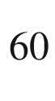

. Proc. Mater. Res. Soc. **247**, 333–338 (1992). [10.​1557/​PROC-247-333](https://doi.org/10.1557/PROC-247-333)

N. Hamada, S.-I. Sawada, A. Oshiyama, New one-dimensional conductors: graphitic microtubule. Phys. Rev. Lett. **68**, 1579–1581 (1992). [10.​1103/​PhysRevLett.​68.​1579](https://doi.org/10.1103/PhysRevLett.68.1579)

X. Blase, L.X. Benedict, E.L. Shirley, S.G. Louie, Hybridization effects and metallicity in small radius carbon nanotubes. Phys. Rev. Lett. **72**, 1878–1881 (1994). [10.​1103/​PhysRevLett.​72.​1878](https://doi.org/10.1103/PhysRevLett.72.1878)

J.W. Mintmire, C.T. White, Universal density of states for carbon nanotubes. Phys. Rev. Lett. **81**, 2506–2509 (1989). [10.​1103/​PhysRevLett.​81.​2506](https://doi.org/10.1103/PhysRevLett.81.2506)

A. Grüneis, R. Saito, G.G. Samsonidze, T. Kimura, M.A. Pimenta, A. Jorio, A.G. Souza Filho, G. Dresselhaus, M.S. Dresselhaus, Inhomogeneous optical absorption around the *K* point in graphite and carbon nanotubes. Phys. Rev. B **67**, 165402:1–7 (2003). [10.​1103/​PhysRevB.​67.​165402](https://doi.org/10.1103/PhysRevB.67.165402)

S.M. Bachilo, M.S. Strano, C. Kittrell, R.H. Hauge, R.E. Smalley, R.B. Weisman, Structure-assigned optical spectra of single-walled carbon nanotubes. Science **298**, 2361–2366 (2002). [10.​1126/​science.​1078727](https://doi.org/10.1126/science.1078727)

H. Telg, J. Maultzsch, S. Reich, F. Hennrich, C. Thomsen, Chirality distribution and transition energies of carbon nanotubes. Phys. Rev. Lett. **93**, 177401:1–4 (2004). [10.​1103/​PhysRevLett.​93.​177401](https://doi.org/10.1103/PhysRevLett.93.177401)

C. Thomsen, S. Reich, Raman scattering in carbon nanotubes, in *Light Scattering in Solids IX*, eds. by M. Cardona, R. Merlin. Topics Appl. Phys. vol. 108 (Springer, Berlin, 2007), pp. 115–234 [10.​1007/​978-3-540-34436-0\_​3](https://doi.org/10.1007/978-3-540-34436-0%255F3)

N.G. Chopra, R.J. Luyken, K. Cherrey, V.H. Crespi, M.L. Cohen, S.G. Louie, A. Zettl, Boron nitride nanotubes. Science **269**, 966–967 (1995). [10.​1126/​science.​269.​5226.​966](https://doi.org/10.1126/science.269.5226.966)

R.S. Lee, J. Gavillet, M.L. de la Chapelle, A. Loiseau, J.-L. Cochon, D. Pigache, J. Thibault, F. Willaime, Catalyst-free synthesis of boron nitride single-wall nanotubes with a preferred zig-zag configuration. Phys. Rev. B **64**, 121405(R):1–4 (2001). [10.​1103/​PhysRevB.​64.​121405](https://doi.org/10.1103/PhysRevB.64.121405)

A. Rubio, J.L. Corkill, M.L. Cohen, Theory of graphitic boron nitride nanotubes. Phys. Rev. B **49**, 5081–5084 (1994). [10.​1103/​PhysRevB.​49.​5081](https://doi.org/10.1103/PhysRevB.49.5081)

L. Wirtz, V. Olevano, A.G. Marinopoulos, L. Reining, A. Rubio, Optical absorption in small BN and C nanotubes. AIP Conf. Proc. **685**, 406–410 (2003). [10.​1063/​1.​1628060](https://doi.org/10.1063/1.1628060)

O. Stier, M. Grundmann, D. Bimberg, Electronic and optical properties of strained quantum dots modeled by 8-band

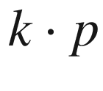

theory. Phys. Rev. B **59**, 5688–5701 (1999). [10.​1103/​PhysRevB.​59.​5688](https://doi.org/10.1103/PhysRevB.59.5688)

R. Santoprete, B. Koiller, R.B. Capaz, P. Kratzer, Q.K.K. Liu, M. Scheffler, Tight-binding study of the influence of the strain on the electronic properties of InAs/GaAs quantum dots. Phys. Rev. B **68**, 235311:1–9 (2003). [10.​1103/​PhysRevB.​68.​235311](https://doi.org/10.1103/PhysRevB.68.235311)

Th. Maltezopoulos, A. Bolz, C. Meyer, C. Heyn, W. Hansen, M. Morgenstern, R. Wiesendanger, Wave-function mapping of InAs quantum dots by scanning tunneling spectroscopy. Phys. Rev. Lett. **91**, 196804:1–4 (2003). [10.​1103/​PhysRevLett.​91.​196804](https://doi.org/10.1103/PhysRevLett.91.196804)

O. Stier, Theory of the optical properties of InGaAs/GaAs quantum dots, in *Nano-Optoelectronics, Concepts, Physics, Devices*, ed. by M. Grundmann (Springer, Berlin, 2002), pp. 167–202. [10.​1007/​978-3-642-56149-8\_​7](https://doi.org/10.1007/978-3-642-56149-8%255F7)

L.P. Kouwenhoven, N.C. van der Vaart, A.T. Johnson, W. Kool, C.J.P.M. Harmans, J.G. Williamson, A.A.M. Staring, C.T. Foxon, Single electron charging effects in semiconductor quantum dots. Z. Phys. B **85**, 367–373 (1991). [10.​1007/​BF01307632](https://doi.org/10.1007/BF01307632)

Th. Heinzel, Single electron tunneling, in *Mesoscopic Electronics in Solid State Nanostructures* (Wiley, Weinheim, 2006), pp. 247–272. [10.​1002/​9783527618910.​ch9](https://doi.org/10.1002/9783527618910.ch9)

X.-X. Song, D. Liu, V. Mosallanejad, J. You, T.-Y. Han, D.-T. Chen, H.-O. Li, G. Cao, M. Xiao, G.-C. Guo, G.-P. Guo, A gate defined quantum dot on the two-dimensional transition metal dichalcogenide semiconductor WSe

$$_2$$

. Nanoscale **7**, 16867–16873 (2015). [10.​1039/​C5NR04961J](https://doi.org/10.1039/C5NR04961J)

E.O. Göbel, Semiconductor applications in metrology. Adv. Solid State Phys. (Festkörperprobleme) **39**, 1–12 (1999). [10.​1007/​BFb0107460](https://doi.org/10.1007/BFb0107460)

S.P. Giblin, M. Kataoka, J.D. Fletcher, P. See, T.J.B.M. Janssen, J.P. Griffiths, G.A.C. Jones, I. Farrer, D.A. Ritchie, Towards a quantum representation of the ampere using single electron pumps. Nat. Commun. **3**, 930:1–6 (2018). [10.​1038/​ncomms1935](https://doi.org/10.1038/ncomms1935)

S. Tarucha, D.G. Austing, T. Honda, R.J. van der Hage, L.P. Kouwenhoven, Shell filling and spin effects in a few electron quantum dot. Phys. Rev. Lett. **77**, 3613–3616 (1996). [10.​1103/​PhysRevLett.​77.​3613](https://doi.org/10.1103/PhysRevLett.77.3613)

N. Horiguchi, T. Futatsugi, Y. Nakata, N. Yokoyama, Electron transport properties through InAs self-assembled quantum dots in modulation doped structures. Appl. Phys. Lett. **70**, 2294–2296 (1997). [10.​1063/​1.​118840](https://doi.org/10.1063/1.118840)

R. Steffen, A. Forchel, T.L. Reinecke, T. Koch, M. Albrecht, J. Oshinowo, F. Faller, Single quantum dots as local probes of electronic properties of semiconductors. Phys. Rev. B **54**, 1510–1513 (1996). [10.​1103/​PhysRevB.​54.​1510](https://doi.org/10.1103/PhysRevB.54.1510)

K.C. Rajkumar, K. Kaviani, J. Chen, P. Chen, A. Madhukar, D. Rich, In-Situ growth of three-dimensionally confined structures on patterned GaAs (111)B substrates. Proc. Mater. Res. Soc. **263**, 163–167 (1992). [10.​1557/​PROC-263-163](https://doi.org/10.1557/PROC-263-163)

Wolfgang Weller, private communication (2006)

M. Liu, G. Zhong, Y. Yin, J. Miao, K. Li, C. Wang, X. Xu, C. Shen, H. Meng, Aluminum-doped cesium lead bromide perovskite nanocrystals with stable blue photoluminescence used for display backlight. Adv. Sci. **4**, 1700335:1–8 (2017). [10.​1002/​advs.​201700335](https://doi.org/10.1002/advs.201700335)

M. Grundmann, Pseudomorphic InAs/GaAs quantum dots on low index planes. Adv. Solid State Phys. (Festkörperprobleme) **35**, 123–154 (1996). [10.​1007/​BFb0107543](https://doi.org/10.1007/BFb0107543)

V.A. Shchukin, N.N. Ledentsov, D. Bimberg, *Epitaxy of Nanostructures* (Springer, Heidelberg, 2004). [10.​1007/​978-3-662-07066-6](https://doi.org/10.1007/978-3-662-07066-6)

V.A. Shchukin, N.N. Ledentsov, P.S. Kop’ev, D. Bimberg, Spontaneous ordering of arrays of coherent strained islands. Phys. Rev. Lett. **75**, 2968–2971 (1995). [10.​1103/​PhysRevLett.​75.​2968](https://doi.org/10.1103/PhysRevLett.75.2968)

N. Moll, M. Scheffler, E. Pehlke, Influence of surface stress on the equilibrium shape of strained quantum dots. Phys. Rev. B **58**, 4566–4571 (1998). [10.​1103/​PhysRevB.​58.​4566](https://doi.org/10.1103/PhysRevB.58.4566)

D. Leonard, M. Krishnamurthy, C.M. Reaves, S.P. Denbaars, P.M. Petroff, Direct formation of quantum-sized dots from uniform coherent islands of InGaAs on GaAs surfaces. Appl. Phys. Lett. **63**, 3203–3205 (1993). [10.​1063/​1.​110199](https://doi.org/10.1063/1.110199)

D.M. Bruls, P.M. Koenraad, H.W.M. Salemink, J.H. Wolter, M. Hopkinson, M.S. Skolnick, Stacked low-growth-rate InAs quantum dots studied at the atomic level by cross-sectional scanning tunneling microscopy. Appl. Phys. Lett. **82**, 3758–3760 (2003). [10.​1063/​1.​1578709](https://doi.org/10.1063/1.1578709)

Q. Xie, A. Madhukar, P. Chen, N. Kobayashi, Vertically self-organized InAs quantum box islands on GaAs(100). Phys. Rev. Lett. **75**, 2542–2545 (1995). [10.​1103/​PhysRevLett.​75.​2542](https://doi.org/10.1103/PhysRevLett.75.2542)

S. Facsko, T. Dekorsy, C. Koerdt, C. Trappe, H. Kurz, A. Vogt, H.L. Hartnagel, Formation of ordered nanoscale semiconductor dots by ion sputtering. Science **285**, 1551–1553 (1999). [10.​1126/​science.​285.​5433.​1551](https://doi.org/10.1126/science.285.5433.1551)

F. Frost, A. Schindler, F. Bigl, Roughness evolution of ion sputtered rotating inp surfaces: pattern formation and scaling laws. Phys. Rev. Lett. **85**, 4116–4419 (2000). [10.​1103/​PhysRevLett.​85.​4116](https://doi.org/10.1103/PhysRevLett.85.4116)

R. Gago, L. Vásquez, R. Cuerno, M. Varela, C. Ballesteros, J.M. Albella, Production of ordered silicon nanocrystals by low-energy ion sputtering. Appl. Phys. Lett. **78**, 3316–3318 (2001). [10.​1063/​1.​1372358](https://doi.org/10.1063/1.1372358)

R. Gago, L. Vásquez, O. Plantevin, T.H. Metzger, J. Muâoz-García, R. Cuerno, M. Castro, Order enhancement and coarsening of self-organized silicon nanodot patterns induced by ion-beam sputtering. Appl. Phys. Lett. **89**, 233101:1–3 (2006). [10.​1063/​1.​2398916](https://doi.org/10.1063/1.2398916)

B. Ziberi, F. Frost, B. Rauschenbach, Th. Höche, Highly ordered self-organized dot patterns on Si surfaces by low-energy ion-beam erosion. Appl. Phys. Lett. **87**, 033113:1–3 (2005). [10.​1063/​1.​2000342](https://doi.org/10.1063/1.2000342)

W.L. Chan, E. Chason, Making waves: Kinetic processes controlling surface evolution during low energy ion sputtering. J. Appl. Phys. **101**, 121301:1–46 (2007). [10.​1063/​1.​2749198](https://doi.org/10.1063/1.2749198)

B. Ziberi, F. Frost, Th. Höche, B. Rauschenbach, Ripple pattern formation on silicon surfaces by low-energy ion-beam erosion: Experiment and theory. Phys. Rev. B **72**, 235310:1–7 (2005). [10.​1103/​PhysRevB.​72.​235310](https://doi.org/10.1103/PhysRevB.72.235310)

F. Findeis, A. Zrenner, G. Böhm, G. Abstreiter, Optical spectroscopy on a single InGaAs/GaAs quantum dot in the few-exciton limit. Solid State Commun. **114**, 227–230 (2000). [10.​1016/​S0038-1098(00)00019-3](https://doi.org/10.1016/S0038-1098(00)00019-3)

O. Stier, A. Schliwa, R. Heitz, M. Grundmann, D. Bimberg, Stability of biexcitons in pyramidal InAs/GaAs quantum dots. Phys. Status Solidi B **224**, 115–118 (2001). [10.​1002/​1521-3951(200103)224:​1<115:​:​AID-PSSB115>3.​0.​CO;2-B](https://doi.org/10.1002/1521-3951(200103)224:1%253C115::AID-PSSB115%253E3.0.CO%3B2-B)

D.J.P. Ellis, R.M. Stevenson, R.J. Young, A.J. Shields, P. Atkinson, D.A. Ritchie, Control of fine-structure splitting of individual InAs quantum dots by rapid thermal annealing. Appl. Phys. Lett. **90**, 011907:1–3 (2007) [10.​1063/​1.​2430489](https://doi.org/10.1063/1.2430489)

B. Urbaszek, R.J. Warburton, K. Karrai, B.D. Gerardot, P.M. Petroff, J.M. Garcia, Fine structure of highly charged excitons in semiconductor quantum dots. Phys. Rev. Lett. **90**, 247403:1–4 (2003). [10.​1103/​PhysRevLett.​90.​247403](https://doi.org/10.1103/PhysRevLett.90.247403)

R.J. Warburton, C. Schäflein, D. Haft, F. Bickel, A. Lorke, K. Karrai, J.M. Garcia, W. Schoenfeld, P.M. Petroff, Optical emission from a charge-tunable quantum ring. Nature **405**, 926–929 (2000). [10.​1038/​35016030](https://doi.org/10.1038/35016030)

L. Besombes, Y. Léger, L. Maingault, D. Ferrand, H. Mariette, Probing the spin state of a single magnetic ion in an individual quantum dot. Phys. Rev. Lett. **93**, 207403:1–4 (2004). [10.​1103/​PhysRevLett.​93.​207403](https://doi.org/10.1103/PhysRevLett.93.207403)

W. Franz, Einfluß eines elektrischen Feldes auf eine optische Absorptionskante. Z. Naturf. **13a**, 484–489 (1958). [10.​1515/​zna-1958-0609](https://doi.org/10.1515/zna-1958-0609)

L.V. Keldysh, Behaviour of non-metallic crystals in strong electric fields. Soviet Phys. JETP **6**, 763–770 (1958)

F. Duque-Gomez, J.E. Sipe, The Franz-Keldysh effect revisited: Electroabsorption including interband coupling and excitonic effects. J. Phys. Chem. Solids **76**, 138–152 (2015). [10.​1016/​j.​jpcs.​2014.​07.​023](https://doi.org/10.1016/j.jpcs.2014.07.023)

H. Shen, M. Dutta, Franz-Keldysh oscillations in modulation spectroscopy. J. Appl. Phys. **78**, 2151– (1995). [10.​1063/​1.​360131](https://doi.org/10.1063/1.360131)

A. Jaeger: *Exzitonen und Franz–Keldysh-Effekt im quaternären Halbleiter InGaAsP/InP*, Ph.D. Thesis, Phillips-Universität Marburg (1997)

D.A.B. Miller, D.S. Chemla, T.C. Damen, A.C. Gossard, W. Wiegmann, T.H. Wood, C.A. Burrus, Electric field dependence of optical absorption near the band gap of quantum-well structures. Phys. Rev. B **32**, 1043–1060 (1985). [10.​1103/​PhysRevB.​32.​1043](https://doi.org/10.1103/PhysRevB.32.1043)

J.M. Luttinger, Quantum theory of cyclotron resonance in semiconductors: general theory. Phys. Rev. **102**, 1030–1041 (1956). [10.​1103/​PhysRev.​102.​1030](https://doi.org/10.1103/PhysRev.102.1030)

N. Miura, *Physics of Semiconductors in High Magnetic Fields* (Oxford University Press, Oxford, 2008)

M. Oestreich, S. Hallstein, A.P. Heberle, K. Eberl, E. Bauser, W.W. Rühle, Temperature and density dependence of the electron Landé *g* factor in semiconductors. Phys. Rev. B **53**, 7911–7916 (1996). [10.​1103/​PhysRevB.​53.​7911](https://doi.org/10.1103/PhysRevB.53.7911)

M.J. Snelling, E. Blackwood, C.J. McDonagh, R.T. Harley, C.T.B. Foxon, Exciton, heavy-hole, and electron

$$g$$

factors in type-I GaAs/Al

$$_x$$

Ga

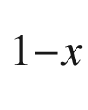

As quantum wells. Phys. Rev. B **45**, 3922–3925 (1992). [10.​1103/​PhysRevB.​45.​3922](https://doi.org/10.1103/PhysRevB.45.3922)

C.L. Chien, C.R. Westgate, eds., *The Hall Effect and its Application* (Plenum Press, New York, 1980). [10.​1007/​978-1-4757-1367-1](https://doi.org/10.1007/978-1-4757-1367-1)

H.-J. Lippmann, F. Kuhrt, Der Geometrieeinfluß auf den Hall-Effekt bei rechteckigen Halbleiterplatten. Z. Naturf. **13a**, 474–483 (1958). [10.​1515/​zna-1958-0608](https://doi.org/10.1515/zna-1958-0608)

L.J. van der Pauw, A method of measuring specific resistivity and Hall effect of discs of arbitrary shape. Philips Res. Reports **13**, 1–9 (1958)

L.J. van der Pauw, A method of measuring the resistivity and Hall coefficient on lamellae of arbitrary shape. Philips Tech. Rev. **20**, 220–224 (1958)

D.S. Perloff, Four-point sheet resistance correction factors for thin rectangular samples. Solid State Electron. **20**, 681–687 (1977). [10.​1016/​0038-1101(77)90044-2](https://doi.org/10.1016/0038-1101(77)90044-2)

O. Breitenstein, W. Warta, M. Langenkamp, *Lock-in Thermography, Basics and Use for Evaluating Electronic Devices and Materials*, 2nd edn. (Springer, Heidelberg, 2010) [10.​1007/​978-3-642-02417-7](https://doi.org/10.1007/978-3-642-02417-7)

O. Madelung, H. Weiss, Die elektrischen Eigenschaften von Indiumantimonid II. Z. Naturf. **9a**, 527–534 (1954). [10.​1515/​zna-1954-0608](https://doi.org/10.1515/zna-1954-0608)

H.G. Svavarsson, J.T. Gudmundsson, H.P. Gislason, Impurity band in lithium-diffused and annealed GaAs: Conductivity and Hall effect measurements. Phys. Rev. B **67**, 205213:1–6 (2003). [10.​1103/​PhysRevB.​67.​205213](https://doi.org/10.1103/PhysRevB.67.205213)

S. Meiboom, B. Abeles, Theory of the galvanomagnetic effects in n-germanium. Phys. Rev. **93**, 1121 (1954). [10.​1103/​PhysRev.​93.​1121](https://doi.org/10.1103/PhysRev.93.1121)

B. Abeles, S. Meiboom, Theory of the galvanomagnetic effects in germanium. Phys. Rev. **95**, 31–37 (1954). [10.​1103/​PhysRev.​95.​31](https://doi.org/10.1103/PhysRev.95.31)

B. Arnaudov, T. Paskova, S. Evtimova, E. Valcheva, M. Heuken, B. Monemar, Multilayer model for Hall effect data analysis of semiconductor structures with step-changed conductivity. Phys. Rev. B **67**, 045314:1–10 (2003). [10.​1103/​PhysRevB.​67.​045314](https://doi.org/10.1103/PhysRevB.67.045314)

D.C. Look, J.R. Sizelove, Dislocation scattering in GaN. Phys. Rev. Lett. **82**, 1237–1240 (1999). [10.​1103/​PhysRevLett.​82.​1237](https://doi.org/10.1103/PhysRevLett.82.1237)

H. von Wenckstern, M. Brandt, H. Schmidt, G. Biehne, R. Pickenhain, H. Hochmuth, M. Lorenz, M. Grundmann, Donor like defects in ZnO substrate materials and ZnO thin films. Appl. Phys. A **88**, 135–139 (2007). [10.​1007/​s00339-007-3966-0](https://doi.org/10.1007/s00339-007-3966-0)

D.C. Look, Two-layer Hall-effect model with arbitrary surface-donor profiles: application to ZnO. J. Appl. Phys. **104**, 063718:1–7 (2008). [10.​1063/​1.​2986143](https://doi.org/10.1063/1.2986143)

J. Antoszweski, D.J. Seymour, L. Faraone, J.R. Meyer, C.A. Hoffmann, Magneto-transport characterization using quantitative mobility-spectrum analysis. J. Electr. Mater. **24**, 1255–1262 (1995). [10.​1007/​BF02653082](https://doi.org/10.1007/BF02653082)

I. Vurgaftman, J.R. Meyer, C.A. Hoffman, D. Redfern, J. Antoszewski, L. Faraone, J.R. Lindemuth, Improved quantitative mobility spectrum analysis for Hall characterization. J. Appl. Phys. **84**, 4966–4973 (1998). [10.​1063/​1.​368741](https://doi.org/10.1063/1.368741)

J. Rothman, J. Meilhan, G. Perrais, J.-P. Belle, O. Gravrand, Maximum entropy mobility spectrum analysis of HgCdTe heterostructures. J. Electr. Mater. **35**, 1174–1184 (2006). [10.​1007/​s11664-006-0238-2](https://doi.org/10.1007/s11664-006-0238-2)

J. Antoszewski, L. Faraone, Quantitative mobility spectrum analysis (QMSA) in multi-layer semiconductor structures. Opto-Electr. Rev. **12**, 347–352 (2004)

L. Friedman, T. Holstein, Studies of polaron motion. Part III: the Hall mobility of the small polaron. Ann. Phys. **21**, 494–549 (1963). [10.​1016/​0003-4916(63)90130-1](https://doi.org/10.1016/0003-4916(63)90130-1)

Y.M. Gal’perin, E.P. German, V.G. Karpov, Hall effect under hopping conduction conditions. Zh. Eksp. Teor. Fiz. **99**, 343–356 (1991) [Sov. Phys. JETP **72**, 193–200 (1991)]

P.G. Le Comber, D.I. Jones, W.E. Spear, Hall effect and impurity conduction in substitutionally doped amorphous silicon. Philos. Mag. **35**, 1173–1187 (1977). [10.​1080/​1478643770823294​3](https://doi.org/10.1080/14786437708232943)

I. Crupi, S. Mirabella, D. D’Angelo, S. Gibilisco, A. Grasso, S. Di Marco, F. Simone, A. Terrasi, Anomalous and normal Hall effect in hydrogenated amorphous Si prepared by plasma enhanced chemical vapor deposition. J. Appl. Phys. **107**, 043503:1–6 (2010). [10.​1063/​1.​3305805](https://doi.org/10.1063/1.3305805)

M. Grünewald, P. Thomas, D. Würtz, The sign anomaly of the Hall effect in amorphous tetrahedrally bonded semiconductors: a chemical-bond orbital approach. J. Phys. C: Solid State Phys. **14**, 4083–4093 (1981). [10.​1088/​0022-3719/​14/​28/​010](https://doi.org/10.1088/0022-3719/14/28/010)

M. Schubert, *Infrared Ellipsometry on Semiconductor Layer Structures: Phonons, Plasmons and Polaritons* (Springer. Heidelberg (2004). [10.​1007/​b11964](https://doi.org/10.1007/b11964)

M. Schubert, T. Hofmann, C.M. Herzinger, Generalized far-infrared magneto-optic ellipsometry for semiconductor layer structures: determination of free-carrier effective-mass, mobility, and concentration parameters in n-type GaAs. J. Opt. Soc. Am. A **20**, 347–356 (2003). [10.​1364/​JOSAA.​20.​000347](https://doi.org/10.1364/JOSAA.20.000347)

B. Lax, J.G. Mavroides, H.J. Zeiger, R.J. Keys, Cyclotron resonance in indium antimonide at high magnetic fields. Phys. Rev. **122**, 31–35 (1961). [10.​1103/​PhysRev.​122.​31](https://doi.org/10.1103/PhysRev.122.31)

K.L. Litvinenko, J.Li, N. Stavrias, A.J. Meaney, P.C.M. Christianen, H. Engelkamp, K.P. Homewood, C.R. Pidgeon, B.N. Murdin, The quadratic Zeeman effect used for state-radius determination in neutral donors and donor bound excitons in Si:P. Semicond. Sci. Technol. **31**, 045007:1–7 (2016). [10.​1007/​b11964](https://doi.org/10.1007/b11964)

S.N. Walck, T.L. Reinecke, Exciton diamagnetic shift in semiconductor nanostructures. Phys. Rev. B **57**, 9088–9096 (1998). [10.​1103/​PhysRevB.​57.​9088](https://doi.org/10.1103/PhysRevB.57.9088)

M. Grochol, F. Grosse, R. Zimmermann, Exciton wave function properties probed by diamagnetic shift in disordered quantum wells. Phys. Rev. B **71**, 125339:1–8 (2005). [10.​1103/​PhysRevB.​71.​125339](https://doi.org/10.1103/PhysRevB.71.125339)

W. Zawadski, R. Lassnig, Specific Heat and magneto-thermal oscillations of two-dimensional electron gas in a magnetic field. Solid State Commun. **50**, 537–539 (1984). [10.​1016/​0038-1098(84)90324-7](https://doi.org//10.1016/0038-1098(84)90324-7)

H.L. Störmer, R. Dingle, A.C. Gossard, W. Wiegmann, R.A. Logan, Electronic properties of modulation-doped GaAs-Al

$$_x$$

Ga



As superlattices. Inst. Phys. Conf. Ser. **43**, 557–560 (1979)

A.B. Fowler, F.F. Fang, W.E. Howard, P.J. Stiles, Magneto-oscillatory conductance in silicon surfaces. Phys. Rev. Lett. **16**, 901–903 (1966). [10.​1103/​PhysRevLett.​16.​901](https://doi.org/10.1103/PhysRevLett.16.901)

M.A. Paalanen, D.C. Tsui, A.C. Gossard, Quantized Hall effect at low temperatures. Phys. Rev. B **25**, 5566–5569 (1982). [10.​1103/​PhysRevB.​25.​5566](https://doi.org/10.1103/PhysRevB.25.5566)

Physikalisch-Technische Bundesanstalt (PTB), Braunschweig

K. von Klitzing, G. Dorda, M. Pepper, New method for high-accuracy determination of the fine-structure constant based on quantized Hall resistance. Phys. Rev. Lett. **45**, 494–497 (1980). [10.​1103/​PhysRevLett.​45.​494](https://doi.org/10.1103/PhysRevLett.45.494)

G. Landwehr, 25 Years quantum Hall effect: how it all came about. Physica E **20**, 1–13 (2003). [10.​1016/​j.​physe.​2003.​09.​015](https://doi.org/10.1016/j.physe.2003.09.015)

J. Falson, Y. Kozuka, M. Uchida, J.H. Smet, T.-h. Arima, A. Tsukazaki, M. Kawasaki, MgZnO/ZnO heterostructures with electron mobility exceeding

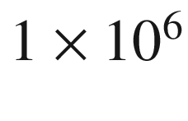

 cm

$$^2$$

/Vs. Sci. Rep. **6**, 26598:1–8 (2016). [10.​1038/​srep26598](https://doi.org/10.1038/srep26598)

J. Faslom, M. Kawasaki, A review of the quantum Hall effects in MgZnO/ZnO heterostructures. Rep. Prog. Phys. **81**, 056501:1–24 (2018). [10.​1088/​1361-6633/​aaa978](https://doi.org/10.1088/1361-6633/aaa978)

H. Bachmair, E.O. Göbel, G. Hein, J. Melcher, B. Schumacher, J. Schurr, L. Schweitzer, P. Warnecke, The von Klitzing resistance standard. Physica E **20**, 14–23 (2003). [10.​1016/​j.​physe.​2003.​09.​017](https://doi.org/10.1016/j.physe.2003.09.017)

J.K. Jain, *Composite Fermions* (Cambridge University Press, Cambridge, 2007). [10.​1017/​CBO9780511607561​](https://doi.org/10.1017/CBO9780511607561)

H. Aoki, T. Ando, Effect of localization of the Hall conductivity in the two-dimensional system in strong magnetic fields. Solid State Commun. **38**, 1079–1082 (1981). [10.​1016/​0038-1098(93)90276-S](https://doi.org/10.1016/0038-1098(93)90276-S)

R.B. Laughlin, Quantized Hall conductivity in two dimensions. Phys. Rev. B **23**, 5632–5633 (1981). [10.​1103/​PhysRevB.​23.​5632](https://doi.org/10.1103/PhysRevB.23.5632)

D.J. Thouless, M. Kohmoto, M.P. Nightingale, M. den Nijs, Quantized Hall conductance in a two-dimensional periodic potential. Phys. Rev. Lett. **49**, 405–408 (1982). [10.​1103/​PhysRevLett.​49.​405](https://doi.org/10.1103/PhysRevLett.49.405)

Y. Hatsugai, Chern number and edge states in the integer quantum Hall effect. Phys. Rev. Lett. **71**, 3697–3700 (1993). [10.​1103/​PhysRevLett.​71.​3697](https://doi.org/10.1103/PhysRevLett.71.3697)

D.R. Hofstadter, Energy levels and wave functions of Bloch electrons in rational and irrational magnetic fields. Phys. Rev. B **14**, 2239–2249 (1976). [10.​1103/​PhysRevB.​14.​2239](https://doi.org/10.1103/PhysRevB.14.2239)

D. Osadchy, J.E. Avron, Hofstadter butterfly as quantum phase diagram. J. Math. Phys. **42**, 5665–5671 (2001). [10.​1063/​1.​1412464](https://doi.org/10.1063/1.1412464)

E. Ahlswede, P. Weitz, J. Weis, K. von Klitzing, K. Eberl, Hall potential profiles in the quantum Hall regime measured by a scanning force microscope. Physica B **298**, 562–566 (2001). [10.​1016/​S0921-4526(01)00383-0](https://doi.org/10.1016/S0921-4526(01)00383-0)

R.E. Prange, Quantized Hall resistance and the measurement of the fine-structure constant. Phys. Rev. B **23**, 4802–4805 (1981). [10.​1103/​PhysRevB.​23.​4802](https://doi.org/10.1103/PhysRevB.23.4802)

M. Büttiker, Absence of backscattering in the quantum Hall effect in multiprobe conductors. Phys. Rev. B **38**, 9375–9389 (1988). [10.​1103/​PhysRevB.​38.​9375](https://doi.org/10.1103/PhysRevB.38.9375)

K. Lier, R.R. Gerhardts, Self-consistent calculation of edge channels in laterally confined two-dimensional electron systems. Phys. Rev. B **50**, 7757–7767 (1994). [10.​1103/​PhysRevB.​50.​7757](https://doi.org/10.1103/PhysRevB.50.7757)

Y. Zhang, Y.-W. Tan, H.L. Stormer, P. Kim, Experimental observation of the quantum Hall effect and Berry’s phase in graphene. Nature **438**, 201–204 (2005). [10.​1038/​nature04235](https://doi.org/10.1038/nature04235)

M.O. Goerbig, The quantum Hall effect in graphene—a theoretical perspective. Comptes Rendus Phys. **12**, 369–378 (2011). [10.​1016/​j.​crhy.​2011.​04.​012](https://doi.org/10.1016/j.crhy.2011.04.012)

Z. Jiang, Y. Zhang, Y.-W. Tan, H.L. Stormer, P. Kim, Quantum Hall effect in graphene. Solid State Commun. **143**, 14–19 (2007). [10.​1016/​j.​ssc.​2007.​02.​046](https://doi.org/10.1016/j.ssc.2007.02.046)

J.P. Eisenstein, H.L. Störmer, The fractional quantum Hall effect. Science **248**, 1510–1516 (1990). [10.​1126/​science.​248.​4962.​1510](https://doi.org/10.1126/science.248.4962.1510)

J.K. Jain, Composite-Fermion approach for the fractional quantum Hall effect. Phys. Rev. Lett. **63**, 199–202 (1989). [10.​1103/​PhysRevLett.​63.​199](https://doi.org/10.1103/PhysRevLett.63.199)

J.K. Jain, Theory of the fractional quantum Hall effect. Phys. Rev. B **41**, 7653–7665 (1990). [10.​1103/​PhysRevB.​42.​9193](https://doi.org/10.1103/PhysRevB.42.9193) Erratum: Phys. Rev. B 42, 9193 (1990). [10.​1103/​PhysRevB.​41.​7653](https://doi.org/10.1103/PhysRevB.41.7653)

H.L. Störmer, D.C. Tsui, A.C. Gossard, The fractional quantum Hall effect. Rev. Mod. Phys. **71**, S298–S305 (1999). [10.​1103/​RevModPhys.​71.​S298](https://doi.org/10.1103/RevModPhys.71.S298)

D. Weiss, M.L. Roukes, A. Menschig, P. Frambow, K. von Klitzing, G. Weimann, Electron pinball and commensurate orbits in a periodic array of scatterers. Phys. Rev. Lett. **66**, 2790–2793 (1991). [10.​1103/​PhysRevLett.​66.​2790](https://doi.org/10.1103/PhysRevLett.66.2790)

M. Fiebig, Revival of the magnetoelectric effect. J. Phys. D: Appl. Phys. **38**, R123–R152 (2005). [10.​1088/​0022-3727/​38/​8/​R01](https://doi.org/10.1088/0022-3727/38/8/R01)

W. Eerenstein, N.D. Mathur, J.F. Scott, Multiferroic and magnetoelectric materials. Nature **442**, 759–765 (2006). [10.​1038/​nature05023](https://doi.org/10.1038/nature05023)

Nils Ashcroft, private communication (2006)

V.M. Fridkin, *Ferroelectric Semiconductors (translated from Russian)* (Plenum, New York, 1980)

Y. Xu, *Ferroelectric Materials and Their Applications* (North Holland, Amsterdam, 1991)

K. Rabe, Ch.H. Ahn, J.-M. Triscone, eds., Physics of ferroelectrics, a modern perspective, in *Topics in Applied Physics*, vol. 105 (Springer, Berlin, 2007). [10.​1007/​978-3-540-34591-6](https://doi.org/10.1007/978-3-540-34591-6)

R. Comes, M. Lambert, A. Guinier, The chain structure of BaTiO

$$_3$$

and KNbO

$$_3$$

. Solid State Commun. **6**, 715–719 (1968). [10.​1016/​0038-1098(68)90571-1](https://doi.org/10.1016/0038-1098(68)90571-1)

R.E. Cohen, Origin of ferroelectricity in perovskite oxides. Nature **358**, 136–138 (1992). [10.​1038/​358136a0](https://doi.org/10.1038/358136a0)

G. Shirane, S. Hoshino, On the phase transition in lead titanate. J. Phys. Soc. Jpn. **6**, 265–270 (1951). [10.​1143/​JPSJ.​6.​265](https://doi.org/10.1143/JPSJ.6.265)

W.J. Merz, The electric and optical behavior of BaTiO

$$_3$$

single-domain crystals. Phys. Rev. **76**, 1221–1225 (1949). [10.​1103/​PhysRev.​76.​1221](https://doi.org/10.1103/PhysRev.76.1221)

D.K. Agrawal, C.H. Perry, Long-wavelength optical phonons and phase transitions in SbSI. Phys. Rev. B **4**, 1893–1902 (1971). [10.​1103/​PhysRevB.​4.​1893](https://doi.org/10.1103/PhysRevB.4.1893)

G. Rupprecht, R.O. Bell, Dielectric constant in paraelectric perovskites. Phys. Rev. **135**, A748–A752 (1964). [10.​1103/​PhysRev.​135.​A748](https://doi.org/10.1103/PhysRev.135.A748)

M.E. Lines, Statistical theory for displacement ferroelectrics. III. Comparison with experiment for lithium tantalate. Phys. Rev. **177**, 819–829 (1969). [10.​1103/​PhysRev.​177.​819](https://doi.org/10.1103/PhysRev.177.819)

W.J. Merz, Double hysteresis loop of BaTiO

$$_3$$

at the Curie point. Phys. Rev. **91**, 513–517 (1953). [10.​1103/​PhysRev.​91.​513](https://doi.org/10.1103/PhysRev.91.513)

P.W. Forsbergh Jr., Domain structures and phase transitions in barium titanate. Phys. Rev. **76**, 1187–1201 (1949). [10.​1103/​PhysRev.​76.​1187](https://doi.org/10.1103/PhysRev.76.1187)

Ch. Gähwiller, Einfluß des elektrischen Feldes auf die fundamentale Absorptionskante von Bariumtitanat. Phys. Kondens. Materie **6**, 269–289 (1967). [10.​1007/​BF02422508](https://doi.org/10.1007/BF02422508)

G. Arlt, P. Quadflieg, Piezoelectricity in III-V compounds with a phenomenological analysis of the piezoelectric effect. Phys. Status Solidi B **25**, 323–330 (1968). [10.​1002/​pssb.​19680250131](https://doi.org/10.1002/pssb.19680250131)

M. Grundmann, O. Stier, D. Bimberg, Symmetry breaking in pseudomorphic V-groove quantum wires. Phys. Rev. B **50**, 14187–14192 (1994). [10.​1103/​PhysRevB.​50.​14187](https://doi.org/10.1103/PhysRevB.50.14187)

D.L. Smith, C. Mailhiot, Piezoelectric effects in strained-layer superlattices. J. Appl. Phys. **63**, 2717–2719 (1988). [10.​1063/​1.​340965](https://doi.org/10.1063/1.340965)

T. Hanada, Basic properties of ZnO, GaN, and related materials, in *Oxide and Nitride Semiconductors: Processing, Properties and Applications*, eds. by T. Yao, S.-K. Hong (Springer, Heidelberg, 2009). [10.​1007/​978-3-540-88847-5\_​1](https://doi.org/10.1007/978-3-540-88847-5%255F1)

M. Catti, Y. Noel, R. Dovesi, Full piezoelectric tensors of wurtzite and zinc blende ZnO and ZnS by first-principles calculations. J. Phys. Chem. Solids **64**, 2183–2190 (2003). [10.​1016/​S0022-3697(03)00219-1](https://doi.org/10.1016/S0022-3697(03)00219-1)

M.S. Shur, B. Gelmont, A. Khan, Electron mobility in two-dimensional electron gas in AlGaN/GaN heterostructures and in bulk GaN. J. Electr. Mater. **25**, 777–785 (1996). [10.​1007/​BF02666636](https://doi.org/10.1007/BF02666636)

F. Bernardini, V. Fiorentini, D. Vanderbilt, Spontaneous polarization and piezoelectric constants of III-V nitrides. Phys. Rev. B **56**, R10024–R10027 (1997). [10.​1103/​PhysRevB.​56.​R10024](https://doi.org/10.1103/PhysRevB.56.R10024)

Oliver Ambacher, private communication (2005)

P. Waltereit, O. Brandt, A. Trampert, H.T. Grahn, J. Menniger, M. Ramsteiner, M. Reiche, K.H. Ploog, Nitride semiconductors free of electrostatic fields for efficient white light-emitting diodes. Nature **406**, 865–868 (2000). [10.​1038/​35022529](https://doi.org/10.1038/35022529)

C.Q. Chen, V. Adivarahan, J.W. Yang, M. Shatalov, E. Kuokstis, M.A. Khan, Ultraviolet light emitting diodes using non-polar a-plane GaN-AlGaN multiple quantum wells. Jpn. J. Appl. Phys. **42**, Part 2, L1039–L1040 (2003). [10.​1143/​JJAP.​42.​L1039](https://doi.org/10.1143/JJAP.42.L1039)

R. Sharma, P.M. Pattison, H. Masui, R.M. Farrel, T.J. Baker, B.A. Haskell, F. Wu, S.P. DenBaars, J.S. Speck, S. Nakamura, Demonstration of a semipolar (

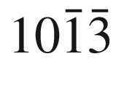

) InGaN/GaN green light emitting diode. Appl. Phys. Lett. **87**, 231110:1–3 (2005). [10.​1063/​1.​2139841](https://doi.org/10.1063/1.2139841)

S.-H. Park, Crystal orientation effects on electronic properties of wurtzite InGaN/GaN quantum wells. J. Appl. Phys. **91**, 9904–9908 (2002). [10.​1063/​1.​1480465](https://doi.org/10.1063/1.1480465)

H. Sato, R.B. Chung, H. Hirasawa, N. Fellows, H. Masui, F. Wu, M. Saito, K. Fujito, J.S. Speck, S.P. DenBaars, S. Nakamura, Optical properties of yellow light-emitting diodes grown on semipolar (

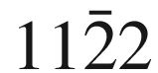

) bulk GaN substrates. Appl. Phys. Lett. **92**, 221110:1–3 (2008). [10.​1063/​1.​2938062](https://doi.org/10.1063/1.2938062)

M. Grundmann, Theory of semiconductor solid and hollow nano- and microwires with hexagonal cross-section under torsion. Phys. Status Solidi B **252**, 773–785 (2015). [10.​1002/​pssb.​201451431](https://doi.org/10.1002/pssb.201451431)

A.D. Andreev, E.P. O’Reilly, Theory of the electronic structure of GaN/AlN hexagonal quantum dots. Phys. Rev. B **62**, 15851–15870 (2000). [10.​1103/​PhysRevB.​62.​15851](https://doi.org/10.1103/PhysRevB.62.15851)

J.K. Furdyna, Diluted magnetic semiconductors. J. Appl. Phys. **64**, R29–R64 (1988). [10.​1063/​1.​341700](https://doi.org/10.1063/1.341700)

J.K. Furdyna, J. Kossut, eds., Diluted magnetic semiconductors. Semicond. Semimet. **25**, (1988). [10.​1016/​S0080-8784(08)62411-4](https://doi.org/10.1016/S0080-8784(08)62411-4)

D. Awshalom, D. Loss, N. Samarth, eds., *Semiconductor Spintronics and Quantum Computation* (Springer, Berlin, 2002). [10.​1007/​978-3-662-05003-3](https://doi.org/10.1007/978-3-662-05003-3)

S.J. Pearton, C.R. Abernathy, M.E. Overberg, G.T. Thaler, D.P. Norton, N. Theodoropoulou, A.F. Hebard, Y.D. Park, F. Ren, J. Kim, L.A. Boatner, Wide band gap ferromagnetic semiconductors and oxides. J. Appl. Phys. **93**, 1–13 (2003). [10.​1063/​1.​1517164](https://doi.org/10.1063/1.1517164)

T. Dietl, H. Ohno, Dilute ferromagnetic semiconductors: Physics and spintronic structures. Rev. Mod. Phys. **86**, 187–251 (2014). [10.​1103/​RevModPhys.​86.​187](https://doi.org/10.1103/RevModPhys.86.187)

I. Tsubokawa, On the magnetic properties of a CrBr

$$_3$$

single crystal. J. Phys. Soc. Jpn. **15**, 1664–1668 (1960). [10.​1143/​JPSJ.​15.​1664](https://doi.org/10.1143/JPSJ.15.1664)

B.T. Matthias, R.M. Bozorth, J.H. van Vleck, Ferromagnetic interaction in EuO. Phys. Rev. Lett. **7**, 160–161 (1961). [10.​1103/​PhysRevLett.​7.​160](https://doi.org/10.1103/PhysRevLett.7.160)

G. Güntherodt, Optical properties and electronic structure of europium chalcogenides. Phys. Cond. Matter **18**, 37–78 (1974). [10.​1007/​BF01950500](https://doi.org/10.1007/BF01950500)

P.G. Steeneken, *New light on EuO thin films: preparation, transport, magnetism and spectroscopy of a ferromagnetic semiconductor*, Ph.D. Thesis, Rijksuniversiteit Groningen (2002)

P. Wachter, Europium chalcogenides: EuO, EuS, EuSe, and EuTe, in: *Handbook on the Physics and Chemistry of Rare Earths*, eds. by K.A. Gschneider, Jr., L. Eyring (North-Holland, Amsterdam, 1979), pp. 507–574

T. Fukumura, H. Toyosaki, Y. Yamada, Magnetic oxide semiconductors. Semicond. Sci. Technol. **20**, S103–S111 (2005). [10.​1088/​0268-1242/​20/​4/​012](https://doi.org/10.1088/0268-1242/20/4/012)

W. Giriat, J.K. Furdyna, Crystal structure, composition, and materials preparation of diluted magnetic semiconductors in Ref. [1514], pp. 1–34. [10.​1016/​S0080-8784(08)62417-5](https://doi.org/10.1016/S0080-8784(08)62417-5)

C. Rigaux, Magnetooptics in narrow gap diluted magnetic semiconductors in Ref. [1517], pp. 229–274. [10.​1016/​S0080-8784(08)62422-9](https://doi.org/10.1016/S0080-8784(08)62422-9)

C. Domb, N.W. Dalton, Crystal statistics with long-range forces. I. The equivalent neighbour model. Proc. Phys. Soc. **89**, 859–871 (1966). [10.​1088/​0370-1328/​89/​4/​311](https://doi.org/10.1088/0370-1328/89/4/311)

C. Zener, Interaction between the d-shells in the transition metals. Phys. Rev. **81**, 440–444 (1951). [10.​1103/​PhysRev.​81.​440](https://doi.org/10.1103/PhysRev.81.440)

H. Akai, Ferromagnetism and its stability in the diluted magnetic semiconductor (In, Mn)As. Phys. Rev. Lett. **81**, 3002–3005 (1998). [10.​1103/​PhysRevLett.​81.​3002](https://doi.org/10.1103/PhysRevLett.81.3002)

T. Dietl, H. Ohno, F. Matsukura, J. Cibert, D. Ferrand, Zener model description of ferromagnetism in zinc-blende magnetic semiconductors. Science **287**, 1019–1022 (2000). [10.​1126/​science.​287.​5455.​1019](https://doi.org/10.1126/science.287.5455.1019)

H. Munekata, H. Ohno, S. von Molnár, A. Segmüller, L.L. Chang, L. Esaki, Diluted magnetic III-V semiconductors. Phys. Rev. Lett. **63**, 1849–1852 (1989). [10.​1103/​PhysRevLett.​63.​1849](https://doi.org/10.1103/PhysRevLett.63.1849)

H. Ohno, M. Munekata, T. Penney, S. von Molnár, L.L. Chang, magnetotransport properties of p-type (In, Mn)As diluted magnetic III-V semiconductors. Phys. Rev. Lett. **68**, 2664–2667 (1992). [10.​1103/​PhysRevLett.​68.​2664](https://doi.org/10.1103/PhysRevLett.68.2664)

H. Ohno, A. Shen, F. Matsukura, A. Oiwa, A. Endo, S. Katsumoto, Y. Iye, (Ga, Mn)As: A new diluted magnetic semiconductor based on GaAs. Appl. Phys. Lett. **69**, 363–365 (1996). [10.​1063/​1.​118061](https://doi.org/10.1063/1.118061)

Y.-J. Zhao, P. Mahadevan, A. Zunger, Comparison of predicted ferromagnetic tendencies of Mn substituting the Ga site in III-V’s and in I-III-VI

$$_2$$

chalcopyrite semiconductors. Appl. Phys. Lett. **84**, 3753–3755 (2004). [10.​1063/​1.​1737466](https://doi.org/10.1063/1.1737466)

H. Ohno, D. Chiba, F. Matsukura, T. Omiya, E. Abe, T. Dietl, Y. Ohno, K. Ohtani, Electric-field control of ferromagnetism. Nature **408**, 944–946 (2000). [10.​1038/​35050040](https://doi.org/10.1038/35050040)

S.T.B. Goennenwein, Th.A. Wassner, H. Huebl, M.S. Brandt, J.B. Philipp, M. Opel, R. Gross, A. Koeder, W. Schoch, A. Waag, Hydrogen control of ferromagnetism in a dilute magnetic semiconductor. Phys. Rev. Lett. **92**, 227202:1–4 (2004). [10.​1103/​PhysRevLett.​92.​227202](https://doi.org/10.1103/PhysRevLett.92.227202)

P. Sharma, A. Gupta, K.V. Rao, F.J. Owens, R. Sharma, R. Ahuja, J.M. Osorio Guillen, B. Johansson, G.A. Gehring, Ferromagnetism above room temperature in bulk and transparent thin films of Mn-doped ZnO. Nature Mater. **2**, 673–677 (2003). [10.​1038/​nmat984](https://doi.org/10.1038/nmat984)

M. Diaconu, H. Schmidt, H. Hochmuth, M. Lorenz, G. Benndorf, D. Spemann, A. Setzer, P. Esquinazi, A. Pöppl, H. von Wenckstern, K.-W. Nielsen, R. Gross, H. Schmid, W. Mader, G. Wagner, M. Grundmann, Room-temperature ferromagnetic Mn-alloyed ZnO films obtained by pulsed laser deposition. J. Magn. Magn. Mat. **307**, 212–221 (2006). [10.​1016/​j.​jmmm.​2006.​04.​004](https://doi.org/10.1016/j.jmmm.2006.04.004)

E.H. Hall, On the “Rotational Coefficient” in nickel and cobalt. Philos. Mag. Series 5 **12**(74), 157–172 (1881). [10.​1080/​1478644810862708​6](https://doi.org/10.1080/14786448108627086)

N. Nagaosa, J. Sinova, S. Onoda, A.H. MacDonald, N.P. Ong, Anomalous Hall effect. Rev. Mod. Phys. **82**, 1539–1592 (2010). [10.​1103/​RevModPhys.​82.​1539](https://doi.org/10.1103/RevModPhys.82.1539)

M.I. Miah, Pure anomalous Hall effect in nonmagnetic zinc-blende semiconductors. Opt. Quant. Electron. **40**, 1033–1042 (2008). [10.​1007/​s11082-009-9296-z](https://doi.org/10.1007/s11082-009-9296-z)

C.-X. Liu, S.-C. Zhang, X.-L. Qi, The quantum anomalous Hall effect: theory and experiment. Ann. Rev. Cond. Matter Phys. **7**, 301–321 (2016). [10.​1146/​annurev-conmatphys-031115-011417](https://doi.org/10.1146/annurev-conmatphys-031115-011417)

C.-Z. Chang, J. Zhang, X. Feng, J. Shen, Z. Zhang, M. Guo, K. Li, Y. Ou, P. Wei, L.-L. Wang, Z.-Q. Ji, Y. Feng, S. Ji, X. Chen, J. Jia, X. Dai, Z. Fang, S.-C. Zhang, K. He, Y. Wang, L. Lu, X.-C. Ma, Q.-K. Xue, Experimental observation of the quantum anomalous Hall effect in a magnetic topological insulator. Science **340**, 167–170 (2013). [10.​1126/​science.​1234414](https://doi.org/10.1126/science.1234414)

Y. Deng, Y. Yu, M.Z. Shi, Z. Guo, Z. Xu, J. Wang, X.H. Chen, Y. Zhang, Quantum anomalous Hall effect in intrinsic magnetic topological insulator MnBi

$$_2$$

Te

$$_4$$

. Science **367**, 895–900 (2020). [10.​1126/​science.​aax8156](https://doi.org/10.1126/science.aax8156)

E.I. Rashba, Electron spin operation by electric fields: spin dynamics and spin injection. Physica E **20**, 189–195 (2004). [10.​1016/​j.​physe.​2003.​08.​002](https://doi.org/10.1016/j.physe.2003.08.002)

M.I. D’yakonov, V.I. Perel’, Spin relaxation of conduction electrons in noncentrosymetric semiconductors. Fiz. Tverd. Tela **13**, 3581–3585 (1971) [Sov. Phys. Solid State **13**, 3023–3026 (1972)]

S. Datta, B. Das, Electronic analog of the electro-optic modulator. Appl. Phys. Lett. **56**, 665–667 (1990). [10.​1063/​1.​102730](https://doi.org/10.1063/1.102730)

A.T. Hanbicki, O.M.J. van ’t Erve, R. Magno, G. Kioseoglou, C.H. Li, B.T. Jonker, Analysis of the transport process providing spin injection through an Fe/AlGaAs Schottky barrier. Appl. Phys. Lett. **82**, 4092–4094 (2003). [10.​1063/​1.​1580631](https://doi.org/10.1063/1.1580631)

B.T. Jonker, S.C. Erwin, A. Petrou, A.G. Petukhov, Electrical spin injection and transport in semiconductor spintronic device. MRS Bull. **28**, 740–748 (2003). [10.​1557/​mrs2003.​216](https://doi.org/10.1557/mrs2003.216)

N. Nishizawa, K. Nishibayashi, H. Munekata, Pure circular polarization electroluminescence at room temperature with spin-polarized light-emitting diodes. PNAS **114**, 1783–1788 (2017). [10.​1073/​pnas.​1609839114](https://doi.org/10.1073/pnas.1609839114)

C.L. Braun, *Organic Semiconductors, Handbook on Semiconductors*, vol. 3 (North Holland, Amsterdam, 1980), pp. 857–873

*Physics of Organic Semiconductors*, 2nd edn., W. Brütting, C. Adachi, eds. (Wiley-VCH, Weinheim, 2012).

10.​1002/​9783527654949

Th.U. Kampen, *Low Molecular Weight Organic Semiconductors* (Wiley-VCH. Weinheim (2009). [10.​1002/​9783527629978](https://doi.org/10.1002/9783527629978)

A. Curioni, W. Andreoni, R. Treusch, F.J. Himpsel, E. Haskal, P. Seidler, C. Heske, S. Kakar, T. van Buuren, L.J. Terminello, Atom-resolved electronic spectra for Alq

$$_3$$

from theory and experiment. Appl. Phys. Lett. **72**, 1575–1577 (1998). [10.​1063/​1.​121119](https://doi.org/10.1063/1.121119)

D. Braun, A. Heeger, Visible light emission from semiconducting polymer diodes. Appl. Phys. Lett. **58**, 1982–1984 (1991). [10.​1063/​1.​105039](https://doi.org/10.1063/1.105039)

A.McL. Mathieson, J.M. Robertson, V.C. Sinclair, the crystal and molecular structure of anthracene. I. x-ray measurements. Acta Cryst. **3**, 245–250 (1950). [10.​1107/​S0365110X5000064​1](https://doi.org/10.1107/S0365110X50000641)

J.M. Robertson, V.C. Sinclair, J. Trotter, The crystal and molecular structure of tetracene. Acta Cryst. **14**, 697–704 (1961). [10.​1107/​S0365110X6100215​1](https://doi.org/10.1107/S0365110X61002151)

N. Karl, High purity organic molecular crystals, in *Crystals: Growth, Properties and Applications*, vol. 4, ed. by H.C. Freyhardt (Springer, Berlin, 1980), pp. 1–100. [10.​1007/​978-3-642-67764-9\_​1](https://doi.org/10.1007/978-3-642-67764-9%255F1)

N. Karl, Growth and electrical properties of high purity organic molecular crystals. J. Cryst. Growth **99**, 1009–1016 (1990). [10.​1016/​S0022-0248(08)80072-3](https://doi.org/10.1016/S0022-0248(08)80072-3)

Ch. Kloc, P.G. Simpkins, T. Siegrist, R.A. Laudise, Physical vapor growth of centimeter-sized crystals of

$$\alpha $$

-hexathiophene. J. Cryst. Growth **182**, 416–427 (1997). [10.​1016/​S0022-0248(97)00370-9](https://doi.org/10.1016/S0022-0248(97)00370-9)

R.A. Laudise, Ch. Kloc, P.G. Simpkins, T. Siegrist, Physical vapor growth of organic semiconductors. J. Cryst. Growth **187**, 449–454 (1998). [10.​1016/​S0022-0248(98)00034-7](https://doi.org/10.1016/S0022-0248(98)00034-7)

M. Mas-Torrent, M. Durkut, P. Hadley, X. Ribas, C. Rovira, High mobility of dithiophene-tetrathiafulvalene single-crystal organic field effect transistors. J. Am. Chem. Soc. **126**, 984–985 (2004). [10.​1021/​ja0393933](https://doi.org/10.1021/ja0393933)

M. Campione, R. Ruggerone, S. Tavazzi, M. Moret, Growth and characterisation of centimetre-sized single crystals of molecular organic materials. J. Mat. Chem. **15**, 2437–2443 (2005). [10.​1039/​B415912H](https://doi.org/10.1039/B415912H)

M. Oehzelt, A. Aichholzer, R. Resel, G. Heimel, E. Venuti, R.G. Della Valle, Crystal structure of oligoacenes under high pressure. Phys. Rev. B **74**, 104103:1–7 (2006). [10.​1103/​PhysRevB.​74.​104103](https://doi.org/10.1103/PhysRevB.74.104103)

B. Part, A. Kahn, N. Koch, W. Gao, Electronic structure and electrical properties of interfaces between metals and

$$\pi $$

-conjugated molecular films. J. Polymer Sc. Polymer Phys. **41**, 2529–2548 (2003). [10.​1002/​polb.​10642](https://doi.org/10.1002/polb.10642)

M. Pfeiffer, A. Beyer, T. Fritz, K. Leo, Controlled doping of phthalocyanine layers by cosublimation with acceptor molecules: A systematic Seebeck and conductivity study. Appl. Phys. Lett. **73**, 3202–3204 (1998). [10.​1063/​1.​122718](https://doi.org/10.1063/1.122718)

B.A. Gregg, S.-G. Chen, R.A. Cormier, Coulomb forces and doping in organic semiconductors. Chem. Mater. **16**, 4586–4599 (2004). [10.​1021/​cm049625c](https://doi.org/10.1021/cm049625c)

G.F. Neumark, Concentration and temperature dependence of impurity-to-band activation energies. Phys. Rev. B **5**, 408–414 (1972). [10.​1103/​PhysRevB.​5.​408](https://doi.org/10.1103/PhysRevB.5.408)

B.A. Gregg, S.-G. Chen, H.M. Branz, On the superlinear increase in conductivity with dopant concentration in excitonic semiconductors. Appl. Phys. Lett. **84**, 1707–1709 (2004). [10.​1063/​1.​1668326](https://doi.org/10.1063/1.1668326)

A.J. Heeger, S. Kivelson, J.R. Schrieffer, W.-P. Su, Solitons in conducting polymers. Rev. Mod. Phys. **60**, 781–850 (1988). [10.​1103/​RevModPhys.​60.​781](https://doi.org/10.1103/RevModPhys.60.781)

P.W.M. Blom, M.C.J.M. Vissenberg, Charge transport in poly(p-phenylene vinylene) light-emitting diodes. Mater. Sci. Engin. **27**, 53–94 (2000). [10.​1016/​S0927-796X(00)00009-7](https://doi.org/10.1016/S0927-796X(00)00009-7)

L.B. Schein, Temperature independent drift mobility along the molecular direction of As

$$_2$$

Se

$$_3$$

. Phys. Rev. B **15**, 1024–1034 (1977). [10.​1103/​PhysRevB.​15.​1024](https://doi.org/10.1103/PhysRevB.15.1024)

L.B. Schein, C.B. Duke, A.R. McGhie, Observation of the band-hopping transition for electrons in naphthalene. Phys. Rev. Lett. **40**, 197–200 (1978). [10.​1103/​PhysRevLett.​40.​197](https://doi.org/10.1103/PhysRevLett.40.197)

L. Li, G. Meller, H. Kosina, Temperature and field-dependence of hopping conduction in organic semiconductors. Microelectr. J. **38**, 47–51 (2007). [10.​1016/​j.​mejo.​2006.​09.​022](https://doi.org/10.1016/j.mejo.2006.09.022)

Y. Kawasumi, I. Akai, T. Karasawa, Photoluminescence and dynamics of excitons in Alq

$$_3$$

single crystals. Int. J. Mod. Phys. B **15**, 3825–3828 (2001). [10.​1142/​S021797920100876​7](https://doi.org/10.1142/S0217979201008767)

M.A. Baldo, S.R. Forrest, Transient analysis of organic electrophosphorescence: I. Transient analysis of triplet energy transfer. Phys. Rev. B **62**, 10958–10966 (2000). [10.​1103/​PhysRevB.​62.​10958](https://doi.org/10.1103/PhysRevB.62.10958)

W. Humbs, H. Zhang, M. Glasbeek, Femtosecond fluorescence upconversion spectroscopy of vapor-deposited tris(8-hydroxyquinoline) aluminum films. Chem. Phys. **254**, 319–327 (2000). [10.​1016/​S0301-0104(00)00044-6](https://doi.org/10.1016/S0301-0104(00)00044-6)

Z. Vardeny, E. Ehrenfreund, J. Shinar, F. Wudl, Photoexcitation spectroscopy of polythiophene. Phys. Rev. B **35**, 2498–2500 (1987). [10.​1103/​PhysRevB.​35.​2498](https://doi.org/10.1103/PhysRevB.35.2498)

J.-W. van der Horst, P.A. Bobbert, M.A.J. Michels, Electronic and optical excitations in crystalline conjugated polymers. Phys. Rev. B **66**, 035206:1–7 (2002). [10.​1103/​PhysRevB.​66.​035206](https://doi.org/10.1103/PhysRevB.66.035206)

A. Baldo, D.F. O’Brien, M.E. Thompson, S.R. Forrest, Excitonic singlet-triplet ratio in a semiconducting organic thin film. Phys. Rev. B **60**, 14422–14428 (1999). [10.​1103/​PhysRevB.​60.​14422](https://doi.org/10.1103/PhysRevB.60.14422)

A. Baldo, D.F. O’Brien, Y. You, A. Shoustikov, S. Sibley, M.E. Thompson, S.R. Forrest, Highly efficient phosphorescent emission from organic electroluminescent devices. Nature **395**, 151–154 (1998). [10.​1038/​25954](https://doi.org/10.1038/25954)

C. Adachi, M.A. Baldo, M.E. Thompson, S.R. Forrest, Nearly 100% internal phosphorescence efficiency in an organic light emitting device. J. Appl. Phys. **90**, 5048–5051 (2001). [10.​1063/​1.​1409582](https://doi.org/10.1063/1.1409582)

M.A. Baldo, S. Lamansky, P.E. Burrows, M.E. Thompson, S.R. Forrest, Very high-efficiency green organic light-emitting devices based on electrophosphorescence. Appl. Phys. Lett. **75**, 4–6 (1999). [10.​1063/​1.​124258](https://doi.org/10.1063/1.124258)

M.A. Baldo, M.E. Thompson, S.R. Forrest, High-efficiency fluorescent organic light-emitting devices using a phosphorescent sensitizer. Nature **403**, 750–753 (2000). [10.​1038/​35001541](https://doi.org/10.1038/35001541)

T. Förster, Transfer mechanisms of electron excitation. Discuss. Faraday Soc. **27**, 7–17 (1959). [10.​2307/​3583604](https://doi.org/10.2307/3583604)

R.R. Willey, *Practical Design and Production of Optical Thin Films* (CRC Press, London, 2002). [10.​1201/​9780203910467](https://doi.org/10.1201/9780203910467)

J.M. Bendickson, J.P. Dowling, M. Scalora, Analytic expressions for the electromagnetic mode density in finite, one-dimensional, photonic band-gap structures. Phys. Rev. E **53**, 4107–4121 (1996). [10.​1103/​PhysRevE.​53.​4107](https://doi.org/10.1103/PhysRevE.53.4107)

J. Gottmann, A. Husmann, T. Klotzbücher, E.W. Kreutz, Optical properties of alumina and zirconia thin films grown by pulsed laser deposition. Surface and Coatings Technol. **100–101**, 415–419 (1998). [10.​1016/​S0257-8972(97)00661-0](https://doi.org/10.1016/S0257-8972(97)00661-0)

J. Sellmann, Ch. Sturm, R. Schmidt-Grund, Ch. Czekalla, J. Lenzner, H. Hochmuth, B. Rheinländer, M. Lorenz, M. Grundmann, Structural and optical properties of ZrO

$$_2$$

and Al

$$_2$$

O

$$_3$$

thin films and Bragg reflectors grown by pulsed laser deposition. Phys. Status Solidi C **5**, 1240–1243 (2008). [10.​1002/​pssc.​200777875](https://doi.org/10.1002/pssc.200777875)

Bernd Rauschenbach, private communication (2006)

Norbert Kaiser, Fraunhofer-Institute for Applied Optics, Jena, Germany

C.M. Soukoulis, ed., Photonic crystals and light localization in the 21st century, in *NATO Science Series C: Mathematical and Physical Sciences*, vol. 563 (Kluwer Academic Publishers, Dordrecht, 1996). [10.​1007/​978-94-010-0738-2](https://doi.org/10.1007/978-94-010-0738-2)

J.D. Joannopoulos, R.D. Meade, J.N. Winn, *Photonic Crystals, Molding the Flow of Light* (Princeton University Press, Princeton, NJ, 1995)

K. Busch, S. Lölkes, R.B. Wehrspohn, H. Föll, eds., *Photonic Crystals: Advances in Design, Fabrication, and Characterization* (Wiley-VCH, Berlin, 1994)

E.-X. Ping, Transmission of electromagnetic waves in planar, cylindrical, and spherical dielectric layer systems and their applications. J. Appl. Phys. **76**, 7188–7194 (1994). [10.​1063/​1.​357999](https://doi.org/10.1063/1.357999)

K.M. Ho, C.T. Chan, C.M. Soukoulis, Existence of a photonic gap in periodic dielectric structures. Phys. Rev. Lett. **65**, 3152–3155 (1990). [10.​1103/​PhysRevLett.​65.​3152](https://doi.org/10.1103/PhysRevLett.65.3152)

O. Toader, S. John, Proposed square spiral microfabrication architecture for large three-dimensional photonic band gap crystals. Science **292**, 1133–1135 (2001). [10.​1126/​science.​1059479](https://doi.org/10.1126/science.1059479)

S.R. Kennedy, M.J. Brett, O. Toader, S. John, Fabrication of tetragonal square spiral photonic crystals. Nano Lett. **2**, 59–62 (2002). [10.​1021/​nl015635q](https://doi.org/10.1021/nl015635q)

K. Busch, S. John, Photonic band gap formation in certain self-organizing systems. Phys. Rev. E **58**, 3896–3908 (1998). [10.​1103/​PhysRevE.​58.​3896](https://doi.org/10.1103/PhysRevE.58.3896)

E. Yablonovitch, T.J. Gmitter, K.M. Leung, Photonic band structure: the face-centered-cubic case employing nonspherical atoms. Phys. Rev. Lett. **67**, 2295–2298 (1991). [10.​1103/​PhysRevLett.​67.​2295](https://doi.org/10.1103/PhysRevLett.67.2295)

K.M. Ho, C.T. Chan, C.M. Soukoulis, R. Biswas, M. Sigalas, Photonic band gaps in three dimensions: new layer-by-layer periodic structures. Solid State Commun. **89**, 413–416 (1994). [10.​1016/​0038-1098(94)90202-X](https://doi.org/10.1016/0038-1098(94)90202-X)

A. Chutinan, S. Noda, Spiral three-dimensional photonic-band-gap structure. Phys. Rev. B **57**, R2006–R2008 (1998). [10.​1103/​PhysRevB.​57.​R2006](https://doi.org/10.1103/PhysRevB.57.R2006)

S. Fan, P.R. Villeneuve, R.D. Meade, J.D. Joannopoulos, Design of three-dimensional photonic crystals at submicron lengthscales. Appl. Phys. Lett. **65**, 1466–1468 (1994). [10.​1063/​1.​112017](https://doi.org/doi.org/10.1063/1.112017)

H.S. Sözüer, J.W. Haus, Photonic bands: simple-cubic lattice. J. Opt. Soc. Am. B **10**, 296–302 (1993). [10.​1364/​JOSAB.​10.​000296](https://doi.org/10.1364/JOSAB.10.000296)

H.S. Sözüer, J.W. Haus, R. Inguva, Photonic bands: Convergence problems with the plane-wave method. Phys. Rev. B **45**, 13962–13972 (1992). [10.​1103/​PhysRevB.​45.​13962](https://doi.org/10.1103/PhysRevB.45.13962)

S. John, K. Busch, Photonic Bandgap formation and tunability in certain self-organizing systems. IEEE J. Lightw. Techn. **17**, 1931–1943 (1999). [10.​1109/​50.​802976](https://doi.org/10.1109/50.802976)

F. García-Santamaria, C. López, F. Meseguer, F. López-Tejeira, J. Sánchez-Dehesa, H.T. Miyazaki, Opal-like photonic crystal with diamond lattice. Appl. Phys. Lett. **79**, 2309–2311 (2001). [10.​1063/​1.​1406560](https://doi.org/10.1063/1.1406560)

A. Blanco, E. Chomski, S. Grabtchak, M. Ibisate, S. John, S.W. Leonard, C. Lopez, F. Meseguer, H. Miguez, J.P. Mondia, G.A. Ozin, O. Toader, H.M. van Driel, Large-scale synthesis of a silicon photonic crystal with a complete three-dimensional bandgap near 1.5 micrometres. Nature **405**, 437–440 (2000). [10.​1038/​35013024](https://doi.org/10.1038/35013024)

A.F. Koenderink, A. Lagendijk, W.L. Vos, Optical extinction due to intrinsic structural variations of photonic crystals. Phys. Rev. B **72**, 153102:1–4 (2005). [10.​1103/​PhysRevB.​72.​153102](https://doi.org/10.1103/PhysRevB.72.153102)

M. Lonc̆ar, D. Nedeljković, T. Doll, J. Vuc̆ović, A. Scherer, T.P. Pearsall, Waveguiding in planar photonic crystals. Appl. Phys. Lett. **77**, 1937–1939 (2000) [10.​1063/​1.​1311604](https://doi.org/10.1063/1.1311604)

A.B. Khanikaev, G. Shvets, Two-dimensional topological photonics. Nature Photon. **11**, 763–773 (2017). [10.​1038/​s41566-017-0048-5](https://doi.org/10.1038/s41566-017-0048-5)

S. Raghu, F.D.M. Haldane, Analogs of quantum-Hall-effect edge states in photonic crystals. Phys. Rev. A **78**, 033834:1–21 (2008). [10.​1103/​PhysRevA.​78.​033834](https://doi.org/10.1103/PhysRevA.78.033834)

B. Bahari, A. Ndao, F. Vallini, A. El Amili, Y. Fainman, B. Kanté, Nonreciprocal lasing in topological cavities of arbitrary geometries. Science **358**, 636–640 (2017). [10.​1126/​science.​aao4551](https://doi.org/10.1126/science.aao4551)

F.D.M. Haldane, Model for a quantum Hall effect without Landau levels: condensed-matter realization of the "Parity Anomaly". Phys. Rev. Lett. **61**, 2015–2018 (1988). [10.​1103/​PhysRevLett.​61.​2015](https://doi.org/10.1103/PhysRevLett.61.2015)

G. Harari, M.A. Bandres, Y. Lumer, M.C. Rechtsman, Y.D. Chong, M. Khajavikhan, D.N. Christodoulides, M. Segev, Topological insulator laser: Theory. Science **359**, 1230 and eaar4003:1–6 (2018). [10.​1126/​science.​aar4003](https://doi.org/10.1126/science.aar4003)

Y. Yang, Z.H. Hang, Topological whispering gallery modes in twodimensional photonic crystal cavities. Opt. Express **26**, 21235–21241 (2018). [10.​1364/​OE.​26.​021235](https://doi.org/10.1364/OE.26.021235)

M.A. Bandres, S. Wittek, G. Harari, M. Parto, J. Ren, M. Segev, D.N. Christodoulides, M. Khajavikhan, Topological insulator laser: Experiments. Science **359**, 1231 and eaar4005:1–5 (2018). [10.​1126/​science.​aar4005](https://doi.org/10.1126/science.aar4005)

Z.-K. Shao, H.-Z. Chen, S. Wang, X.-R. Mao, Z.-Q. Yang, S.-L. Wang, X.-X. Wang, X. Hu, R.-M. Ma, A high-performance topological bulk laser based on band-inversion-induced reflection. Nature Nanotechn. **15**, 67–72 (2020). [10.​1038/​s41565-019-0584-x](https://doi.org/10.1038/s41565-019-0584-x)

Y. Zhu, Q. Wu, S. Morin, T.W. Mossberg, Observation of a two-photon gain feature in the strong-probe absorption spectrum of driven two-level atoms. Phys. Rev. Lett. **65**, 1200–1203 (1990). [10.​1103/​PhysRevLett.​65.​1200](https://doi.org/10.1103/PhysRevLett.65.1200)

C. Weisbuch, M. Nishioka, A. Ishikawa, Y. Arakawa, Observation of the coupled exciton-photon mode splitting in a semiconductor quantum microcavity. Phys. Rev. Lett. **69**, 3314–3317 (1992). [10.​1103/​PhysRevLett.​69.​3314](https://doi.org/10.1103/PhysRevLett.69.3314)

V. Savona, Z. Hradil, A. Quattropani, P. Schwendimann, Quantum theory of quantum-well polaritons in semiconductor microcavities. Phys. Rev. B **49**, 8774–8779 (1994). [10.​1103/​PhysRevB.​49.​8774](https://doi.org/10.1103/PhysRevB.49.8774)

G. Khitrova, H.M. Gibbs, F. Jahnke, M. Kira, S.W. Koch, Nonlinear optics of normal-mode-coupling semiconductor microcavities. Rev. Mod. Phys. **71**, 1591–1639 (1999). [10.​1103/​RevModPhys.​71.​1591](https://doi.org/10.1103/RevModPhys.71.1591)

M.S. Skolnick, T.A. Fisher, D.M. Whittaker, Strong coupling phenomena in quantum microcavity structures. Semicond. Sci. Technol. **13**, 645–669 (1998). [10.​1088/​0268-1242/​13/​7/​003](https://doi.org/10.1088/0268-1242/13/7/003)

P.J. Klar, G. Rowland, P.J.S. Thomas, A. Onischenko, T.E. Sale, T.J.C. Hosea, R. Grey, Photomodulated reflectance study of In

$$_x$$

Ga

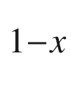

As/GaAs/AlAs microcavity vertical-cavity surface emitting laser structures in the weak-coupling regime: The cavity/ground-state-exciton resonance. Phys. Rev. B **59**, 2894–2901 (1999). [10.​1103/​PhysRevB.​59.​2894](https://doi.org/10.1103/PhysRevB.59.2894)

J.J. Baumberg, P.G. Savvidis, R.M. Stevenson, A.I. Tartakovskii, M.S. Skolnick, D.M. Whittaker, J.S. Roberts, Parametric oscillation in a vertical microcavity: A polariton condensate or micro-optical parametric oscillation. Phys. Rev. B **62**, R16247–R16250 (2000). [10.​1103/​PhysRevB.​62.​R16247](https://doi.org/10.1103/PhysRevB.62.R16247)

A. Kavokin, G. Malpuech, B. Gil, Semiconductor microcavities: towards polariton lasers. MRS Internet J. Nitride Semicond. Res. **8**, 3:1–25 (2003). [10.​1557/​S109257830000046​6](https://doi.org/10.1557/S1092578300000466)

Le Si Dang, D. Heger, R. André, F. Bœuf, R. Romestain, Stimulation of polariton photoluminescence in semiconductor microcavity. Phys. Rev. Lett. **81**, 3920–3923 (1998). [10.​1103/​PhysRevLett.​81.​3920](https://doi.org/10.1103/PhysRevLett.81.3920)

A. Pawlis, D.J. As, D. Schikora, J. Schörmann, K. Lischka, Photonic devices based on wide gap semiconductors for room temperature polariton emission. Phys. Status Solidi C **1**, S202–S209 (2004). [10.​1002/​pssc.​200405141](https://doi.org/10.1002/pssc.200405141)

T. Tawara, H. Gotoh, T. Akasaka, N. Kobayashi, T. Saitoh, Cavity polaritons in InGaN microcavities at room temperature. Phys. Rev. Lett. **92**, 256402:1–4 (2004). [10.​1103/​PhysRevLett.​92.​256402](https://doi.org/10.1103/PhysRevLett.92.256402)

N. Antoine-Vincent, F. Natali, D. Byrne, P. Disseix, A. Vasson, J. Leymarie, F. Semond, J. Massies, Potentialities of GaN-based microcavities in strong coupling regime at room temperature. Superlatt. Microstruct. **36**, 599–606 (2004). [10.​1016/​j.​spmi.​2004.​09.​017](https://doi.org/10.1016/j.spmi.2004.09.017)

E. Feltin, G. Christmann, R. Butté, J.-F. Carlin, M. Mosca, N. Grandjean, Room temperature polariton luminescence from a GaN/AlGaN quantum well microcavity. Appl. Phys. Lett. **89**, 071107:1–3 (2006) [10.​1063/​1.​2335404](https://doi.org/10.1063/1.2335404)

F. Semond, I. R. Sellers, F. Natali, D. Byrne, M. Leroux, J. Massies, N. Ollier, J. Leymarie, P. Disseix, A. Vasson, trong light-matter coupling at room temperature in simple geometry GaN microcavities grown on silicon. Appl. Phys. Lett. **87**, 021102:1–3 (2005). [10.​1063/​1.​1994954](https://doi.org/10.1063/1.1994954)

R. Schmidt-Grund, B. Rheinländer, C. Czekalla, G. Benndorf, H. Hochmuth, M. Lorenz, M. Grundmann, Exciton-polariton formation at room temperature in a planar ZnO resonator structure. Appl. Phys. A **93**, 331–337 (2008). [10.​1007/​s00340-008-3160-x](https://doi.org/10.1007/s00340-008-3160-x)

P.G. Savvidis, J.J. Baumberg, R.M. Stevenson, M.S. Skolnick, D.M. Whittaker, J.S. Roberts, Angle-Resonant stimulated polariton amplifier. Phys. Rev. Lett. **84**, 1547–1550 (2000). [10.​1103/​PhysRevLett.​84.​1547](https://doi.org/10.1103/PhysRevLett.84.1547)

Y. Yamamoto, T. Tassone, H. Cao, *Semiconductor Cavity Quantum Electrodynamics* (Springer, Berlin, 2000). [10.​1007/​3-540-45515-9](https://doi.org/10.1007/3-540-45515-9)

D. Sanvitto, V. Timofeev, *Exciton Polaritons in Microcavities* (Springer, Berlin, 2012). [10.​1007/​978-3-642-24186-4](https://doi.org/10.1007/978-3-642-24186-4)

A. Poddubny, I. Iorsh, P. Belov, Y. Kivshar, Hyperbolic metamaterials. Nat. Photon. **7**, 958–967 (2013). [10.​1038/​nphoton.​2013.​243](https://doi.org/10.1038/nphoton.2013.243)

P. Huo, S. Zhang, Y. Liang, Y. Lu, T. Xu, Hyperbolic metamaterials and metasurfaces: fundamentals and applications. Adv. Opt. Mater. **7**, 1801616:1–25 (2019). [10.​1002/​adom.​201801616](https://doi.org/10.1002/adom.201801616)

A. Poddubny, P. Belov, Y. Kivshar, Spontaneous radiation of a finite-size dipole emitter in hyperbolic media. Phys. Rev. A **84**, 023807:1–6 (2011). [10.​1103/​PhysRevA.​84.​023807](https://doi.org/10.1103/PhysRevA.84.023807)

G.V. Naik, B. Saha, J. Liu, S.M. Saber, E.A. Stach, J.M.K. Irudayaraj, T.D. Sands, V.M. Shalaev, A. Boltasseva, Epitaxial superlattices with titanium nitride as a plasmonic component for optical hyperbolic metamaterials. PNAS **111**, 7546–7551 (2014). [10.​1073/​pnas.​1319446111](https://doi.org/10.1073/pnas.1319446111)

S.S. Kruk, Z.J. Wong, E. Pshenay-Severin, K. O’Brien, D.N. Neshev, Y.S. Kivshar, X. Zhang, Magnetic hyperbolic optical metamaterials. Nat. Commun. **7**, 11329;1–7 (2016). [10.​1038/​ncomms11329](https://doi.org/10.1038/ncomms11329)

S.L. McCall, A.F.J. Levi, R.E. Slusher, S.J. Pearton, R.A. Logan, Whispering-gallery mode microdisk lasers. Appl. Phys. Lett. **60**, 289–291 (1992). [10.​1063/​1.​106688](https://doi.org/10.1063/1.106688)

R.P. Wang, M.-M. Dumitrescu, Theory of optical modes in semiconductor microdisk lasers. J. Appl. Phys. **81**, 3391–3397 (1997). [10.​1063/​1.​365034](https://doi.org/10.1063/1.365034)

A.F.J. Levi, R.E. Slusher, S.L. McCall, J.L. Glass, S.J. Pearton, R.A. Logan, Directional light coupling from microdisk lasers. Appl. Phys. Lett. **62**, 561–563 (1993). [10.​1063/​1.​108911](https://doi.org/10.1063/1.108911)

S.-K. Kim, S.-H. Kim, G.-H. Kim, H.-G. Park, D.-J. Shin, Y.-H. Lee, Highly directional emission from few-micron-size elliptical microdisks. Appl. Phys. Lett. **84**, 861–863 (2004). [10.​1063/​1.​1646459](https://doi.org/10.1063/1.1646459)

E. Peter, P. Senellart, D. Martrou, A. Lemaître, J. Hours, J. M. Gérard, J. Bloch, Exciton-photon strong-coupling regime for a single quantum dot embedded in a microcavity. Phys. Rev. Lett. **95**, 067401:1–4 (2005). [10.​1103/​PhysRevLett.​95.​067401](https://doi.org/10.1103/PhysRevLett.95.067401)

E.M. Purcell, Spontaneous emission probabilities at radio frequencies. Phys. Rev. **69**, 681 (1946). [10.​1103/​PhysRev.​69.​674.​2](https://doi.org/10.1103/PhysRev.69.674.2)

J.M. Gérard, B. Sermage, B. Gayral, B. Legrand, E. Costard, V. Thierry-Mieg, Enhanced spontaneous emission by quantum boxes in a monolithic optical microcavity. Phys. Rev. Lett. **81**, 1110–1113 (1998). [10.​1103/​PhysRevLett.​81.​1110](https://doi.org/10.1103/PhysRevLett.81.1110)

A. Kiraz, P. Michler, C. Becher, B. Gayral, A. Imamoğlu, Lidong Zhang, E. Hu, W.V. Schoenfeld, P.M. Petroff, Cavity-quantum electrodynamics using a single InAs quantum dot in a microdisk structure. Appl. Phys. Lett. **78**, 3932–3934 (2001). [10.​1063/​1.​1379987](https://doi.org/10.1063/1.1379987)

J.U. Nöckel, A.D. Stone, Ray and wave chaos in asymmetric resonant optical cavities. Nature **385**, 45–47 (1997). [10.​1038/​385045a0](https://doi.org/10.1038/385045a0)

C. Gmachl, F. Capasso, E.E. Narimanov, J.U. Nöckel, A.D. Stone, J. Faist, D.L. Sivco, A.Y. Cho, High-power directional emission from microlasers with chaotic resonators. Science **280**, 1556–1564 (1998). [10.​1126/​science.​280.​5369.​1556](https://doi.org/10.1126/science.280.5369.1556)

G.D. Chern, H.E. Tureci, A. Douglas Stone, R.K. Chang, M. Kneissl, N.M. Johnson, Unidirectional lasing from InGaN multiple-quantum-well spiral-shaped micropillars. Appl. Phys. Lett. **83**, 1710–1712 (2003). [10.​1063/​1.​1605792](https://doi.org/10.1063/1.1605792)

S.-Y. Lee, S. Rim, J.-W. Ryu, T.-Y. Kwon, M. Choi, C.-M. Kim, Quasiscarred resonances in a spiral-shaped microcavity. Phys. Rev. Lett. **93**, 164102:1–4 (2004). [10.​1103/​PhysRevLett.​93.​164102](https://doi.org/10.1103/PhysRevLett.93.164102)

M. Kneissl, M. Teepe, N. Miyashita, N.M. Johnson, G.D. Chern, R.K. Chang, Current-injection spiral-shaped microcavity disk laser diodes with unidirectional emission. Appl. Phys. Lett. **84**, 2485–2498 (2004). [10.​1063/​1.​1691494](https://doi.org/10.1063/1.1691494)

T. Nobis, E.M. Kaidashev, A. Rahm, M. Lorenz, M. Grundmann, Whispering gallery modes in nanosized dielectric resonators with hexagonal cross section. Phys. Rev. Lett. **93**, 103903:1–4 (2004). [10.​1103/​PhysRevLett.​93.​103903](https://doi.org/10.1103/PhysRevLett.93.103903)

F. Leiter, H. Zhou, F. Henecker, A. Hofstaetter, D.M. Hofmann, B.K. Meyer, Magnetic resonance experiments on the green emission in undoped ZnO crystals. Physica B **308–310**, 908–911 (2001). [10.​1016/​S0921-4526(01)00837-7](https://doi.org/10.1016/S0921-4526(01)00837-7)

J. Wiersig, Hexagonal dielectric resonators and microcrystal lasers. Phys. Rev. A **67**, 023807:1–12 (2003). [10.​1103/​PhysRevA.​67.​023807](https://doi.org/10.1103/PhysRevA.67.023807)

C. Czekalla, C. Sturm, R. Schmidt-Grund, B. Cao, M. Lorenz, M. Grundmann, Whispering gallery mode lasing in zinc oxide microwires. Appl. Phys. Lett. **92**, 241102:1–3 (2008). [10.​1063/​1.​2946660](https://doi.org/10.1063/1.2946660)

C.P. Dietrich, M. Lange, T. Böntgen, M. Grundmann, The corner effect in hexagonal whispering gallery microresonators. Appl. Phys. Lett. **101**, 141116:1–5 (2012). [10.​1063/​1.​4757572](https://doi.org/10.1063/1.4757572)

F. Streintz, Ueber die elektrische Leitfähigkeit vom gepressten Pulvern. Ann. Physik **314**, 854–885 (1902). [10.​1002/​andp.​19023141207](https://doi.org/10.1002/andp.19023141207)

H.L. Hartnagel, A.L. Dawar, A.K. Jain, C. Jagadish, *Semiconducting Transparent Thin Films* (Institute of Physics Publishing, Philadelphia, 1995)

MRS Bull. **25**(8), issue on *Transparent Conducting Oxides*. [10.​1557/​mrs2000.​256](https://doi.org/10.1557/mrs2000.256)

T. Minami, Transparent conducting oxide semiconductors for transparent electrodes. Semicond. Sci. Technol. **20**, S35–S44 (2005). [10.​1088/​0268-1242/​20/​4/​004](https://doi.org/10.1088/0268-1242/20/4/004)

R.G. Gordon, Criteria for choosing transparent conductors. MRS Bull. **25**, 52–57 (2000). [10.​1557/​mrs2000.​151](https://doi.org/10.1557/mrs2000.151)

H. Kawazoe, M. Yasukawa, H. Hyodo, M. Kurita, H. Yanagi, H. Hosono, P-type electrical conduction in transparent thin films of CuAlO

$$_2$$

. Nature **389**, 939–942 (1997). [10.​1038/​40087](https://doi.org/10.1038/40087)

M. Dekkers, G. Rijnders, D.H.A. Blank, ZnIr

$$_2$$

O

$$_4$$

, a p-type transparent oxide semiconductor in the class of spinel zinc-d

$$^6$$

-transition metal oxide. Appl. Phys. Lett. **90**, 021903:1–3 (2007). [10.​1063/​1.​2431548](https://doi.org/10.1063/1.2431548)

F.-L. Schein, H. von Wenckstern, H. Frenzel, M. Grundmann, ZnO-based n-channel junction field-effect transistor with room-temperature-fabricated amorphous p-Type ZnCo

$$_2$$

O

$$_4$$

gate. IEEE Electr. Dev. Lett. **33**, 676–678 (2012). [10.​1109/​LED.​2012.​2187633](https://doi.org/10.1109/LED.2012.2187633)

M. Marezio, Refinement of the crystal structure of In

$$_2$$

O

$$_3$$

at two wavelengths. Acta Cryst. **20**, 723–728 (1966). [10.​1107/​S0365110X6600174​9](https://doi.org/10.1107/S0365110X66001749)

S.H. Brewer, S. Franzen, Calculation of the electronic and optical properties of indium tin oxide by density functional theory. Chem. Phys. **300**, 285–293 (2004). [10.​1016/​j.​chemphys.​2003.​11.​039](https://doi.org/10.1016/j.chemphys.2003.11.039)

O.N. Mryasov, A.J. Freeman, Electronic band structure of indium tin oxide and criteria for transparent conducting behavior. Phys. Rev. B **64**, 233111:1–3 (2001). [10.​1103/​PhysRevB.​64.​233111](https://doi.org/10.1103/PhysRevB.64.233111)

H. Agura, A. Suzuki, T. Matsushita, T. Aoki, M. Okuda, Low resistivity transparent conducting Al-doped ZnO films prepared by pulsed laser deposition. Thin Solid Films **445**, 263–267 (2003). [10.​1016/​S0040-6090(03)01158-1](https://doi.org/10.1016/S0040-6090(03)01158-1)

K. Ellmer, Resistivity of polycrystalline zinc oxide films: current status and physical limit. J. Phys. D: Appl. Phys. **34**, 3097–3108 (2001). [10.​1088/​0022-3727/​34/​21/​301](https://doi.org/10.1088/0022-3727/34/21/301)

T. Minami, S. Suzuki, T. Miyata, Electrical conduction mechanism of highly transparent and conductive ZnO thin films. Proc. Mater. Res. Soc. **666**, F1.3.1 (2001). [10.​1557/​PROC-666-F1.​3](https://doi.org/10.1557/PROC-666-F1.3)

D.S. Ginley, C. Bright, Transparent conducting oxides. MRS Bull. **8**, 15–18 (2000). [10.​1557/​mrs2000.​256](https://doi.org/10.1557/mrs2000.256)

J.R. Bellingham, W.A. Phillips, C.J. Adkins, Intrinsic performance limits in transparent conducting oxides. J. Mat. Sci. Lett. **11**, 263–265 (1992). [10.​1007/​BF00729407](https://doi.org/10.1007/BF00729407)

J.A. Fleming, *The Thermionic Valve and Its Developments in Radiotelegraphy and Telephony* (The Wireless Press, London, 1919)

G.S. Meikle, The hot cathode argon gas filled rectifier. General Electric Rev. **XIX**, 297–304 (1916), see also. J. Franklin Inst. **181**, 704–705 (1916). [10.​1016/​S0016-0032(16)90633-1](https://doi.org/10.1016/S0016-0032(16)90633-1)

H.C. Torrey, C.A. Whitmer, *Crystal Rectifiers*, MIT Radiation Lab. Series, Vol. 15 (McGraw-Hill, New York, 1948)

H.K. Henisch, Rectifying semiconductor contacts. J. Electrochem. Soc. **103**, 637–643 (1956). [10.​1149/​1.​2430178](https://doi.org/10.1149/1.2430178)

H.K. Henisch, *Rectifying Semiconductor Contacts* (Clarendon Press, Oxford, 1957)

J.R. Macdonald, Accurate solution of an idealized one-carrier metal-semiconductor junction problem. Solid State Electron. **5**, 11–37 (1962). [10.​1016/​0038-1101(62)90013-8](https://doi.org/10.1016/0038-1101(62)90013-8)

F.A. Padovani, The voltage-current characteristic of metal-semiconductor contacts. Semicond. Semimet. **7A**, 75–146 (1971). [10.​1016/​S0080-8784(08)63007-0](https://doi.org/10.1016/S0080-8784(08)63007-0)

E.H. Rhoderick, R.H. Williams, *Metal-Semiconductor Contacts*, 2nd edn. (Oxford University Press, Oxford, 1988)

R.T. Tung, Recent advances in Schottky barrier concepts. Mater. Sci. Engin. R **35**, 1–138 (2001). [10.​1016/​S0927-796X(01)00037-7](https://doi.org/10.1016/S0927-796X(01)00037-7)

L. Magaud, F. Cryot-Lackmann, Schottky barriers. Digital Encycl. Appl. Phys. 573–591 (2003). [10.​1002/​3527600434.​eap406](https://doi.org/10.1002/3527600434.eap406)

G.N. Derry, M.E. Kern, E.H. Worth, Recommended values of clean metal surface work functions. J. Vac. Sci. Technol. A **33**, 060801:1–9 (2015). [10.​1116/​1.​4934685](https://doi.org/10.1116/1.4934685)

K.W. Boer, *Introduction to Space Charge Effects in Semiconductors* (Springer, Heidelberg. 2010). [10.​1007/​978-3-642-02236-4](https://doi.org/10.1007/978-3-642-02236-4)

A.M. Cowley, S.M. Sze, Surface states and barrier height of metal-semiconductor systems. J. Appl. Phys. **36**, 3212–3220 (1965). [10.​1063/​1.​1702952](https://doi.org/10.1063/1.1702952)

A. Dimoulas, P. Tsipas, A. Sotiropoulos, E.K. Evangelou, Fermi-level pinning and charge neutrality level in germanium. Appl. Phys. Lett. **89**, 252110:1–3 (2006). [10.​1063/​1.​2410241](https://doi.org/10.1063/1.2410241)

C.A. Mead, W.G. Spitzer, Fermi level position at metal-semiconductor interfaces. Phys. Rev. **134**, A713–A716 (1964). [10.​1103/​PhysRev.​134.​A713](https://doi.org/10.1103/PhysRev.134.A713)

S. Kurtin, T.C. McGill, C.A. Mead, Fundamental transition in the electronic nature of solids. Phys. Rev. Lett. **22**, 1433–1436 (1969). [10.​1103/​PhysRevLett.​22.​1433](https://doi.org/10.1103/PhysRevLett.22.1433)

C.A. Mead, Surface barriers on ZnSe and ZnO. Phys. Lett. **18**, 218 (1965). [10.​1016/​0031-9163(65)90295-7](https://doi.org/10.1016/0031-9163(65)90295-7)

J. Bardeen, Surface states and rectification at a metal-semiconductor contact. Phys. Rev. **71**, 717–727 (1947). [10.​1103/​PhysRev.​71.​717](https://doi.org/10.1103/PhysRev.71.717)

W. Mönch, 125 years of metal-semiconductor contacts: where do we stand? Adv. Solid State Phys. (Festkörperprobleme) **39**, 13–24 (1999). [10.​1007/​BFb0107461](https://doi.org/10.1007/BFb0107461)

M. Schmidt, R. Pickenhain, M. Grundmann, Exact solutions for the capacitance of space charge regions at semiconductor interfaces. Solid State Electron. **51**, 1002–1004 (2007). [10.​1016/​j.​sse.​2007.​04.​004](https://doi.org/10.1016/j.sse.2007.04.004)

W. Schottky, Über den Einfluß von Strukturwirkungen, besonders der Thomsonschen Bildkraft, auf die Elektronenemission der Metalle. Phys. Zeitschrift **15**, 872–878 (1914)

E.D. Courant, Image force and tunnel effect in crystal rectifiers. Phys. Rev. **69**, 684 (1946). [10.​1103/​PhysRev.​69.​674.​2](https://doi.org/10.1103/PhysRev.69.674.2)

W.E. Meyerhof, Contact potential difference in silicon crystal rectifiers. Phys. Rev. **71**, 727–735 (1947). [10.​1103/​PhysRev.​71.​727](https://doi.org/10.1103/PhysRev.71.727)

S.M. Sze, C.R. Crowell, D. Kahng, Photoelectric determination of the image force dielectric constant for hot electrons in schottky barriers. J. Appl. Phys. **35**, 2534–2536 (1964). [10.​1063/​1.​1702894](https://doi.org/10.1063/1.1702894)

A.M. Goodman, Metal-semiconductor barrier height measurement by the differential capacitance method - degenerate one-carrier system. J. Appl. Phys. **34**, 329–338 (1963). [10.​1063/​1.​1713221](https://doi.org/10.1063/1.1713221)

C. van Opdorp, Evaluation of doping profiles from capacitance measurements. Solid State Electron. **11**, 397–406 (1968). [10.​1016/​0038-1101(68)90020-8](https://doi.org/10.1016/0038-1101(68)90020-8)

S. Dueñas, M. Jaraiz, J. Vicente, E. Rubio, L. Bailón, J. Barbolla, Optical admittance spectroscopy: A new method for deep level characterization. J. Appl. Phys. **61**, 2541–2545 (1987). [10.​1063/​1.​337930](https://doi.org/10.1063/1.337930)

D.L. Losee, Admittance spectroscopy of impurity levels in Schottky barriers. J. Appl. Phys. **46**, 2204–2214 (1975). [10.​1063/​1.​321865](https://doi.org/10.1063/1.321865)

M.P. Verkhovodov, H.P. Peka, D.A. Pulemyotov, Capacitance behaviour of junctions with frozen dopant levels. Semicond. Sci. Technol. **8**, 1842–1847 (1993). [10.​1088/​0268-1242/​8/​10/​009](https://doi.org/10.1088/0268-1242/8/10/009)

F.D. Auret, J.M. Nel, M. Hayes, L. Wu, W. Wesch, E. Wendler, Electrical characterization of growth-induced defects in bulk-grown ZnO. Superlatt. Microstruct. **39**, 17–23 (2006). [10.​1016/​j.​spmi.​2005.​08.​021](https://doi.org/10.1016/j.spmi.2005.08.021)

M. Schmidt, M. Ellguth, C. Czekalla, H. von Wenckstern, R. Pickenhain, M. Grundmann, G. Brauer, W. Skorupa, M. Helm, Q. Gu, Ch.Ch. Ling, Defects in zinc-implanted ZnO thin films. J. Vac. Sci. Technol. B **27**, 1597–1600 (2009). [10.​1116/​1.​3086659](https://doi.org/10.1116/1.3086659)

C. Wagner, Zur Theorie der Gleichrichterwirkung. Phys. Zeitschrift **32**, 641–645 (1931)

W. Schottky, E. Spenke, Zur quantitativen Durchführung der Raumladungs- und Randschichttheorie der Kristallgleichrichter. Wiss. Veröff. Siemens Werke **18**, 225–291 (1939)

P.T. Landsberg, The theory of direct-current characteristics of rectifiers. Proc. Roy. Soc. London A **206**, 463–477 (1951). [10.​1098/​rspa.​1951.​0082](https://doi.org/10.1098/rspa.1951.0082)

P.T. Landsberg, Contributions to the theory of heterogeneous barrier layer rectifiers. Proc. Roy. Soc. London A **206**, 477–488 (1951). [10.​1098/​rspa.​1951.​0083](https://doi.org/10.1098/rspa.1951.0083)

M.W. Allen, S.M. Durbin, X. Weng, J.M. Redwing, K. Sarpatwari, S.E. Mohney, H. von Wenckstern, M. Grundmann, Temperature-dependent properties of nearly ideal ZnO Schottky diodes. IEEE Trans. Electron Devices **56**, 2160–2164 (2009). [10.​1109/​TED.​2009.​2026393](https://doi.org/10.1109/TED.2009.2026393)

L.F. Wagner, R.W. Young, A. Sugerman, A note on the correlation between the Schottky diode barrier height and the ideality factor as determined from I-V measurements. IEEE Electr. Dev. Lett. **4**, 320–322 (1983). [10.​1109/​EDL.​1983.​25748](https://doi.org/10.1109/EDL.1983.25748)

H.J. Yearian, D.C. characteristics of Ge and Si crystal rectifiers. Phys. Rev. **69**, 682 (1946). [10.​1103/​PhysRev.​69.​674.​2](https://doi.org/10.1103/PhysRev.69.674.2)

R.G. Sachs, Theory of crystal rectifiers. Phys. Rev. **69**, 682 (1946). [10.​1103/​PhysRev.​69.​674.​2](https://doi.org/10.1103/PhysRev.69.674.2)

V.A. Johnson, R.N. Smith, H.J. Yearian, Semi-quantitative explanation of D.C. characteristics of crystal rectifiers. Phys. Rev. **69**, 682–683 (1946). [10.​1103/​PhysRev.​69.​674.​2](https://doi.org/10.1103/PhysRev.69.674.2)

H.J. Yearian, D.C. characteristics of silicon and germanium point contact crystal rectifiers. Part I. Experimental. J. Appl. Phys. **21**, 214–221 (1950). [10.​1063/​1.​1699637](https://doi.org/10.1063/1.1699637)

V.A. Johnson, R.N. Smith, H.J. Yearian, D.C. characteristics of silicon and germanium point contact crystal rectifiers. Part II. The multicontact theory. J. Appl. Phys. **21**, 283–289 (1950). [10.​1063/​1.​1699654](https://doi.org/10.1063/1.1699654)

J.H. Werner, H.H. Güttler, Barrier inhomogeneities at Schottky contacts. J. Appl. Phys. **69**, 1522–1533 (1991). [10.​1063/​1.​347243](https://doi.org/10.1063/1.347243)

V.B. Bondarenko, YuA Kudinov, S.G. Ershov, V.V. Korablev, Natural nonuniformities in the height of a Schottky barrier. Semicond. **32**, 495–496 (1998). [10.​1134/​1.​1187426](https://doi.org/10.1134/1.1187426)

D. Defives, O. Noblanc, C. Dua, C. Brylinski, M. Barthula, V. Aubry- Fortuna, F. Meyer, Barrier inhomogeneities and electrical characteristics of Ti/4H-SiC Schottky rectifiers. IEEE Trans. Electron Devices **46**, 449–455 (1999). [10.​1109/​16.​748861](https://doi.org/10.1109/16.748861)

S. Müller, H. von Wenckstern, O. Breitenstein, J. Lenzner, M. Grundmann, Microscopic identification of hot spots in multibarrier Schottky contacts on pulsed laser deposition grown zinc oxide thin films. IEEE Trans. Electron Devices **59**, 536–541 (2012). [10.​1109/​TED.​2011.​2177984](https://doi.org/10.1109/TED.2011.2177984)

H. von Wenckstern, G. Biehne, R. Abdel Rahman, H. Hochmuth, M. Lorenz, M. Grundmann, Mean barrier height of Pd Schottky contacts on ZnO thin films. Appl. Phys. Lett. **88**, 092102:1–3 (2006). [10.​1063/​1.​2180445](https://doi.org/10.1063/1.2180445)

J.H. Werner, Schottky barrier and pn-junction

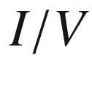

plots - small signal evaluation. Appl. Phys. A **47**, 291–200 (1988). [10.​1007/​BF00615935](https://doi.org/10.1007/BF00615935)

F.A. Padovani, G.G. Sumner, Experimental study of gold-gallium arsenide Schottky barriers. J. Appl. Phys. **36**, 3744–3747 (1965). [10.​1063/​1.​1713940](https://doi.org/10.1063/1.1713940)

F.A. Padovani, R. Stratton, Field and thermionic-field emission in Schottky barriers. Solid State Electron. **9**, 695–707 (1966). [10.​1016/​0038-1101(66)90097-9](https://doi.org/10.1016/0038-1101(66)90097-9)

W. Mönch, Barrier heights of real Schottky contacts explained by metal-induced gap states and lateral inhomogeneities. J. Vac. Sci. Technol. B **17**, 1867–1876 (1999). [10.​1116/​1.​590839](https://doi.org/10.1116/1.590839)

C.R. Crowell, S.M. Sze, Current transport in metal-semiconductor barriers. Solid State Electron. **9**, 1035–1048 (1966). [10.​1016/​0038-1101(66)90127-4](https://doi.org/10.1016/0038-1101(66)90127-4)

C.R. Crowell, M. Beguwala, Recombination velocity effects on current diffusion and imref in Schottky barriers. Solid State Electron. **14**, 1149–1157 (1971). [10.​1016/​0038-1101(71)90027-X](https://doi.org/10.1016/0038-1101(71)90027-X)

A. Lajn, H. von Wenckstern, M. Grundmann, G. Wagner, P. Barquinha, E. Fortunato, R. Martins, Comparative study of transparent rectifying contacts on semiconducting oxide single crystals and amorphous thin films. J. Appl. Phys. **113**, 044511:1–13 (2013). [10.​1063/​1.​4789000](https://doi.org/10.1063/1.4789000)

J.M. Andrews, M.P. Lepselter, Reverse current-voltage characteristics of metal-silicide Schottky diodes. Solid State Electron. **13**, 1011–1023 (1970). [10.​1016/​0038-1101(70)90098-5](https://doi.org/10.1016/0038-1101(70)90098-5)

J.H.B. Deane, R.G. Forbes, The formal derivation of an exact series expansion for the principal Schottky-Nordheim barrier function

$$v$$

, using the Gauss hypergeometric differential equation. J. Phys. A: Math. Theor. **41**, 395301:1–9 (2008). [10.​1088/​1751-8113/​41/​39/​395301](https://doi.org/10.1088/1751-8113/41/39/395301)

R. Holm, *Electrical Contacts. Theory and Applications*, 4th edn. (Springer, Berlin, 1981) [10.​1007/​978-3-662-06688-1](https://doi.org/10.1007/978-3-662-06688-1)

A.Y.C. Yu, Electron tunneling and contact resistance of metal-silicon contact barriers. Solid State Electron. **13**, 239–247 (1970). [10.​1016/​0038-1101(70)90056-0](https://doi.org/10.1016/0038-1101(70)90056-0)

C.Y. Chang, Y.K. Fang, S.M. Sze, Specific contact resistance of metal-semiconductor barriers. Solid State Electron. **14**, 541–550 (1971). [10.​1016/​0038-1101(71)90129-8](https://doi.org/10.1016/0038-1101(71)90129-8)

T. Sanada, O. Wada, Ohmic Contacts to p-GaAs with Au/Zn/Au Structure. Jpn. J. Appl. Phys. **19**, L491–L494 (1980). [10.​1143/​JJAP.​19.​L491](https://doi.org/10.1143/JJAP.19.L491)

N. Braslau, J.B. Gunn, J.L. Staples, Metal-semiconductor contacts for GaAs bulk effect devices. Solid State Electron. **10**, 381–383 (1967). [10.​1016/​0038-1101(67)90037-8](https://doi.org/10.1016/0038-1101(67)90037-8)

C.L. Chen, L.J. Mahoney, M.C. Finn, R.C. Brooks, A. Chu, J.G. Mavroides, Low resistance Pd/Ge/Au and Ge/Pd/Au ohmic contacts to n-type GaAs. Appl. Phys. Lett. **48**, 535–537 (1986). [10.​1063/​1.​96498](https://doi.org/10.1063/1.96498)

V.L. Rideout, A review of the theory and technology for ohmic contacts to group III-V compound semiconductors. Solid State Electron. **18**, 541–550 (1975). [10.​1016/​0038-1101(75)90031-3](https://doi.org/10.1016/0038-1101(75)90031-3)

B.C. Sharma, Ohmic contacts to III-V compound semiconductors. Semicond. Semimet. **15**, 1–38 (1981). [10.​1016/​S0080-8784(08)60284-7](https://doi.org/10.1016/S0080-8784(08)60284-7)

G.Y. Robinson, Metallurgical and electrical properties of alloyed Ni/Au-Ge Films on n-type GaAs. Solid State Electron. **18**, 331–342 (1975). [10.​1016/​0038-1101(75)90088-X](https://doi.org/10.1016/0038-1101(75)90088-X)

N.F. Mott, R.W. Gurney, *Electronic Processes in Ionic Crystals* (Clarendon Press, Oxford, 1940), pp. 168–173

P. Zhang, Á. Valfells, L.K. Ang, J.W. Luginsland, Y.Y. Lau, 100 years of the physics of diodes. Appl. Phys. Rev. **4**, 011304:1–29 (2017). [10.​1063/​1.​4978231](https://doi.org/10.1063/1.4978231)

C.D. Child, Discharge from hot CaO. Phys. Rev. (Series I) **32**, 492–511 (1911). [10.​1103/​PhysRevSeriesI.​32.​492](https://doi.org/10.1103/PhysRevSeriesI.32.492)

I. Langmuir, The effect of space charge and residual gases on thermionic currents in high vacuum. Phys. Rev. **2**, 450–486 (1913). [10.​1103/​PhysRev.​2.​450](https://doi.org/10.1103/PhysRev.2.450)

G. González, Quantum theory of space charge limited current in solids. J. Appl. Phys. **117**, 084306:1–3 (2015). [10.​1063/​1.​4913512](https://doi.org/10.1063/1.4913512)

R.W. Smith, A. Rose, Space-charge-limited currents in single crystals of cadmium sulfide. Phys. Rev. **97**, 1531–1537 (1955). [10.​1103/​PhysRev.​97.​1531](https://doi.org/10.1103/PhysRev.97.1531)

G.T. Wright, Space-charge limited currents in insulating materials. Nature **182**, 1296–1297 (1958). [10.​1038/​1821296a0](https://doi.org/10.1038/1821296a0)

U. Büget, G.T. Wright, Space-charge-limited current in silicon. Solid State Electron. **10**, 199–207 (1967). [10.​1016/​0038-1101(67)90074-3](https://doi.org/10.1016/0038-1101(67)90074-3)

J.W. Orton, M.J. Powell, The relationship between space-charge-limited current and density of states in amorphous silicon. Philos. Mag. **50**, 11–21 (1984). [10.​1080/​1364281840823882​4](https://doi.org/10.1080/13642818408238824)

C.M. Heller, I.H. Campbell, D.L. Smith, N.N. Barashkov, J.P. Ferraris, Chemical potential pinning due to equilibrium electron transfer at metal/C

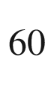

-doped polymer interfaces. J. Appl. Phys. **81**, 3227–3231 (1997). [10.​1063/​1.​364154](https://doi.org/10.1063/1.364154)

I.H. Campbell, T.W. Hagler, D.L. Smith, J.P. Ferraris, Direct measurement of conjugated polymer electronic excitation energies using metal/polymer/metal structures. Phys. Rev. Lett. **76**, 1900–1903 (1996). [10.​1103/​PhysRevLett.​76.​1900](https://doi.org/10.1103/PhysRevLett.76.1900)

I.H. Campbell, D.L. Smith, Physics of organic electronic devices. Solid State Phys. **55**, 1–117 (2001). [10.​1016/​S0081-1947(01)80003-5](https://doi.org/10.1016/S0081-1947(01)80003-5)

P. Mark, W. Helfrich, Space-charge-limited currents in organic crystals. J. Appl. Phys. **33**, 205–215 (1962). [10.​1063/​1.​1728487](https://doi.org/10.1063/1.1728487)

Frieder Baumann, Lucent Technologies Bell Labs

C.G.B. Garrett, W.H. Brattain, Physical theory of semiconductor surfaces. Phys. Rev. **99**, 376–387 (1955). [10.​1103/​PhysRev.​99.​376](https://doi.org/10.1103/PhysRev.99.376)

A.S. Grove, B.E. Deal, E.H. Snow, C.T. Shah, Investigation of thermally oxidised silicon surfaces using metal-oxide-semiconductor structures. Solid State Electron. **8**, 145–163 (1965). [10.​1016/​0038-1101(65)90046-8](https://doi.org/10.1016/0038-1101(65)90046-8)

B.E. Deal, E.H. Snow, C.A. Mead, Barrier energies in metal-silicon dioxide-silicon structures. J. Phys. Chem. Solids **27**, 1873–1879 (1966). [10.​1016/​0022-3697(66)90118-1](https://doi.org/10.1016/0022-3697(66)90118-1)

W.M. Werner, The work function difference of the MOS-system with aluminum field plates and polycrystalline silicon field plates. Solid State Electron. **17**, 769–775 (1974). [10.​1016/​0038-1101(74)90023-9](https://doi.org/10.1016/0038-1101(74)90023-9)

J.F. Guilleomoles, I. Lubomirsky, I. Riess, D. Cahen, Thermodynamic stability of p/n junctions. J. Phys. Chem. **99**, 14486–14493 (1995). [10.​1021/​j100039a041](https://doi.org/10.1021/j100039a041)

W.F. O’Hearn, Y.F. Chang, An analysis on the frequency dependence of the capacitance of abrupt p-n junction semiconductor devices. Solid State Electron. **13**, 473–483 (1970). [10.​1016/​0038-1101(70)90158-9](https://doi.org/10.1016/0038-1101(70)90158-9)

J. Yang, Y. Zhang, W. Chen, G. Liu, p-n junction theory in view of excess majority carriers. EPL **120**, 28004:1–4 (2017). [10.​1209/​0295-5075/​120/​28004](https://doi.org/10.1209/0295-5075/120/28004)

Y. Yoshizumi, S. Hashimoto, T. Tanabe, M. Kiyama, High-breakdown-voltage pn-junction diodes on GaN substrates. J. Cryst. Growth **298**, 875–878 (2007). [10.​1016/​j.​jcrysgro.​2006.​10.​246](https://doi.org/10.1016/j.jcrysgro.2006.10.246)

C.-T. Sah, R.N. Noyce, W. Shockley, Carrier generation and recombination in P-N junctions and P-N junction characteristics. Proc. IRE **45**, 1228–1243 (1957). [10.​1109/​JRPROC.​1957.​278528](https://doi.org/10.1109/JRPROC.1957.278528)

M. Grundmann, The bias dependence of the non-radiative recombination current in p-n diodes. Solid State Electron. **49**, 1446–1448 (2005). [10.​1016/​j.​sse.​2005.​06.​015](https://doi.org/10.1016/j.sse.2005.06.015)

H.K. Gummel, Hole-electron product of pn junctions. Solid State Electron. **10**, 209–212 (1967). [10.​1016/​0038-1101(67)90075-5](https://doi.org/10.1016/0038-1101(67)90075-5)

J.L. Moll, *Physics of Semiconductors* (McGraw-Hill, New York, 1964)

M.J.O. Strutt, Properties of semiconductor diodes, in *Semiconductor Devices*, vol. 1 (Academic Press, New York, 1966), English translation of W. Guggenbühl, M.J.O. Strutt, W. Wunderlin, *Halbleiterbauelemente, I. Halbleiter und Halbleiterdioden* (Springer, Basel, 1962). [10.​1007/​978-3-0348-6854-9](https://doi.org/10.1007/978-3-0348-6854-9)

S. Mahadevan, S.M. Hardas, G. Suryan, Electrical breakdown in semiconductors. Phys. Status Solidi A **8**, 335–374 (1971). [10.​1002/​pssa.​2210080202](https://doi.org/10.1002/pssa.2210080202)

D. Lausch, K. Petter, H. von Wenckstern, M. Grundmann, Correlation of pre-breakdown sites and bulk defects in multicrystalline silicon solar cells. Phys. Status Solidi RRL **3**, 70–72 (2009). [10.​1002/​pssr.​200802264](https://doi.org/10.1002/pssr.200802264)

S.M. Sze, G. Gibbons, Avalanche breakdown voltages of abrupt and linearly graded p-n junctions in Ge, Si, GaAs and GaP. Appl. Phys. Lett. **8**, 111–113 (1966). [10.​1063/​1.​1754511](https://doi.org/10.1063/1.1754511)

W. Fulop, Calculation of avalanche breakdown voltages of silicon p-n junctions. Solid State Electron. **10**, 39–43 (1967). [10.​1016/​0038-1101(67)90111-6](https://doi.org/10.1016/0038-1101(67)90111-6)

B.J. Baliga, S.K. Ghandhi, Analytical solutions for the breakdown voltage of abrupt cylindrical and spherical junctions. Solid State Electron. **19**, 739–744 (1976). [10.​1016/​0038-1101(76)90152-0](https://doi.org/10.1016/0038-1101(76)90152-0)

M.H. Lee, S.M. Sze, Orientation dependence of breakdown voltage in GaAs. Solid State Electron. **23**, 1007–1009 (1980). [10.​1016/​0038-1101(80)90072-6](https://doi.org/10.1016/0038-1101(80)90072-6)

A. Goetzberger, B. McDonald, R.H. Haitz, R.M. Scarlet, Avalanche effects in silicon p-n junctions. II. Structurally Perfect Junctions. J. Appl. Phys. **34**, 1591–1600 (1963). [10.​1063/​1.​1702640](https://doi.org/10.1063/1.1702640)

B.J. Baliga, *Modern Power Devices* (Wiley, New York, 1987)

B.J. Baliga, *Fundamentals of Power Semiconductor Devices* (Springer, Berlin, 2008). [10.​1007/​978-0-387-47314-7](https://doi.org/10.1007/978-0-387-47314-7)

S.M. Sze, G. Gibbons, Effect of junction curvature on breakdown voltage in semiconductors. Solid State Electron. **9**, 831–845 (1966). [10.​1016/​0038-1101(66)90033-5](https://doi.org/10.1016/0038-1101(66)90033-5)

A.G. Milnes, D.L. Feucht, *Heterojunctions and Metal Semiconductor Junctions* (Academic Press, New York, 1972)

H.J.A. Bluyssen, L.J. van Ruyven, F. Williams, Effects of quantum confinement and compositional grading on the band structure of heterojunctions. Solid State Electron. **22**, 573–579 (1979). [10.​1016/​0038-1101(79)90020-0](https://doi.org/10.1016/0038-1101(79)90020-0)

F.-L. Schein, H. von Wenckstern, M. Grundmann, Transparent p-CuI/n-ZnO heterojunction diodes. Appl. Phys. Lett. **102**, 092109:1–4 (2013). [10.​1063/​1.​4794532](https://doi.org/10.1063/1.4794532)

M. Grundmann, R. Karsthof, H. von Wenkstern, M. Grundmann, Interface recombination current in type II heterostructure bipolar diodes. ACS Appl. Mat. Interf. **6**, 14785–14789 (2014). [10.​1021/​am504454g](https://doi.org/10.1021/am504454g)

C. Yang, M. Kneiß, F.-L- Schein, M. Lorenz, M. Grundmann, Room-temperature domain-epitaxy of copper iodide thin films for transparent CuI/ZnO heterojunctions with high rectification ratios larger than 10

$$^9$$

. Sci. Rep. **6**, 21937:1–8 (2016). [10.​1038/​srep21937](https://doi.org/10.1038/srep21937)

J. Yang, J. Shen, Effects of discrete trap levels on organic light emitting diodes. J. Appl. Phys. **85**, 2699–2705 (1999). [10.​1063/​1.​369587](https://doi.org/10.1063/1.369587)

J. Staudigel, M. Stößel, F. Steuber, J. Simmerer, A quantitative numerical model of multilayer vapor-deposited organic light emitting diodes. J. Appl. Phys. **86**, 3895–3910 (1999). [10.​1063/​1.​371306](https://doi.org/10.1063/1.371306)

J. Blochwitz: *Organic light-emitting diodes with doped charge transport layers*, Ph.D. Thesis, Technische Universität Dresden (2001)

K. Harada, A.G. Werner, M. Pfeiffer, C.J. Bloom, C.M. Elliott, K. Leo, Organic homojunction diodes with a high built-in potential: interpretation of the current-voltage characteristics by a generalized einstein relation. Phys. Rev. Lett. **94**, 036601:1–4 (2005). [10.​1103/​PhysRevLett.​94.​036601](https://doi.org/10.1103/PhysRevLett.94.036601)

S.A. Van Slyke, C.H. Chen, C.W. Tang, Organic electroluminescent devices with improved stability. Appl. Phys. Lett. **69**, 2160–2162 (1996). [10.​1063/​1.​117151](https://doi.org/10.1063/1.117151)

T. Oyamada, H. Yoshizaki, H. Sasabe, C. Adachi, Efficient electron injection characteristics of triazine derivatives for transparent OLeds. (TOLEDs). Chemistry Lett. **33**, 1034–1035 (2004). [10.​1246/​cl.​2004.​1034](https://doi.org/10.1246/cl.2004.1034)

B.L. Sharma, *Metal-Semiconductor Schottky Barrier Junctions and Their Applications* (Plenum Press, New York, 1984). [10.​1007/​978-1-4684-4655-5](https://doi.org/10.1007/978-1-4684-4655-5)

Virginia Diodes, Inc., [www.​virginiadiodes.​com](http://www.virginiadiodes.com)

A. Dearn, L. Devlin, Plextek Ltd., UK

*Tuning varactors*, Application Note, MicroMetrics Inc., Londonderry, NH, USA

*BY329 Product Specifications*, Philips Semiconductors (1998)

*Step recovery diodes*, Application Note, MicroMetrics Inc., Londonderry, NH, USA

M.R.T. Tan, S.Y. Yang, D.E. Mars, J.L. Moll, *A 12 psec GaAs double heterostructure step recovery diode, HPL-91-187:1–11* (Hewlett-Packard Co., Palo Alto, CA, 1991)

L. Esaki, New phenomenon in narrow germanium p-n junctions. Phys. Rev. **109**, 603–604 (1958). [10.​1103/​PhysRev.​109.​603](https://doi.org/10.1103/PhysRev.109.603)

E.E. Mendez, L. Esaki, Resonant tunneling. Digital Encycl. Appl. Phys., pp. 437–454 (2003). [10.​1002/​3527600434.​eap400](https://doi.org/10.1002/3527600434.eap400)

A. Seabaugh, R. Lake, Tunnel diodes. Digital Encycl. Appl. Phys., pp. 335–359 (2003). [10.​1002/​3527600434.​eap541](https://doi.org/10.1002/3527600434.eap541)

E.O. Kane, Zener tunneling in semiconductors. J. Phys. Chem. Solids **12**, 181–188 (1959). [10.​1016/​0022-3697(60)90035-4](https://doi.org/10.1016/0022-3697(60)90035-4)

L. Esaki, Y. Miyahara, A new device using the tunneling process in narrow p-n junctions. Solid State Electron. **1**, 13–21 (1960). [10.​1016/​0038-1101(60)90052-6](https://doi.org/10.1016/0038-1101(60)90052-6)

N. Holonyak Jr., I.A. Lesk, R.N. Hall, J.J. Tiemann, H. Ehrenreich, Direct observation of phonons during tunneling in narrow junction diodes. Phys. Rev. Lett. **3**, 167–168 (1959). [10.​1103/​PhysRevLett.​3.​167](https://doi.org/10.1103/PhysRevLett.3.167)

A.G. Chynoweth, R.A. Logan, D.E. Thomas, Phonon-assisted tunneling in silicon and germanium Esaki junctions. Phys. Rev. **125**, 877–881 (1962). [10.​1103/​PhysRev.​125.​877](https://doi.org/10.1103/PhysRev.125.877)

M. Bao, K.L. Wang, Accurately measuring current-voltage characteristics of tunnel diodes. IEEE Trans. Electron Devices **53**, 2564–2568 (2006). [10.​1109/​TED.​2006.​882281](https://doi.org/10.1109/TED.2006.882281)

Datasheet *Tunneling Diode 1N4396*, American Semiconductors, [www.​americanmicrosem​i.​com](http://www.americanmicrosemi.com)

Datasheet *Tunneling Diode 1N4397*, American Semiconductors, [www.​americanmicrosem​i.​com](http://www.americanmicrosemi.com)

P.J. Bulmann, G.S. Hobson, B.S. Taylor, *Transferred Electron Devices* (Academic, New York, 1972)

A. Khalid, N.J. Pilgrim, G.M. Dunn, M.C. Holland, C.R. Stanley, I.G. Thayne, D.R.S. Cumming, A planar Gunn diode operating above 100 GHz. IEEE Electr. Dev. Lett. **28**, 849–851 (2007). [10.​1109/​LED.​2007.​904218](https://doi.org/10.1109/LED.2007.904218)

V.N. Sokolov, K.W. Kim, V.A. Kochelap, D.L. Woolard, Terahertz generation in submicron GaN diodes within the limited space-charge accumulation regime. J. Appl. Phys. **98**, 064507:1–7 (2005). [10.​1063/​1.​2060956](https://doi.org/10.1063/1.2060956)

A. Rydberg, High efficiency and output power from second and third-harmonic millimeter-wave InP-TED oscillators at frequencies above 170 GHz. IEEE Electr. Dev. Lett. **11**, 439–441 (1990). [10.​1109/​55.​62989](https://doi.org/10.1109/55.62989)

H. Eisele, Dual Gunn device oscillator with 10 mW at 280 GHz. Electron. Lett. **43**, 636–637 (2007). [10.​1049/​el:​20070936](https://doi.org/10.1049/el:20070936)

S. Yngvesson, Transferred Electron Devices (TED)—Gunn devices. in Ref. [1815], pp. 23–58. [10.​1007/​978-1-4615-3970-4\_​2](https://doi.org/10.1007/978-1-4615-3970-4%255F2)

R. Van Zyl, W. Perold, R. Botha, The Gunn-diode: fundamentals and fabrication, in *Proceedings 1998 South African Symposium on Communications and Signal Processing* (1998), pp. 407–412. [10.​1109/​COMSIG.​1998.​736992](https://doi.org/10.1109/COMSIG.1998.736992)

S. Yngvesson, Microwave semiconductor devices, in *Springer International Series in Engineering and Computer Science*, vol. 134 (Springer, New York, 1991). [10.​1007/​978-1-4615-3970-4](https://doi.org/10.1007/978-1-4615-3970-4)

A.L. Linsebigler, G. Lu, J.T. Yates, Photocatalysis on TiO

$$_2$$

surfaces: principles, mechanisms, and selected results. Chem. Rev. **95**, 735–758 (1995). [10.​1021/​cr00035a013](https://doi.org/10.1021/cr00035a013)

D. Duonghong, E. Borgarello, M. Grätzel, Dynamics of light-induced water cleavage in colloidal systems. J. Am. Chem. Soc. **103**, 4685–4690 (1981). [10.​1021/​ja00406a004](https://doi.org/10.1021/ja00406a004)

K.Y. Jung, YCh. Kang, S.B. Park, Photodegradation of trichloroethylene using nanometre-sized ZnO particles prepared by spray pyrolysis. J. Mater. Sci. Lett. **16**, 1848–1849 (1997). [10.​1023/​A:​1018589206858](https://doi.org/10.1023/A:1018589206858)

J.L. Yang, S.J. An, W.I. Park, G-Ch. Yi, W. Choi, Photocatalysis using ZnO thin films and nanoneedles grown by metal-organic chemical vapor deposition. Adv. Mater. **16**, 1661–1664 (2004). :[10.​1002/​adma.​200306673](https://doi.org/10.1002/adma.200306673)

J.B. Johnson, Thermal agitation of electricity in conductors. Nature **119**, 50–51 (1927). [10.​1038/​119050c0](https://doi.org/10.1038/119050c0)

J.B. Johnson, Thermal agitation of electricity in conductors. Phys. Rev. **32**, 97 (1928). [10.​1103/​PhysRev.​32.​97](https://doi.org/10.1103/PhysRev.32.97)

H. Nyquist, Thermal agitation of electric charge in conductors. Phys. Rev. **32**, 110 (1928). [10.​1103/​PhysRev.​32.​110](https://doi.org/10.1103/PhysRev.32.110)

A. Van der Ziel, *Fluctuation Phenomena in Semiconductors* (Butterworth Scientific Publ, London, 1959)

R.W. Boyd, *Radiometry and Detection of Optical Radiation* (Wiley, New York, 1983)

S. Nudelman, The detectivity of infrared photodetectors. Appl. Optics **1**, 627–636 (1962). [10.​1364/​AO.​1.​000627](https://doi.org/10.1364/AO.1.000627)

R.C. Jones, Method of rating the performance of photoconductive cells. Proc. IRIS (Infrared Radiation Information Symposium) **2**, 9–12 (1957)

R.C. Jones, Proposal of the detectivity D



for detectors limited by radiation noise. J. Opt. Soc. Am. **50**, 1058 (1960). [10.​1364/​JOSA.​50.​001058](https://doi.org/10.1364/JOSA.50.001058)

Canon Inc., [www.​canon.​com/​technology](http://www.canon.com/technology)

B.F. Levine, Quantum-well infrared photodetectors. J. Appl. Phys. **74**, R1–R81 (1993). [10.​1063/​1.​354252](https://doi.org/10.1063/1.354252)

H.C. Liu, R. Dudek, A. Shen, E. Dupont, C.Y. Song, Z.R. Wasilewski, M. Buchanan, High absorption (

$$&gt;$$

90%) quantum-well infrared photodetectors. Appl. Phys. Lett. **79**, 4237–4239 (2001). [10.​1063/​1.​1425066](https://doi.org/10.1063/1.1425066)

A. Rogalski, Progress in focal plane array technologies. Prog. Quantum Electr. **36**, 342–473 (2012). [10.​1016/​j.​pquantelec.​2012.​07.​001](https://doi.org/10.1016/j.pquantelec.2012.07.001)

Fraunhofer-Institut für Angewandte Festkörperphysik, Freiburg, [www.​iaf.​fraunhofer.​de](http://www.iaf.fraunhofer.de)

M.D. Petroff, M.G. Stapelbroek, *Blocked impurity band detectors*, US Patent 4,568,960, filed 1980, awarded 1986

N.M. Haegel, BIB detector development for the far infrared: from Ge to GaAs. Proc. SPIE **4999**, 182–194 (2003). [10.​1117/​12.​479623](https://doi.org/10.1117/12.479623)

L.A. Reichertz, J.W. Beeman, B.L. Cardozo, N.M. Haegel, E.E. Haller, G. Jakob, R. Katterloher, GaAs BIB photodetector development for far-infrared astronomy. Proc. SPIE **5543**, 231–238 (2004). [10.​1117/​12.​560291](https://doi.org/10.1117/12.560291)

F. Szmulowicz, F.L. Madarsz, Blocked impurity band detectors—An analytical model: Figures of merit. J. Appl. Phys. **62**, 2533–2540 (1987). [10.​1063/​1.​339466](https://doi.org/10.1063/1.339466)

H. Melchior, Demodulation and Photodetection Techniques, in *Laser Handbook*, vol. 1, eds. by F.T. Arecchi, E.O. Schulz-Dubois (North-Holland, Amsterdam, 1972), pp. 725–835

G.E. Stillman, C.M. Wolfe, Avalanche photodiodes. Semicond. Semimet. **12**, 291–393 (1977). [10.​1016/​S0080-8784(08)60150-7](https://doi.org/10.1016/S0080-8784(08)60150-7)

Datasheet *Position Sensitive Photodiodes, DL-100-7-KER pin* (2002), Silicon Sensor GmbH, Berlin (Germany), [www.​silicon-sensor.​com](http://www.silicon-sensor.com)

S.M. Sze, D.J. Coleman, A. Loya, Current transport in metal-semiconductor-metal (MSM) structures. Solid State Electron. **14**, 1209–1218 (1971). [10.​1016/​0038-1101(71)90109-2](https://doi.org/10.1016/0038-1101(71)90109-2)

D. Kuhl, *Herstellung und Charakterisierung von MSM Detektoren*, Ph.D. Thesis, Technische Universität Berlin (1992)

S.Y. Chou, M.Y. Liu, Nanoscale tera-hertz metal-semiconductor-metal photodetectors. IEEE J. Quantum Electr. **QE-28**, 2358–2368 (1992). [10.​1109/​3.​159542](https://doi.org/10.1109/3.159542)

R.J. McIntyre, Multiplication noise in uniform avalanche diodes. IEEE Trans. Electron Devices **13**, 164–168 (1966). [10.​1109/​T-ED.​1966.​15651](https://doi.org/10.1109/T-ED.1966.15651)

R.D. Baertsch, Noise and ionization rate measurements in silicon photodiodes. IEEE Trans. Electron Devices **13**, 987 (1966). [10.​1109/​T-ED.​1966.​15880](https://doi.org/10.1109/T-ED.1966.15880)

Datasheet APD Silicon Sensor AD500-12 TO, Silicon Sensor International AG (2010)

G.M. Williams, M. Compton, D.A. Ramirez, M.M. Hayat, A.S. Huntington, Multi-gain-stage InGaAs avalanche photodiode with enhanced gain and reduced excess noise. IEEE J. Electr. Dev. Soc. **1**, 54–65 (2013). [10.​1109/​JEDS.​2013.​2258072](https://doi.org/10.1109/JEDS.2013.2258072)

K.S. Giboney, M.J.W. Rodwell, J.E. Bowers, Traveling-wave photodetectors. IEEE Phot. Technol. Lett. **4**, 1363–1365 (1992). [10.​1109/​68.​180577](https://doi.org/10.1109/68.180577)

J.-W. Shi, K.-G. Gan, Y.-J. Chiu, Y.-H. Chen, C.-K. Sun, Y.-J. Yang, J.E. Bowers, Metal-semiconductor-metal traveling-wave photodetectors. IEEE Phot. Technol. Lett. **16**, 623–635 (2001). [10.​1109/​68.​924045](https://doi.org/10.1109/68.924045)

J.D.E. Beynon, D.R. Lamb, eds., *Charge-coupled Devices and their Applications* (McGraw-Hill, Maidenhead, 1977)

A.J.P. Theuwissen, *Solid-State Imaging with Charge-Coupled Devices* (Kluwer, New York, 1995). [10.​1007/​0-306-47119-1](https://doi.org/10.1007/0-306-47119-1)

A. Goetzberger, E.H. Nicollian, Temperature dependence of inversion-layer frequency response in silicon. Bell Syst. Tech. J. **46**, 513–522 (1967). [10.​1002/​j.​1538-7305.​1967.​tb04232.​x](https://doi.org/10.1002/j.1538-7305.1967.tb04232.x)

J.D.E. Beynon, The basic principles of charge-coupled devices. Microelectron. **7**, 7–13 (1975)

*Charge-coupled device (CCD) image sensors*, MTD/PS-0218, Rev. 2 (2008), Eastman Kodak Company, Rochester, NY,

www.​kodak.​com

J.E. Carnes, W.F. Kosonocky, E.G. Ramberg, Free charge transfer in charge-coupled devices. IEEE Trans. Electron Devices **19**, 798–808 (1972). [10.​1109/​T-ED.​1972.​17497](https://doi.org/10.1109/T-ED.1972.17497)

C.H. Sequin, M.F. Tompsett, *Charge Transfer Devices* (Academic, New York, 1975)

D.J. Burt, *Basic Operation of the Charge Coupled Device* (Int. Conf. Technol. Appl. CCD, University of Edinburgh, 1974), pp. 1–12

SONY Corporation, [www.​sony.​net](http://www.sony.net)

B.E. Bayer, *Color imaging array*, US Patent 3,971,065, filed 1975, awarded 1976

M. Bigas, E. Cabruja, J. Forest, J. Salvi, Review of CMOS image sensors. Microelectron. J. **37**, 433–451 (2006). [10.​1016/​j.​mejo.​2005.​07.​002](https://doi.org/10.1016/j.mejo.2005.07.002)

A.J.P. Theuwissen, CMOS image sensors: State-of-the-art. Solid State Electron. **52**, 1401–1406 (2008). [10.​1016/​j.​mejo.​2005.​07.​002](https://doi.org/10.1016/j.mejo.2005.07.002)

Datasheet *CMOS linear image sensor, S9226* (2003), [www.​hamamatsu.​com](http://www.hamamatsu.com)

Foveon Inc., [www.​foveon.​com](http://www.foveon.com)

R.B. Merrill, *Color separation in an active pixel cell imaging array using a triple-well structure*, US Patent 5,965,875, filed 1998, awarded 1999

Datasheet *16 element APD array 16AA0.4-9 SMD* (2018), First Sensor AG, Berlin, [www.​first-sensor.​com](http://www.first-sensor.com)

Datasheet *InGaAs Linear Photodiode Array, SU1024LE-1.7* (2019), Sensors Unlimited, Inc., [www.​sensorsinc.​com](http://www.sensorsinc.com)

Datasheet *Quadrant Photodiode with Position Sensing, QD50-0* (2019), OSI Optoelectronics, Hawthorne, CA, USA, [www.​osioptoelectroni​cs.​com](http://www.osioptoelectronics.com)

T. Yokoyama, M. Tsutsui, Y. Nishi, I. Mizuno, V. Dmitry, A. Lahav, High performance 2.5um global shutter pixel with new designed light-pipe structure, in *Proceedings 2018 IEEE International Electron Devices Meeting (IEDM)* (IEEE, 2018), pp. 10.5.1–10.5.4. [10.​1109/​IEDM.​2018.​8614569](https://doi.org/10.1109/IEDM.2018.8614569)

H. Tsugawa, H. Takahashi, R. Nakamura, T. Umebayashi, T. Ogita, H. Okano, K. Iwase, H. Kawashima, T. Yamasaki, D. Yoneyama, J. Hashizume, T. Nakajima, K. Murata, Y. Kanaishi, K. Ikeda, K. Tatani, T. Nagano, H. Nakayama, T. Harutam, T. Nomoto, Pixel/DRAM/logic 3-layer stacked CMOS image sensor technology, in *Proceedings 2017 IEEE International Electron Devices Meeting (IEDM)* (IEEE, 2017), pp. 3.2.1–3.2.4. [10.​1109/​IEDM.​2017.​8268317](https://doi.org/10.1109/IEDM.2017.8268317)

IMX250MZRMYR flyer, SONY corporation, www.sony-semicon.co.jp

J.J. Loferski, The first forty years: A brief history of the modern photovoltaic age. Prog. Photovolt.: Res. Appl. **1**, 67–78 (1993) [10.​1002/​pip.​4670010109](https://doi.org/10.1002/pip.4670010109)

The most up to date table at printing can be found in M. Green, E. Dunlop, J. Hohl-Ebinger, M. Yoshita, N. Kopidakis, X. Hao, Solar cell efficiency tables (Version 57). Prog. Photovolt.: Res. Appl. **29**, 3–15 (2021). [10.​1002/​pip.​3371](https://doi.org/10.1002/pip.3371)

R. Leemans, W.P. Cramer, *The IIASA database for mean monthly values of temperature, precipitation and cloudiness on a global terrestrial grid, Research Report RR-91-18* (International Institute of Applied Systems Analyses, Laxenburg, Austria, 1991)

W.W. Gärtner, Depletion-layer photoeffects in semiconductors. Phys. Rev. **116**, 84–87 (1959). [10.​1103/​PhysRev.​116.​84](https://doi.org/10.1103/PhysRev.116.84)

X. Liu, J. Sites, Solar-cell collection efficiency and its variation with voltage. J. Appl. Phys. **75**, 577–581 (1994). [10.​1063/​1.​355842](https://doi.org/10.1063/1.355842)

H.H. Hovel, Carrier collection, spectral response, and photocurrent. Semicond. Semimet. **11**, 8–47 (1975). [10.​1016/​S0080-8784(08)62358-3](https://doi.org/10.1016/S0080-8784(08)62358-3)

S. Hegedus, D. Desai, C. Thompson, Voltage dependent photocurrent collection in CdTe/CdS solar cells. Prog. Photovolt.: Res. Appl. **15**, 587–602 (2007). [10.​1002/​pip.​767](https://doi.org/10.1002/pip.767)

C.H. Henry, Limiting efficiencies of ideal single and multiple energy gap terrestrial solar cells. J. Appl. Phys. **51**, 4494–4500 (1980). [10.​1063/​1.​328272](https://doi.org/10.1063/1.328272)

W. Shockley, H.-J. Queisser, Detailed balance limit of efficiency of p-n junction solar cells. J. Appl. Phys. **32**, 510–519 (1961). [10.​1063/​1.​1736034](https://doi.org/10.1063/1.1736034)

H.-J. Queisser, Detailed balance limit for solar cell efficiency. Mater. Sci. Engin. B **159–160**, 322–328 (2008). [10.​1016/​j.​mseb.​2008.​06.​033](https://doi.org/10.1016/j.mseb.2008.06.033)

Th Kirchartz, U. Rau, Detailed balance and reciprocity in solar cells. Phys. Status Solidi A **205**, 2737–2751 (2008). [10.​1002/​pssa.​200880458](https://doi.org/10.1002/pssa.200880458)

J.H. Werner, S. Kolodinski, H.-J. Queisser, Novel optimization principles and efficiency limits for semiconductor solar cells. Phys. Rev. Lett. **72**, 3851–3854 (1994). [10.​1103/​PhysRevLett.​72.​3851](https://doi.org/10.1103/PhysRevLett.72.3851)

T. Markvart, Solar cell as a heat engine: energy-entropy analysis of photovoltaic conversion. Phys. Status Solidi A **205**, 2752–2756 (2008). [10.​1002/​pssa.​200880460](https://doi.org/10.1002/pssa.200880460)

M.B. Prince, Silicon solar energy converters. J. Appl. Phys. **26**, 534–540 (1955). [10.​1063/​1.​1722034](https://doi.org/10.1063/1.1722034)

R.T. Ross, Some thermodynamics of photochemical systems. J. Chem. Phys. **46**, 4590–4593 (1967). [10.​1063/​1.​1840606](https://doi.org/10.1063/1.1840606)

O.D. Miller, E. Yablonovitch, S.R. Kurtz, Strong internal and external luminescence as solar cells approach the Shockley-Queisser limit. IEEE J. Photovoltaics **2**, 303–311 (2012). [10.​1109/​JPHOTOV.​2012.​2198434](https://doi.org/10.1109/JPHOTOV.2012.2198434)

J. Mandelkorn, J.H. Lamneck, Simplified fabrication of back surface electric field silicon cells and novel characteristics of such cells. Solar Cells **29**, 121–130 (1990). reprinted from: Conf. Rec. 9th IEEE Photovoltaic Spec. Conf. (IEEE, New York, 1972), pp. 83–90. [10.​1016/​0379-6787(90)90021-V](https://doi.org/10.1016/0379-6787(90)90021-V)

A. Hauser, I. Melnyk, P. Fath, S. Narayanan, S. Roberts, T.M. Bruton, A simplified process for isotropic texturing of mc-Si, in *Proceedings 3rd World Conference on Photovoltaic Energy Conversion*, vol. 2 (2003), pp. 1447–1450

K. Wambach, S. Schlenker, I. Röver, Deutsche Solar AG, Freiberg

R.A. Arndt, J.F. Allison, J.G. Haynos, A. Meulenberg, Jr., Optical properties of the COMSAT non-reflective cell, in *11th IEEE Photovoltaic Specialists Conference Rec.* (IEEE, New York, 1975), pp. 40–43

NREL, [www.​nrel.​gov/​gis/​solar.​html](http://www.nrel.gov/gis/solar.html)

Australian CRC for Renewable Energy Ltd. (ACRE), [www.​acre.​murdoch.​edu.​au](http://www.acre.murdoch.edu.au)

A. Woyte, J. Nijs, R. Belmans, Partial shadowing of photovoltaic arrays with different system configurations: literature review and field test results. Solar Energy **74**, 217–233 (2003). [10.​1016/​S0038-092X(03)00155-5](https://doi.org/10.1016/S0038-092X(03)00155-5)

J.W. Bishop, Computer simulation of the effects of electrical mismatches in photovoltaic cell interconnection circuits. Solar Cells **25**, 73–89 (1988). [10.​1016/​0379-6787(88)90059-2](https://doi.org/10.1016/0379-6787(88)90059-2)

G. Hahn, S. Joos, State-of-the-art industrial crystalline silicon solar cells. Semicond. Semimet. **90**, 1–72 (2014). [10.​1016/​B978-0-12-388417-6.​00005-2](https://doi.org/10.1016/B978-0-12-388417-6.00005-2)

J.H. Werner, K. Taretto, U. Rau, Grain boundary recombination in thin-film silicon solar cells. Solid State Phenomena **80–81**, 299–304 (2001). [10.​4028/​www.​scientific.​net/​SSP.​80-81.​299](https://doi.org/10.4028/www.scientific.net/SSP.80-81.299)

M. Imaizumi, T. Ito, M. Yamaguchi, K. Kaneko, Effect of grain size and dislocation density on the performance of thin film polycrystalline silicon solar cells. J. Appl. Phys. **81**, 7635–7640 (1997). [10.​1063/​1.​365341](https://doi.org/10.1063/1.365341)

A.K. Ghosh, C. Fishman, T. Feng, Theory of the electrical and photovoltaic properties of polycrystalline silicon. J. Appl. Phys. **51**, 446–454 (1980). [10.​1063/​1.​327342](https://doi.org/10.1063/1.327342)

K.R. Taretto, *Modeling and characterization of polycrystalline silicon for solar cells and microelectronics*, Ph.D. Thesis, Universität Stuttgart (2003)

R.R. King, D.C. Law, K.M. Edmondson, C.M. Fetzer, G.S. Kinsey, H. Yoon, R.A. Sherif, N.H. Karam, 40% efficient metamorphic GaInP/GaInAs/Ge multijunction solar cells. Appl. Phys. Lett. **90**, 183516 (2007). [10.​1063/​1.​2734507](https://doi.org/10.1063/1.2734507)

Sharp Corporation, [https://​global.​sharp/​corporate/​news/​120531.​html](https://global.sharp/corporate/news/120531.html)

B. Dimmler, Overview of thin-film solar cell technologies. Semicond. Semimet. **90**, 121–136 (2014). [10.​1016/​B978-0-12-388417-6.​00004-0](https://doi.org/10.1016/B978-0-12-388417-6.00004-0)

V. Probst, J. Palm, S. Visbeck, T. Niesen, R. Tölle, A. Lerchenberger, M. Wendl, H. Vogt, H. Calwer, W. Stetter, F. Karg, New developments in Cu(In, Ga)(S, Se)

$$_2$$

thin film modules formed by rapid thermal processing of stacked elemental layers. Solar Energy Mater Solar Cells **90**, 3115–3123 (2006). [10.​1016/​j.​solmat.​2006.​06.​031](https://doi.org/10.1016/j.solmat.2006.06.031)

H. Hoppe, N.S. Sariciftci, Organic solar cells: An overview. J. Mater. Res. **19**, 1924–1944 (2004). [10.​1557/​JMR.​2004.​0252](https://doi.org/10.1557/JMR.2004.0252)

S.E. Shaheen, C.J. Brabec, N.S. Sariciftci, F. Padinger, T. Fromherz, J.C. Hummelen, 2.5% efficient organic plastic solar cells. Appl. Phys. Lett. **78**, 841–843 (2001). [10.​1063/​1.​1345834](https://doi.org/10.1063/1.1345834)

V. Shrotriya, G. Li, Y. Yao, T. Moriarty, K. Emery, Y. Yang, Accurate measurement and characterization of organic solar cells. Adv. Funct. Mater. **16**, 2016–2023 (2006). [10.​1002/​adfm.​200600489](https://doi.org/10.1002/adfm.200600489)

Solarion AG, Leipzig (Germany)

T. Trupke, M.A. Green, P. Würfel, Improving solar cell efficiencies by down-conversion of high-energy photons. J. Appl. Phys. **92**, 1668–1674 (2002). [10.​1063/​1.​1492021](https://doi.org/10.1063/1.1492021)

T. Trupke, M.A. Green, P. Würfel, Improving solar cell efficiencies by up-conversion of sub-band-gap light. J. Appl. Phys. **92**, 4117–4122 (2002). [10.​1063/​1.​1505677](https://doi.org/10.1063/1.1505677)

A. Luque, A. Martí, Increasing the efficiency of ideal solar cells by photon induced transitions at intermediate levels. Phys. Rev. Lett. **78**, 5014–5017 (1997). [10.​1103/​PhysRevLett.​78.​5014](https://doi.org/10.1103/PhysRevLett.78.5014)

K.M. Yu, W. Walukiewicz, J. Wu, W. Shan, J.W. Beeman, M.A. Scarpulla, O.D. Dubon, P. Becla, Diluted II–VI oxide semiconductors with multiple band gaps. Phys. Rev. Lett. **91**, 246403:1–4 (2003). [10.​1103/​PhysRevLett.​91.​246403](https://doi.org/10.1103/PhysRevLett.91.246403)

A. Franceschetti, S. Lanya, G. Bester, Quantum-dot intermediate-band solar cells with inverted band alignment. Physica E **41**, 15–17 (2008). [10.​1016/​j.​physe.​2008.​05.​023](https://doi.org/10.1016/j.physe.2008.05.023)

A. Luque, A. Martí, A.J. Nozik, Solar cells based on quantum dots: multiple exciton generation and intermediate bands. MRS Bull. **32**, 236–241 (2007). [10.​1557/​mrs2007.​28](https://doi.org/10.1557/mrs2007.28)

S. Suraprapapich, S. Thainoi, S. Kanjanachuchai, S. Panyakeow, Quantum dot integration in heterostructure solar cells. Solar Energy Mater. Solar Cells **90**, 2968–2974 (2006). [10.​1016/​j.​solmat.​2006.​06.​011](https://doi.org/10.1016/j.solmat.2006.06.011)

F. Dimroth, High-efficiency solar cells from III-V compound semiconductors. Phys. Status Solidi C **3**, 373–379 (2006). [10.​1002/​pssc.​200564172](https://doi.org/10.1002/pssc.200564172)

R.R. King, D.E. Joslin, H. Karam, *Multijunction photovoltaic cell with thin 1st (top) subcell and thick 2nd subcell of same or similar semiconductor material*, US patent 6,316,715, filed 2000, awarded 2001

Gergö Létay: *Modellierung von III–V Solarzellen*, Ph.D. Thesis, Universität Konstanz (2003)

Spectrolab, [www.​spectrolab.​com](http://www.spectrolab.com)

F. Dimroth, S. Kurtz, High-efficiency multijunction solar cells. MRS Bull. **32**, 230–235 (2007). [10.​1557/​mrs2007.​27](https://doi.org/10.1557/mrs2007.27)

M.A. Green, A. Ho-Baillie, H.J. Snaith, The emergence of perovskite solar cells. Nature Photonics **8**, 506–514 (2014). [10.​1038/​nphoton.​2014.​134](https://doi.org/10.1038/nphoton.2014.134)

H.J. Snaith, Perovskites: The emergence of a new era for low-cost, high-efficiency solar cells. Phys. Chem. Lett. **4**, 3623–3630 (2013). [10.​1021/​jz4020162](https://doi.org/10.1021/jz4020162)

Y. Okada, N.J. Ekins-Daukes, T. Kita, R. Tamaki, M. Yoshida, A. Pusch, O. Hess, C.C. Phillips, D.J. Farrell, K. Yoshida, N. Ahsan, Y. Shoji, T. Sogabe, J.-F. Guillemoles, Intermediate band solar cells: Recent progress and future directions. Appl. Phys. Rev. **2**, 0213021:1–48 (2015). [10.​1063/​1.​4916561](https://doi.org/10.1063/1.4916561)

US Department of Energy, [www.​eere.​energy.​gov/​solar](http://www.eere.energy.gov/solar)

J.H. Werner, Second and third generation photovoltaics - Dreams and reality. Adv. Solid State Phys. (Festkörperprobleme) **44**, 51–66 (2004). [10.​1007/​978-3-540-39970-4\_​5](https://doi.org/10.1007/978-3-540-39970-4%255F5)

D. Lincot, The new paradigm of photovoltaics: From powering satellites to powering humanity. C. R. Physique **18**, 381–390 (2017). [10.​1016/​j.​crhy.​2017.​09.​003](https://doi.org/10.1016/j.crhy.2017.09.003)

R.M. Swanson, A vision for crystalline silicon photovoltaics. Prog. Photovolt: Res. Appl. **14**, 443–453 (2006). [10.​1002/​pip.​709](https://doi.org/10.1002/pip.709)

M.J. de Wild-Scholten, Energy payback time and carbon footprint of commercial photovoltaic systems. Solar Energy Materials & Solar Cells **119**, 296–305 (2013). [10.​1016/​j.​solmat.​2013.​08.​037](https://doi.org/10.1016/j.solmat.2013.08.037)

Fraunhofer-Institut für solare Energiesysteme (ISE), [www.​energy-charts.​de](http://www.energy-charts.de) (2019)

S.E. Derenzo, M.J. Weber, E. Bourret-Courchesne, M.K. Klintenberg, The quest for the ideal inorganic scintillator. Nucl. Instrum. Meth. A **505**, 111–117 (2003). [10.​1016/​S0168-9002(03)01031-3](https://doi.org/10.1016/S0168-9002(03)01031-3)

Y.A. Ono, *Electroluminescent Displays* (World Scientific, Singapore, 1995). [10.​1142/​2504](https://doi.org/10.1142/2504)

G.F. Knoll, *Radiation Detection and Measurement*, 4th edn. (Wiley, New York, 2010)

G. Hoffmann, FH Emden

M. Nikl, V.V. Laguta, A. Vedda, Complex oxide scintillators: Material defects and scintillation performance. Phys. Status Solidi B **245**, 1701–1722 (2008). [10.​1002/​pssb.​200844039](https://doi.org/10.1002/pssb.200844039)

S.E. Derenzo, W.W. Moses, M.J. Weber, A.C. West, Methods for a systematic, comprehensive search for fast, heavy scintillator materials. Proc. Mater. Res. Soc. **348**, 39–49 (1994). [10.​1557/​PROC-348-39](https://doi.org/10.1557/PROC-348-39)

E.F. Schubert, *Light-Emitting Diodes*, 2nd edn. (Cambridge University Press, Cambridge, 2006). [10.​1017/​CBO9780511790546​](https://doi.org/10.1017/CBO9780511790546)

J. Li, G.Q. Zhang, eds., *Light-Emitting Diodes, Materials, Processes, Devices and Applications* (Springer, Cham, 2019). [10.​1007/​978-3-319-99211-2](https://doi.org/10.1007/978-3-319-99211-2)

A.A. Bergh, P.J. Dean, Light-emitting diodes. Proc. IEEE **60**, 156–223 (1972). [10.​1109/​PROC.​1972.​8592](https://doi.org/10.1109/PROC.1972.8592)

M.R. Krames, O.B. Shchekin, R. Mueller-Mach, G.O. Mueller, L. Zhou, G. Harbers, M.G. Craford, Status and future of high-power light-emitting diodes for solid-state lighting. J. Display Technol. **3**, 160–175 (2007). [10.​1109/​JDT.​2007.​895339](https://doi.org/10.1109/JDT.2007.895339)

R.D. Dupuis, M.R. Krames, History, development, and applications of high-brightness visible light-emitting diodes. IEEE J. Lightw. Techn. **26**, 1154–1171 (2008). [10.​1109/​JLT.​2008.​923628](https://doi.org/10.1109/JLT.2008.923628)

H.P. Maruska, D.A. Stevenson, J.I. Pankove, Violet luminescence of Mg-doped GaN. Appl. Phys. Lett. **22**, 303–305 (1973). [10.​1063/​1.​1654648](https://doi.org/10.1063/1.1654648)

N. Koide, H. Kato, S. Yamasaki, K. Manabe, M. Hashimoto, H. Amano, K. Hiramatsu, I. Aksaki, Doping of GaN with Si and properties of blue m/i/n/n

$$^+$$

GaN LED with Si-doped n

$$^+$$

-layer by MOVPE. J. Cryst. Growth **115**, 639–642 (1991). [10.​1016/​0022-0248(91)90818-P](https://doi.org/10.1016/0022-0248(91)90818-P)

P. Santhanam, D.J. Gray, Jr., R.J. Ram, Thermoelectrically pumped light-emitting diodes operating above unity efficiency. Phys. Rev. Lett. **108**, 097403:1–5 (2012). [10.​1103/​PhysRevLett.​108.​097403](https://doi.org/10.1103/PhysRevLett.108.097403)

J. Tauc, The share of thermal energy taken from the surroundings in the electro-luminescent energy radiated from a p-n junction. Czech. J. Phys. **7**, 275–276 (1957). [10.​1007/​BF01688028](https://doi.org/10.1007/BF01688028)

A. David, C.A. Hurni, R.I. Aldaz, M.J. Cich, B. Ellis, K. Huang, F.M. Steranka, M.R. Krames, High light extraction efficiency in bulk-GaN based volumetric violet light-emitting diodes. Appl. Phys. Lett. **105**, 23111:1–5 (2014). [10.​1063/​1.​4903297](https://doi.org/10.1063/1.4903297)

Soora, [www.​soora.​com](http://www.soora.com)

W.N. Carr, Photometric figures of merit for semiconductor luminescent sources operating in spontaneous mode. Infrared Phys. **6**, 1–19 (1966). [10.​1016/​0020-0891(66)90019-4](https://doi.org/10.1016/0020-0891(66)90019-4)

S.V. Galginaitis, Improving the external efficiency of electroluminescent diodes. J. Appl. Phys. **36**, 460–461 (1965). [10.​1063/​1.​1714011](https://doi.org/10.1063/1.1714011)

M.G. Craford, Recent developments in light-emitting-diode technology. IEEE Trans. Electron Devices **24**, 935–943 (1977). [10.​1109/​T-ED.​1977.​18854](https://doi.org/10.1109/T-ED.1977.18854)

OSRAM Opto Semiconductors GmbH, Regensburg, Germany (2001), [www.​osram-os.​com](http://www.osram-os.com)

LumiLeds Lighting, [www.​lumileds.​com](http://www.lumileds.com)

V. Haerle, B. Hahn, S. Kaiser, A. Weimar, S. Bader, F. Eberhard, A. Plössl, D. Eisert, High brightness LEDs for general lighting applications using the new ThinGaN™-technology. Phys. Status Solidi A **201**, 2736–2739 (2004). [10.​1002/​pssa.​200405119](https://doi.org/10.1002/pssa.200405119)

OSRAM Opto Semiconductors GmbH, Regensburg, Germany (2003), [www.​osram-os.​com](http://www.osram-os.com)

O.B. Shchekin, J.E. Epler, T.A. Trottier, T. Margalith, D.A. Steigerwald, M.O. Holcomb, P.S. Martin, M.R. Krames, High performance thin-film flip-chip InGaN/GaN light-emitting diodes. Appl. Phys. Lett. **89**, 071109 (2006). [10.​1063/​1.​2337007](https://doi.org/10.1063/1.2337007)

C.A. Hurni, A. David, M.J. Cich, R.I. Aldaz, B. Ellis, K. Huang, A. Tyagi, R.A. DeLille, M.D. Craven, F.M. Steranka, M.R. Krames, Bulk GaN flip-chip violet light-emitting diodes with optimized efficiency for high-power operation. Appl. Phys. Lett. **106**, 031101:1–4 (2015). [10.​1063/​1.​4905873](https://doi.org/10.1063/1.4905873)

F. Akyol, S. Krishnamoorthy, Y. Zhang, S. Rajan, Tunneling-based carrier regeneration in cascaded GaN light emitting diodes to overcome efficiency droop. Appl. Phys. Lett. **103**, 081107:1–4 (2013) [10.​1063/​1.​4819737](https://doi.org/10.1063/1.4819737)

F. Akyol, S. Krishnamoorthy, Y. Zhang, S. Rajan, GaN-based three-junction cascaded light-emitting diode with low-resistance InGaN tunnel junctions. Appl. Phys. Express **8**, 082103:1–3 (2015). [10.​7567/​APEX.​8.​082103](https://doi.org/10.7567/APEX.8.082103)

M. Auf der Maur, A. Pecchia, G. Penazzi, W. Rodrigues, A. Di Carlo, Efficiency drop in green InGaN/GaN light emitting diodes: the role of random alloy fluctuations. Phys. Rev. Lett. **116**, 027401:1–5 (2016). [10.​1103/​PhysRevLett.​116.​027401](https://doi.org/10.1103/PhysRevLett.116.027401)

M.G. Craford, Visible light-emitting diodes: past, present, and very bright future. MRS Bull. **25**, 27–31 (2000). [10.​1557/​mrs2000.​200](https://doi.org/10.1557/mrs2000.200)

R. Mueller-Mach, G. Mueller, M.R. Krames, H.A. Höppe, F. Stadler, W. Schnick, Th. Juestel, P. Schmidt, Highly efficient all-nitride phosphor-converted white light emitting diode. Phys. Status Solidi A **202**, 1727–1732 (2005). [10.​1002/​pssa.​200520045](https://doi.org/10.1002/pssa.200520045)

*Balancing White Color*, Application note SE-AP00042:1–3, Nichia Corp. (2016)

J. Christen, T. Riemann, F. Bertram, D. Rudloff, P. Fischer, A. Kaschner, U. Haboeck, A. Hoffmann, C. Thomsen, Optical micro-characterization of group-III-nitrides: correlation of structural, electronic and optical properties. Phys. Status Solidi C 1795–1815 (2003). [10.​1002/​pssc.​200303125](https://doi.org/10.1002/pssc.200303125)

*Power Light Source Luxeon*

$$^{\copyright }$$

*K2*, Technical Datasheet DS51 (6/08), Philips Lumileds Lighting Company (2008)

Y.C. Shen, G.O. Mueller, S. Watanabe, N.F. Gardner, A. Munkholm, M.R. Krames, Auger recombination in InGaN measured by photoluminescence. Appl. Phys. Lett. **91**, 141101:1–3 (2007). [10.​1063/​1.​2785135](https://doi.org/10.1063/1.2785135)

C. Weisbuch, M. Piccardo, L. Martinelli, J. Iveland, J. Peretti, J.S. Speck, The efficiency challenge of nitride light-emitting diodes for lighting. Phys. Status Solidi A **212**, 899–913 (2015). [10.​1002/​pssa.​201431868](https://doi.org/10.1002/pssa.201431868)

S. Weise, Th. Zahner, Th. Lutz, A. Stich, *Reliability of the DRAGON* *®* *Product Family* (Application Note, Osram Opto Semiconductors, 2009)

A. Lochmann, E. Stock, O. Schulz, F. Hopfer, D. Bimberg, V.A. Haisler, A.I. Toropov, A.K. Bakarov, A.K. Kalagin, Electrically driven single quantum dot polarised single photon emitter. Electron. Lett. **42**, 774–775 (2006). [10.​1049/​el:​20061076](https://doi.org/10.1049/el:20061076)

R.M. Stevenson, R.J. Young, P. Atkinson, K. Cooper, D.A. Ritchie, A.J. Shields, A semiconductor source of triggered entangled photon pairs. Nature **439**, 179–182 (2006). [10.​1038/​nature04446](https://doi.org/10.1038/nature04446)

R.J. Young, R.M. Stevenson, P. Atkinson, D.A. Ritchie, A.J. Shields, Improved fidelity of triggered entangled photons from single quantum dots. New J. Phys. **8**, 29 (2006). [10.​1088/​1367-2630/​8/​2/​029](https://doi.org/10.1088/1367-2630/8/2/029)

A.J. Shields, Semiconductor quantum light sources. Nat. Photonics **1**, 215 (2007). [10.​1038/​nphoton.​2007.​46](https://doi.org/10.1038/nphoton.2007.46)

A. Lochmann, E. Stock, O. Schulz, F. Hopfer, D. Bimberg, V.A. Haisler, A.I. Toropov, A.K. Bakarov, M. Scholz, S. Büttner, O. Benson, Electrically driven quantum dot single photon source. Phys. Status Solidi C **4**, 547–550 (2007). [10.​1002/​pssc.​200673201](https://doi.org/10.1002/pssc.200673201)

S.K. Ray, K.M. Groom, M.D. Beattie, H.Y. Liu, M. Hopkinson, R.A. Hogg, Broad-band superluminescent light-emitting diodes incorporating quantum dots in compositionally modulated quantum wells. IEEE Phot. Technol. Lett. **18**, 58–60 (2006). [10.​1109/​LPT.​2005.​860028](https://doi.org/10.1109/LPT.2005.860028)

E.U. Rafailov, M.A. Cataluna, W. Sibbett, Mode-locked quantum-dot lasers. Nat. Photonics **1**, 395–401 (2007). [10.​1038/​nphoton.​2007.​120](https://doi.org/10.1038/nphoton.2007.120)

C.W. Tang, S.A. Van Slyke, Organic electroluminescent diodes. Appl. Phys. Lett. **51**, 913–915 (1987). [10.​1063/​1.​98799](https://doi.org/10.1063/1.98799)

OSRAM Opto Semiconductors GmbH, Regensburg, Germany (2007), [www.​osram-os.​com](http://www.osram-os.com)

Pioneer Electronics, [www.​pioneerelectroni​cs.​com](http://www.pioneerelectronics.com)

Sony Model XEL-1 (2009), [www.​sony.​com](http://www.sony.com)

H.C. Casey, Jr., M.B Panish, *Heterostructure Lasers* (Academic Press, New York, 1978) (Two volumes, Part A: *Fundamental Principles*, Part B: *Materials and Operating Characteristics*)

H. Kressel, J. Butler, *Semiconductor Lasers and Heterojunction LEDs* (Academic Press, New York, 1977)

Lasers and Photonics Marketplace Seminar, as published by Laser Focus World, [www.​laserfocusworld.​com](http://www.laserfocusworld.com)

H. Haug, S.W. Koch, *Quantum Theory of the Optical and Electronic Properties of Semiconductors*, 5th edn. (World Scientific, Singapore, 2009). [10.​1142/​7184](https://doi.org/10.1142/7184)

W.W. Chow, P.M. Smowton, P. Blood, A. Girndt, F. Jahnke, S.W. Koch, Comparison of experimental and theoretical GaInP quantum well gain spectra. Appl. Phys. Lett. **71**, 157–159 (1997). [10.​1063/​1.​119489](https://doi.org/10.1063/1.119489)

M. Grundmann, The present status of quantum dot lasers. Physica E **5**, 167–184 (2000). [10.​1016/​S1386-9477(99)00041-7](https://doi.org/10.1016/S1386-9477(99)00041-7)

M.B. Panish, I. Hayashi, S. Sumski, Double-heterostructure injection lasers with room-temperature thresholds as low as 2300 A/cm

$$^2$$

. Appl. Phys. Lett. **16**, 326–327 (1970). [10.​1063/​1.​1653213](https://doi.org/10.1063/1.1653213)

L.A. D’Asaro, Advances in GaAs junction lasers with stripe geometry. J. Lumin. **7**, 310–337 (1973). [10.​1016/​0022-2313(73)90073-2](https://doi.org/10.1016/0022-2313(73)90073-2)

H. Wenzel, F. Bugge, G. Erbert, R. Hülsewede, R. Staske, G. Tränkle, High-power diode lasers with small vertical beam divergence emitting at 808 nm. Electron. Lett. **37**, 1024–1026 (2001). [10.​1049/​el:​20010712](https://doi.org/10.1049/el:20010712)

H. Yonezu, I. Sakuma, K. Kobayashi, T. Kamejima, M. Ueno, Y. Nannichi, A GaAs/Al

$$_x$$

Ga

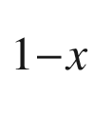

As double heterostructure planar stripe laser. Jpn. J. Appl. Phys. **12**, 1585–1592 (1973). [10.​1143/​JJAP.​12.​1585](https://doi.org/10.1143/JJAP.12.1585)

W.G. Scheibenzuber, *GaN-Based Laser Diodes: Towards Longer Wavelengths and Short Pulses* (Springer, Berlin, 2012). [10.​1007/​978-3-642-24538-1](https://doi.org/10.1007/978-3-642-24538-1)

M. Kamp, J. Hofmann, A. Forchel, S. Lourdudoss, Ultrashort InGaAsP/InP lasers with deeply etched Bragg mirrors. Appl. Phys. Lett. **78**, 4074–4075 (2001). [10.​1063/​1.​1377623](https://doi.org/10.1063/1.1377623)

Mathias Kamp, private communication

M. Fujita, R. Ushigome, T. Baba, Large spontaneous emission factor of 0.1 in a microdisk injection laser. IEEE Phot. Technol. Lett. **13**, 403–405 (2001) [10.​1109/​68.​920731](https://doi.org/10.1109/68.920731)

G. Björk, A. Karlsson, Y. Yamamoto, Definition of a laser threshold. Phys. Rev. A **50**, 1675–1680 (1994). [10.​1103/​PhysRevA.​50.​1675](https://doi.org/10.1103/PhysRevA.50.1675)

Y. Yamamoto, S. Machida, G. Björk, Microcavity semiconductor laser with enhanced spontaneous emission. Phys. Rev. A **44**, 657–668 (1991). [10.​1103/​PhysRevA.​44.​657](https://doi.org/10.1103/PhysRevA.44.657)

H.S. Sommers, Spectral characteristics of single-mode injection lasers: The power-gain curve from weak stimulation to full output. J. Appl. Phys. **52**, 156–160 (1982). [10.​1063/​1.​331591](https://doi.org/10.1063/1.331591)

T. Erneux, P. Glorieux, *Laser Dynamics* (Cambridge University Press, Cambridge, 2010), [10.​1017/​CBO9780511776908​](https://doi.org/10.1017/CBO9780511776908)

N.A. Pikhtin, S.O. Slipchenko, Z.N. Sokolova, A.L. Stankevich, D.A. Vinokurov, I.S. Tarasov, Zh.I. Alferov, 16 W continuous-wave output power from 100

$$\mu $$

m-aperture laser with quantum well asymmetric heterostructure. Electron. Lett. **40**, 1413–1414 (2004). [10.​1049/​el:​20045885](https://doi.org/10.1049/el:20045885)

A. Knigge, G. Erbert, J. Jonsson, W. Pittroff, R. Staske, B. Sumpf, M. Weyers, G. Tränkle, Passively cooled 940 nm laser bars with 73% wall-plug efficiency at 70 W and 25

$$^{\circ }$$

C. Electron. Lett. **41**, 250–251 (2005). [10.​1049/​el:​20058180](https://doi.org/10.1049/el:20058180)

D. Garbuzov, I. Kudryashov, A. Komissarov, M. Maiorov, W. Roff, J. Connolly, 14xx nm DFB InGaAsP/InP pump lasers with 500 mW CW output power for WDM combining, in *Optical Fiber Communication Conference, OSA Technical Digest Series, WD1* (Optical Society of America, Washington, D.C., 2003), pp. 486–487. [10.​1109/​OFC.​2002.​1036504](https://doi.org/10.1109/OFC.2002.1036504)

T. Kimura, M. Nakae, J. Yoshida, S. Iizuka, A. Sato, 14XX nm over 1 W pump laser module with integrated PBC, in *Optical Fiber Communication Conference, OSA Technical Digest Series* (Optical Society of America, Washington, D.C., 2003), pp. 485–486. [10.​1109/​OFC.​2002.​1036503](https://doi.org/10.1109/OFC.2002.1036503)

W.T. Tsang, R.A. Logan, J.P. Van der Ziel, Low-current-threshold strip-buried-heterostructure lasers with self-aligned current injection stripes. Appl. Phys. Lett. **34**, 644–647 (1979). [10.​1063/​1.​90623](https://doi.org/10.1063/1.90623)

D. Garbuzov, M. Maiorov, R. Menna, A. Komissarov, V. Khalfin, I. Kudryashov, A. Lunev, L. DiMarco, J. Connolly, High-power 1300-nm Fabry-Perot and DFB ridge-waveguide lasers. Proc. SPIE **4651**, 92–100 (2002). [10.​1117/​12.​467937](https://doi.org/10.1117/12.467937)

M. Grundmann, O. Stier, S. Bognár, C. Ribbat, F. Heinrichsdorff, D. Bimberg, Optical properties of self-organized quantum dots: modeling and experiments. Phys. Status Solidi A **178**, 255–262 (2000). [10.​1002/​1521-396X(200003)178:​1<255:​:​AID-PSSA255>3.​0.​CO;2-Q](https://doi.org/10.1002/1521-396X(200003)178:1%253C255::AID-PSSA255%253E3.0.CO%3B2-Q)

M. Grundmann, How a quantum-dot laser turns on. Appl. Phys. Lett. **77**, 1428–1430 (2000). [10.​1063/​1.​1290716](https://doi.org/10.1063/1.1290716)

F. Heinrichsdorff, C. Ribbat, M. Grundmann, D. Bimberg, High-power quantum-dot lasers at 1100 nm. Appl. Phys. Lett. **76**, 556–558 (2000). [10.​1063/​1.​125816](https://doi.org/10.1063/1.125816)

Ch. Ribbat, R. Sellin, M. Grundmann, D. Bimberg, High power quantum dot lasers at 1160 nm. Phys. Status Solidi B **224**, 819–822 (2001). [10.​1002/​(SICI)1521-3951(200104)224:​3<819:​:​AID-PSSB819>3.​0.​CO;2-1](https://doi.org/10.1002/(SICI)1521-3951(200104)224:3%253C819::AID-PSSB819%253F3.0.CO%3B2-1)

D. Garbuzov, I. Kudryashov, A. Tsekoun, A. Komissarov, W. Roff, M. Maiorov, R. Menna, A. Lunev, J. Connolly, 14xx nm DFB InGaAsP/InP pump lasers with 500 mw CW output power for WDM combining, in *Optical Fiber Communication Conference 2002, Technical Digest: ThN6* (2002). [10.​1109/​OFC.​2002.​1036504](https://doi.org/10.1109/OFC.2002.1036504)

*High-Power 1550 nm DFB Source Lasers, A1112*, Datasheet DS00-281OPTO-1, Agere Systems (2001)

M.-C. Amann, J. Buus, *Tunable Laser Diodes* (Artech House, Boston, 1998)

J.N. Walpole, A.R. Calawa, T.C. Harman, S.H. Groves, Double-heterostructure PbSnTe lasers grown by molecular-beam epitaxy with cw operation up to 114 K. Appl. Phys. Lett. **28**, 552–554 (1976). [10.​1063/​1.​88820](https://doi.org/10.1063/1.88820)

S.-L. Lee, I.-F. Jang, C.-T. Pien, C.-Y. Wang, T.-T. Shih, Sampled grating DBR laser arrays with adjustable 0.8/1.6-nm wavelength spacing. IEEE Phot. Technol. Lett. **11**, 955–957 (1999). [10.​1109/​68.​775311](https://doi.org/10.1109/68.775311)

B. Mason, G.A. Fish, S.P. DenBaars, L.A. Coldren, Ridge waveguide sampled grating DBR lasers with 22-nm quasi-continuous tuning range. IEEE Phot. Technol. Lett. **10**, 1211–1213 (1998). [10.​1109/​68.​705593](https://doi.org/10.1109/68.705593)

K. Petermann, *Laser Diode Modulation and Noise* (Kluwer. Dordrecht (1988). [10.​1007/​978-94-009-2907-4](https://doi.org/10.1007/978-94-009-2907-4)

S. Wieczorek, B. Krauskopf, T.B. Simpson, D. Lenstra, The dynamical complexity of optically injected semiconductor lasers. Phys. Rep. **416**, 1–128 (2005). [10.​1016/​j.​physrep.​2005.​06.​003](https://doi.org/10.1016/j.physrep.2005.06.003)

C.J. Hwang, J.C. Dyment, Dependence of threshold and electron lifetime on acceptor concentration in GaAs-Ga

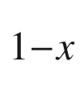

Al

$$_x$$

As lasers. J. Appl. Phys. **44**, 3240–3244 (1973). [10.​1063/​1.​1662740](https://doi.org/10.1063/1.1662740)

N.K. Dutta, S.J. Wang, A.B. Piccirilli, R.F. Karlicek Jr., R.L. Brown, M. Washington, U.K. Chakrabarti, A. Gnauck, Wide-bandwidth and high-power InGaAsP distributed feedback lasers. J. Appl. Phys. **66**, 4640–4644 (1989). [10.​1063/​1.​343820](https://doi.org/10.1063/1.343820)

F. Grillot, B. Dagens, J.-G. Provost, H. Su, L.F. Lester, Gain Compression and above-threshold linewidth enhancement factor in 1.3-

$$\mu $$

m InAs-GaAs quantum-dot lasers. IEEE J. Quantum Electr. **44**, 946–951 (2008). [10.​1109/​JQE.​2008.​2003106](https://doi.org/10.1109/JQE.2008.2003106)

J.S. Gustavsson, Å. Haglund, J. Bengtsson, A. Larsson, High-speed digital modulation characteristics of oxide-confined vertical-cavity surface-emitting lasers—Numerical simulations consistent with experimental results. IEEE J. Quantum Electr. **QE-38**, 1089–1096 (2002). [10.​1109/​JQE.​2002.​801009](https://doi.org/10.1109/JQE.2002.801009)

C.H. Henry, *Theory of the linewidth of semiconductor lasers*, IEEE J. Quantum Electr. **QE-18**, 259–264 (1982). [10.​1109/​JQE.​1982.​1071522](https://doi.org/10.1109/JQE.1982.1071522)

Y. Yamamoto, H.A. Haus, Commutation relations and laser linewidth. Phys. Rev. A **41**, 5164–5170 (1990). [10.​1103/​PhysRevA.​41.​5164](https://doi.org/10.1103/PhysRevA.41.5164)

D. Welford, A. Mooradian, Output power and temperature dependence of the linewidth of single-frequency cw (GaAl)As diode lasers. Appl. Phys. Lett. **40**, 865–867 (1982). [10.​1063/​1.​92945](https://doi.org/10.1063/1.92945). Erratum: Appl. Phys. Lett. 41, 1007 (1982). [10.​1063/​1.​93718](https://doi.org/10.1063/1.93718)

Quintessence Photonics Corporation, [www.​qpclasers.​com](http://www.qpclasers.com)

BinOptics Corporation, Ithaca, NY, now MACOM, [www.​binoptics.​com](http://www.binoptics.com)

H.E. Li, K. Iga, eds., *Vertical-cavity Surface-emitting Laser Devices* (Springer, Berlin, 2003)

Sandia National Laboratories, [www.​sandia.​gov](http://www.sandia.gov)

Ulm Photonics, now Philips, [www.​ulm-photonics.​de](http://www.ulm-photonics.de), [10.​1007/​978-3-662-05263-1](https://doi.org/10.1007/978-3-662-05263-1)

K.D. Choquette, Vertical-cavity surface-emitting lasers: light for the information age. MRS Bull. **27**, 507–511 (2002). [10.​1557/​mrs2002.​168](https://doi.org/10.1557/mrs2002.168)

C.J. Chang-Hasnain, Tunable VCSELs. IEEE J. Sel. Topics Quantum Electron. **6**, 978–987 (2000). [10.​1109/​2944.​902146](https://doi.org/10.1109/2944.902146)

Bandwidth 9 (company closed 2005)

F. Römer, C. Prott, J. Daleiden, S. Irmer, M. Strassner, A. Tarraf, H. Hillmer, Micromechanically tunable air gap resonators for long wavelength VCSEL’s, in *IEEE LEOS International Semiconductor Laser Conference*. Garmisch/Germany 13–14 (2002). [10.​1109/​ISLC.​2002.​1041095](https://doi.org/10.1109/ISLC.2002.1041095)

M. Schulze, J.-M. Pelaprat, Efficiency experts. Photonics Spectra **35**(5), 150–151 (2001)

*Sapphire*



*488-20 laser*, Datasheet MC-027-10-0M0111Rev.A, Coherent Inc. (2004)

Federico Capasso, private communication

Jérôme Faist, private communication

F. Capasso, K. Mohammed, A.Y. Cho, Resonant tunneling through double barriers, perpendicular quantum transport phenomena in superlattices, and their device applications. IEEE J. Quantum Electr. **QE-22**, 1853–1869 (1986). [10.​1109/​JQE.​1986.​1073171](https://doi.org/10.1109/JQE.1986.1073171)

H. Krömer, Proposed negative-mass microwave amplifier. Phys. Rev. **109**, 1856 (1958). [10.​1103/​PhysRev.​109.​1856](https://doi.org/10.1103/PhysRev.109.1856)

A.A. Andronov, I.V. Zverev, V.A. Kozlov, Yu.N. Nozdrin, S.A. Pavlov, V. N. Shastin, Stimulated emission in the long-wavelength region from hot holes in Ge in crossed electric and magnetic fields. Pis’ma Zh. Eksp. Teor. Fiz. **40**, 69–72 (1984) [JETP Lett. **40**, 804–807 (1984)]

Optical and Quantum Electronics **23**(2), Special Issue *Far-infrared Semiconductor Lasers*, eds. by E. Gornik, A.A. Andronov (Chapman and Hall, London, 1991). [10.​1007/​BF00619760](https://doi.org/10.1007/BF00619760)

E. Bründermann, Widely tunable far infrared hot hole semiconductor lasers, in *Long-wavelength Infrared Semiconductor Lasers*, ed. by H.K. Choi (Wiley, New York, 2004), pp. 279–350

E. Bründermann, A.M. Linhart, H.P. Röser, O.D. Dubon, W.L. Hansen, E.E. Haller, Miniaturization of p-Ge lasers: progress toward continuous wave operation. Appl. Phys. Lett. **68**, 1359–1361 (1996). [10.​1063/​1.​116079](https://doi.org/10.1063/1.116079)

E. Bründermann, D.R. Chamberlin, E.E. Haller, High duty cycle and continuous terahertz emission from germanium. Appl. Phys. Lett. **76**, 2991–2993 (2000). [10.​1063/​1.​126555](https://doi.org/10.1063/1.126555)

N.K. Dutta, Q. Wang, *Semiconductor Optical Amplifiers*, 2nd edn. (World Scientific, Singapore, 2013). [10.​1142/​8781](https://doi.org/10.1142/8781)

A.J. Collar, G.D. Henshall, J. Farré, B. Mikkelsen, Z. Wang, L. Eskildsen, D.S. Olesen, K.E. Stubkjaer, Low residual reflectivity of angled-facet semiconductor laser amplifiers. IEEE Phot. Technol. Lett. **2**, 553–555 (1990). [10.​1109/​68.​58046](https://doi.org/10.1109/68.58046)

G. Jost, *University of Ulm* (Annual Report, Department of Optoelectronics, 1998), p. 64

Ferdinand-Braun-Institut für Höchstfrequenztechnik, Berlin, [www.​fbh-berlin.​de](http://www.fbh-berlin.de)

M. Sugawara, N. Hatori, M. Ishida, H. Ebe, Y. Arakawa, T. Akiyama, K. Otsubo, T. Yamamoto, Y. Nakata, Recent progress in self-assembled quantum-dot optical devices for optical telecommunication: temperature-insensitive 10 Gb s

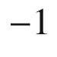

directly modulated lasers and 40 Gb s

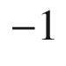

signal-regenerative amplifiers. J. Phys. D: Appl. Phys. **38**, 2126–2134 (2005). [10.​1088/​0022-3727/​38/​13/​008](https://doi.org/10.1088/0022-3727/38/13/008)

N. Yasuoka, K. Kawaguchi, H. Ebe, T. Akiyama, M. Ekawa, K. Morito, M. Sugawara, Y. Arakawa, Quantum-dot semiconductor optical amplifiers with polarization-independent gains in 1.5-

$$\mu $$

m wavelength bands. IEEE Phot. Technol. Lett. **20**, 1908–1910 (2008). [10.​1109/​LPT.​2008.​2004695](https://doi.org/10.1109/LPT.2008.2004695)

P. Borri, S. Schneider, W. Langbein, U. Woggon, A.E. Zhukov, V.M. Ustinov, N.N. Ledentsov, Zh.I. Alferov, D. Ouyang, D. Bimberg, Ultrafast carrier dynamics and dephasing in InAs quantum-dot amplifiers emitting near 1.3-

$$\mu $$

m-wavelength at room temperature. Appl. Phys. Lett. **79**, 2633–2635 (2001). [10.​1063/​1.​1411986](https://doi.org/10.1063/1.1411986)

W.B. Shockley, Transistor technology evokes new physics, Nobel Lecture (1956), in *Nobel Lectures, Physics* 1942–1962 (Elsevier, Amsterdam, 1964), pp. 344–374

R.R. Nelson, The link between science and invention: the case of the transistor, in *The Rate and Direction of Inventive Activity: Economic and Social Factors* (Princeton University Press, Princeton, 1962), pp. 549–583

Sh.S. Li, *Semiconductor Physical Electronics*, 2nd edn. (Springer, New York, 2006). [10.​1007/​0-387-37766-210.​1007/​0-387-37766-2](https://doi.org/10.1007/0-387-37766-210.1007/0-387-37766-2)

P.G.A Jespers, Measurements for bipolar devices in: *Process and Device Modeling for Integrated Circuit Design*, ed. by F. van de Wiele, W.L. Engl, P.G. Jespers, NATO Science Series E, vol. 21 (Noordhoff, Leyden, 1977)

M.J. Morant, *Introduction to Semiconductor Devices* (Addison-Wesley, Reading, MA, 1964)

H.K. Gummel, H.C. Poon, An integral charge control model of bipolar transistors. Bell Syst. Tech. J. **49**, 827–852 (1970). [10.​1002/​j.​1538-7305.​1970.​tb01803.​x](https://doi.org/10.1002/j.1538-7305.1970.tb01803.x)

J.M. Early, Effects of space-charge layer widening in junction transistors. Proc. IRE **40**, 1401–1406 (1952). [10.​1109/​JRPROC.​1952.​273969](https://doi.org/10.1109/JRPROC.1952.273969)

C.C. McAndrew, L.W. Nagel, Early effect modeling in SPICE. IEEE J. Solid-State Circ. **31**, 136–138 (1996). [10.​1109/​4.​485877](https://doi.org/10.1109/4.485877)

D.C. Herbert, Extended velocity overshoot in GaAs HBT. Semicond. Sci. Technol. **10**, 682–686 (1995). [10.​1088/​0268-1242/​10/​5/​019](https://doi.org/10.1088/0268-1242/10/5/019)

Solid State Electronics Laboratory, University of Michigan, [www.​eecs.​umich.​edu](http://www.eecs.umich.edu)

D. Cui, D. Sawdai, D. Pavlidis, S.H. Hsu, P. Chin, T. Block, High Power Performance Using InAlAs/InGaAs single heterojunction bipolar transistors, in *Proceedings of the 12th Int. Conf. on Indium Phosphide and Related Materials*, pp. 473–476 (2000). [10.​1109/​ICIPRM.​2000.​850336](https://doi.org/10.1109/ICIPRM.2000.850336)

M. Feng, N. Holonyak Jr., R. Chan, Quantum-well-base heterojunction bipolar light-emitting transistor. Appl. Phys. Lett. **84**, 1952–1954 (2004). [10.​1063/​1.​1669071](https://doi.org/10.1063/1.1669071)

R.R. Bockemuehl, Analysis of field effect transistors with arbitrary charge distribution. IEEE Trans. Electron Dev. **10**, 31–34 (1963). [10.​1109/​T-ED.​1963.​15076](https://doi.org/10.1109/T-ED.1963.15076)

R.D. Middlebrook, I. Richer, Limits on the power-law exponent for field-effect transistor transfer characteristics. Solid State Electron. **6**, 542–544 (1963). [10.​1016/​0038-1101(63)90043-1](https://doi.org/10.1016/0038-1101(63)90043-1)

K. Lehovec, R. Zuleeg, Voltage-current characteristics of GaAs-JFET’s in the hot electron range. Solid State Electron. **13**, 1415–1425 (1970). [10.​1016/​0038-1101(70)90175-9](https://doi.org/10.1016/0038-1101(70)90175-9)

H.C. Pao, C.T. Sah, Effects of diffusion current on characteristics of metal-oxide (insulator)-semiconductor transistors. Solid State Electron. **9**, 927–937 (1966). [10.​1016/​0038-1101(66)90068-2](https://doi.org/10.1016/0038-1101(66)90068-2)

K. Yamaguchi, Field-dependent mobility model for two-dimensional numerical analysis of MOSFET’s. IEEE Trans. Electron Dev. **26**, 1068–1074 (1979). [10.​1109/​T-ED.​1979.​19547](https://doi.org/10.1109/T-ED.1979.19547)

R.R. Troutman, Subthreshold design considerations for insulated gate field-effect transistors. IEEE J. Solid-State Circ. **9**, 55–60 (1974). [10.​1109/​JSSC.​1974.​1050462](https://doi.org/10.1109/JSSC.1974.1050462)

W. Maly, *Atlas of IC technologies—An Introduction to VLSI Processes* (Benjamin/Cummings Publishing Company, San Francisco, 1987)

D. Udeshi, E. Maldonado, Y. Xu, M. Tao, W.P. Kirk, Thermal stability of ohmic contacts between Ti and Se-passivated n-type Si(001). J. Appl. Phys. **95**, 4219–4222 (2004). [10.​1063/​1.​1687047](https://doi.org/10.1063/1.1687047)

V. Sverdlov, *Strain-Induced Effects in Advanced MOSFETs* (Springer. Berlin (2011). [10.​1007/​978-3-7091-0382-1](https://doi.org/10.1007/978-3-7091-0382-1)

G.E. Moore, Cramming more components onto integrated circuits. Electronics **38**(8), 114–117 (1965). [10.​1109/​JPROC.​1998.​658762](https://doi.org/10.1109/JPROC.1998.658762). Reprinted. In: Proc. IEEE 86, 82-85 (1998)

M. Fayolle, F. Romagna, Copper CMP evaluation: planarization issues. Microelectron. Eng. **37**(38), 135–141 (1997). [10.​1016/​S0167-9317(97)00104-4](https://doi.org/10.1016/S0167-9317(97)00104-4)

Z. Stavreva, D. Zeidler, M. Plötner, K. Drescher, Characteristics in chemical-mechanical polishing of copper: comparison of polishing pads. Appl. Surf. Sci. **108**, 39–44 (1997). [10.​1016/​S0169-4332(96)00572-7](https://doi.org/10.1016/S0169-4332(96)00572-7)

C.-H. Tung, G.T.T. Sheng, C.-Y. Lu, *ULSI Semiconductor Technology Atlas* (Wiley, Hoboken (2003). [10.​1002/​0471668796](https://doi.org/10.1002/0471668796)

K. Hinode, Y. Hanaoka, K.-I. Takeda, S. Kondo, Resistivity increase in ultrafine-line copper conductor for ULSIs. Jpn. J. Appl. Phys. **40**, L1097–L1099 (2001). [10.​1143/​JJAP.​40.​L1097](https://doi.org/10.1143/JJAP.40.L1097)

T. Harada, A. Ueki, K. Tomita, K. Hashimoto, J. Shibata, H. Okamura, K. Yoshikawa, T. Iseki, M. Higashi, S. Maejima, K. Nomura, K. Goto, T. Shono, S. Muranaka, N. Torazawa, S. Hirao, M. Matsumoto, T. Sasaki, S. Matsumoto, S. Ogawa, M. Fujisawa, A. Ishii, M. Matsuura, T. Ueda, Extremely low Keff (

$$\sim $$

1.9) Cu interconnects with air gap formed using SiOC, in *IEEE International Interconnect Technology Conference (IITC)* (2007), pp. 141–143. [10.​1109/​IITC.​2007.​382364](https://doi.org/10.1109/IITC.2007.382364)

P. Bai, C. Auth, S. Balakrishnan, M. Bost, R. Brain, V. Chikarmane, R. Heussner, M. Hussein, J. Hwang, D. Ingerly, R. James, J. Jeong, C. Kenyon, E. Lee, S.-H. Lee, N. Lindert, M. Liu, Z. Ma, T. Marieb, A. Murthy, R. Nagisetty, S. Natarajan, J. Neirynck, A. Ott, C. Parker, J. Sebastian, R. Shaheed, S. Sivakumar, J. Steigerwald, S. Tyagi, C. Weber, B. Woolery, A. Yeoh, K. Zhang, M. Bohr, A 65nm logic technology featuring 35nm gate lengths, enhanced channel strain, 8 Cu interconnect layers, Low-k ILD and 0.57

$$\mu $$

m

$$^2$$

SRAM cell, in *IEDM Technical Digest* (IEEE, Piscataway, 2004), pp. 657–660. [10.​1109/​IEDM.​2004.​1419253](https://doi.org/10.1109/IEDM.2004.1419253)

[www.​chipworks.​com](http://www.chipworks.com)

Y. Taur, CMOS design near the limit of scaling. IBM J. Res. Dev. **46**, 213–222 (2002). [10.​1147/​rd.​462.​0213](https://doi.org/10.1147/rd.462.0213)

E.J. Nowak, Maintaining the benefits of CMOS scaling when scaling bogs down. IBM J. Res. Dev. **46**, 169–180 (2002). [10.​1147/​rd.​462.​0169](https://doi.org/10.1147/rd.462.0169)

S.-H. Lo, D.A. Buchanan, Y. Taur, W. Wang, Quantum-mechanical modeling of electron tunneling current from the inversion layer of ultra-thin-oxide nMOSFET’s. IEEE Electr. Dev. Lett. **18**, 209–211 (1997). [10.​1109/​55.​568766](https://doi.org/10.1109/55.568766)

G.D. Wilk, R.M. Wallace, J.M. Anthony, Hafnium and zirconium silicates for advanced gate dielectrics. J. Appl. Phys. **87**, 484–492 (2000). [10.​1063/​1.​371888](https://doi.org/10.1063/1.371888)

Ch. Auth, M. Buehler, A. Cappellani, C.-H. Choi, G. Ding, W. Han, S. Joshi, B. McIntyre, M. Prince, P. Ranade, J. Sandford, Ch. Thomas, 45nm high-k + metal gate strain-enhanced transistors. Intel Techn. J. **12**, 77 (2008). [10.​1535/​itj.​1201](https://doi.org/10.1535/itj.1201)

M.A. Quevedo-Lopez, S.A. Krishnan, D. Kirsch, C.H.J. Li, J.H. Sim, C. Huffman, J.J. Peterson, B.H. Lee, G. Pant, B.E. Gnade, M.J. Kim, R.M. Wallace, D. Guo, H. Bu, T.P. Ma, High performance gate first HfSiON dielectric satisfying 45nm node requirements, in *IEDM Technical Digest* (IEEE, Piscataway, 2005), pp. 425–428. [10.​1109/​IEDM.​2005.​1609369](https://doi.org/10.1109/IEDM.2005.1609369)

K. Mistry, C. Allen, C. Auth, B. Beattie, D. Bergstrom, M. Bost, M. Brazier, M. Buehler, A. Cappellani, R. Chau, C.-H. Choi, G. Ding, K. Fischer, T. Ghani, R. Grover, W. Han, D. Hanken, M. Hattendorf, J. He, J. Hicks, R. Heussner, D. Ingerly, P. Jain, R. James, L. Jong, S. Joshi, C. Kenyon, K. Kuhn, K. Lee, H. Liu, J. Maiz, B. McIntyre, P. Moon, J. Neirynck, S. Pae, C. Parker, D. Parsons, C. Prasad, L. Pipes, M. Prince, P. Ranade, T. Reynolds, J. Sandford, L. Shifren, J. Sebastian, J. Seiple, D. Simon, S. Sivakumar, P. Smith, C. Thomas, T. Troeger, P. Vandervoorn, S. Williams, K. Zawadzki, A 45nm logic technology with high-k+metal gate transistors, strained silicon, 9 Cu interconnect layers, 193nm dry patterning, and 100% Pb-free packaging, IEDM Technical Digest (IEEE, Piscataway, 2007), pp. 247–250. [10.​1109/​IEDM.​2007.​4418914](https://doi.org/10.1109/IEDM.2007.4418914)

K. Mistry, M. Armstrong, C. Auth, S. Cea, T. Coan, T. Ghani, T. Hoffmann, A. Murthy, J. Sandford, R. Shaheed, K. Zawadzki, K. Zhang, S. Thompson, M. Bohr, Delaying forever: uniaxial strained silicon transistors in a 90nm CMOS technology, Symp. VLSI Technology Digest (IEEE, Piscataway, 2004), pp. 50–51. [10.​1109/​VLSIT.​2004.​1345387](https://doi.org/10.1109/VLSIT.2004.1345387)

T. Krishnamohan, C. Jungemann, D. Kim, E. Ungersboeck, S. Selberherr, A.-T. Pham, B. Meinerzhagen, P. Wong, Y. Nishi, K.C. Saraswat, High performance, uniaxially-strained, silicon and germanium, double-gate p-MOSFETs. Microelectron. Eng. **84**, 2063–2066 (2007). [10.​1016/​j.​mee.​2007.​04.​085](https://doi.org/10.1016/j.mee.2007.04.085)

T. Guillaume, M. Mouis, Calculations of hole mass in [110]-uniaxially strained silicon for the stress-engineering of p-MOS transistors. Solid State Electron. **50**, 701–708 (2006). [10.​1016/​j.​sse.​2006.​03.​040](https://doi.org/10.1016/j.sse.2006.03.040)

E. Ungersboeck, S. Dhar, G. Karlowatz, H. Kosina, S. Selberherr, Physical modeling of electron mobility enhancement for arbitrarily strained silicon. J. Comput. Electron. **6**, 55–58 (2007). [10.​1007/​s10825-006-0047-0](https://doi.org/10.1007/s10825-006-0047-0)

M. Bohr, *The Invention of Uniaxial Strained Silicon Transistors at Intel* (Intel, 2007)

Synopsys, Inc., [www.​synopsys.​com/​products/​tcad/​examples/​strain2d.​pdf](http://www.synopsys.com/products/tcad/examples/strain2d.pdf)

W. Hansch, C. Fink, J. Schulze, I. Eisele, A vertical MOS-gated Esaki tunneling transistor in silicon. Thin Solid Films **369**, 387–389 (2000). [10.​1016/​S0040-6090(00)00896-8](https://doi.org/10.1016/S0040-6090(00)00896-8)

P.-F. Wang, K. Hilsenbeck, Th Nirschl, M. Oswald, Ch. Stepper, M. Weis, D. Schmitt-Landsiedel, W. Hansch, Complementary tunneling transistor for low power application. Solid State Electron. **48**, 2281–2286 (2004). [10.​1016/​j.​sse.​2004.​04.​006](https://doi.org/10.1016/j.sse.2004.04.006)

W.M. Reddick, G.A.J. Amaratunga, Silicon surface tunnel transistor. Appl. Phys. Lett. **67**, 494–496 (1995). [10.​1063/​1.​114547](https://doi.org/10.1063/1.114547)

P.-F. Wang, T. Nirschl, D. Schmitt-Landsiedel, W. Hansch, Simulation of the Esaki-tunneling FET. Solid State Electron. **47**, 1187–1192 (2003). [10.​1016/​S0038-1101(03)00045-5](https://doi.org/10.1016/S0038-1101(03)00045-5)

E.-H. Toh, G.H. Wang, G. Samudra, Y.-C. Yeo, Device physics and design of germanium tunneling field-effect transistor with source and drain engineering for low power and high performance applications. J. Appl. Phys. **103**, 104504:1–5 (2008). [10.​1063/​1.​2924413](https://doi.org/10.1063/1.2924413)

L.M. Grupp, J.D. Davis, S. Swanson, The bleak future of NAND flash memory, in *Proceedings 10th USENIX Conferences File and Storage Technologies (FAST 2012)* (USENIX Association, Berkeley, USA, 2012), pp. 2:1–8

G.R. Fox, R.Bailey, W.B. Kraus, F. Chu, S. Sun, T. Davenport, The current status of FeRAM, in *Ferroelectric Random Access Memories*, Topics in Applied Physics 93, eds. by H. Ishiwara, M. Okuyama, Y. Arimoto (Springer, Berlin, 2004), pp. 139–148. [10.​1007/​978-3-540-45163-1\_​10](https://doi.org/10.1007/978-3-540-45163-1%255F10)

Y.C. Chen, C.T. Rettner, S. Raoux, G.W. Burr, S.H. Chen, R.M. Shelby, M. Salinga, W.P. Risk, T.D. Happ, G.M. McClelland, M. Breitwisch, A. Schrott, J.B. Philipp, M.H. Lee, R. Cheek, T. Nirschl, M. Lamorey, C.F. Chen, E. Joseph, S. Zaidi, B. Yee, H.L. Lung, R. Bergmann, C. Lam, Ultra-thin phase-change bridge memory device using GeSb, IEDM Technical Digest (IEEE, Piscataway, 2006), pp. 777–780. [10.​1109/​IEDM.​2006.​346910](https://doi.org/10.1109/IEDM.2006.346910)

Z. Sun, J. Zhou, R. Ahuja, Unique melting behavior in phase-change materials for rewritable data storage. Phys. Rev. Lett. **98**, 055505:1–4 (2007). [10.​1103/​PhysRevLett.​98.​055505](https://doi.org/10.1103/PhysRevLett.98.055505)

J. Hegedüs, S.R. Elliott, Microscopic origin of the fast crystallization ability of Ge-Sb-Te phase-change memory materials. Nat. Mater. **7**, 399–405 (2008). [10.​1038/​nmat2157](https://doi.org/10.1038/nmat2157)

P.K. Naji, M. Durlam, S. Tehrani, J. Calder, M.F. DeHerrera, A 256kb 3.0V 1T1MTJ nonvolatile magnetoresistive RAM, ISSCC Digest of Technical Papers (IEEE, Piscataway, 2001), pp. 122–124. [10.​1109/​ISSCC.​2001.​912570](https://doi.org/10.1109/ISSCC.2001.912570)

W.J. Gallagher, S.S.P. Parkin, Development of the magnetic tunnel junction MRAM at IBM: From first junctions to a 16-Mb MRAM demonstrator chip. IBM J. Res. Dev. **50**, 5–23 (2006). [10.​1147/​JRD.​2006.​5388775](https://doi.org/10.1147/JRD.2006.5388775); Erratum: IBM J. Res. Dev. 50, 23A (2006). [10.​1147/​rd.​501.​0005](https://doi.org/10.1147/rd.501.0005)

M.N. Kozicki, C. Gopalan, M. Balakrishnan, M. Park, M. Mitkova, Non-volatile memory based on solid electrolytes, in *Proceedings IEEE Non-Volatile Memory Technology Symposium* (IEEE, Piscataway, 2004), pp. 10–17. [10.​1109/​NVMT.​2004.​1380792](https://doi.org/10.1109/NVMT.2004.1380792)

M.N. Kozicki, P. Mira, M. Mitkova, Nanoscale memory elements based on solid-state electrolytes. IEEE Trans. Nanotechnol. **4**, 331–338 (2005). [10.​1109/​TNANO.​2005.​846936](https://doi.org/10.1109/TNANO.2005.846936)

K. Szot, W. Speier, G. Bihlmayer, R. Waser, Switching the electrical resistance of individual dislocations in single-crystalline SrTiO

$$_3$$

. Nat. Mater. **5**, 312–320 (2006). [10.​1038/​nmat1614](https://doi.org/10.1038/nmat1614)

A. Beck, J.G. Bednorz, Ch. Gerber, C. Rossel, D. Widmer, Reproducible switching effect in thin oxide films for memory applications. Appl. Phys. Lett. **77**, 139–141 (2000). [10.​1063/​1.​126902](https://doi.org/10.1063/1.126902)

S. Karg, G.I. Meijer, D. Widmer, R. Stutz, J.G. Bednorz, Ch. Rettner, Nanoscale resistive memory device using SrTiO

$$_3$$

films, in *22nd IEEE Non-Volatile Semiconductor Memory Workshop, Monterey* (IEEE, Piscataway, 2007), pp. 68–70. [10.​1109/​NVSMW.​2007.​4290584](https://doi.org/10.1109/NVSMW.2007.4290584)

M. Janousch, G.I. Meijer, U. Staub, B. Delley, S.F. Karg, B.P. Andreasson, Role of oxygen vacancies in Cr-doped SrTiO

$$_3$$

for resistance-change memory. Adv. Mater. **19**, 2232–2235 (2007). [10.​1002/​adma.​200602915](https://doi.org/10.1002/adma.200602915)

M.A. Reed, C. Zhou, C.J. Muller, T.P. Burgin, J.M. Tour, Conductance of a molecular junction. Science **278**, 252–254 (1997). [10.​1126/​science.​278.​5336.​252](https://doi.org/10.1126/science.278.5336.252)

J.R. Heath, P.J. Kuekes, G.S. Snider, R.S. Williams, A defect-tolerant computer architecture: opportunities for nanotechnology. Science **280**, 1716–1721 (1998). [10.​1126/​science.​280.​5370.​1716](https://doi.org/10.1126/science.280.5370.1716)

A. Aviram, M. Ratner, eds., Molecular electronics: science and technology. Ann. N. Y. Acad. Sci. **852** (1998). [10.​1111/​j.​1749-6632.​1998.​tb09860.​x](https://doi.org/10.1111/j.1749-6632.1998.tb09860.x)

E.F. Schubert, Delta-doping of semiconductors: electronic, optical and structural properties of materials and devices. Semicond. Semimet. **40**, 1–151 (1994). [10.​1016/​S0080-8784(08)62662-9](https://doi.org/10.1016/S0080-8784(08)62662-9)

M. Schlechtweg, A. Tessmann, A. Leuther, C. Schwörer, M. Lang, U. Nowotny, O. Kappeler, Integrated circuits based on 300 GHz f

$$_T$$

metamorphic HEMT technology for millimeter-wave and mixed-signal applications, in *Proceedings of the European Gallium Arsenide and other Compound Semiconductors Application Symposium (GAAS 2003)* (Horizon House, London, 2003), pp. 465–468

D. Lubyshev, W.K. Liu, T.R. Stewart, A.B. Cornfeld, X.M. Fang, X. Xu, P. Specht, C. Kisielowski, M. Naidenkova, M.S. Goorsky, C.S. Whelan, W.E. Hoke, P.F. Marsh, J.M. Millunchick, S.P. Svensson, Strain relaxation and dislocation filtering in metamorphic high electron mobility transistor structures grown on GaAs substrates. J. Vac. Sci. Technol. B **19**, 1510–1514 (2001). [10.​1116/​1.​1376384](https://doi.org/10.1116/1.1376384)

S.D. Brotherton, *Introduction to Thin Film Transistors. Physics and Technology of TFTs* (Springer, Heidelberg, 2013). [10.​1007/​978-3-319-00002-2](https://doi.org/10.1007/978-3-319-00002-2)

Y. Kuo, ed., *Thin Film Transistors: Materials and Processes* (Kluwer, Boston, 2003) (Two volumes, Vol. 1: *Amorphous silicon thin film transistors*, Vol. 2: *Polycrystalline silicon thin film transistors*)

G. Horowitz, Organic field-effect transistors. Adv. Mater. **10**, 365–377 (1998). [10.​1002/​(SICI)1521-4095(199803)10:​5<365:​:​AID-ADMA365>3.​0.​CO;2-U](https://doi.org/10.1002/(SICI)1521-4095(199803)10:5%253C365::AID-ADMA365%253E3.0.CO%3B2-U)

C.D. Dimitrakopoulos, P.R.L. Malenfant, Organic thin film transistors for large area electronics. Adv. Mater. **14**, 99–117 (2002). [10.​1002/​1521-4095(20020116)14:​2<99:​:​AID-ADMA99>3.​0.​CO;2-9](https://doi.org/10.1002/1521-4095(20020116)14:2%253C99::AID-ADMA99%253E3.0.CO%3B2-9)

BCh. Shekar, J. Lee, S.-W. Rhee, Organic thin film transistors: materials, processes and devices. Korean J. Chem. Eng. **21**, 267–285 (2004). [10.​1007/​BF02705409](https://doi.org/10.1007/BF02705409)

Y.M. Sun, Y.Q. Liu, D.B. Zhu, Advances in organic field-effect transistors. J. Mater. Chem. **15**, 53–65 (2005). [10.​1039/​B411245H](https://doi.org/10.1039/B411245H)

C.T. Liu, Revolution of the TFT LCD technology. J. Display Technol. **3**, 342–350 (2007). [10.​1109/​JDT.​2007.​908348](https://doi.org/10.1109/JDT.2007.908348)

U. Köster, Crystallization of amorphous silicon films. Phys. Status Solidi A **48**, 313–321 (1978). [10.​1002/​pssa.​2210480207](https://doi.org/10.1002/pssa.2210480207)

D. Toet, P.M. Smith, T.W. Sigmon, T. Takehara, C.C. Tsai, W.R. Harshbarger, M.O. Thompson, Laser crystallization and structural characterization of hydrogenated amorphous silicon thin films. J. Appl. Phys. **85**, 7914–7918 (1999). [10.​1063/​1.​370607](https://doi.org/10.1063/1.370607)

R.B. Iverson, R. Reif, Recrystallization of amorphized polycrystalline silicon films on SiO

$$_2$$

: Temperature dependence of the crystallization parameters. J. Appl. Phys. **62**, 1675–1681 (1987). [10.​1063/​1.​339591](https://doi.org/10.1063/1.339591)

N. Yamauchi, R. Reif, Polycrystalline silicon thin films processed with silicon ion implantation and subsequent solid-phase crystallization: Theory, experiments, and thin-film transistor applications. J. Appl. Phys. **75**, 3235–3257 (1994). [10.​1063/​1.​356131](https://doi.org/10.1063/1.356131)

G. Liu, S.J. Fonash, Polycrystalline silicon thin film transistors on Corning 7059 glass substrates using short time, low-temperature processing. Appl. Phys. Lett. **62**, 2554–2556 (1993). [10.​1063/​1.​109294](https://doi.org/10.1063/1.109294)

M.S. Haque, H.A. Naseem, W.D. Brown, Aluminum-induced crystallization and counter-doping of phosphorous-doped hydrogenated amorphous silicon at low temperatures. J. Appl. Phys. **79**, 7529–7536 (1996). [10.​1063/​1.​362425](https://doi.org/10.1063/1.362425)

L.H. Lee, Y.K. Fang, S.H. Fan, Au metal-induced lateral crystallisation (MILC) of hydrogenated amorphous silicon thin film with very low annealing temperature and fast MILC rate. Electron. Lett. **35**, 1108–1109 (1999). [10.​1049/​el:​19990743](https://doi.org/10.1049/el:19990743)

T.K. Kim, T.H. Ihn, B.I. Lee, S.K. Joo, High-performance low-temperature poly-silicon thin film transistors fabricated by new metal-induced lateral crystallization process. Jpn. J. Appl. Phys. **37**, 4244–4247 (1998). [10.​1143/​JJAP.​37.​4244](https://doi.org/10.1143/JJAP.37.4244)

S.-W. Lee, Y.-C. Jeon, S.-K. Joo, Pd induced lateral crystallization of amorphous Si thin films. Appl. Phys. Lett. **66**, 1671–1673 (1995). [10.​1063/​1.​113888](https://doi.org/10.1063/1.113888)

K. Sera, F. Okumura, H. Uchida, S. Itoh, S. Kaneko, K. Hotta, High-performance TFTs fabricated by XeCl excimer laser annealing of hydrogenated amorphous-silicon film. IEEE Trans. Electron Dev. **36**, 2868–2872 (1989). [10.​1109/​16.​40970](https://doi.org/10.1109/16.40970)

H. Gleskova, S. Wagner, Electron mobility in amorphous silicon thin-film transistors under compressive strain. Appl. Phys. Lett. **79**, 3347–3349 (2001). [10.​1063/​1.​1418254](https://doi.org/10.1063/1.1418254)

N. Yamauchi, N. Kakuda, T. Hisaki, Characteristics of high mobility polysilicon thin-film transistors using very thin sputter-deposited SiO

$$_2$$

films. IEEE Trans. Electron Dev. **41**, 1882–1885 (1994). [10.​1109/​16.​324606](https://doi.org/10.1109/16.324606)

M. Zaghdoudi, R. Rogel, N. Alzaied, M. Fathallah, T. Mohammed-Brahim, High polysilicon TFT field effect mobility reached thanks to slight phosphorus content in the active layer. Mater. Sci. Engin. C **28**, 1010–1013 (2008). [10.​1016/​j.​msec.​2007.​10.​087](https://doi.org/10.1016/j.msec.2007.10.087)

J.F. Wager, Transparent electronics. Science **300**, 1245–1246 (2003). [10.​1126/​science.​1085276](https://doi.org/10.1126/science.1085276)

K. Nomura, H. Ohta, K. Ueda, T. Kamiya, M. Hirano, H. Hosono, Thin-film transistor fabricated in single-crystalline transparent oxide semiconductor. Science **300**, 1269–1272 (2003). [10.​1126/​science.​1083212](https://doi.org/10.1126/science.1083212)

E.M.C. Fortunato, P.M.C. Barquinha, A. Pimentel, A.M.F. Gonçalves, A.J.S. Marques, L.M.N. Pereira, R.F.P. Martins, Fully transparent ZnO thin-film transistor produced at room temperature. Adv. Mater. **17**, 590–594 (2005). [10.​1002/​adma.​200400368](https://doi.org/10.1002/adma.200400368)

H. Frenzel, A. Lajn, M. Brandt, H. von Wenckstern, G. Biehne, H. Hochmuth, M. Lorenz, M. Grundmann, ZnO metal-semiconductor field-effect transistors with Ag-Schottky gates. Appl. Phys. Lett. **92**, 192108:1–3 (2008). [10.​1063/​1.​2926684](https://doi.org/10.1063/1.2926684)

M. Grundmann, H. Frenzel, A. Lajn, M. Lorenz, F. Schein, H. von Wenckstern, Transparent semiconducting oxides: materials and devices. Phys. Status Solidi A **207**, 1437–1449 (2010). [10.​1002/​pssa.​200983771](https://doi.org/10.1002/pssa.200983771)

H. Frenzel, A. Lajn, H. von Wenckstern, M. Grundmann, Ultrathin gate-contacts for metal-semiconductor field-effect transistor devices: An alternative approach in transparent electronics. J. Appl. Phys. **107**, 114515:1–6 (2010). [10.​1063/​1.​3430988](https://doi.org/10.1063/1.3430988)

S. Jit, P.K. Pandey, P.K. Tiwari, Modeling of the subthreshold current and subthreshold swing of fully depleted short-channel Si-SOI-MESFETs. Solid State Electron. **53**, 57–62 (2009). [10.​1016/​j.​sse.​2008.​09.​013](https://doi.org/10.1016/j.sse.2008.09.013)

S.R. Forrest, Ultrathin organic films grown by organic molecular beam deposition and related techniques. Chem. Rev. **97**, 1793–1896 (1997). [10.​1021/​cr941014o](https://doi.org/10.1021/cr941014o)

D. Jariwala, V.K. Sangwan, L.J. Lauhon, T.J. Marks, M.C. Hersam, Emerging device applications for semiconducting two-dimensional transition metal dichalcogenides. ACS Nano **8**, 1102–1120 (2014). [10.​1021/​nn500064s](https://doi.org/10.1021/nn500064s)

Y. Liu, X. Duan, Y. Huang, X. Duan, Two-dimensional transistors beyond graphene and TMDCs. Chem. Soc. Rev. **47**, 6388–6409 (2018). [10.​1039/​c8cs00318a](https://doi.org/10.1039/c8cs00318a)

B. Radisavljevic, A. Radenovic, J. Brivio, V. Giacometti, A. Kis, Single-layer MoS

$$_2$$

transistors. Nature Nanotechn. **6**, 147–150 (2011). [10.​1038/​nnano.​2010.​279](https://doi.org/10.1038/nnano.2010.279)

S. Ahmed, J. Yi, Two-dimensional transition metal dichalcogenides and their charge carrier mobilities in field-effect transistors. Nano-Micro Lett. **9**, 50:1–23 (2017). [10.​1007/​s40820-017-0152-6](https://doi.org/10.1007/s40820-017-0152-6)

Z. Yu, Z.-Y. Ong, S. Li, J.-B. Xu, G. Zhang, Y.-W. Zhang, Y. Shi, X. Wang, Analyzing the carrier mobility in transition-metal dichalcogenide MoS

$$_2$$

field-effect transistors. Adv. Funct. Mater. **27**, 1604093:1–17 (2017). [10.​1002/​adfm.​201604093](https://doi.org/10.1002/adfm.201604093)

G. Horowitz, Organic thin film transistors: from theory to real devices. J. Mater. Res. **19**, 1946–1962 (2004). [10.​1557/​JMR.​2004.​0266](https://doi.org/10.1557/JMR.2004.0266)

Z. Bao, J. Locklin, eds., *Organic Field-Effect Transistors* (CRC Press, New York, 2007)

Ch. Wöll, ed., *Organic Electronics: Structural and Electronic Properties of OFETs* (Wiley-VCH, Weinheim, 2009). [10.​1002/​9783527627387](https://doi.org/10.1002/9783527627387)

G. Horowitz, F. Garnier, A. Yassar, R. Hajlaoui, F. Kouki, Field-effect transistor made with a sexithiophene single crystal. Adv. Mater. **8**, 52–54 (1996). [10.​1002/​adma.​19960080109](https://doi.org/10.1002/adma.19960080109)

H.E. Katz, C. Kloc, V. Sundar, J. Zaumseil, A.L. Briseno, Z. Bao, Field-effect transistors made from macroscopic single crystals of tetracene and related semiconductors on polymer dielectrics. J. Mater. Res. **19**, 1995–1998 (2004). [10.​1557/​JMR.​2004.​0254](https://doi.org/10.1557/JMR.2004.0254)

G. Kindlmann, Tensor invariants and their gradients, in *Visualization and Processing of Tensor Fields*, eds. by J. Weickert, H. Hagen (Springer, Berlin, 2006), pp. 215-224. [10.​1007/​3-540-31272-2\_​12](https://doi.org/10.1007/3-540-31272-2%255F12)

C.G. Koay, On the six-dimensional orthogonal tensor representation of the rotation in three dimensions: a simplified approach. Mech. Mater. **41**, 951–953 (2009). [10.​1016/​j.​mechmat.​2008.​12.​006](https://doi.org/10.1016/j.mechmat.2008.12.006)

H.A. Kramers, Some remarks on the theory of absorption and refraction of X-rays. Nature **117**, 775 (1926). [10.​1038/​117774a0](https://doi.org/10.1038/117774a0)

R. de L. Kronig, On the theory of dispersion of X-rays. J. Opt. Soc. Am. **12**, 547–557 (1926). [10.​1364/​JOSA.​12.​000547](https://doi.org/10.1364/JOSA.12.000547)

W.P. Su, J.R. Schrieffer, A.J. Heeger, Solitons in polyacetylene. Phys. Rev. Lett. **42**, 1698–1701 (1979). [10.​1103/​PhysRevLett.​42.​1698](https://doi.org/10.1103/PhysRevLett.42.1698)

N. Batra, G. Sheet, *Understanding Basic Concepts of Topological Insulators Through Su-Schrieffer-Heeger (SSH) Model*. [arXiv:​1906.​08435](http://arxiv.org/abs/1906.08435)

F. Liu, K. Wakabayashi, Novel topological phase with a zero Berry curvature. Phys. Rev. Lett. **118**, 076803:1–5 (2017). [10.​1103/​PhysRevLett.​118.​076803](https://doi.org/10.1103/PhysRevLett.118.076803)

J. Cayssol, Introduction to Dirac materials and topological insulators. Comptes Rendus Phys. **14**, 760–778 (2013). [10.​1016/​j.​crhy.​2013.​09.​012](https://doi.org/10.1016/j.crhy.2013.09.012)

F. Liu, M. Yamamoto, K. Wakabayashi, Topological edge states of honeycomb lattices with zero Berry curvature. J. Phys. Soc. Jpn. **86**, 123707:1–4 (2017). [10.​7566/​JPSJ.​86.​123707](https://doi.org/10.7566/JPSJ.86.123707)

Y. Hatsugai, T. Fukui, H. Aoki, Topological aspects of graphene, Dirac fermions and the bulk-edge correspondence in magnetic fields. Eur. Phys. J. Special Topics **148**, 133–141 (2007). [10.​1140/​epjst/​e2007-00233-5](https://doi.org/10.1140/epjst/e2007-00233-5)

Y. Hatsugai, Topological aspects of graphene. J. Phys.: Conf. Ser. **334**, 012004:1–14 (2011). [10.​1088/​1742-6596/​334/​1/​012004](https://doi.org/10.1088/1742-6596/334/1/012004)

G.W. Semenoff, Condensed-matter simulation of a three-dimensional anomaly. Phys. Rev. Lett. **53**, 2449–2452 (1984). [10.​1103/​PhysRevLett.​53.​2449](https://doi.org/10.1103/PhysRevLett.53.2449)

C.L. Kane, E.J. Mele, Quantum spin Hall effect in graphene. Phys. Rev. Lett. **95**, 226801:1–4 (2005). [10.​1103/​PhysRevLett.​95.​226801](https://doi.org/10.1103/PhysRevLett.95.226801)

D. Sticlet, F. Piéchon, J.-N. Fuchs, P. Kalugin, P. Simon, Geometrical engineering of a two-band Chern insulator in two dimensions with arbitrary topological index. Phys. Rev. B **85**, 165456:1–10 (2012). [10.​1103/​PhysRevLett.​95.​226801](https://doi.org/10.1103/PhysRevLett.95.226801)

O.A. Dobrescu, M. Apostol, Electronic edge states in graphene sheets. Romanian J. Phys. **60**, 466–480 (2015)

P.-O. Löwdin, A note on the quantum-mechanical perturbation theory. J. Chem. Phys. **19**, 1396–1401 (1951). [10.​1063/​1.​1748067](https://doi.org/10.1063/1.1748067)

G.H. Wannier, The structure of electronic excitation levels in insulating crystals. Phys. Rev. **52**, 191–197 (1937). [10.​1103/​PhysRev.​52.​191](https://doi.org/10.1103/PhysRev.52.191)

M. Cutler, N.F. Mott, Observation of Anderson localization in an electron gas. Phys. Rev. **181**, 1140–1336 (1969). [10.​1103/​PhysRev.​181.​1336](https://doi.org/10.1103/PhysRev.181.1336)

C. Herring, Theory of the thermoelectric power of semiconductors. Phys. Rev. **96**, 1163–1187 (1954). [10.​1103/​PhysRev.​96.​1163](https://doi.org/10.1103/PhysRev.96.1163)

E.D. Kriger, A.F. Kravchenko, B.V. Morozov, V.G. Polovinkin, E.M. Skok, Investigation of the phonon drag effect in n-GaAs. Phys. Status Solidi A **13**, 389–398 (1972). [10.​1002/​pssa.​2210130207](https://doi.org/10.1002/pssa.2210130207)

M.W. Wu, N.J.M Horing, H.L. Cui, Phonon-drag effects on thermoelectric power. Phys. Rev. B **54**, 5438–5443 (1996). [10.​1103/​PhysRevB.​54.​5438](https://doi.org/10.1103/PhysRevB.54.5438)

A. van der Ziel, *Noise Sources, Characterization, Measurement* (Prentice-Hall, Englewood Cliffs, 1970)

A. van der Ziel, E.R. Chenette, Noise in solid state devices. Adv. Electron. Electr. Phys. **46**, 313–383 (1978). [10.​1016/​S0065-2539(08)60414-X](https://doi.org/10.1016/S0065-2539(08)60414-X)

J. Engberg, T. Larsen, *Noise Theory of Linear and Nonlinear Circuits* (Wiley, Chichester, 1995)

Sh. Kogan, *Electronic Noise and Fluctuations in Solids* (Cambridge University Press, Cambridge, 1996). [10.​1017/​CBO9780511551666​](https://doi.org/10.1017/CBO9780511551666)

N.B. Lukyanchikova, *Noise Research in Semiconductor Physics* (Gordon and Breach, Amsterdam, 1996)

B. Schiek, H.-J. Siweris, I. Rolfes, *Noise in High-Frequency Circuits and Oscillators* (Wiley. Hoboken (2006). [10.​1002/​0470038942.​fmatter](https://doi.org/10.1002/0470038942.fmatter)

R. Müller, *Rauschen*, 2nd edn. (Springer, Berlin, 2013). [10.​1007/​978-3-642-61501-6](https://doi.org/10.1007/978-3-642-61501-6)

S. Yngvesson, Review of noise processes and noise concepts relevant to microwave semiconductor devices, in Ref. [1815], pp. 207–228. [10.​1007/​978-1-4615-3970-4\_​8](https://doi.org/10.1007/978-1-4615-3970-4%255F8)

P. Dutta, P.M. Horn, Low-frequency fluctuations in solids:

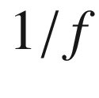

noise. Rev. Mod. Phys. **53**, 497–516 (1981). [10.​1103/​RevModPhys.​53.​497](https://doi.org/10.1103/RevModPhys.53.497)

M.B. Weissmann,

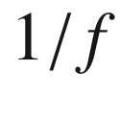

noise and other slow, nonexponential kinetics in condensed matter. Rev. Mod. Phys. **60**, 537–571 (1988). [10.​1103/​RevModPhys.​60.​537](https://doi.org/10.1103/RevModPhys.60.537)

T.G.M. Kleinpenning, A.H. de Kuijper, Relation between variance and sample duration of

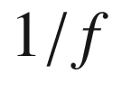

noise signals. J. Appl. Phys. **63**, 43–45 (1988). [10.​1063/​1.​340460](https://doi.org/10.1063/1.340460)

T.M. Chen, S.F. Su, D. Smith,

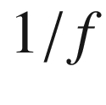

Noise in Ru-based thick-film resistor. Solid State Electron. **25**, 821–827 (1982). [10.​1016/​0038-1101(82)90213-1](https://doi.org/10.1016/0038-1101(82)90213-1)

J.M. Boudry, L.E. Antonuk, Current-noise-power spectra of amorphous silicon thin-film transistors. J. Appl. Phys. **76**, 2529–2534 (1994). [10.​1063/​1.​357614](https://doi.org/10.1063/1.357614)

J.E. Hill, K.M. van Vliet, Ambipolar transport of carrier density fluctuations in germanium. Physica **24**, 709–720 (1958). [10.​1016/​S0031-8914(58)80087-7](https://doi.org/10.1016/S0031-8914(58)80087-7)

G. Ferrari, M. Sampietro, G. Bertuccio, G. Gomila, L. Reggiani, On the origin of shot noise in CdTe detectors. Appl. Phys. Lett. **83**, 2450–2452 (2003). [10.​1063/​1.​1611648](https://doi.org/10.1063/1.1611648)

C.W.J. Beenakker, M. Büttiker, Suppression of shot noise in metallic diffusive conductors. Phys. Rev. B **46**, 1889–1892 (1992). [10.​1103/​PhysRevB.​46.​1889](https://doi.org/10.1103/PhysRevB.46.1889)

H. Schomerus, E.G. Mishchenko, C.W.J. Beenakker, Shot-noise in non-degenerate semiconductors with energy-dependent elastic scattering, in *Statistical and Dynamical Aspects of Mesoscopic Systems*, eds. by D. Reguera, J.M. Rubí, G. Platero, L.L. Bonilla, eds., Lecture Notes in Physics, vol. 547, pp. 96–104 (Springer, Berlin, 2000). [10.​1007/​3-540-45557-4\_​9](https://doi.org/10.1007/3-540-45557-4%255F9)

A. van der Ziel, Shot noise in semiconductors. J. Appl. Phys. **24**, 222–223 (1953). [10.​1063/​1.​1721242](https://doi.org/10.1063/1.1721242)

R. Müller, Generation-recombination noise, in *Noise in Physical Systems*, ed. by D. Wolf, Springer Series in Electrophysics, vol. 2, pp. 13–25 (1978). [10.​1007/​978-3-642-87640-0\_​2](https://doi.org/10.1007/978-3-642-87640-0%255F2)

V. Mitin, L. Reggiani, L. Varani, Generation-recombination noise in semiconductors, in: *Noise and Fluctuations Control in Electronic Devices*, ed. by A. Balandin (American Scientific Publishers, Valencia, USA, 2002), pp. 1–19 (Chap. 2)

V. Bareikis, J. Liberis, I. Matulioniene, A. Matulionis, P. Sakalas, Experiments on hot electron noise in semiconductor materials for high-speed devices. IEEE Trans. Electron Dev. **41**, 2050–2060 (1994). [10.​1109/​16.​333822](https://doi.org/10.1109/16.333822)

B.K. Jones, Low-frequency noise spectroscopy. IEEE Trans. Electron Dev. **41**, 2188–2197 (1994). [10.​1109/​16.​333840](https://doi.org/10.1109/16.333840)